    Joint Video Experts Team (JVET)  of ITU-T SG 16 WP 3 and ISO/IEC JTC 1/SC 29  26th Meeting, by teleconference, 20–29 April 2022 | Document: JVET-Z0132-v1

Title: | AHG13: On film grain synthesis
Status: | Input document to JVET
Purpose: | Proposal
Author(s) or  Contact(s): | Yong He, Muhammed Coban, Marta Karczewicz  Philippe de Lagrange, Edouard François  Miloš Radosavljević  Sean McCarthy, Walt Husak | Email: | yonghe@qti.qualcomm.com, Philippe.DeLagrange@interdigital.com  milosr@xiaomi.com Sean.McCarthy@dolby.com
Source: | Qualcomm Inc., InterDigital, Xiaomi, Dolby Laboratories, Inc.
_____________________________

Abstract
This contribution proposes study of film grain synthesis and relevant conformance requirements in AHG13 with the following items:
- Conformance requirements
- Auto-regressive model reference software development
- Reference film grain synthesis process

Introduction
Film grain synthesis technologies are used to improve the compression efficiency by removing noise prior to or during the encoding process and reconstructing film grain during or after the decoding process. The film grain metadata generated from the film grain analysis process is signaled to the decoder to produce an approximation of the film grain of the original content [1]. Film grain parameters can also be manually selected and provided to the encoder within the configuration file and can be added to decoded video even if source video is noiseless. Film grain modelling technologies may also be used to add visual noise to decoded video to mask or attenuate the visibility of compression artefacts.
Figure 1 illustrates the film grain appearance before and after denoising, on the luma channel of the CrowdRun sequence, which was shot with a Kodak Vision 250D film and scanned such that 1 pixel covers about 17µm of film. Original is on the left, followed by a denoised version, then the difference (x4 to be more visible) which is the film grain, and finally an FFT cloud indicative of the grain sharpness (or “size”). The difference in both amplitude and spatial frequency response of film grain between dark and light areas is clearly observable.
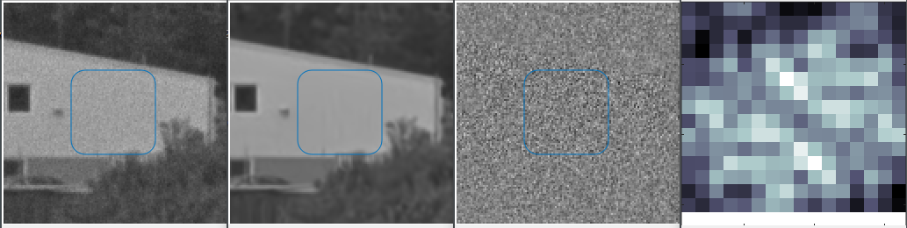
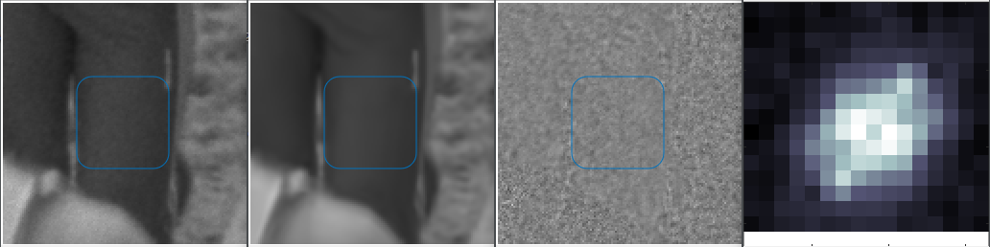
Figure 1 Film grain example, showing original / denoised / diff / FFT
Figure 2 illustrates film grain synthesis with parameters adjusted to match the original as much as possible, while Figure 3 illustrates film grain synthesis used to mask compression artefact on a content that is originally grain-free.
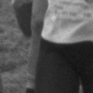
Figure 2 Example usage of film grain synthesis to match original (artistic intent), showing original / decoded / synthesis
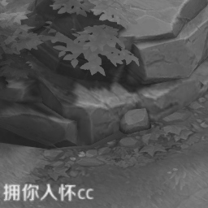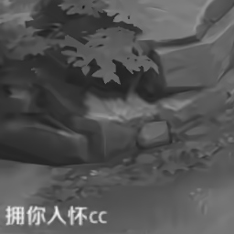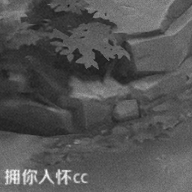
Figure 3 Example usage of film grain synthesis to mask artefacts, showing original / decoded / synthesis
AVC, HEVC and VVC/VSEI provide film grain parameter values in film grain characteristics (FGC) SEI message and two models are supported, frequency filtering model (one implementation variant of frequency model is commonly known as SMPTE RDD-5 [2]), and auto-regressive (AR) model. Since the decoder is not required to apply film grain synthesis, most deployed AVC and HEVC decoders did not include support for such SEI messages which ended up discouraging the use of film grain synthesis [3]. As a result, some applications may not utilize the film grain technology benefits since the film grain cannot be guaranteed to be restored at the decoder side, or may choose other codec instead.
The AR film grain synthesis developed by AOM is specified in AV1 as normative process and the film grain parameters are carried in the frame syntax. Given the fact that the implementations of film grain modeling may vary due to the HW pipeline design, AV1 specifies "soft" conformance requirements for the film grain synthesis process. A conformant decoder shall satisfy at least one of the two options (1) a bit exact film grain synthesis and addition implementation; (2) any film grain synthesis method that produces output frames that are in the same order and do not have perceptually significant differences with the frames produced by the reference film grain synthesis process. The definition of "perceptually significant differences" is beyond the scope of AV1 specification and the film grain process applied by a conformant decoder should be feature complete.
Contribution JVET-Q0424 [4] and JVET-Q0533 [5] each proposed a different film grain method as a mandatory required feature of VVC. JVET-W0095 [6] proposed bit-exact conformance requirement for FGC SEI message in VSEI. None of the contributions was adopted.

Proposal
This contribution proposes to investigate the FGC SEI message-based film grain process with soft conformance requirement in AHG13, including the following aspects.
- Conformance requirement: A conformant decoder shall either produce output frames that are identical in all aspects and have the same output order as those produced by the exact film grain process; or produce output frames that are in the same order and do not have perceptually significant differences with the frames produced by the reference film grain synthesis process specified. The definition of "perceptually significant differences" is beyond the scope of VSEI specification.
- Current VTM supports frequency filtering film grain model but not AR model, an AR model simulation is necessary to evaluate the reference film grain synthesis process for conformance requirements.
- Determine the reference film grain synthesis process for bit-exact conformance requirements and soft conformance requirements.

Reference
- JVET-Y2020, "Film grain synthesis technology for video applications", Jan. 2022
- RDD 5:2006 - SMPTE Registered Disclosure Doc - Film Grain Technology — Specifications for H.264 | MPEG-4 AVC Bitstreams,” RDD 5:2006, pp. 1–18, Mar. 2006, doi: 10.5594/SMPTE.RDD5.2006.
- JVET-Q0614, "Film grain synthesis support in VVC', Jan. 2020
- JVET-Q0424, "Mandatory film grain", Jan. 2020
- JVET-Q0533, "Film grain synthesis support", Jan. 2020
- JVET-W0095, "AHG 9: Bit-accurate grain blending process for film grain characteristics SEI message", July 2020

Patent rights declaration(s)
Qualcomm Inc., InterDigital, Xiaomi and Dolby Laboratories, Inc. do not have any current or pending patent rights relating to the technology described in this contribution.

