    Joint Video Experts Team (JVET)  of ITU-T SG 16 WP 3 and ISO/IEC JTC 1/SC 29  26th Meeting, by teleconference, 20–29 April 2022 | Document: JVET-Z0108

Title: | Evaluation of 17 objective quality metrics on JVET contents
Status: | Input document to JVET
Purpose: | Information
Author(s) or  Contact(s): | Joel Jung  J.G. Lopez  Xiang Li  Shan Liu | Tel:  Email: | joeljung@tencent.com
Source: | Tencent
_____________________________

Abstract
Objective metrics are usually considered to correlate insufficiently with Mean Opinion Scores (MOS) to provide a reliable overall quality score. This contribution updates the contribution m58816. It evaluates 13 full-reference and 4 no-reference objective metrics using subjective scores obtained on JVET content, and during JVET remote expert viewing sessions. Instead of computing classical correlations (Pearson, Spearman, etc) with average MOS, and trying to assess how much the metric reflects the overall quality level, the contribution investigates the ability of the metrics to answer the question: “Is the proposal better than the anchor?”. A Receiver Operating Characteristics approach with a binary classifier is used. The confidence intervals and the bias resulting from the usage of a forced-choice scale are taken into account. It is reported that a group of metrics can be considered as reliable for most of the decisions, with correct decision rates above 85%.

Introduction
It is frequently reported that objective metrics, such as VMAF, PSNR, SSIM, have insufficient correlation with MOS. Even if subjective tests are occasionally performed on carefully selected contributions, coding activities rely strongly on the PSNR to take decisions on adoption. This has never prevented any standard to reach at least 40% improvement over its predecessor, according to subjective evaluation made through verification tests. It is legitimate to wonder how this can happen.

In most quality evaluation studies, the Mean Opinion Score (MOS) is obtained through an Absolute Category Rating (ACR) approach, which gives an overall quality level. It is typically compared to objective scores obtained from metrics. The scales of the subjective scores vary, as well as the scales of the objective metrics. The conclusion is that metrics’ scores fit insufficiently the MOS, considering typical correlations, like the Pearson correlation, or the Spearman rank order correlation.

In this contribution, we don’t evaluate the ability of the metrics to correlate with MOS overall quality level. The main reason is that remote expert viewing session in JVET are pairwise comparison, based on a Comparison Category Rating (CCR) methodology, and MOS is not available. There is no notion of overall quality level, but only a notion of comparative quality, through a Comparison Mean Opinion Score (CMOS). We consequently evaluate the ability of the metric to take correct decisions when a proposal is compared to an anchor. This evaluation is even more valid in the framework of JVET, for which the 4-grade scale can provide an answer to the question “which of A or B is better”, but gives very limited, if any, information of how much “A is better to B” or not.

We consider JVET content only and rely on subjective scores obtained from JVET remote expert viewing sessions of the four latest meetings. We evaluate several full-reference and no-reference metrics.

This contribution is an update of the contribution m58816 on the same topic. It adds:
- Consideration of JVET-Y content,
- Consideration of subjective scores bias resulting from the forced-choice scale,
- Consideration of confidence intervals,
- Addition of two metrics: DISTS and 3SSIM,
- Split per categories of proposals.

Subjective test methodology and content
The dataset is made of CMOS obtained from JVET-U, JVET-V, JVET-W, JVET-X and JVET-Y meetings. A total of 148 pairs of sequence are considered. No sequence or CMOS score has been rejected for this study.
The subjective tests were performed by following the remote expert viewing guidelines [REV] with a number of viewers varying from 10 to 15 for each session. A pairwise comparison, comparison category rating (CCR), was used with the following rating scale:

+3 : “Proposal much better than anchor”
+1 : “Proposal better than anchor”
-1 : “Anchor better than proposal”
-3 : “Anchor much better than proposal”

Objective metrics evaluation methodology
The JVET subjective tests use an indirect scaling, with pairwise comparison (CCR, Comparison Category Ranking): only comparative scores (CMOS) are available, and there is no indication of overall quality level. This is in line with the need of detecting whether a proposal performs better than the anchor or not.

We have consequently computed the objective score of the proposal and the objective score of the anchor, and the difference between these two scores, reflecting whether the proposal is better than the anchor or not, according to the metric.

We have used a Receiver Operating Characteristic (ROC) analysis, which is adapted to such binary classifiers, and arbitrarily selected that a positive case correspond to the situation were the proposal is better than the anchor. We have then derived true positive, true negative, false positive and false negative cases as follows:
- TP: True Positive: CMOS says A<P and metric says A<P
- TN: True Negative: CMOS says A>P and metric says A>P
- FP: False positive: CMOS says A<P and metric says A>P
- FN: False negative: CMOS says A>P and metric says A<P

We have also computed the percentage of correct decisions, CD:

CD = (TP + TN) / (TP + TN + FP + FN).

It could have been possible, theoretically, to additionally compute Pearson and Spearman correlations on the CMOS and the difference between the two objective scores. We however consider that this information is not relevant (and even wrong), because there is no reason for having a linear correlation between the JVET subjective scale and the objective scores (non-linear correlation are possible):
- There is a similar gap of “2” units between “much better and better”, similarly as between “better and worse”.
- The forced-choice creates situations where viewers score randomly “-1“ or “+1” when the anchor and the proposal are close. This yields in average CMOS between -0.5 and 0.5 when the anchor and the proposal are close. While this might be acceptable for subjective tests, it is not fair for computing linear correlations with metrics, that, in this situation will typically report a value close to 0.

Evaluated objective metrics
13 full-reference metrics are evaluated:
- VMAF, PSNR, SSIM, MS-SSIM
- 3SSIM (Three Component SSIM) [3SSIM]. It is computing a weighted average of SSIM for three different categories: edges, textures and smooth regions.
- VQM [VQM]: DCT-based Video Quality Metric, an 8x8 DCT is used to get the frequencies in the image, the DCT coefficients are converted to local contrast, further converted to just noticeable differences to derive the score.
VIF (Visual Information Fidelity) [VIF]. It is based on natural scene statistics and the notion of image information extracted by the human visual system.
- WaDiQAM (Weighted Average Deep Image QuAlity Measure) [WADIQAM]. It is a deep neural network-based approach for image quality assessment. The network is trained end-to-end and comprises ten convolutional layers and five pooling layers for feature extraction, and two fully connected layers for regression.
- LPIPS (Learned Perceptual Image Patch Similarity) [LPIPS], and two variants, LPIPS modified with a squeezeNet network, and LPIPS modified with a VGG network. LPIPS is a family of deep learning based objective metrics, that evaluates the similarity of an image with a reference image, rather than the quality itself.
- AVQT (Advanced Video Quality Tool) [AVQT]
- DISTS (Deep Image Structure and Texture Similarity) [DISTS]. It is a full-reference image quality assessment model. It is based on a CNN that combines texture similarity spatial averages and structure similarity. It is designed to provide explicit tolerance to texture resampling, and insensitivity to geometric transformations.

4 no-reference metrics are considered:
- DBCNN (Deep Bilinear Convolutional Neural Network) [DBCNN]. It is a no-reference deep learning based method.
- PIQE (Perception based Image Quality Evaluator) [PIQE]. It is an opinion-unaware and unsupervised metric. It does not require a trained model. PIQE measures the quality of images with arbitrary distortion. It estimates block-wise distortion and measures the local variance of perceptibly distorted blocks to compute the quality score.
- NIQE (Natural Image Quality Evaluator) [NIQE]. It is a blind image quality analyzer that only makes use of measurable deviations from statistical regularities observed in natural images, without training on human-rated distorted images, and, indeed without any exposure to distorted images.
- BRISQUE (Blind/Referenceless Image Spatial Quality Evaluator) [BRISQUE]. It is a natural scene statistic (NSS)-based distortion-generic blind/no-reference (NR) image quality assessment (IQA) model which operates in the spatial domain. It does not compute distortion specific features such as ringing, blur or blocking, but instead uses scene statistics of locally normalized luminance coefficients to quantify possible losses of ‘naturalness’ in the image due to the presence of distortions, thereby leading to a holistic measure of quality.

None of the evaluated metrics was re-trained. The metrics were applied on each frame of the sequence, and the score of each frame averaged with equal weight.

Experimental results

Full dataset
Table 1 reports for each metric the number of true positive, true negative, false positive, false negative cases according to the ROC analysis. We can observe that the number of true positive, corresponding to situations where the proposal is claimed better than the anchor by both humans and metrics is high. The wrong decisions of the metrics are reflected by false positive and false negative. Table 1 also provides the rate of correct decisions. These results are obtained on 148 pairs of sequences (“anchor”/”proposal”).

On average, SSIM, VMAF, MD-SSIM, LPIPS with VGG net and AVQT take correct decisions for more than 75% of the test cells, with a small advantage for SSIM.

Full Reference Metrics | TP | TN | FP | FN | CD
SSIM | 101 | 13 | 25 | 9 | 77.0%
VMAF | 97 | 16 | 22 | 13 | 76.4%
MS-SSIM | 102 | 11 | 27 | 8 | 76.4%
LPIPS (with VGGNet) | 95 | 16 | 22 | 15 | 75.0%
AVQT | 97 | 14 | 24 | 13 | 75.0%
PSNR | 98 | 12 | 26 | 12 | 74.3%
VIF | 85 | 24 | 14 | 25 | 73.6%
LPIPS (with squeezeNet) | 93 | 15 | 23 | 17 | 73.0%
VQM | 85 | 17 | 20 | 24 | 71.9%
3SSIM | 93 | 13 | 25 | 17 | 71.6%
LPIPS (default, alexNet) | 92 | 13 | 25 | 18 | 70.9%
WaDIQam | 86 | 14 | 24 | 24 | 67.6%
DISTS | 68 | 13 | 24 | 42 | 55.1%
No Reference Metrics | TP | TN | FP | FN | CD
DBCNN | 90 | 12 | 26 | 20 | 68.9%
NIQE | 74 | 24 | 14 | 36 | 66.2%
BRISQUE | 71 | 16 | 22 | 39 | 58.8%
PIQE | 58 | 9 | 29 | 52 | 45.3%
Table 1: number of true positive, true negative, false positive, false negative situations, and percentage of correct decisions

Considering the confidence interval
The results in section 5.1 do not consider the confidence interval of the subjective test. It is generally agreed that when the score +/- the confidence interval crosses the x-axis, there is some uncertainty regarding which of the proposal or the anchor is better. In that case, it is unfair to sanction a metric, for a possibly wrong decision.
To handle the confidence interval, in Table 2, all pairs for which there is uncertainty according to the confidence interval have been removed. With CI constraint, only 66 test cells are remaining (out of 148).
With this criterion, we can observe that SSIM, VMAF and MS-SSIM have a very high correct decision rate, close to 90%, which makes them highly reliable for taking decisions. In addition, the scores of several other metrics are above 80%. Due to the very high number of test cells for which the confidence interval crosses the x-axis, and so the reduced amount of test cells remaining, we tend to believe that the correct decisions rate of the metrics, in this test, is slightly overestimated. Still, it is more reliable than the one reported in section 5.1.

Full Reference Metrics | CD with CI constraint
SSIM | 89,4%
VMAF | 89,4%
MS-SSIM | 89,4%
LPIPS (with VGGNet) | 86,4%
PSNR | 86,4%
AVQT | 83,3%
3SSIM | 83.3%
LPIPS (default, alexNet) | 81,8%
VIF | 81,8%
LPIPS (with squeezeNet) | 80,3%
WaDIQam | 77,3%
VQM | 77.3%
DISTS | 58.5%
No Reference Metrics
DBCNN | 75,8%
NIQE | 74,2%
BRISQUE | 66,7%
PIQE | 43,9%
Table 2: percentage of correct decisions, considering the confidence interval

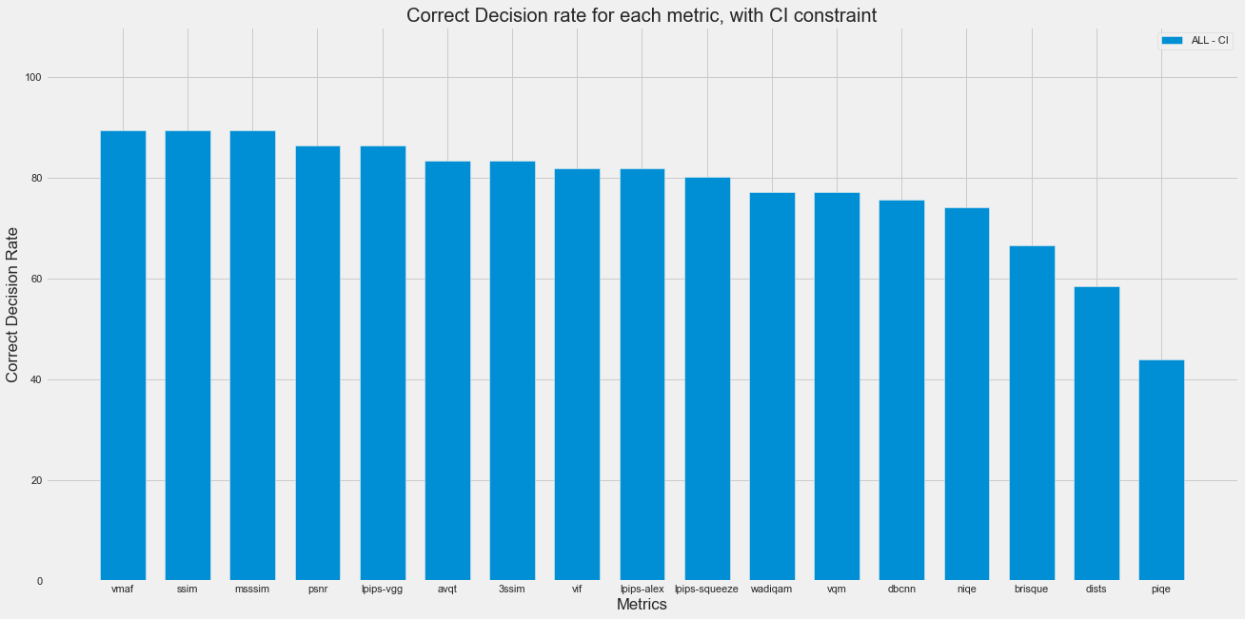
Figure 1: percentage of correct decisions, considering the confidence interval

Considering the bias of the remote viewing test methodology
In section 5.1, any CMOS value, reflecting the score difference between the proposal and the anchor, whatever its amplitude, decides which of the anchor or the proposal is better. It is understandable that a small |CMOS| might rather indicate doubts of human subject, rather than a strict binary decision.
Moreover, the JVET subjective viewing methodology makes usage of a forced-choice approach, that is to say without “0” in the rating scale. There is no possibility for the viewer to tell that the anchor and the proposal are of similar quality. While it has the advantage to force expert viewers to focus and avoid laziness of scoring with “0” too often, it has the major drawback that when anchor and proposal are similar or close enough, the viewer scores randomly “+1” or “-1”. Given that the number of viewers remains small (typically below 20), there is no mathematical reason to converge to “0” for such test cells.

In table 2, we consequently remove all test cells for which there is an incertitude, based on the CMOS amplitude. Only the test cells with |CMOS| >= 0.4 are kept. As a consequence, 88 test cells are remaining out of 148.

We believe these results reflects with much more accuracy the ability of the metrics to take correct decisions, when the anchor and the proposal are not of similar quality.

The correct decision rate is logically in between those reported in sections 5.1 and 5.2. SSIM, VMAF and LPIPS (VGG), with nearly 85% of correct decisions, can be considered as reliable. Several other metrics have a correct decision rate above 80%.

Full Reference Metrics | CD with  |CMOS|  >= 0.4
SSIM | 84.1%
VMAF | 84.1%
LPIPS (with VGGNet) | 84.1%
MS-SSIM | 83.0%
PSNR | 83.0%
AVQT | 81.8%
LPIPS (default, alexNet) | 80.7%
3SSIM | 79.5%
VQM | 78.7%
LPIPS (with squeezeNet) | 78.4%
WaDIQam | 77.3%
VIF | 76.1%
DISTS | 56.3%
No Reference Metrics | |CMOS|  >0.5
DBCNN | 73.9%
NIQE | 69.3%
BRISQUE | 63.6%
PIQE | 45.5%
Table 3: percentage of correct decisions, considering the |CMOS| amplitude

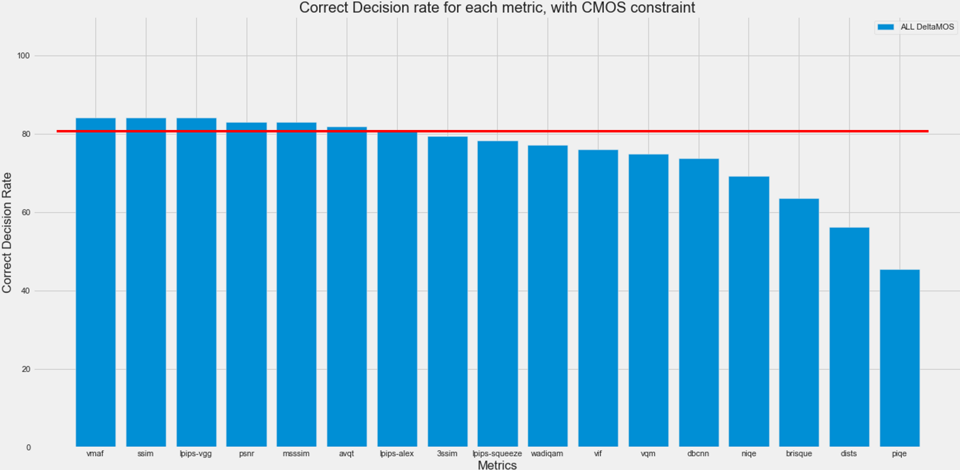
Figure 2: percentage of correct decisions, considering the |CMOS| amplitude

Split per category
In this section, the constraint |CMOS| >= 0.4 is applied, to deal only with test cells for which humans have made a reliable choice. Among the 148 pairs evaluated, three different categories of methods were considered:
- DNN in loop filter (42 pairs)
- DNN super resolution (28 pairs)
- Deblocking (8 pairs)
All other test cells, including trapping pairs (for instance made of the same content, or with a very low quality vs original pair), reference picture resampling, and DCS (decomposition, compression, synthesis) are gathered in the same “others” category. They represent 10 pairs.

The number of pairs per categories is a bit low. We suggest to consider the results in this section as preliminary.

Full Reference Metrics | DNN in loop filter | DNN super resolution | Deblocking | Others
SSIM | 81,0% | 89,3% | 62,5% | 100%
VMAF | 78,6% | 92,9% | 62,5% | 100%
MS-SSIM | 81,0% | 89,3% | 50,0% | 100%
LPIPS (with VGGNet) | 83,3% | 85,7% | 62,5% | 100%
PSNR | 78,6% | 89,3% | 62,5% | 100%
AVQT | 76,2% | 85,7% | 75,0% | 100%
LPIPS (default, alexNet) | 81,0% | 78,6% | 62,5% | 100%
LPIPS (with squeezeNet) | 81,0% | 78,6% | 50,0% | 90.0%
VIF | 69,0% | 75,0% | 100,0% | 90.0%
WaDIQam | 78,6% | 71,4% | 75,0% | 90.0%
VQM | 76.2% | 75.0% | 50% | 100%
DISTS | 40.5% | 67.9% | 50.0% | 80.0%
3SSIM | 81.0% | 78.6% | 50.0% | 100.0%
No Reference Metrics | DNN in loop filter | DNN super resolution | Deblocking | Others
DBCNN | 76,2% | 71,4% | 62,5% | 80.0%
NIQE | 69,0% | 60,7% | 75,0% | 90.0%
BRISQUE | 59,5% | 67,9% | 50,0% | 80.0%
PIQE | 64,3% | 32,1% | 12,5% | 30.0%
Table 4: percentage of correct decisions, per category, considering the |CMOS| amplitude

For DNN in loop filter category, LPIPS-VGG has the highest score (83.3%), and MS-SSIM, SSIM, LPIPS-SQUEEZE, LPIPS-ALEX have scores above 80%.

For DNN super resolution category, with a correct decision rate close to 90% (respectively 92.9%, 89.3%, 89.3%, 89.3%) VMAF, SSIM and MS-SSIM and PSNR can be considered as highly reliable. AVQT, PSNR and LPIPS-VGG still have good scores, above 85% of correct decisions.

For Deblocking category, VIF (100%) has the best correct decision rate. AVQT, WADIQAM, and NIQE have the remaining best scores, that are however too low (75%) to be qualified as reliable. It is clearly visible that classical VMAF, SSIM, MS-SSIM and PSNR fail with very low rates of 62.5%. The scores for deblocking are generally lower than for other categories.

Note: to analyze if metrics work better on some categories than on others, it is important to consider the |CMOS| of the considered test cells, for each category. As a simple example, let’s assume that for the deblocking category, the |CMOS| is high (happening if there is a huge difference between the anchor and the proposal), then CD rate for the deblocking category could be very high, because the task would be easy for the metrics too. This would however not mean that metrics are more efficient on deblocking category than on other categories. The |CMOS| is 0.6, 1.0, 0.8 for DNN in loop filter, DNN super resolution, and deblocking categories respectively, indicating that the variation of CD might indeed come from the category itself.

Summary
Table 5 provides a visual representation of the efficiency of each metric, in the different cases studied. A green color indicates a correct decision rate above or equal to 85%. An orange color indicates a correct decision rate above or equal to 75%, and below 85%.
The best metric in each category is additionally marked with “###”.

Full Reference Metrics | CI constraint | CMOS constraint |  | DNN in loop filter | DNN super resolution | Deblocking
SSIM | ### | ###
VMAF | ### | ### |  |  | ###
LPIPS (with VGGNet) |  | ### |  | ###
MS-SSIM | ###
PSNR
AVQT
LPIPS (default, alexNet)
VQM
LPIPS (with squeezeNet)
3SSIM
WaDIQam
VIF |  |  |  |  |  | ###
DISTS
No Reference Metrics | CI constraint | CMOS constraint |  | DNN in loop filter | DNN super resolution | Deblocking
DBCNN
NIQE
BRISQUE
PIQE

Highly reliable (>85%) | Reliable (>75%) | Not reliable
Table 5: visual representation of the efficiency of each metric.

Discussion and conclusions
We report the ability for several metrics to correctly decide whether a proposal is better than an anchor or not. The correct decision rate is around 84% for SSIM, VMAF and LPIPS (with VGG network) in the most realistic scenario. These three metrics are on average the most efficient, when considering different conditions and situations. This rate is higher when the confidence interval constraint, only, is considered.
Given that the PSNR is consistently less reliable than VMAF in all tested configurations, we believe considering VMAF for future development is recommended.
Preliminary results, when splitting by categories of proposals, show that several metrics are perfectly reliable for the DNN super resolution, and reliable for the DNN in loop filter methods. The results on deblocking show that classical metrics, VMAF, SSIM, MS-SSIM, PSNR fail for this category, while VIF, AVQT and WaDIQAM seem more appropriate.
This contribution also confirm that no-reference metrics are far less reliable than full-reference metrics, and that neural network based approaches, without being specifically retrained, do not systematically outperform classical approaches.

The next steps of this study can consist in:
- Add data related to JVET-Z meeting, to confirm the preliminary results obtained when splitting per categories, with more test points,
- Train some models based on JVET data.

References
[DBCNN] W. Zhang, K. Ma, J. Yan, D. Deng and Z. Wang, "Blind Image Quality Assessment Using a Deep Bilinear Convolutional Neural Network," in IEEE Transactions on Circuits and Systems for Video Technology, vol. 30, no. 1, pp. 36-47, Jan. 2020, doi: 10.1109/TCSVT.2018.2886771.
[PIQE] Venkatanath, N.; Praneeth, D.; Maruthi Chandrasekhar, B.H.; Channappayya, S.S.; Medasani, S.S. Blind image quality evaluation using perception based features. In Proceedings of the 2015 21st National Conference on Communications, NCC 2015, Bombay, Indian, 27 February–1 March; 2015.
[NIQE] A. Mittal, R. Soundararajan and A. C. Bovik, “ Making a Completely Blind Image Quality Analyzer ”, IEEE Signal processing Letters, pp. 209-212, vol. 22, no. 3, March 2013.
[BRISQUE] A. Mittal, A. K. Moorthy and A. C. Bovik, "Blind/Referenceless Image Spatial Quality Evaluator," 2011 Conference Record of the Forty Fifth Asilomar Conference on Signals, Systems and Computers (ASILOMAR), 2011, pp. 723-727, doi: 10.1109/ACSSC.2011.6190099.
[WADIQAM] S. Bosse, D. Maniry, K. Müller, T. Wiegand and W. Samek, "Deep Neural Networks for No-Reference and Full-Reference Image Quality Assessment," in IEEE Transactions on Image Processing, vol. 27, no. 1, pp. 206-219, Jan. 2018, doi: 10.1109/TIP.2017.2760518.
[REV] J. Jung, M. Wien, V. Baroncini, Guidelines for remote experts viewing sessions, ISO/IEC JTC 1/SC 29/AG 5 N00040 Online, October 2021.
[VQM] F. Xiao, “DCT-based Video Quality Evaluation”, final project of the EE392J, 2000.
[AVQT] https://developer.apple.com/videos/play/wwdc2021/10145/
[VIF] Sheikh, Hamid; Bovik, Alan (2006). "Image Information and Visual Quality". IEEE Transactions on Image Processing. 15 (2): 430–444.
[LPIPS] R. Zhang, P. Isola, A.A. Efros, E. Shechtman, O. Wang, “The Unreasonable Effectiveness of Deep Features as a Perceptual Metric”, CVPR 2018.
[DISTS] K. Ding, K. Ma, S. Wang, E.P. Simoncelli, Image Quality Assessment: Unifying Structure and Texture Similarity, IEEE Transactions on Pattern Analysis and Machine Intelligence, 2021, 10.48550/arXiv.2004.07728.
[3SSIM] C. Li, A. Bovik, Content-Weighted Video Quality Assessment Using a Three-Component Image Model. Journal of Electronic Imaging. 29. 10.1117/1.3267087.

Patent rights declaration(s)
Tencent does not have any current or pending patent rights relating to the technology described in this contribution.

