    Joint Video Experts Team (JVET)  of ITU-T SG 16 WP 3 and ISO/IEC JTC 1/SC 29  26th Meeting, by teleconference, 20–29 April 2022 | Document: JVET-Z0106-v1

Title: | EE1-related: Reduced complexity NN loop filter and ablation study
Status: | Input document to JVET
Purpose: | Proposal
Author(s) or  Contact(s): | Jacob Strom, Du Liu, Mitra Damghanian, Kenneth Andersson, Yun Li,  Per Wennersten and Ruoyang Yu  Torshamnsgatan 23  164 83 Stockholm | Tel:  Email: | +46702672192  {jacob.strom, du.liu, mitra.damghanian, kenneth.r.andersson, yun.y.li, per.wennersten, ruoyang.yu} @ericsson.com
Source: | Ericsson
_____________________________

Abstract
This contribution presents an ablation study of the intra model in the neural network-based loop filter from JVET-Y0143. It is stated that the network is trained several times from scratch, each time changing a single variable, such as removing one of the inputs to the filter. Some changes are claimed to hurt BD-rate performance, such as removing the prediction input. It is further claimed that other changes do not seem to impact the BD-rate performance. As an example, the contribution states that removing the partitioning input lowers the complexity of the intra luma-filter without harming the BD-rate, giving BD-rate figures over the VTM-11.0 + newMCTF anchor of
BDR-Y: -7.57% (AI) -9.82% (RA), -8.54% (LDB)
while keeping the intra chroma model and the inter models the same as in JVET-Y0143. It is further reported that removing the attention branch in all residual blocks except the last one decreases BDR-Y performance by 0.01% (AI). The contribution proposes to further study the best inputs and attention mechanisms for NN loop filters in an exploration experiment.

Introduction
This contribution describes an ablation study, i.e., a study where we change one variable at a time, retrain the network from scratch and measure the performance. In this study we have concentrated on the intra luma model from JVET-Y0143 [1]. The inputs of the intra luma model include the reconstruction samples (rec), the prediction samples (pred), the partition information (part), the block boundary strength (BS), and QP. The intra luma model contains 8 sequential residual blocks, each with an attention mask. We have investigated the following approaches
- Longer training – around 146 hours versus 60 hours
- Removing inputs from the model
  - Removing partitioning input
  - Removing BS input
  - Removing both partitioning input and BS input
  - Removing prediction input
- Making the network shallower (4 residual blocks instead of 8)
- Making the network deeper (16 residual blocks instead of 8)
- Removing the attention from all but the last residual block
The evaluation is done using VTM in the same way as in JVET-Y0143, with necessary modifications (such as removing inputs) but no other changes. The intra chroma model as well as the inter luma and chroma models are identical to those of JVET-Y0143.
The results of the experiments are summarized in Table 1 below. The complexity measures in kMACs/sample and number of parameters were calculated using the thop library [3]. All BDR figures are for AI, and all complexity figures are for the intra luma model except for the kMACs per pixel value, which includes the MACs for the intra chroma model (110 kMACs).
Table 1: Summary of ablation study for the intra luma model
Test | BDR-Y (AI) | Inputs used | kMACs per sample (Y) | kMACs per pixel (YUV) | Num. of param luma  (10⁶) | Mem  luma  (10⁶ bytes) | Epochs trained | Training time (h)
JVET-Y0143 | -7.39% | rec, pred, part, BS, QP | 429 | 539 | 1.56 | 6.25 | 90¹ | 60¹
Retrain 60 h | -7.38% | rec, pred, part, BS, QP | 429 | 539 | 1.56 | 6.25 | 155 | 60
Retrain 146 h | -7.57% | rec, pred, part, BS, QP | 429 | 539 | 1.56 | 6.25 | 378 | 146
Without part | -7.57% | rec, pred, BS, QP | 418 | 528 | 1.55 | 6.20 | 378 | 138
Without BS | -7.56% | rec, pred, part, QP | 418 | 528 | 1.55 | 6.20 | 378 | 138
Without part and BS | -7.42% | rec, pred, QP | 407 | 518 | 1.54 | 6.15 | 378 | 131
Without pred | -7.35% | rec, part, BS, QP | 418 | 528 | 1.55 | 6.20 | 378 | 138
4 res. blocks | -6.67% | rec, pred, part, BS, QP | 261 | 371 | 0.89 | 3.57 | 378 | 131
16 res. blocks | -8.28% | rec, pred, part, BS, QP | 765 | 875 | 2.91 | 11.62 | 378 | 235
Attention only at last res. block | -7.56% | rec, pred, part, BS, QP | 426 | 536 | 1.55 | 6.20 | 378 | 132

Detailed description of the tests

Retraining
In this study we first retrained the intra luma model from JVET-Y0143 to approximately the same BDR performance but using our own training scripts. The structure of the network is the same as in JVET-Y0143 but is outlined in Figures 1-3 for the convenience of the reader: In the first part (Figure 1), the different inputs are convolved, concatenated, fused and subsampled once to create the output y. This output is then fed through 8 residual blocks, each one with the structure shown in Figure 2. The output from the last residual block is fed into the last part of the network, shown in Figure 3.
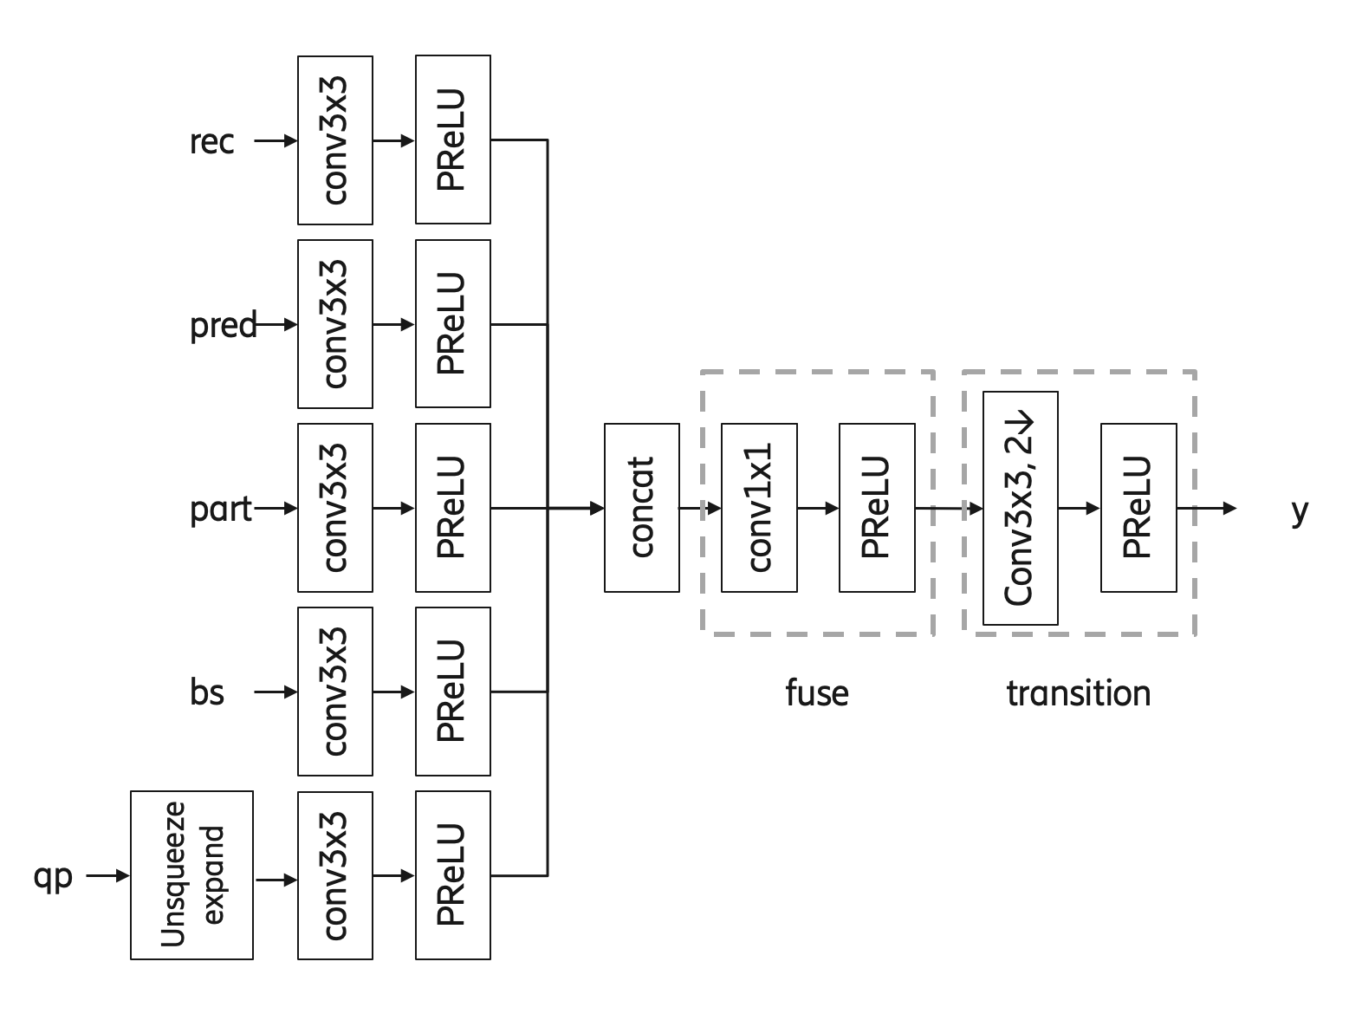
Figure 1. Head of network from JVET-Y0143. The different inputs rec, pred, part, bs and qp are combined to form the input y to the next part of the network.
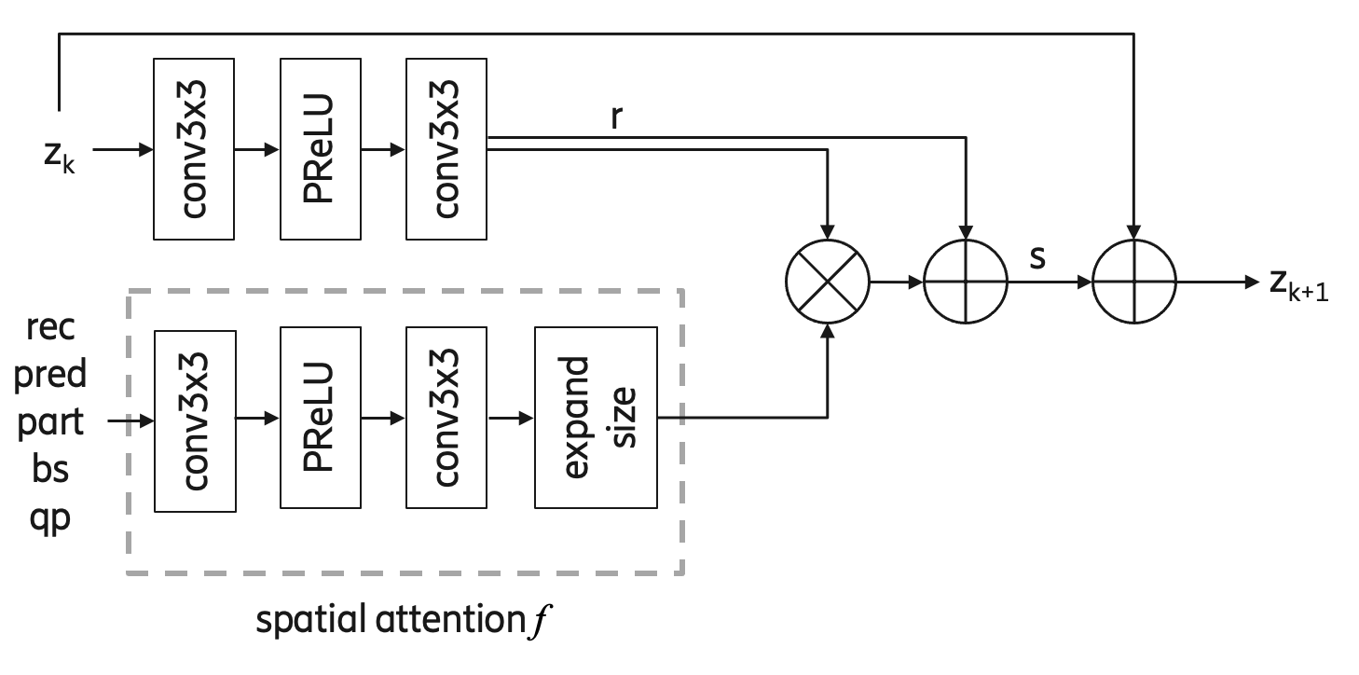
Figure 2. The k-th residual block (k=0..7). The output y of the head is fed into a first residual block with input z₀=y, which also takes the inputs rec, pred, part, bs and qp. The output z₁ is then fed into another such residual block.
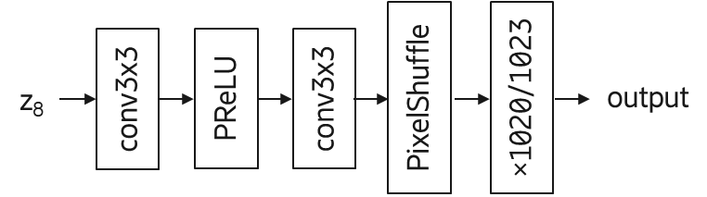
Figure 3. The output of the last residual block is fed into this last part of the network.
For the retraining, we aimed for about the same BDR-Y gain as the model in JVET-Y0143 (-7.39%) and reached -7.38% after 155 epochs, which took 60 hours. It should be noted that this and other timing figures presented in this contribution cannot be directly compared to the timing figure reported in JVET-Y0143 (also 60 hours). The reason is that different GPUs were used (V100 in JVET-Y0143 and A100 here), different number of GPUs were used (2 in JVET-Y0143 and 1 here), as well as different training scripts. Also, different training data was used, since the one in JVET-Y0143 uses QPs 17, 22, 27, 32, 37 and 42 and we have used QPs 20, 25, 30, 35 and 40. Therefore, while the results from JVET-Y0143 is included in the first row of Table 1 above, the relevant comparisons are between the other rows.

Longer training (reference network)
The first test in our ablation study is to see what happens if continuing to train the network for longer. By training for 378 epochs (146 hours) instead of 155 epochs (60 hours), the BDR-Y results becomes -7.57% instead of -7.38%, an improvement of -0.19%. This seems big enough not to be caused by training noise, although such judgements are difficult to make. This indicates that training for longer can help improving BDR results for this model. Therefore, we have used this trained network as the reference, and all the remaining training sessions reported in this document have also been trained for 378 epochs. By always training for this long, we hope to reduce the uncertainty coming from the training as much as possible in this contribution.

Removing inputs from the model
In this series of experiments, we have removed an input from the network. The input is removed both from the head (Figure 1) and the attention (Figure 2).

Removing partitioning input
In this test, we remove the partitioning (part) input from the neural network, resulting in only the following inputs being used: rec, pred, BS and QP. The BDR-Y result then becomes -7.57% after 378 epochs. When not removing the partitioning input (i.e., the input is rec, pred, part, BS, and QP) the result is -7.57% (the reference). This indicates that removing the partitioning input does not harm the BDR for the intra luma model. Due to the removal of the partitioning input, the complexity in terms of kMACs per sample goes down from 429 kMACs/sample to 418 kMACs/sample. Also including the intra chroma network, this means that the complexity goes down from 539 kMACs/pixel to 528 kMACs/pixel.

Removing boundary strength input
In this test, we remove the boundary strength (BS) input from the neural network, resulting in only the following inputs being used: rec, pred, part and QP. The BDR-Y result then becomes -7.56% after 378 epochs. The result of the reference (i.e., when the input is rec, pred, part, BS, and QP) is -7.57%. This indicates that removing the BS input does not harm the BDR for the intra luma model substantially. Due to the removal of the BS input, the complexity in terms of kMACs per sample goes down from 429 kMACs/sample to 418 kMACs/sample. Also including the intra chroma network, this means that the complexity goes down from 539 kMACs/pixel to 528 kMACs/pixel.

Removing both partitioning and boundary strength input
Given that both partitioning and boundary strength could be removed from the model with hardly any degradation, we tested to remove both inputs, resulting in only the following inputs being used: rec, pred, and QP. The BDR-Y result then becomes -7.42% after 378 epochs. This is +0.15% worse than the reference of -7.57%. Unless this difference is due to training noise, this indicates that removing both part and BS input harms the BDR for the intra luma model. It can be speculated that the partitioning information and the boundary strength information play similar roles, and that at least one is necessary for full performance. Due to the removal of the partitioning and the BS input, the complexity in terms of kMACs per sample goes down from 429 kMACs/sample to 407 kMACs/sample. Also including the intra chroma network, this means that the complexity goes down from 539 kMACs/pixel to 518 kMACs/pixel.

Removing prediction input
In this test, we remove the prediction (pred) input from the neural network, resulting in only the following inputs being used: reconstruction (rec), partitioning (part), boundary strength (BS) and QP. The BDR-Y result then becomes -7.35% when training for 378 epochs. This is significantly worse than the reference of -7.57%. This indicates that removing the prediction input does indeed seem to harm the BDR for the intra luma model.

Making the network shallower
In this test, we reduce the size of the network by reducing the number of residual blocks shown in Figure 2 from 8 to 4. The BDR-Y result then becomes -6.76% after training for 378 epochs. The reference, which has 8 residual blocks, has a BDR-Y result of -7.57%. This indicates that making the network shallower substantially harms the BDR of the intra luma model. Due to the removal of half of the residual blocks, the complexity in terms of kMACs per sample goes down from 429 kMACs/sample to 261 kMACs/sample. Also including the intra chroma network, this means that the complexity goes down from 539 kMACs/pixel to 371 kMACs/pixel.

Making the network deeper
In this test, we increase the size of the network by increasing the number of residual blocks from 8 to 16. The BDR-Y result then becomes -8.28% after training for 378 epochs. Note that due to the size of the network, this takes considerably longer than for the reference network, 235 hours rather than 146 hours. The BDR performance is also considerably better than the reference, which gets -7.57%. This indicates that making the network deeper substantially increases the BDR gain of the intra luma model. Due to the doubling of the number of residual blocks, the complexity in terms of kMACs per sample goes up from 429 kMACs/sample to 765 kMACs/sample. Also including the intra chroma network, this means that the complexity goes up from 539 kMACs/pixel to 875 kMACs/pixel.

Removing the attention from all but the last residual block
In this test, we reduce the size of the network by removing the calculation of the attention mask from all of the residual blocks except the last one. Fig. 4 depicts the structure of a residual block without the attention mask, which is used for residual block 0 through 6. Residual block 7 uses the same structure as in JVET-Y0143 shown in Figure 2. When removing the attention this way, the BDR-Y result becomes -7.56% after training for 378 epochs. This is quite close to the reference, which gets -7.57%. If the small difference of +0.01% is due to noise, this would indicate that removing the attention from all but the last residual block may not be harmful for the BD-rate in the case of the intra luma model. Due to the removal of the attention from most residual blocks, the complexity in terms of kMACs per sample goes down from 429 kMACs/sample to 426 kMACs/sample. Also including the intra chroma network, this means that the complexity goes down from 539 kMACs/pixel to 536 kMACs/pixel.
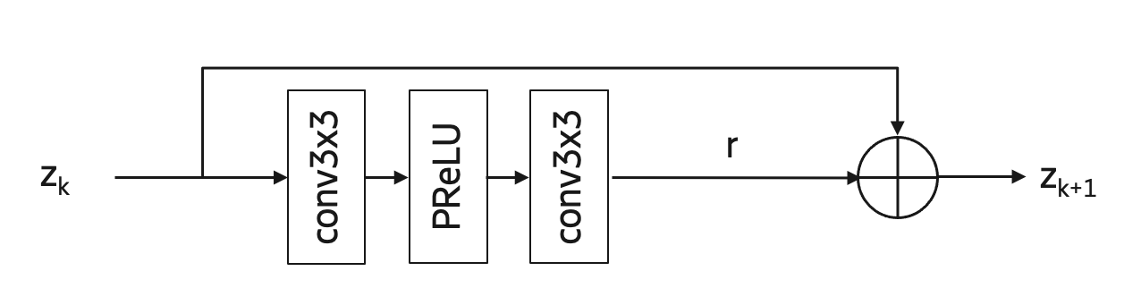
Fig. 4. The structure of a residual block without the attention mask, where z_{k} is the input to the residual block, r is the residual signal, and z_{k+1} is the output of the residual block.

Results
Here we present the BDR results for the different tests in this study. The results are in comparison to the NNVC CTC [2]. For most cases, we have only AI results, given that only the intra luma model has been changed. For the case of removing the partitioning input, we also have RA and LDB results. In this case, we have used the same models as in JVET-Y0143 for intra chroma and inter luma/chroma. The reason why these results (-9.82% (RA), -8.54% (LDB)) have a slightly higher gain than those of JVET-Y0143 (-9.82% (RA) -8.52% (LDB)) is because the higher gain of the intra luma model influences also RA and LDB.

Retraining
Results for AI.
 | Y-PSNR | U-PSNR | V-PSNR | EncT | DecT
Class A1 | -6.43% | -16.87% | -17.86% | 169% | 23601%
Class A2 | -6.74% | -18.91% | -16.12% | 136% | 18057%
Class B | -6.79% | -18.71% | -19.95% | 129% | 17653%
Class C | -7.49% | -18.42% | -20.94% | 122% | 11202%
Class E | -9.83% | -19.98% | -19.44% | 132% | 18624%
Overall | -7.38% | -18.58% | -19.10% | 135% | 16961%
Class D | -7.54% | -18.66% | -20.85% | 118% | 10054%
Class F | -5.10% | -11.89% | -11.56% | 117% | 14514%

Longer training
Results for AI.
 | Y-PSNR | U-PSNR | V-PSNR | EncT | DecT
Class A1 | -6.61% | -16.48% | -17.73% | 142% | 19521%
Class A2 | -6.92% | -18.97% | -16.26% | 118% | 15805%
Class B | -6.95% | -18.70% | -20.00% | 111% | 14397%
Class C | -7.68% | -18.30% | -20.85% | 105% | 9492%
Class E | -10.09% | -19.98% | -19.44% | 117% | 16208%
Overall | -7.57% | -18.50% | -19.09% | 116% | 14304%
Class D | -7.66% | -18.46% | -20.73% | 100% | 8212%
Class F | -5.04% | -11.85% | -11.54% | 103% | 12179%

Removing partitioning input
Results for RA:
 | Y-PSNR | U-PSNR | V-PSNR | EncT | DecT
Class A1 | -9.19% | -17.14% | -20.17% | 170% | 32181%
Class A2 | -10.59% | -20.41% | -17.54% | 160% | 29829%
Class B | -9.44% | -23.15% | -22.48% | 156% | 29294%
Class C | -10.19% | -22.50% | -23.04% | 134% | 22747%
Class E
Overall | -9.82% | -21.23% | -21.18% | 153% | 28004%
Class D | -11.71% | -24.39% | -24.97% | 136% | 22394%
Class F | -5.04% | -12.58% | -12.45% | 194% | 12267%
Results for LDB:
 | Y-PSNR | U-PSNR | V-PSNR | EncT | DecT
Class A1
Class A2
Class B | -7.99% | -14.13% | -14.51% | 165% | 31211%
Class C | -9.38% | -13.92% | -14.31% | 136% | 24419%
Class E | -8.32% | -15.78% | -14.10% | 243% | 26948%
Overall | -8.54% | -14.04% | -14.42% | 170% | 27723%
Class D | -10.86% | -18.15% | -18.17% | 124% | 18769%
Class F | -5.05% | -7.50% | -6.26% | 198% | 13566%
Results for AI:
 | Y-PSNR | U-PSNR | V-PSNR | EncT | DecT
Class A1 | -6.62% | -16.73% | -19.50% | 151% | 21390%
Class A2 | -6.94% | -18.98% | -16.31% | 125% | 16599%
Class B | -6.96% | -18.22% | -19.61% | 119% | 15922%
Class C | -7.64% | -18.28% | -20.89% | 111% | 10049%
Class E | -10.08% | -19.98% | -19.42% | 126% | 17210%
Overall | -7.57% | -18.41% | -19.30% | 124% | 15402%
Class D | -7.64% | -18.40% | -20.70% | 107% | 8981%
Class F | -4.84% | -11.88% | -11.56% | 108% | 13098%

Removing boundary strength input
Results for AI:
 | Y-PSNR | U-PSNR | V-PSNR | EncT | DecT
Class A1 | -6.60% | -16.43% | -17.68% | 160% | 22684%
Class A2 | -6.92% | -18.76% | -15.89% | 131% | 17622%
Class B | -6.94% | -18.53% | -19.78% | 126% | 17135%
Class C | -7.64% | -18.41% | -20.96% | 119% | 10736%
Class E | -10.06% | -19.99% | -19.45% | 132% | 18191%
Overall | -7.56% | -18.43% | -18.99% | 131% | 16422%
Class D | -7.67% | -18.51% | -20.75% | 116% | 9735%
Class F | -5.28% | -11.88% | -11.56% | 114% | 13777%

Removing both partitioning and boundary strength input
Results for AI:
 | Y-PSNR | U-PSNR | V-PSNR | EncT | DecT
Class A1 | -6.46% | -17.15% | -18.68% | 164% | 21602%
Class A2 | -6.80% | -18.95% | -16.22% | 133% | 16869%
Class B | -6.83% | -18.51% | -19.80% | 127% | 16299%
Class C | -7.52% | -18.36% | -20.93% | 118% | 10363%
Class E | -9.85% | -19.98% | -19.45% | 136% | 18099%
Overall | -7.42% | -18.57% | -19.21% | 133% | 15810%
Class D | -7.55% | -18.42% | -20.67% | 115% | 9222%
Class F | -5.13% | -11.88% | -11.55% | 114% | 13212%

Removing prediction input
Results for AI:
 | Y-PSNR | U-PSNR | V-PSNR | EncT | DecT
Class A1 | -6.44% | -16.57% | -17.81% | 159% | 22408%
Class A2 | -6.72% | -19.03% | -16.34% | 133% | 18869%
Class B | -6.75% | -18.76% | -19.88% | 126% | 16914%
Class C | -7.45% | -18.13% | -20.78% | 121% | 10950%
Class E | -9.74% | -19.97% | -19.42% | 132% | 18231%
Overall | -7.35% | -18.50% | -19.07% | 132% | 16595%
Class D | -7.49% | -18.30% | -20.60% | 119% | 9587%
Class F | -5.00% | -11.85% | -11.55% | 113% | 13470%

Making the network shallower
Results for AI:
 | Y-PSNR | U-PSNR | V-PSNR | EncT | DecT
Class A1 | -5.83% | -17.76% | -18.89% | 153% | 17379%
Class A2 | -6.19% | -19.45% | -17.06% | 128% | 13651%
Class B | -6.17% | -20.42% | -20.62% | 127% | 13239%
Class C | -6.88% | -18.52% | -21.08% | 117% | 8561%
Class E | -9.09% | -19.96% | -19.41% | 126% | 14429%
Overall | -6.76% | -19.32% | -19.64% | 129% | 12821%
Class D | -7.10% | -18.55% | -20.87% | 111% | 7243%
Class F | -4.59% | -11.84% | -11.55% | 115% | 10789%

Making the network deeper
Results for AI:
 | Y-PSNR | U-PSNR | V-PSNR | EncT | DecT
Class A1 | -7.29% | -15.38% | -17.75% | 176% | 32971%
Class A2 | -7.56% | -18.54% | -15.55% | 138% | 25702%
Class B | -7.62% | -16.91% | -18.46% | 129% | 24911%
Class C | -8.34% | -18.04% | -20.60% | 113% | 14939%
Class E | -11.00% | -20.00% | -19.42% | 134% | 25889%
Overall | -8.28% | -17.70% | -18.49% | 134% | 23571%
Class D | -8.18% | -18.27% | -20.54% | 108% | 13571%
Class F | -5.23% | -11.85% | -11.56% | 112% | 19381%

Attention only at the last residual block
Results for AI:
 | Y-PSNR | U-PSNR | V-PSNR | EncT | DecT
Class A1 | -6.60% | -16.87% | -19.84% | 144% | 20195%
Class A2 | -6.84% | -19.44% | -17.05% | 121% | 16209%
Class B | -6.95% | -19.07% | -20.09% | 114% | 15905%
Class C | -7.69% | -18.06% | -20.77% | 106% | 10390%
Class E | -10.08% | -19.98% | -19.43% | 119% | 17378%
Overall | -7.56% | -18.69% | -19.58% | 119% | 15329%
Class D | -7.69% | -18.24% | -20.58% | 103% | 9118%
Class F | -5.20% | -11.88% | -11.56% | 94% | 12873%

Training and inference information

Training
Table 2. Network Information for NN-based video coding tool testing in training stage for the intra luma model. The intra chroma, inter luma and inter chroma models are the same as in JVET-Y0143.
Network Information in Training Stage
Mandatory | GPU Type | GPU: NVIDIA A100-SXM-80GB
Mandatory | Framework: | PyTorch v1.9
Mandatory | Number of GPUs per Task | 1
Mandatory | Epoch: | see Table 1
Mandatory | Batch size: | 64
Mandatory | Loss function: | L1 and L2
Mandatory | Training time: | see Table 1
Mandatory | Training data information: | DIV2K, BVI-DVC
Mandatory | Training configurations for generating compressed training data (if different to VTM CTC): | VTM-11.0 + new MCTF, qp {20, 25, 30, 35, 40}
Optional
Optional | Number of iterations
Optional | Patch size | 128x128
Optional | Learning rate: | 1e-4 and 1e-5
Optional | Optimizer: | ADAM
Optional | Preprocessing:
Optional | Mini-batch selection process:
Optional | Other information:

Inference
Table 3. Network Information for NN-based video coding tool testing in inference stage for the intra luma model. The intra chroma, inter luma and inter chroma models are the same as in JVET-Y0143.
Network Information in Inference Stage
Mandatory | HW environment:
Mandatory | GPU Type | N/A
Mandatory | Framework: | libtorch
Mandatory | Number of GPUs per Task | 0
Mandatory | Total Parameter Number | see Table 1
Mandatory | Parameter Precision (Bits) | fp32
Mandatory | Memory Parameter (MB) | see Table 1
Mandatory | Multiplay Accumulate (MAC) | see Table 1
Optional
Optional | Total Conv. Layers
Optional | Total FC Layers
Optional | Total Memory (MB)
Optional | Batch size: | 1
Optional | Patch size | 128x128, 256x256
Optional | Changes to network configuration or weights required to generate rate points
Optional | Peak Memory Usage (Total)
Optional | Peak Memory Usage (per Model)
Optional | Border handling
Optional | Other information:

Conclusions
While this analysis per definition contains randomness due to the statistical nature of neural network training, this study indicates that there is limited effect on objective performance for the intra luma model in JVET-Y0143 when removing some inputs. It can be seen that some changes are likely to be undesirable (e.g., removing the prediction input) whereas others seem likely to be desirable (such as removing the partitioning input or the BS input, but not both). The study also indicates that reducing the number of attention subnetworks has limited impact on the BD-rate.
The contribution proposes to further study the best inputs and attention mechanisms for NN loop filters in an exploration experiment.

References
[1] Y. Li, K. Zhang, L. Zhang, H. Wang, K. Reuze, A.M. Kotra, M. Karczewicz, “EE1-1.2: Test on Deep In-Loop Filter with Adaptive Parameter Selection and Residual Scaling”, JVET-Y0143, on-line meeting, January 2022
[2] Common Test Conditions and evaluation procedures for neural network-based video coding technology, E. Alshina, R.-L. Liao, S. Liu, A. Segall, JVET-X2016, October 2021
[3] https://pypi.org/project/thop/

Patent rights declaration(s)
Ericsson may have current or pending patent rights relating to the technology described in this contribution and, conditioned on reciprocity, is prepared to grant licenses under reasonable and non-discriminatory terms as necessary for implementation of the resulting ITU-T Recommendation | ISO/IEC International Standard (per box 2 of the ITU-T/ITU-R/ISO/IEC patent statement and licensing declaration form).

Data from this row is taken from the JVET-Y0143 contribution. The number of epochs trained and the training time are likely not comparable to those of the other rows.

