    Joint Video Experts Team (JVET)  of ITU-T SG 16 WP 3 and ISO/IEC JTC 1/SC 29  26th Meeting, by teleconference, 20–29 April 2022 | Document: JVET-Z0091-v4

Title: | EE1-1.2: neural network based in-loop filter with a single model
Status: | Input document to JVET
Purpose: | Proposal
Author(s) or  Contact(s): | Liqiang Wang  Xiaozhong Xu  Shan Liu  Franck Galpin | Email: | liqiangwang@tencent.com  xiaozhongxu@tencent.com  shanl@tencent.com  franck.galpin@interdigital.com
Source: | Tencent, Interdigital
_____________________________

Abstract
This contribution reports the EE results of JVET-Y0080[]. A neural network based in-loop filter with constrained memory size and lower complexity is proposed in this contribution, compared with the previous implementation. In all, only one single model is used in the proposed filter design. In addition to the reconstruction image, other side information, such as the prediction image, slice QP, based QP and slice type, is fed into the network. Based on the EE1 anchor, the related results are shown in order of RA, LB and AI configurations as follows.
Test 1.2.1 (flt32, Libtorch implementation):
{-8.68%, -18.62%, -18.97%}, {-7.57%, -15.68%, -17.08%}, {-6.50%, -14.88%, -15.96%}
Test 1.2.2 (flt32, SADL implementation):
{-8.67%, -18.63%, -18.97%}, {-7.60%, -15.72%, -16.87%}, {-6.50%, -14.88%, -15.97%}
Test 1.2.3 (int16, SADL implementation):
{-8.67%, -18.65%, -18.97%}, {-7.61%, -15.74%, -17.08%}, {-6.50%, -14.89%, -15.98%}

Introduction
Based on the network architecture in JVET-W0113 [], more side information is utilized. The inference complexity and memory size are also taken into consideration. Compared with previous method in JVET-Y0080 [1], the filter is refined in both the network and the implementation. For the network, the convolutional block attention module is removed for the simplicity. For the implementation, a simpler Nearest method is used to replace Lanczos method in the resampling process for chroma components. Multi-scaling refinement method, like the one in [], is used to further improve the performance. In addition, SADL deployment is studied in Test 1.2.2 and Test 1.2.3.

Proposed method
The reconstructed image after LMCS is fed into the network. Then, the output of NN filter is processed by ALF and CCALF. In detail, as shown in Fig. 1, U and V channels are up-sampled and down-sampled in the pre-processing and post-processing, respectively.

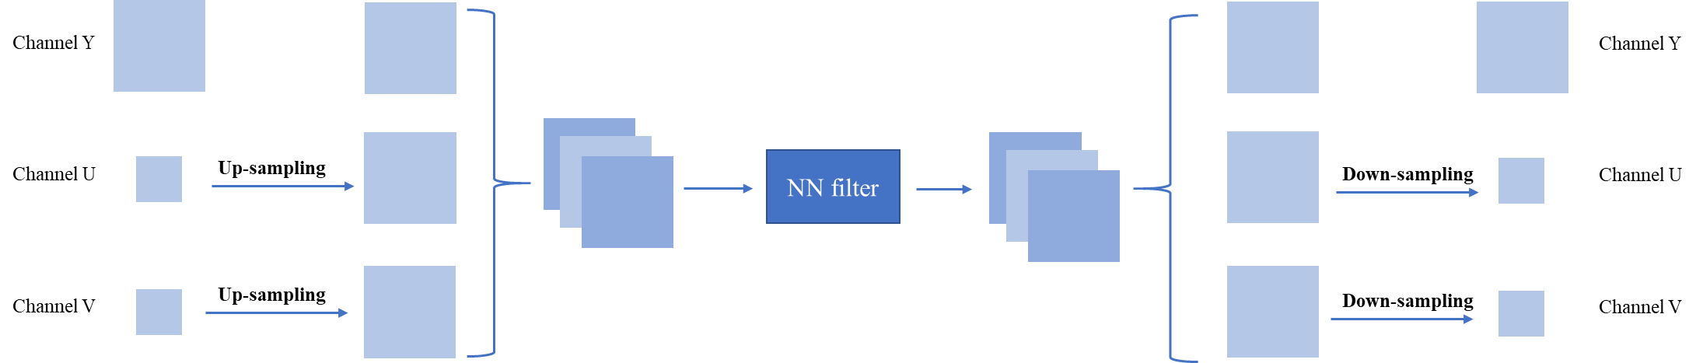
Fig. 1 the pre-processing and post-processing units

Network architecture
The network structure of the proposed NN filter is shown in Fig. 2. Along with the reconstructed image (rec_yuv), additional side information is also fed into the network, such as the prediction image (pred_yuv) [], slice QP, base QP and slice type.

Compared with the implementation in JVET-W0113[2], the ResBlock is also modified as shown in Fig. 3. With the same spirit in JVET-W0113, the number of channels firstly goes up before the activation layer, and then goes down after the activation layer. In addition, and the convolution in the skip-layer connection is removed.

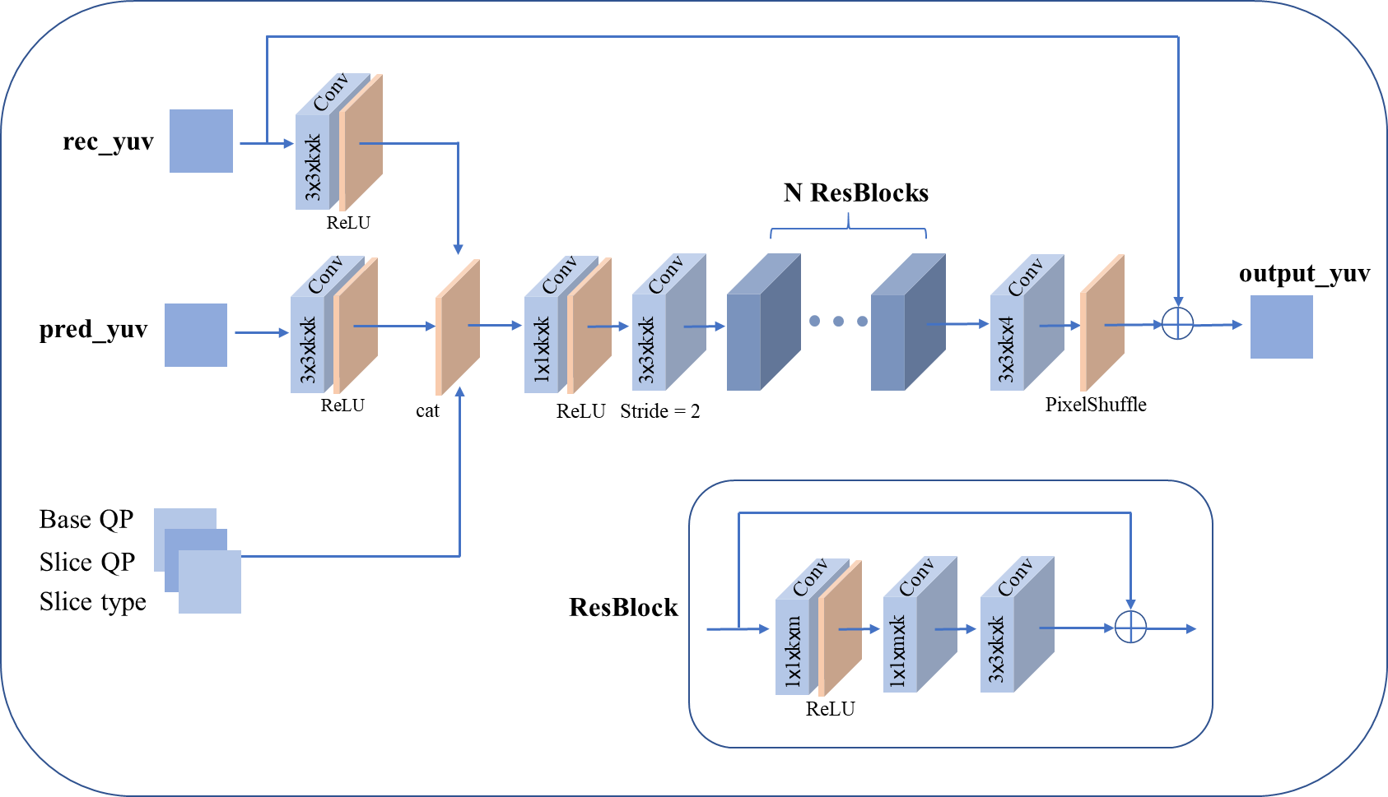

Fig. 2: Network architecture

Network information in training stage
Table 1: Network information for the NN-based video coding tool testing in training stage
Network Information in Training Stage
Mandatory | GPU Type | Tesla A100 40GB
Mandatory | Framework: | Torch v1.9.0
Mandatory | Number of GPUs per Task | 1
Mandatory | Epoch: | ~1000
Mandatory | Batch size: | 64
Mandatory | Loss function: | L1
Mandatory | Training time: | ~150h
Mandatory | Training data information: | DIV2K, TVD, BVI-DVC
Mandatory | Training configurations for generating compressed training data (if different to VTM CTC):
Optional
Optional | Number of iterations | 1200
Optional | Patch size | 144x144
Optional | Learning rate: | 1e-4
Optional | Optimizer: | ADAM
Optional | Preprocessing: | flipped, rotated
Optional | Mini-batch selection process: | random cropped
Optional | Other information:

Network information in inference stage

Table 2: Network information for the NN-based video coding tool testing in inference stage
Network Information in Inference Stage
 | Test items | Test 1.2.1 / Test 1.2.2 |  | Test 1.2.3
Mandatory | HW environment:
Mandatory | GPU Type |  | CPU only
Mandatory | Framework: |  | Libtorch v1.9.0 or SADL
Mandatory | Number of GPUs per Task |  | 0
Mandatory | Number of Parameters (Each Model) |  | 1.9M
Mandatory | Total Number of Parameters (All Models) |  | 1.9M
Mandatory | Parameter Precision (Bits) |  | 32 | 16
Mandatory | Memory Parameter (MB) |  | 7.6MB/model, 1 model in all | 3.8MB/model, 1 model in all
Mandatory | Multiplay Accumulate (MAC)/pixel, worst-case |  | 485K
Optional
Optional | Total Conv. Layers |  | 101
Optional | Total FC Layers |  | 0
Optional | Total Memory (MB)
Optional | Batch size: |  | 1
Optional | Patch size |  | 144x144
Optional | Changes to network configuration or weights required to generate rate points
Optional | Peak Memory Usage (Total)
Optional | Peak Memory Usage (per Model)
Optional | Border handling
Optional | Other information:

Implementation details
- For I slices and B slices, Deblock and SAO are both enabled. The optimal filtered result is decided between the two outputs from the proposed filter and the SAO.
- A scaling operation is carried out to refine the result of NN filter. The scaling factors are signaled in the slice header for each component. The specific process is the same as the scaling process used in []. Additionally, there are 3 fixed weights to blend the results of the proposed filter and the conventional filter. These fixed weights are 1, 0.75 and 0.5, which are similar as those in [3].
- The proposed filter can be turned on/off at the CTU level and slice level.

Results
All the 3 test results are provided as follows, which are based on the EE1 anchor [][].

Results of EE1-1.2.1 (flt32, Libtorch implementation)
Table 3. Performance of the proposed method (RA)
 | Random access Main10
 | BD-rate Over VTM-11.0_nnvc-1.0
 | YUV-PSNR | Y-PSNR | U-PSNR | V-PSNR | EncT | DecT CPU
Class A1 | -11.35% | -9.34% | -15.99% | -18.74% | 124% | 34810%
Class A2 | -11.06% | -9.30% | -17.82% | -14.84% | 123% | 33875%
Class B | -11.06% | -8.29% | -18.99% | -19.70% | 124% | 35045%
Class C | -11.41% | -8.20% | -20.74% | -21.33% | 115% | 31965%
Class E
Overall | -11.21% | -8.68% | -18.62% | -18.97% | 121% | 33918%
Class D | -11.82% | -9.02% | -19.10% | -21.32% | 115% | 32507%
Class F | -5.79% | -3.77% | -12.08% | -11.64% | 139% | 15108%

Table 4. Performance of the proposed method (LB)
 | Low delay B Main10
 | BD-rate Over VTM-11.0_nnvc-1.0
 | YUV-PSNR | Y-PSNR | U-PSNR | V-PSNR | EncT | DecT CPU
Class A1 | -10.29% | -8.70% | -12.09% | -18.04% | 122% | 34917%
Class A2 | -9.52% | -7.75% | -15.42% | -14.21% | 122% | 33744%
Class B | -9.33% | -7.27% | -14.59% | -16.42% | 122% | 34816%
Class C | -10.24% | -7.83% | -17.03% | -17.91% | 114% | 31571%
Class E | -9.39% | -7.71% | -13.81% | -15.08% | 155% | 28242%
Overall | -9.77% | -7.57% | -15.68% | -17.08% | 126% | 31981%
Class D | -11.08% | -8.85% | -17.16% | -18.37% | 113% | 32036%
Class F | -5.77% | -4.16% | -11.18% | -10.06% | 140% | 15691%

Table 5. Performance of the proposed method (AI)
 | All Intra Main10
 | BD-rate Over VTM-11.0_nnvc-1.0
 | YUV-PSNR | Y-PSNR | U-PSNR | V-PSNR | EncT | DecT CPU
Class A1 | -8.33% | -6.18% | -13.48% | -16.09% | 148% | 22594%
Class A2 | -7.70% | -5.80% | -14.77% | -12.04% | 125% | 18936%
Class B | -8.25% | -5.86% | -14.79% | -16.04% | 121% | 18100%
Class C | -9.06% | -6.44% | -15.94% | -17.95% | 112% | 13759%
Class E | -10.53% | -8.69% | -15.12% | -17.00% | 124% | 20774%
Overall | -8.73% | -6.50% | -14.88% | -15.96% | 124% | 18218%
Class D | -8.95% | -6.47% | -15.00% | -17.77% | 110% | 15079%
Class F | -5.87% | -4.06% | -11.21% | -11.44% | 110% | 15172%

Results of EE1-1.2.2 (flt32, SADL implementation)
Table 6. Performance of the proposed method (RA)
 | Random access Main10
 | BD-rate Over VTM-11.0_nnvc-1.0
 | YUV-PSNR | Y-PSNR | U-PSNR | V-PSNR | EncT | DecT CPU
Class A1 | -11.32% | -9.31% | -15.90% | -18.79% | 234% | 211290%
Class A2 | -11.06% | -9.30% | -17.80% | -14.87% | 223% | 200064%
Class B | -11.06% | -8.30% | -19.03% | -19.66% | 237% | 215668%
Class C | -11.42% | -8.20% | -20.81% | -21.32% | 199% | 196621%
Class E
Overall | -11.21% | -8.67% | -18.63% | -18.97% | 223% | 206430%
Class D | -11.82% | -9.02% | -19.11% | -21.36% | 207% | 202803%
Class F | -5.78% | -3.76% | -12.04% | -11.62% | 326% | 94190%

Table 7. Performance of the proposed method (LB)
 | Low delay B Main10
 | BD-rate Over VTM-11.0_nnvc-1.0
 | YUV-PSNR | Y-PSNR | U-PSNR | V-PSNR | EncT | DecT CPU
Class A1 | -10.30% | -8.72% | -11.94% | -18.10% | 230% | 209506%
Class A2 | -9.47% | -7.75% | -15.15% | -14.10% | 224% | 196726%
Class B | -9.28% | -7.26% | -14.54% | -16.14% | 224% | 206378%
Class C | -10.27% | -7.86% | -17.20% | -17.80% | 192% | 186328%
Class E | -9.50% | -7.81% | -13.84% | -15.28% | 419% | 176924%
Overall | -9.77% | -7.60% | -15.72% | -16.87% | 249% | 191933%
Class D | -10.98% | -8.86% | -16.35% | -18.33% | 199% | 194878%
Class F | -5.67% | -4.12% | -10.74% | -9.90% | 318% | 93038%

Table 8. Performance of the proposed method (AI)
 | All Intra Main10
 | BD-rate Over VTM-11.0_nnvc-1.0
 | YUV-PSNR | Y-PSNR | U-PSNR | V-PSNR | EncT | DecT CPU
Class A1 | -8.33% | -6.18% | -13.48% | -16.09% | 351% | 140807%
Class A2 | -7.70% | -5.80% | -14.78% | -12.06% | 237% | 113229%
Class B | -8.25% | -5.86% | -14.79% | -16.03% | 218% | 111593%
Class C | -9.06% | -6.44% | -15.94% | -17.95% | 171% | 84772%
Class E | -10.53% | -8.69% | -15.12% | -17.00% | 247% | 131778%
Overall | -8.73% | -6.50% | -14.88% | -15.97% | 232% | 112467%
Class D | -8.95% | -6.47% | -15.00% | -17.77% | 164% | 92188%
Class F | -5.87% | -4.06% | -11.21% | -11.44% | 158% | 94921%

Results of EE1-1.2.3 (int16, SADL implementation)
Table 9. Performance of the proposed method (RA)
 | Random access Main10
 | BD-rate Over VTM-11.0_nnvc-1.0
 | YUV-PSNR | Y-PSNR | U-PSNR | V-PSNR | EncT | DecT CPU
Class A1 | -11.35% | -9.34% | -16.02% | -18.72% | 235% | 212333%
Class A2 | -11.04% | -9.28% | -17.85% | -14.81% | 224% | 199960%
Class B | -11.05% | -8.29% | -19.00% | -19.69% | 236% | 215216%
Class C | -11.42% | -8.19% | -20.79% | -21.40% | 198% | 195140%
Class E
Overall | -11.21% | -8.67% | -18.65% | -18.97% | 222% | 206052%
Class D | -11.84% | -9.02% | -19.27% | -21.31% | 205% | 200519%
Class F | -5.80% | -3.77% | -12.20% | -11.61% | 323% | 93010%

Table 10. Performance of the proposed method (LB)
 | Low delay B Main10
 | BD-rate Over VTM-11.0_nnvc-1.0
 | YUV-PSNR | Y-PSNR | U-PSNR | V-PSNR | EncT | DecT CPU
Class A1 | -10.28% | -8.71% | -11.96% | -18.02% | 229% | 210077%
Class A2 | -9.54% | -7.76% | -15.55% | -14.24% | 223% | 196243%
Class B | -9.34% | -7.29% | -14.60% | -16.36% | 225% | 205872%
Class C | -10.31% | -7.89% | -17.16% | -17.98% | 192% | 190126%
Class E | -9.48% | -7.77% | -13.55% | -15.64% | 420% | 176058%
Overall | -9.81% | -7.61% | -15.74% | -17.08% | 249% | 192794%
Class D | -11.17% | -8.91% | -17.12% | -18.81% | 198% | 193736%
Class F | -5.76% | -4.14% | -11.69% | -9.54% | 318% | 93360%

Table 11. Performance of the proposed method (AI)
 | All Intra Main10
 | BD-rate Over VTM-11.0_nnvc-1.0
 | YUV-PSNR | Y-PSNR | U-PSNR | V-PSNR | EncT | DecT CPU
Class A1 | -8.34% | -6.18% | -13.50% | -16.15% | 350% | 142206%
Class A2 | -7.71% | -5.80% | -14.80% | -12.08% | 236% | 113635%
Class B | -8.24% | -5.86% | -14.77% | -16.03% | 218% | 112040%
Class C | -9.06% | -6.43% | -15.96% | -17.95% | 170% | 83904%
Class E | -10.53% | -8.69% | -15.12% | -17.01% | 244% | 131151%
Overall | -8.73% | -6.50% | -14.89% | -15.98% | 231% | 112498%
Class D | -8.95% | -6.46% | -15.03% | -17.77% | 163% | 91392%
Class F | -5.88% | -4.06% | -11.21% | -11.44% | 157% | 95131%

Conclusions
With a constrained memory size and lower complexity, a neural network based in-loop filter is presented in this contribution. Good trade-off between performance and complexity can be achieved by applying the proposed method.

References

Patent rights declaration(s)
Tencent may have current or pending patent rights relating to the technology described in this contribution and, conditioned on reciprocity, is prepared to grant licenses under reasonable and non-discriminatory terms as necessary for implementation of the resulting ITU-T Recommendation | ISO/IEC International Standard (per box 2 of the ITU-T/ITU-R/ISO/IEC patent statement and licensing declaration form).

InterDigital does not have any current or pending patent rights relating to the technology described in this contribution.

[] L. Wang, X. Xu, S. Liu. EE1-1.1-related: alternative filter designs. JVET-Y0080, 25th Meeting, by teleconference, 12–21 January 2022.
[] L. Wang, W. Jiang, X. Xu, S. Liu. AHG11: neural network based in-loop filter. JVET-W0113, 23rd Meeting, by teleconference, 7–16 July 2021.
[] K. Andersson, J. Ström, D. Liu, R. Sjöberg. EE1-related: Combination of VVC deblocking and NN loop filtering. JVET-Y0098, 25th Meeting, by teleconference, 12–21 January 2022.
[] H. Zhu, X. Xu, and S. Liu, “Deep learning based in-loop filter with QP and residual distribution information,” Doc. AVS-M5654, Aug. 2020.
[] H. Wang, J. Chen, K. Reuze, A. M. Kotra, M. Karczewicz. EE1-1.4: Test on Neural Network-based In-Loop Filter with Large Activation Layer. JVET-W0130, 23rd Meeting, by teleconference, 7–16 July 2021.
[] https://vcgit.hhi.fraunhofer.de/jvet-ahg-nnvc/VVCSoftware_VTM/-/tree/VTM-11.0_nnvc.
[] S. Liu, A. Segall, E. Alshina, R.-L. Liao. JVET common test conditions and evaluation procedures for neural network-based video coding technology. JVET-X2016, 24th Meeting, by teleconference, 6–15 October 2021.

