    Joint Video Experts Team (JVET)  of ITU-T SG 16 WP 3 and ISO/IEC JTC 1/SC 29  26th Meeting, by teleconference, 20–29 April 2022 | Document: JVET-Z0066-v2

Title: | EE2-related: Template matching using extended MVP candidate list
Status: | Input document to JVET
Purpose: | Proposal
Author(s) or  Contact(s): | Kyungyong (Kyle) Kim  Dongcheol Kim  Ju-Hyung (John) Son  Jin Sam Kwak | Email: | kyungyong.kim@wilusgroup.com
Source: | WILUS Inc.
_____________________________

Abstract
This contribution proposes to use extended MVP candidate list for template matching in AMVP mode. Additional MVP candidates are generated by adding or subtracting an offset distance (k) in both horizontal and vertical directions from the initial MVP candidates. From the extended MVP candidate list which composed of the initial MVP candidates and the additional MVP candidates derived from the offset distance (k), an MVP candidate with the minimum TM cost is selected as the optimal MVP candidate to perform template matching. On top of ECM-4.0, simulation results of the proposed method are reported as below:
RA: {-0.03%, -0.08%, 0.04%, 101%, 100%}
LDB: {-0.06%, -0.15%, -0.08%, 102%, 99%}

Introduction
In ECM 4.0, the template matching is performed on an MVP candidate which has the minimum difference between the current block and the reference block templates (reordering stage based on TM cost). The performance of the template matching depends on the selected MVP candidate which also depends on the motion vector predictor list (mvpList). Insufficient MVP candidate list may result in suboptimal MVP candidate for the template matching. Therefore, selecting the optimal MVP candidate is important for performing TM. By performing a reordering stage using various MVP candidates, it would produce an optimal MVP candidate for the template matching.

Proposal
Additional MVP candidates are generated by adding or subtracting an offset distance ‘k’ (e.g., k=4) in both horizontal and vertical directions from the initial MVP candidates (e.g., initial MVP 1) as shown in Fig. 1. The additional MVP candidates are located on the corner of the square-region. The motion vector basis for the square-region is defined as (1, 1), (1, -1), (-1, 1) and (-1, -1). Four additional MVP candidates per each initial MVP candidate in the mvpList are generated. This process is applied to all of the initial MVP candidates in the mvpList. From the extended MVP candidate list which composed of the initial MVP candidates and the additional MVP candidates derived from the offset distance (k), an MVP candidate with the minimum TM cost is selected as the optimal MVP candidate to perform template matching.
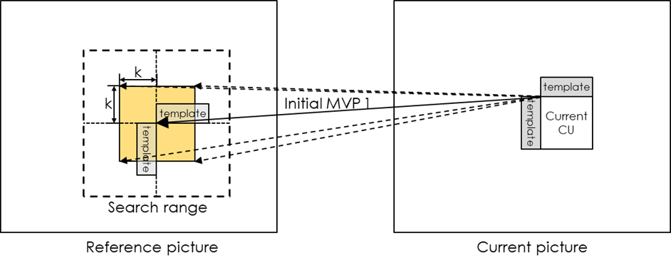
Figure 1. Illustration of four additional MVP candidates
(Solid line: initial MVP, dashed line: additional MVP)
For an offset distance (k) for the additional MVP candidates, the actual offset distance varies according to the AMVR mode of the current CU, as shown in Fig. 2. For example, if the MVD precision of the current CU is 1/4-pel, 1/2-pel, 1-pel or 4-pel AMVR mode, the actual offset distance is calculated as ‘k * 1/4’, ‘k * 1/2’, ‘k * 1’ or ‘k * 4’ respectively.
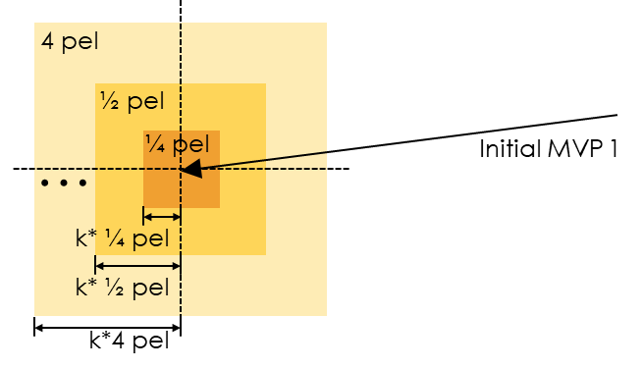
Figure 2. Actual offset distance according to the AMVR mode

Test Result
The proposed method was implemented on top of the ECM-4.0 [1]. Simulations were performed by following the common test conditions [2]. More detailed results could be found in the attached excel sheets. The test results are summarized below. The offset distance (k) is set as ‘4’ in our simulations.
Table 1. Performance results of proposed method relative to ECM-4.0 anchor
(An offset distance k = 4)
 | Random Access Main 10
 | Over ECM-4.0
 | Y | U | V | EncT | DecT
Class A1 | -0.04% | -0.11% | 0.03% | 101% | 100%
Class A2 | -0.02% | -0.12% | -0.05% | 101% | 100%
Class B | -0.02% | 0.00% | 0.07% | 101% | 100%
Class C | -0.03% | -0.13% | 0.07% | 102% | 101%
Class E
Overall | -0.03% | -0.08% | 0.04% | 101% | 100%
Class D | -0.02% | 0.05% | -0.15% | 102% | 101%
Class F | -0.01% | -0.13% | -0.03% | 101% | 100%
 | Low delay B Main 10
 | Over ECM-4.0
 | Y | U | V | EncT | DecT
Class A1
Class A2
Class B | 0.00% | -0.05% | -0.25% | 103% | 99%
Class C | -0.05% | -0.13% | -0.19% | 104% | 100%
Class E | -0.20% | -0.36% | 0.33% | 100% | 97%
Overall | -0.06% | -0.15% | -0.08% | 102% | 99%
Class D | -0.03% | 0.75% | 0.33% | 104% | 101%
Class F | -0.11% | 0.72% | -0.19% | 102% | 101%

Conclusion
This contribution proposes to use the extended MVP candidate list for the template matching in AMVP mode. By performing a reordering stage using the extended MVP candidate list, an optimal MVP candidate is selected as a good starting point to perform the template matching. Compared with ECM-4.0, it achieves -0.03% and -0.06% gain in RA and LDB configurations, respectively. It is recommended to further study this proposal in EE2.

Reference
[1] M. Coban, and et al., “Algorithm description of Enhanced Compression Model 4 (ECM 4),” JVET-Y2025, January 2022.
[2] M. Karczewicz and Y. Ye, “Common Test Conditions and evaluation procedures for enhanced compression tool testing,” JVET-Y2017, January 2022.

Patent rights declaration(s)
WILUS Inc. may have current or pending patent rights relating to the technology described in this contribution and, conditioned on reciprocity, is prepared to grant licenses under reasonable and non-discriminatory terms as necessary for implementation of the resulting ITU-T Recommendation | ISO/IEC International Standard (per box 2 of the ITU-T/ITU-R/ISO/IEC patent statement and licensing declaration form).

