    Joint Video Experts Team (JVET)  of ITU-T SG 16 WP 3 and ISO/IEC JTC 1/SC 29  26th Meeting, by teleconference, 20–29 April 2022 | Document: JVET-Z0058

Title: | EE2-2.5: Adaptive reordering of merge candidates with refined motion
Status: | Input document to JVET
Purpose: | Proposal
Author(s) or  Contact(s): | Yang Wang¹, Kai Zhang², Na Zhang¹, Zhipin Deng¹, Li Zhang²  ¹Zijinshumayuan 4th building F9, 18 Zhongguancun Nansijie, Haidian District, 100190, Beijing, China  ²8910 University Center Lane, San Diego, CA 92122, USA | Tel:  Email: | wangyang.cs@bytedance.com  zhangkai.video@bytedance.com  lizhang.idm@bytedance.com
Source: | Bytedance Inc.
_____________________________

Abstract
This contribution reports test results for EE2-2.5 on adaptive reordering of merge candidates (ARMC) with refined motion. In ARMC with refined motion, each merge candidate in the merge candidate list is refined using TM/multi-pass DMVR first and the refined motion will be used in ARMC to reorder the merge candidate list. When multi-pass DMVR is used to derive the refined motion, only the first pass (i.e., PU level) of multi-pass DMVR is applied in reordering. ARMC with refined motion is tested in Test #2.5a, while a simplified version is tested in Test #2.5b. On top of ECM-4.0, simulation results of EE2-2.5 are reported as below:
Test #2.5a:
RA: {-0.19%, -0.29%, -0.24%; 105%, 111%};
LDB: {-0.16%, -0.25%, -0.24%; 107%, 112%}.
Test #2.5b:
RA: {-0.10%, -0.19%, -0.14%; 103%, 104%};
LDB: {-0.09%, -0.22%, -0.18%; 103%, 103%}.

Introduction
Adaptive reordering of merge candidates with refined motion was proposed in JVET-Y0151 [1] and established as Test-2.5 in JVET-Y EE2 [2]. In ARMC with refined motion, each merge candidate in the merge candidate list is refined using TM/multi-pass DMVR first and the refined motion is used in ARMC to reorder the merge candidate list as shown in Figure 1. ARMC with refined motion is applied to template matching merge (TM merge) mode, adaptive DMVR mode, and template matching for advanced motion vector prediction (TM-AMVP) mode. When multi-pass DMVR is used to derive the refined motion, only the first pass (i.e., PU level) of multi-pass DMVR is applied in reordering.

Proposed methods
ARMC with refined motion as proposed in JVET-Y0151 is tested in Test #2.5a. while a simplified version is tested in Test #2.5b. In Test #2.5b, when template matching is used to derive the refined motion, the template size is set equal to 1. And only the first eight merge candidates are reordered with the refined motion in TM merge mode.
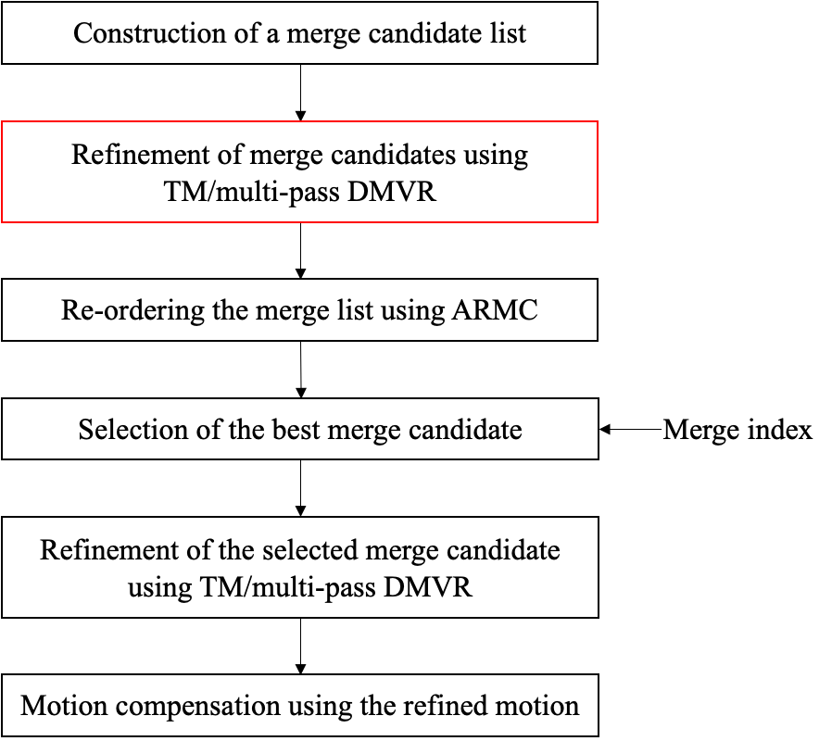
Figure 1. ARMC with refined motion.

Simulation results
ARMC with refined motion is implemented on top of ECM-4.0 [3]. Simulations are performed following the common test conditions [4]. More detailed results could be found in the attached excel sheets. The results of Test #2.5a and Test #2.5b compared to ECM-4.0 are shown in Table 1 and Table 2, respectively.
Table 1: Test results of Test #2.5a
 | Random Access Main 10 |  |  |  |  | Low delay B Main 10
 | Y | U | V | EncT | DecT | Y | U | V | EncT | DecT
Class A1 | -0.17% | -0.40% | -0.12% | 104% | 109%
Class A2 | -0.22% | -0.41% | -0.41% | 104% | 111%
Class B | -0.17% | -0.21% | -0.21% | 104% | 110% | -0.14% | -0.25% | -0.32% | 107% | 112%
Class C | -0.19% | -0.24% | -0.23% | 106% | 116% | -0.17% | -0.01% | -0.26% | 108% | 120%
Class E |  |  |  |  |  | -0.19% | -0.58% | -0.07% | 105% | 104%
Overall | -0.19% | -0.29% | -0.24% | 105% | 111% | -0.16% | -0.25% | -0.24% | 107% | 112%
Class D | -0.14% | -0.12% | -0.23% | 107% | 115% | -0.07% | 0.49% | -0.01% | 109% | 118%
Class F | -0.14% | -0.18% | -0.17% | 103% | 106% | -0.22% | 0.42% | -0.01% | 105% | 108%
Table 2: Test results of Test #2.5b
 | Random Access Main 10 |  |  |  |  | Low delay B Main 10
 | Y | U | V | EncT | DecT | Y | U | V | EncT | DecT
Class A1 | -0.10% | -0.25% | -0.05% | 102% | 104%
Class A2 | -0.12% | -0.26% | -0.22% | 102% | 104% | -0.07% | -0.13% | -0.13% | 103% | 102%
Class B | -0.07% | -0.09% | -0.11% | 102% | 102% | -0.10% | -0.20% | -0.12% | 105% | 106%
Class C | -0.11% | -0.21% | -0.17% | 103% | 106% | -0.10% | -0.38% | -0.35% | 101% | 101%
Class E
Overall | -0.10% | -0.19% | -0.14% | 103% | 104% | -0.09% | -0.22% | -0.18% | 103% | 103%
Class D | -0.07% | -0.02% | -0.08% | 104% | 106% | -0.04% | 0.80% | 0.42% | 106% | 106%
Class F | -0.09% | -0.17% | -0.13% | 101% | 102% | 0.19% | 0.42% | -0.46% | 103% | 103%

Conclusions
In this contribution, test results of EE2-2.5 on ARMC with refined motion are reported. It is recommended to adopt ARMC with refined motion in ECM.

Reference
- Y. Wang, K. Zhang, N. Zhang, Z. Deng, and L. Zhang, “Non-EE2: Adaptive re-ordering of merge candidates with refined motion,” Document of Joint Video Experts Team, JVET-Y0151, by teleconference, January 2022.
- V. Seregin, J. Chen, L. Li, K. Naser, J. Strom, M. Winken, X. Xiu, and K. Zhang, “Exploration Experiment on Enhanced Compression beyond VVC capability (EE2),” Document of Joint Video Experts Team, JVET-Y2024, by teleconference, January 2022.
- ECM-4.0, https://vcgit.hhi.fraunhofer.de/ecm/ECM/-/tree/ECM-4.0.
- M. Karczewicz, and Y. Ye, “Common test conditions and evaluation procedures for enhanced compression tool testing,” Document of Joint Video Experts Team, JVET-Y2017, by teleconference, January 2022.

Patent rights declaration(s)
Bytedance Inc. may have current or pending patent rights relating to the technology described in this contribution and, conditioned on reciprocity, is prepared to grant licenses under reasonable and non-discriminatory terms as necessary for implementation of the resulting ITU-T Recommendation | ISO/IEC International Standard (per box 2 of the ITU-T/ITU-R/ISO/IEC patent statement and licensing declaration form).

