    Joint Video Experts Team (JVET)  of ITU-T SG 16 WP 3 and ISO/IEC JTC 1/SC 29  25th Meeting, by teleconference, 12–21 January 2022 | Document: JVET-Y2020-v2

Title: | Film grain synthesis technology for video applications (Draft 1)
Status: | Output document of JVET
Purpose: | Draft text
Author(s) or  Contact(s): | D. Grois  Y. He  W. Husak  M. Radosavljević  A. Tourapis  W. Wan | Email: | Dan_Grois@comcast.com  yonghe@qti.qualcomm.com  wjh@dolby.com  milosr@xiaomi.com  atourapis@apple.com  wade.wan@broadcom.com
Source: | Editors
_____________________________

Summary
This draft technical report provides guidance on the use of film grain synthesis technology for video applications. Such technology may be used in conjunction with metadata signalling mechanisms, such as the supplemental enhancement information messages available in several video coding standards. The purpose of this document is to provide a publicly referenceable overview of end-to-end processing steps for film grain synthesis, that may include content analysis, noise/film grain removal and film grain model parameter estimation, parameter encoding, encapsulation, and decoding, and film grain synthesis and blending for consumer distribution applications.

Keywords
Film Grain, Synthesis, Analysis, Modelling, Metadata.

Table of Contents
1 Scope 4
2 References 4
3 Definitions 4
4 Abbreviations and acronyms 4
5 Conventions 5
5.1 General 5
5.2 Arithmetic operators 5
5.3 Bit-wise operators 5
5.4 Assignment operators 6
5.5 Relational, logical and other operators 6
5.6 Mathematical functions [Ed. Note: Many of these are not used and these should be updated] 6
5.7 Order of operations 7
6 Overview of film grain technologies 8
7 Film grain metadata: syntax and semantics 10
7.1 General 10
7.2 Film grain characteristics SEI message 10
7.2.1 General 10
7.2.2 Interpretation of FGC SEI message syntax 10
7.3 Alternative autoregressive film grain synthesis model 13
7.3.1 General 13
8 Film grain synthesis [Ed. Note: describe algorithmic part] 13
8.1 Frequency filtering model for film grain synthesis 13
8.1.1 Overview of the generalized frequency filtering model 13
8.1.2 Fixed-point example of the frequency filtering model for film grain synthesis 15
8.1.3 Fixed-point example of the frequency filtering model conforming to SMPTE RDD-5 19
8.1.4 Fixed-point example of resolution-adaptive frequency filtering model for film grain synthesis 19
8.1.5 Fixed-point example of film grain synthesis for line buffer reduction 19
8.2 Autoregressive models for film grain synthesis 20
8.2.1 Overview of the generalized autoregressive model 20
8.2.2 Example of the autoregressive model for film grain synthesis 21
8.2.3 Use of an FCS SEI message with the example autoregressive model for film grain synthesis 22
9 Film grain analysis 22
9.1 Frequency filtering model parameter estimation for an FGC SEI message 23
9.1.1 General 23
9.1.2 Determination of cut-off frequencies 23
9.1.3 Determination of intensity intervals and grain variance 24
9.2 Autoregressive model parameter estimation 25
Annex A Example process for inserting, modifying, or removing an FGC SEI message from a coded bitstream 26
Annex B Deployment status film grain analysis and synthesis technology 27
– B.1 Open-source implementations 27

Film Grain Synthesis Technology for Video Applications
[WORKING DRAFT]

Scope
This report provides guidance on the use of film grain synthesis technology in video applications, including for use in the ITU-T H.264/AVC (MPEG-4 Part 10), ITU-T H.265/HEVC (MPEG-H Part 2), and ITU-T H.266/VVC (MPEG-I Part 3) standards. Such technology can provide subjective quality benefits for certain video applications and thus can effectively achieve improved video compression. This can be achieved by commonly removing or reducing the amount of noise that may be present in a video or image signal prior to compression, and by resynthesizing and adding back an approximation of the removed noise, given a set of signalled parameters, during decoding. Such parameters may be signalled using appropriate mechanisms, such as the supplemental enhancement information messages that are supported by several video coding standards. The purpose of this document is to provide a publicly referenceable overview of the end-to-end processing steps for film grain and sensor noise removal, estimation, parameterization, synthesis, and blending for consumer distribution applications. This document includes examples of encoder-side processing steps and post-decoding processing steps for grain blending for some of the currently defined technologies.

References
- Rec. ITU-T H.266 | ISO/IEC 23090-3, Versatile Video Coding.
- Rec. ITU-T H.274 | ISO/IEC 23002-7, Versatile supplemental enhancement information messages for coded video bitstreams
- Rec. ITU-T H.265 | ISO/IEC 23008-2, High efficiency video coding.
- Rec. ITU-T H.264 | ISO/IEC 14496-10, Advanced video coding for generic audiovisual services.
- SMPTE RDD 5-2006, Film grain technology specifications for H.264 | MPEG-4 AVC bitstreams
- C. Gomila and A. Kobilansky, “SEI message for film grain encoding.” document JVT-H022, May 2003.
- T. Chen, "Elimination of Subband-Coding Artifacts Using the Dithering Technique", Proceeding of International Conference on Image Processing (ICIP), pp. 874-877, 1994.
- X. Jin, S. Goto and K. N. Ngan, "Composite Model-Based DC Dithering for Suppressing Contour Artifacts in Decompressed Video," in IEEE Transactions on Image Processing, vol. 20, no. 8, pp. 2110-2121, Aug. 2011, doi: 10.1109/TIP.2011.2114356.
- J. M. Boyce and A. M. Tourapis, "Comfort noise for compressed video," International Conference on Consumer Electronics (ICCE), 2005, pp. 323-324, doi: 10.1109/ICCE.2005.1429848.
…

[Ed. Note: Any additional IEEE, JVT or other references to be added here.]

Definitions
For the purpose of this document, the definitions given in [2] [3] and [4] apply. [Ed. Note: It might be necessary to add new definitions directly in this document]

Abbreviations and acronyms
For the purpose of this document, the abbreviations and acronyms given in [2] [3] [4] and the following apply.
FGS Film Grain Synthesis
FGC Film Grain Characteristics
VSEI Versatile Supplemental Enhancement Information

Conventions

General
The mathematical operators used in this document are similar to those used in the C programming language. However, the results of integer division and arithmetic shift operations are defined more precisely and additional operations are defined, such as exponentiation and real-valued division. Numbering and counting conventions generally begin from 0, e.g., "the first" is equivalent to the 0-th, "the second" is equivalent to the 1-th, etc.

Arithmetic operators
The following arithmetic operators are defined as follows:
+ | Addition
− | Subtraction (as a two-argument operator) or negation (as a unary prefix operator)
* | Multiplication, including matrix multiplication
x^{y} | Exponentiation. Denotes x to the power of y. In other contexts, such notation is used for superscripting not intended for interpretation as exponentiation.
/ | Integer division with truncation of the result towards zero. For example, 7 / 4 and (−7) / (−4) are truncated to 1 and (−7) / 4 and 7 / (−4) are truncated to −1.
÷ | Used to denote division in mathematical formulae where no truncation or rounding is intended.
$$\frac{x}{y}$$ | Used to denote division in mathematical formulae where no truncation or rounding is intended.
$$\sum_{i=x}^{y}{f(i)}$$ | The summation of f( i ) with i taking all integer values from x up to and including y.
x % y | Modulus. Remainder of x divided by y, defined only for integers x and y with x >= 0 and y > 0.

Bit-wise operators
The following bit-wise operators are defined as follows:
& | Bit-wise "and". When operating on integer arguments, operates on a two's complement representation of the integer value. When operating on a binary argument that contains fewer bits than another argument, the shorter argument is extended by adding more significant bits equal to 0.
| | Bit-wise "or". When operating on integer arguments, operates on a two's complement representation of the integer value. When operating on a binary argument that contains fewer bits than another argument, the shorter argument is extended by adding more significant bits equal to 0.
^ | Bit-wise "exclusive or". When operating on integer arguments, operates on a two's complement representation of the integer value. When operating on a binary argument that contains fewer bits than another argument, the shorter argument is extended by adding more significant bits equal to 0.
x >> y | Arithmetic right shift of a two's complement integer representation of x by y binary digits. This function is defined only for non-negative integer values of y. Bits shifted into the MSBs as a result of the right shift have a value equal to the MSB of x prior to the shift operation.
x << y | Arithmetic left shift of a two's complement integer representation of x by y binary digits. This function is defined only for non-negative integer values of y. Bits shifted into the LSBs as a result of the left shift have a value equal to 0.

Assignment operators
The following assignment operators are defined as follows:
= | Assignment operator
++ | Increment, i.e., x+ + is equivalent to x = x + 1; when used in an array index, evaluates to the value of the variable prior to the increment operation.
− − | Decrement, i.e., x− − is equivalent to x = x − 1; when used in an array index, evaluates to the value of the variable prior to the decrement operation.
+= | Increment by amount given, i.e., x += 3 is equivalent to x = x + 3, and x += (−3) is equivalent to x = x + (−3).
−= | Decrement by amount given, i.e., x −= 3 is equivalent to x = x − 3, and x −= (−3) is equivalent to x = x − (−3).

Relational, logical and other operators
The following operators are defined as follows:
== | Equality operator
!= | Not equal to operator
!x | Logical negation "not"
> | Larger than operator
< | Smaller than operator
≥ | Larger than or equal to operator
≤ | Smaller than or equal to operator
&& | Conditional/logical "and" operator. Performs a logical "and" of its Boolean operators, but only evaluates the second operand if necessary.
| | | Conditional/logical "or" operator. Performs a logical "or" of its Boolean operators, but only evaluates the second operand if necessary.
a ? b : c | Ternary conditional. If condition a is true, then the result is equal to b; otherwise the result is equal to c.

Mathematical functions [Ed. Note: Many of these are not used and these should be updated]
The following mathematical functions are defined as follows:
$Abs\left(x\right)=\left\{\begin{matrix}x & ; & x≥0 \\ -x & ; & x<0\end{matrix}\right.$
$Ceil\left(x\right)$ the smallest integer greater than or equal to x.
$Clip3( x, y, z ) = \left\{ \begin{matrix}x & ; & z<x \\ y & ; & z>y \\ z & ; & otherwise\end{matrix}\right.$
$Floor\left(x\right)$ the largest integer less than or equal to x.
${EOTF}^{-1}\left(x\right)$ the inverse EOTF used to convert a linear light representation to a non-linear light representation.
$Max\left(x,y\right)=\left\{ \begin{matrix}x & ; & x>y \\ y & ; & otherwise\end{matrix}\right.$
$Max\left(x,y,z\right)=\left\{ \begin{matrix}x & ; & x>Max(y,z) \\ y & ; & y>Max(x,z) \\ z & ; & otherwise\end{matrix}\right.$
$Min\left(x,y\right)=\left\{ \begin{matrix}x & ; & x<y \\ y & ; & otherwise\end{matrix}\right.$
$Min\left(x,y,z\right)=\left\{ \begin{matrix}x & ; & x<Min(y,z) \\ y & ; & y<Min(x,z) \\ z & ; & otherwise\end{matrix}\right.$
$Round\left(x\right)=Sign\left(x\right)*Floor\left(Abs\left(x\right)+0.5\right)$
$Sign( x ) =\left\{\begin{matrix}1 & ; & x>0 \\ 0 & ; & x=0 \\ -1 & ; & x<0\end{matrix}\right.$
$EOTF\left(x\right)$ the EOTF used to convert a non-linear light representation $x$ to a linear light representation.

Order of operations
When order of precedence in an expression is not indicated explicitly by use of parentheses, the following rules apply:
– Operations of a higher precedence are evaluated before any operation of a lower precedence.
– Operations of the same precedence are evaluated sequentially from left to right.
Table 1 specifies the precedence of operations from highest to lowest; a higher position in the table indicates a higher precedence.
NOTE – For those operators that are also used in the C programming language, the order of precedence used in this document is the same as that used in the C programming language.
Table 1 – Operation precedence from highest (at top of table) to lowest (at bottom of table)
Operations (with operands x, y and z)

"x++", "x− −"

"!x", "−x" (as a unary prefix operator)

"x^{y}"
"x * y", "x / y", "x ÷ y", "", "x % y"
$$\frac{x}{y}$$
"x + y", "x − y" (as a two-argument operator), ""
$$\sum_{i=x}^{y}{f(i)}$$

"x << y", "x >> y"

"x < y", "x <= y", "x > y", "x >= y"

"x = = y", "x != y"

"x & y"

"x | y"

"x && y"

"x | | y"

"x ? y : z"

"x..y"

"x = y", "x += y", "x −= y"

Overview of film grain technologies
The use of film grain modelling technologies can be beneficial in the context of image and video compression by providing improved subjective quality at a lower bitrate for certain types of video content. For example, these technologies can potentially provide benefits to video content that contains noise, such as film grain noise or image sensor noise. In some cases, film grain noise is a result of the physical process of photographically developing light-exposed silver-halide crystals in the emulsion on the film negative used in the capture process. In other cases, noise may be synthetic film grain that was added in post-production to create a particular artistic look. In yet other cases, noise in digitally captured content may be the result of image sensor noise. In each case, film grain and sensor noise tend to be temporally and spatially unpredictable, which significantly impairs the compressibility of video material containing such noise.
Film grain is considered a primary contributor to what is commonly referred to as the film look or cinematic look. Film grain modelling technologies provide a means of optionally removing noise prior to or during the encoding process in order to improve compression efficiency and, subsequently, to reconstruct an approximation of the film grain during or after the decoding process. Film grain modelling technologies may also be used to add visual noise to decoded video to mask or attenuate the visibility of compression artefacts, such as blockiness, or bit-depth-related artefacts, such as banding or contouring.
Use of film grain modelling technologies to denoise source video by using a preprocessor is illustrated in Figure 1. Source video is input to a denoising process that outputs a video in which noise or film grain is attenuated or removed. A film grain parameterization process then compares the source and denoised videos to determine film grain model parameter values, which relate to the variance, spatial frequency characteristics, colour correlation, and other statistical characteristics of the film grain. The denoised video is then encoded and the film grain model parameter values are either signalled in the coded bit stream or provided to the decoder by some external means. In turn, at the decoder, the film grain model parameter values are parsed and input to a film grain synthesis process that generates simulated film grain and blends the grain with the decoded video to output decoded video with simulated film grain, as illustrated in Figure 4. Use of film grain modelling technologies to denoise source video is also illustrated in Figure 2; but, in this case, the encoder itself acts as the denoising process. The use of film grain modelling technologies with pre-determined film grain parameter values is illustrated in Figure 3. Note that film grain parameter values may be pre-determined in case the film grain was added in post-production, for example, or when the statistical characteristics of the film grain are otherwise known a priori. Figure 4 presents a decoding process, along with the film grain synthesis post-processing, for each of the examples provided in Figures 1 to 3.
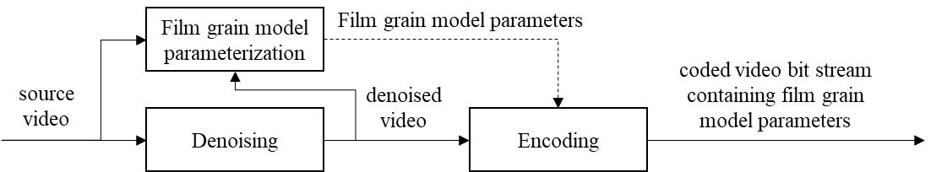
[Ed. Note: Is it better to split these figures into two, one for the encoder and another for the decoder? Otherwise, they look a bit weird and crowded. The same applies for the subsequent figures. Basically, there are 3 different encoder modules and a single decoding module.]
Figure 1: Use of film grain modelling technologies by preprocessing in order to denoise source video and to determine film grain model parameter values that are signalled in a coded bit stream to a decoder and film grain synthesis post-processing (see Figure 4).
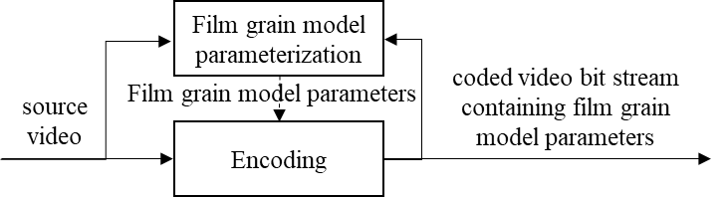

Figure 2: Use of film grain modelling technologies using an encoder to denoise source video.
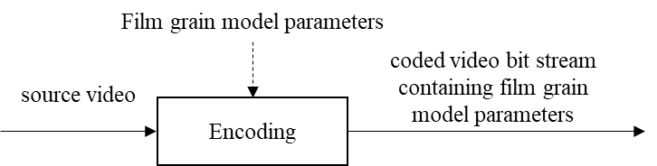

Figure 3: Use of film grain modelling technologies with pre-determined film grain model parameter values.
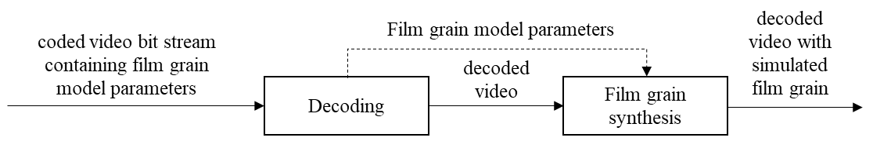
Figure 4: Decoding process along with the film grain synthesis post-processing.

[Ed. Note: A section on denoising is needed]

Film grain metadata: syntax and semantics

General
[Ed. Note: A General sub-clause is needed since this otherwise breaks ISO rules]
[Ed. Note: Some details about models that are covered in the TR. In general, describe how they are supported in standards.]
[Ed. Note: Say how metadata is organized for those methods/standards (just structure and semantics, maybe even just references), without going into estimation and synthesis algorithmic details. Just metadata.]
The VVC, HEVC, and AVC standards natively support signalling of film grain parameter values using well defined supplemental enhancement information message supplement
The VVC, HEVC, and AVC standards currently directly specify a supplemental enhancement information (SEI) message for indicating the usage of film grain synthesis when decoding and rendering video or image data. In particular, these standards support the film grain characteristics (FGC) SEI message, which is capable of indicating two different film grain models and different blending modes. More specifically, this SEI message supports a frequency filtering and an autoregressive film grain model, and additive or multiplicative blending modes. It can also indicate one or more intensity intervals, the film grain variance for each intensity interval, and the spatial frequency characteristics of the film grain for each intensity interval, providing considerable flexibility to content creators and encoding manufacturers on signaling different types and levels of film grain noise.
An alternative film grain synthesis scheme, such as a different use of an autoregressive model, can also be indicated through the use of the ITU-T T.35 registered or unregistered user data SEI messages that are also supported in these standards. The VVC, HEVC, and AVC standards intentionally do not specify any constraints or limitations on the postprocessing techniques that can be used with decoded data from such user data SEI messages, therefore enabling more applications and implementations.
Use of light-dependent film grain model parameters may be useful, particularly for simulation of photographic film grain. Photographic film grain is intrinsically intensity dependent. Light-sensitive crystals have a distribution of sizes. Larger crystals capture more photons and are more likely to be exposed than smaller crystals, particularly in darker region. As a result, darker regions tend to have larger and more noticeable film grain. This characteristic results in a frequency dependence on brightness. [Ed. Note: This section seems a bit out of place]

Film grain characteristics SEI message

General
Film grain metadata for use with VVC, HEVC, and AVC can be signalled via an FGC SEI message specified in the corresponding coding standard. For VVC, the SEI payload Type is specified in [2] Annex D and the syntax and semantics are specified in [3] clause 8.5. For HEVC, the FGC SEI message is specified in [4] clauses D.2.13 and D.3.13. For AVC, the FGC SEI message is specified in [5] clauses D.1.21 and D.2.21. The different FGC SEI message versions are similar but have some standard-specific differences. For example, persistence of the FGC SEI message is specified differently for AVC than it is for HEVC and VVC. [Ed. Note: Changed "is" to "can be" since film grain metadata could also be signalled using the ITU-T T.35 mechanism. However this section seems to be more about the FGC SEI. Should maybe the first sentence be changed to emphasize that?]

Interpretation of FGC SEI message syntax
The syntax of the FGC SEI message specified for VVC is shown in Table 1. A guide to interpretation of the syntax in the FGC SEI message is shown in Table 2. Similar interpretations apply to the FGC SEI messages specified in AVC and HEVC.
Table 1: Film grain characteristics SEI message syntax [Ed. Note: Should a descriptor column be added? Also, why is the font size different and why is the format changed? Is this syntax really in VVC, or is it in VSEI? Check especially the persistence aspect, and comment about how the syntax differs in other standards.]
film_grain_characteristics( payloadSize ) {
fg_characteristics_cancel_flag
if( !fg_characteristics_cancel_flag ) {
fg_model_id
fg_separate_colour_description_present_flag
if( fg_separate_colour_description_present_flag ) {
fg_bit_depth_luma_minus8
fg_bit_depth_chroma_minus8
fg_full_range_flag
fg_colour_primaries
fg_transfer_characteristics
fg_matrix_coeffs
}
fg_blending_mode_id
fg_log2_scale_factor
for( c = 0; c < 3; c++ )
fg_comp_model_present_flag[ c ]
for( c = 0; c < 3; c++ ) {
if( fg_comp_model_present_flag[ c ] ) {
fg_num_intensity_intervals_minus1[ c ]
fg_num_model_values_minus1[ c ]
for( i = 0; i <= fg_num_intensity_intervals_minus1[ c ]; i++ ) {
fg_intensity_interval_lower_bound[ c ][ i ]
fg_intensity_interval_upper_bound[ c ][ i ]
for( j = 0; j <= fg_num_model_values_minus1[ c ]; j++ )
fg_comp_model_value[ c ][ i ][ j ]
}
}
}
fg_characteristics_persistence_flag
}
}

Table 2: Guide to interpretation of the FGC SEI message syntax
Parameter | Range | Significance
fg_model_id | 0,1 | Model to be used in grain synthesis. 0: Frequency filtering, 1: Auto-regression
fg_separate_colour_description_present_flag | 0,1 | Defines whether the colour description for the film grain specified is same as for the coded video sequence.
fg_blending_mode_id | 0,1 | Blending mode used to combine grain and decoded samples.0: Additive, 1: Multiplicative
fg_comp_model_present_flag | 0,1 | Defines the presence of film grain model parameters for each colour component
fg_num_intensity_intervals_minus1 | 0-255 | Defines the number of intensity intervals for each colour component
fg_num_model_values_minus1 | 0-5 | Specifies the number of component model values available in the SEI ( default values will be used for the remaining component model values)
fg_intensity_interval_lower_bound | 0-255 | Lower bound for each intensity intervals for which the model is applicable
fg_intensity_interval_upper_bound | 0-255 | Upper bound for each intensity intervals for which the model is applicable
fg_comp_model_value | Range_0 | Component model values have different meaning depending on the value of fg_film_grain_model_id (see below).
fg_comp_model_value | Range_1
fg_characteristics_persistence_flag | 0,1 | Indicates the persistence of the FGC SEI message.
[Ed. Note: The Range_X values read somewhat odd. Is that better to define these variables using the same process as in other documents within the semantic section?]

The component model values specify the strength, shape, density, and other characteristics of the film grain. A unique set of component model values can be signalled for each intensity interval for each colour component to be processed.
When the frequency-filtering film grain model is signalled (film_grain_model_id = 0), comp_model_values are interpreted as follows for each colour component, c, and intensity interval, i.

- comp_model_value[ c ][ i ][ 0 ] : the standard deviation of Gaussian noise
- comp_model_value[ c ][ i ][ 1 ] : horizontal high cutoff frequency
- comp_model_value[ c ][ i ][ 2 ] : vertical high cutoff frequency
- comp_model_value[ c ][ i ][ 3 ] : horizontal low cutoff frequency
- comp_model_value[ c ][ i ][ 4 ] : vertical low cutoff frequency
- comp_model_value[ c ][ i ][ 5 ] : correlation between consecutive colour components

When the autoregressive film grain model is signalled (film_grain_model_id = 1), comp_model_values are interpreted as follows:

- comp_model_value[ c ][ i ][ 0 ] : the standard deviation of Gaussian noise
- comp_model_value[ c ][ i ][ 1 ] : first order correlation for neighboring samples ( x − 1, y ) and ( x, y − 1 )
- comp_model_value[ c ][ i ][ 2 ] : correlation between consecutive colour components
- comp_model_value[ c ][ i ][ 3 ] : first order correlation for neighboring samples ( x − 1, y − 1 ) and ( x + 1, y – 1 )
- comp_model_value[ c ][ i ][ 4 ] : aspect ratio of the modelled grain
- comp_model_value[ c ][ i ][ 5 ] : second order correlation for neighboring samples ( x - 2, y ) and ( x, y - 2 )
The frequency-filtering and autoregressive models for film grain synthesis share the following processing steps:
- Determination of applicable intensity intervals for each sample for each applicable colour component. A different set of FGS model parameters may be signalled in the FGC SEI message for each intensity interval.
- Generation of synthesized grain.
- Blending of synthesized grain and decoded image.
The methods for determining intensity intervals and generating synthesized grain depend on the signalled FGS model. Methods for the frequency-filtering model are described in subclause ‎8.1. Methods for the autoregressive model are described in subclause ‎8.2. Methods of blending grain with a decoded image are described in subclause xyz.
comp_model_value[ c ][ i ][ 0 ] together with intensity interval boundaries is used to define a scaling function (piece-wise constant scaling function). The scaling function indicates the level at which the film grain will be perceived in the final output frame.
Additive (fg_blending_mode_id = 0) and multiplicative (fg_blending_mode_id = 1) grain blending methods are specified in the FGC SEI message.

Alternative autoregressive film grain synthesis model

General
An alternative autoregressive film grain synthesis model can be indicated in the VVC, HEVC, and AVC standards using the ITU-T T.35 registered or unregistered user data SEI messages. [Ed. Note: Currently this section is intentionally left mostly empty]

[TO BE COMPLETED]

Film grain synthesis [Ed. Note: describe algorithmic part]
[TO BE COMPLETED]

Frequency filtering model for film grain synthesis

Overview of the generalized frequency filtering model

General
This subclause describes grain synthesis using the frequency filtering model (fg_model_id is equal to 0). The overall process is illustrated in Figure 4 and consists of the following steps:
[Ed. Note: This seems to relate to the 7.2 FGS. Is placement appropriate?]
- Pre-compute a grain pattern database using a transform T [Ed. Note: More details are required.].
- Calculate an average luma value for each BlockSize x BlockSize block in the decoded picture to determine the intensity interval(s) to which the block belongs.
- Calculate pseudo-random offsets to be used to select grain blocks from the pre-computed grain pattern database.
- Deblock vertical edges across adjacent grain blocks.
- Blend grain blocks and the decoded picture.

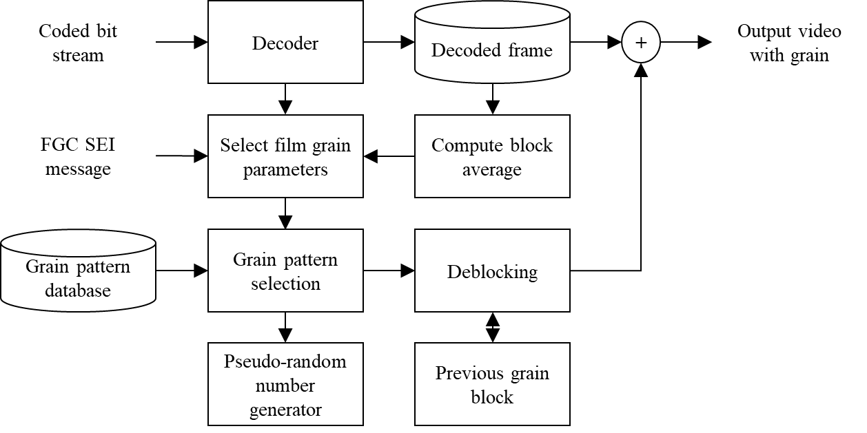
Figure 5 Film grain synthesis workflow [Ed. Note: Should this say "according to the model XYZ"?]
[Ed. Note: Should the arrow between the grain pattern selection and PRNG be bidirectional?]

Generate a grain pattern database
In general, a database of grain patterns corresponding to each unique set of component model values signalled in an FGC SEI message can be determined as follows:
- Generate a 2-dimensional array of random-value elements having a normalized Gaussian distribution. The 2-dimensional array represents discrete cosine transform (DCT2) coefficients. The row and column indexes of the array represent horizontal and vertical frequencies, respectively. (Note - The example method described in the FGC SEI message uses 16x16 arrays. The methods specified in [6] and subclause 8.1.2 of this document use 64x64 arrays.)
- Set the value of all elements of the random-value DCT2 array to 0 when the corresponding row and column indexes are not within the corresponding high and low horizontal and vertical cut-off frequencies signalled in the FGC SEI message for the intensity interval.
- Calculate the inverse discrete cosine transform (IDCT2) of the array produced in step2.
- Repeat steps 1 through 3 for each intensity interval signalled in the FGC SEI message.
Note that the database of grain patterns can be pre-computed and stored.
A fixed-point example of generating a grain pattern database is provided in subclause 8.1.2.

Determine applicable intensity intervals
For the frequency filtering model, applicable intensity intervals for each sample for each applicable colour component can be determined as follows:
- Assign each sample of the decoded image to a unique block of neighbouring sample values
- Calculate the average value of the sample values in the block
- Associate all samples within the block with the index of each interval value signalled in the FGC SEI message when the block average is within the upper and lower bounds of the intensity interval. Note that more than one or no intensity interval may be applicable to each block of samples.
A fixed-point example of determining applicable intensity intervals is provided in subclause 8.1.2.

Synthesize and blend film grain with a decoded picture
Synthesized grain can be constructed as follows:
- For each block of samples of the decoded picture having the same applicable intensity interval, select a block of the same size from the grain pattern for the corresponding intensity interval.
- Scale the values of the selected grain pattern block by the standard deviation applicable to the intensity interval.
- When correlation between consecutive colour components is signalled in the SEI message, add scaled sample values of the grain pattern for colour component (c – 1) to calculate the grain pattern for colour component c when the value of c is greater than 0.
Optionally, apply deblocking filters across block boundaries. [Ed. Note: should expected benefits for deblocking be mentioned? Also, this section is very vague, with no description of the deblocking filters applied. Maybe it could also be said that what is provided are only the parameters. How the parameters are interpreted and/or used may differ from implementation to implementation and to achieve different complexity/performance tradeoffs. Should we have some reference to the deblocking process?]
A more detailed example of synthesizing and blending film grain with the decoded picture is provided in subclause 8.1.2.

Fixed-point example of the frequency filtering model for film grain synthesis

General
The following describes a constrained fixed-point example of the generalized frequency filtering synthesis process described above. The fixed-point grain synthesis process can be used to produce numerically identical cropped decoded output pictures when the following apply:
– ChromaFormatIdc is equal to 1
– fg_model_id is equal to 0.
– fg_separate_colour_description_present_flag equal is to 0.
– fg_blending_mode_id is equal to 0.
– fg_log2_scale_factor is in the range of 2 to 7, inclusive.
– fg_intensity_interval_upper_bound[ c ][ i ] is less than fg_intensity_interval_lower_bound[ c ][ i + 1 ].
– fg_num_model_values_minus1[ c ] is in the range of 0 to 2, inclusive.
– fg_comp_model_value[ c ][ i ][ 0 ] is in the range of 0 to 255, inclusive.
– fg_comp_model_value[ c ][ i ][ 1 ] is in the range of 2 to 14, inclusive.
– fg_comp_model_value[ c ][ i ][ 2 ] is in the range of 2 to 14, inclusive.
Inputs to the process are the decoded picture sample arrays before grain blending decPicture_{L,} decPicture_{Cb,} and decPicture_{Cr}.
Outputs of this process are the modified decoded picture sample arrays after grain blending blendPicture_{L,} blendPictureCb, and blendPictureCr.
[Ed. note: what happens for mono? Also what is the resolution of the pictures? These seem missing from the above description. Add more info.]
Each sample of synthesized grain, G[ c ][ x ][ y ], is added to the collocated sample of the decoded picture, I_{decoded}[ c ][ x ][ y ], for each applicable colour component followed by clipping to prevent out of range sample values.
The grain synthesis process is derived using the following ordered steps:
– The grain pattern database generation is invoked in clause 8.1.2.1with a 13x13x64x64 array GrainDb as the output.
– The grain selection and blending process as specified in clause ‎8.1.2.3 is invoked with decPicture_{L,} decPicture_{Cb,} and decPicture_{Cr}. as inputs, and blendPicture_{L,} blendPicture_{Cb,} and blendPicture_{Cr} as outputs.

Grain pattern database generation
[Ed. Note: Some introduction should be provided here]
Output of this process is a 13x13x64x64 grain pattern database array GrainDb.
The variable prngVal is a value produced by a uniform pseudo-random number generator.
The variable gaussianLUT[ m ] is a LUT of 2,048 Gaussian random numbers stored in 2’s complement form and ranging from -127 to 127, inclusive.
The variable fgCutFreqH[ h ] is set equal to ( ( h + 3 ) << 2) – 1, with h being in the range of 0 to 12, inclusive.
The variable fgCutFreqV[ v ] is set equal to ( ( v + 3 ) << 2) – 1, with v being in the range of 0 to 12, inclusive.
The variable $R_{64}^{}$ is an IDCT2 64x64 transform matrix.
The variable fgCoeffs[ h ][ v ][ i ][ j ] is initially set equal to 0, with h = 0..12, v = 0..12, i = 0..63, j = 0..63, and is derived as follows:
for(h = 0; h < 13 , h++ ) {
for(v = 0; v < 13 , v++ ) {
prngVal = SeedLUT( h + 13 * v )
for( j = 0; j <= fgCutFreqV[ v ] ; j++ ) {
for( i = 0; i <= fgCutFreqH[ h ] ; i + = 4 ) {
for( k = 0; k < 4; k++ )
fgCoeffs[ h ][ v ][ i + k ][ j ] = gaussianLUT[ ( prngVal + k ) % 2048 ]
prngVal = Prng( prngVal )
}
}
fgCoeffs[ h ][ v ][ 0 ][ 0 ] = 0
}
}
For given h, and v, with h in the range of 0 to 12, inclusive, v in the range of 0 to 12, inclusive, the 64x64 array GrainDb[ h ][ v ][ x][ y ] is derived as follows:
$$b\left[h\right][v]=\left(((R_{64}^{T}\right.*\text{fgCoeff[h][v]}+128) ≫8)*R_{64}\left.+128\right)≫8$$
GrainDb[ h ][ v ][ x ][ y ] = Clip3( -127, 127 , b[ h ][ v ][ x ][ y ] )
The grain pattern database GrainDb is further refined as follows, where the value of BlockSize is equal to 8:
deblockFactor[ v ] = { 64, 71, 77, 84, 90, 96, 103, 109, 116, 122, 128, 128, 128 } (xx)
for( j = 0; j < 64 ; j += BlockSize ) {
for( i = 0; i < 64 ; i++ ) {
GrainDb[ h ][ v ][ i ][ j ] = ( GrainDb[ h ][ v ][ i ][ j ] * deblockFactor[ v ] ) >> 7
GrainDb[ h ][ v ][ i ][ j+ BlockSize – 1 ] =
( GrainDb[ h ][ v ][ i ][ j+ BlockSize – 1 ] * deblockFactor[ v ] ) >> 7
}
}
}

Grain selection and blending process

General
[Ed. Note: Some introduction should be provided here]
Input to this process is the decoded picture prior to grain blending, i.e., the arrays decPicture_{L}, decPicture_{Cb}, and decPicture_{Cr}.
Output of this process is the modified decoded picture after grain blending, i.e., the array blendPicture_{L}, blendPicture_{Cb}, and blendPicture_{Cr}.
The variable BlockSize indicates the BlockSize x BlockSize size of grain blocks.
The variable prngArray is an array of values produced by a uniform pseudo-random number generator.
For cIdx = 0..2, the following apply:
- If cIdx is equal to 0, decSamples, PicWidth, PicHeight, PicWidthInBlock, and PicHeightInBlock are derived as follows:
  - decSamples corresponds to the decoded picture sample array decPicture_{L} and blendSamples corresponds to the blended sample array blendPicture_{L}
  - PicWidth is set equal to PicWidthInLumaSamples
  - PicHeight is set equal to PicHeightInLumaSamples
  - PicWidthInBlock is set equal to Ceil( PicWidthInLumaSamples ÷ BlockSize )
  - PicHeightInBlock is set equal to Ceil( PicHeightInLumaSamples ÷ BlockSize )
[Ed. Note: The above contains undefined variables. Where are PicHeightInLumaSamples and PicHeightInLumaSamples defined for example? All variables used in the document should be defined.]
- Otherwise (cIdx is not equal to 0), decSamples, blendSamples, PicWidth, PicHeight, PicWidthInBlock, and PicHeightInBlock are derived as follows:
  - If cIdx is equal to 1, decSamples corresponds to the decoded picture sample array decPicture_{Cb} and blendSamples corresponds to the blended sample array blendPicture_{Cb}
  - Otherwise (cIdx is not equal to 1), decSamples corresponds to the decoded picture sample array decPicture_{Cr} and blendSamples corresponds to the blended sample array blendPicture_{Cr.}
  - PicWidth is set equal to PicWidthInLumaSamples / 2
  - PicHeight is set equal to PicHeightInLumaSamples / 2
  - PicWidthInBlock is set equal to Ceil( PicWidthInLumaSamples ÷ 2 ÷ BlockSize )
  - PicHeightInBlock is set equal to Ceil( PicHeightInLumaSamples ÷ 2 ÷ BlockSize )
- If fg_comp_model_present_flag[ cIdx ] is equal to 0, blendSamples[ i ][ j ] is set equal to decSamples[ i ][ j ], with i=0.. PicWidth, j=0..PicHeight

Film grain block blending process
[Ed. Note: Some introduction should be provided here?]
Inputs to this process are:
- a location ( xCurr, yCurr ) specifying the top-left sample of the current block relative to the top-left sample of the current picture component,
- a variable cIdx specifying the colour component of the current block,
- a block index ( xIdx, yIdx ) specifying the block index of the current block,
- a picture seed array prngArray,
- a decoded sample array decSamples.
Output to this process is the blended sample array blendSamples.
The variable picWidth is set equal to ( cIdx = = 0 ) ? PicWidthInLumaSamples : PicWidthInLumaSamples / 2.
The variable picHeight is set equal to ( cIdx = = 0 ) ? PicHeightInLumaSamples : PicHeightInLumaSamples / 2.
The variable intensityIntevalIdx for the current block is initialized to be – 1 and is derived as follows:
[Ed. Note: Do we need such long names for such variables?]
sumBlock = 0
avgRatio = Log2( BlockSize / 8)
for( i = 0; i < BlockSize ; i++ )
for( j = 0; j < BlockSize ; j++ )
sumBlock += decSamples[ Min( picWidth − 1, xCurr + i ) ][ Min( picHeight − 1, yCurr + j ) ]
b_{avg} = Clip3( 0, 255, ( sumBlock + ( 1 << fgBitDepth[ cIdx ] ) ) >> ( fgBitDepth[ cIdx ] + 2 * avgRatio − 2 )
for( i = 0; i <= fg_num_intensity_intervals_minus1[ cIdx ]; i++ )
if( b_{avg} >= fg_intensity_interval_lower_bound[ cIdx ][ i ] &&
b_{avg} <= fg_intensity_interval_upper_bound[ cIdx ][ i ] ) {
intensityIntervalIdx = i break
}
The derivation of decSamples for the current block is as follows:
- If intensityIntervalIdx is equal to –1, blendSamples[ xCurr + i ][ yCurr + j ] is set equal to decSamples[ xCurr + i ][ yCurr + j ], for i=0..Min(picWidth – xCurr – 1, BlockSize – 1), j=0.. Min(picHeight – yCurr – 1, BlockSize – 1;
- Otherwise (intensityIntervalIdx is not equal to –1), the following applies:
  - The variable scaleFactor is set equal to fg_comp_model_value[ cIdx ][ intensityIntervalIdx ][ 0 ] * ( 1 – 2 * BIT0( prngArray[ xIdx ][ yIdx ] )
  - The variable hFreq is derived as follows:
hFreq = fg_comp_model_value[ cIdx ][ intensityIntervalIdx ][ 1 ]
hFeq = (cIdx = = 0) ? hFreq : Clip3( 2, 14, ( hFreq << 1 ) )
hFeq = hFreq – 2
  - The variable vFreq is derived as follows:
vFreq = fg_comp_model_value[ cIdx ][ intensityIntervalIdx][ 2 ]
vFeq = (cIdx = = 0) ? vFreq : Clip3( 2, 14, ( vFreq << 1 ) )
vFeq = vFreq – 2
  - The variable horzDenom = (BlockSize = = 32)? 36: 52
  - The variable vertDenom = (BlockSize = = 32)? 40: 56
  - The variable horzOffset is derived as follows:
horzOffset = ( MSB16( prngArray[ xIdx ][ yIdx ] ) % horzDenom )
horzOffset & = 0xFFFC
horzOffset + = ( BlockSize = = 8 ) ? ( xIdx & 0x0008 ) : 0
  - The variable vertOffset is derived as follows:
vertOffset = ( LSB16( prngArray[ xIdx ][ yIdx ] ) % vertDenom )
vertOffset & = 0xFFF8
vertOffset + = ( BlockSize = = 8 ) ? ( yIdx & 0x0008) : 0
  - grainSamples is derived as follows, for i = 0..Min( picWidth – xCurr – 1, BlockSize – 1 ), j = 0.. Min( picHeight – yCurr – 1, BlockSize – 1 ):
grainSamples[ xCurr + i ][ yCurr + j ] =
( scaleFactor * GrainDb[ hFreq ][ vFreq ][ i + horzOffset ][ j + vertOffset] ) >> ( fg_log2_scale_factor + 6 )
- if xCurr > 0, the following applies:
for( k = 0; k < BlockSize; k++ ) {
l1 = grainSamples[ xCurr – 2 ][ k ]
l0 = grainSamples[ xCurr – 1 ][ k ]
r0 = grainSample[ xCurr ][ k ]
r1 = grainSample[ xCurr + 1 ][ k ]
grainSamples[ xCurr ][ k ] = ( ( l0 + ( r0 << 1 ) + r1 ) >> 2 )
grainSamples[ xCurr – 1 ][ k ] = ( ( l1 + ( l0 << 1 ) + r0 ) >> 2 )
}
  - blendSamples[ xCurr + i ][ yCurr + j ] is derived as follows, for i = 0..Min( picWidth – xCurr – 1, BlockSize – 1 ), j = 0.. Min( picHeight – yCurr – 1, BlockSize – 1 )
blendSample[ xCurr + i ][ yCurr + j ] = Clip3( 0, ( 1 << fgBitDepth[ cIdx ] ) − 1,
decodedSamples[ xCurr + i ][ yCurr + j ] + ( grainSamples[ xCurr + i ][ yCurr + j ] < < (fgBitDepth[ cIdx ] – 8 ) ) )

Fixed-point example of the frequency filtering model conforming to SMPTE RDD-5
SMPTE RDD-5 [6] specifies a constrained version of the process described in subclause 8.1.2. An implementation conforms to SMPTE RDD-5 when the following apply: [Ed. Note: Poor sentence. Please revise]
– variable prngVal is specified in [6] subclause 1.5.2.
– The variable gaussianLUT[ m ] is specified in [6] subclause 2.2.1.
– The variable $R_{64}^{}$ is the IDCT2 transform specified in [6] subclause 2.2.3.
– The variable BlockSize is equal to 8.
– The variable prngArray is determined as specified in [6] subclause 1.5.3.3

Fixed-point example of resolution-adaptive frequency filtering model for film grain synthesis
The following describes a resolution-adaptive version of the process described in subclause 8.1.2 for use cases in which it may be beneficial to adjust the grain block size in proportion to common picture formats, e.g., HD, 4K UHD, and 8K. The resolution-adaptive fixed-point grain synthesis process can be used to produce numerically identical cropped decoded output pictures when the following apply:
– variable prngVal is specified in [6] subclause 1.5.2.
– The variable gaussianLUT[ m ] is specified in [6] subclause 2.2.1.
– The variable $R_{64}^{}$ is the IDCT2 transform specified in [2] clause 8.7.4.4.
– BlockSize is determined as follows:
if PicSizeInLumaSamples <= (1920*1080)
BlockSize = 8
elseif PicSizeInLumaSamples <= (3840*2160)
BlockSize = 16
else
BlockSize = 32
– The variable prngArray is determined as specified in [6] subclause 1.5.3.3

Fixed-point example of film grain synthesis for line buffer reduction
The following describes a resolution-adaptive version of the process described in subclause 8.1.2 for use cases in which it may be beneficial to eliminate the need of line buffers to compute the block average described in 8.1.1. The resolution-adaptive fixed-point grain synthesis process can be used to produce numerically identical cropped decoded output pictures when the following apply:
– variable prngVal is specified in [6] subclause 1.5.2.
– The variable gaussianLUT[ m ] is specified in [6] subclause 2.2.1.
– The block size is indicated by BlockWidth x 1 and determined as follows:
if PicSizeInLumaSamples <= (1920*1080)
BlockWidth = 8
elseif PicSizeInLumaSamples <= (3840*2160)
BlockWidth = 16
else
BlockWidth = 32
– The variable prngArray is determined as specified in [6] subclause 1.5.3.3

Autoregressive models for film grain synthesis

Overview of the generalized autoregressive model
This subclause describes grain synthesis using the autoregressive model (e.g., fg_model_id is equal to 1) . The overall process consists of the following steps:
- Generate a grain pattern using an autoregressive filter applied to a series of Gaussian variables. The grain pattern may be pre-computed.
- Calculate the intensity or intensity interval(s) to which each sample in the decoded picture belongs.
- Select a grain sample from the grain pattern for each sample location in the decoded picture.
- Blend grain samples and the decoded picture samples.

Grain pattern generation
A grain pattern can be generated using an autoregressive filter as follows:
[Ed. Note: The indices in the following should be reviewed.]

$$\text{G}\text{(}\text{x}\text{,}\text{y,c}\text{) = }{\text{a}}_{0,0}n+\sum_{\text{i}\text{=-}\text{L}}^{\text{-1}}{{\text{a}}_{0,j}\text{G}\text{(}\text{x+i}\text{,}\text{y,c}\text{)}}+\sum_{\text{i}\text{=-}\text{L}}^{\text{L}}{\sum_{\text{j}\text{=-}\text{L}}^{\text{-1}}{{\text{a}}_{\text{i,j}}\text{G}\text{(}\text{x+i}\text{,}\text{y+j,c}\text{)}}+\sum_{\text{k}\text{<c}}{{\text{b}}_{k}\text{G}\text{(}\text{x}\text{,}\text{y,k}\text{)}}}$$
Where n is a zero-mean Gaussian variable, a_{i,j} are autoregressive coefficients, b_{k} are colour correlation coefficients, L is a lag parameter, c is the colour component index, and G(x,y,c) is the grain value for colour component, c, at the sample location x,y. An autoregressive filter with lag parameter value equal to 2 is illustrated in Figure 5.

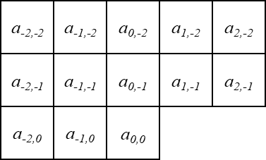
Figure 6 Autoregressive filter with lag equal to 2
For the FGC autoregressive model, the lag parameter is not signalled explicitly. Instead it is implicitly specified to be in the range of 0 to 2, inclusive, depending on the value of fg_num_model_values_minus1[ c ] where, c, is the index of the colour component. The coefficients allowed for the FGC autoregressive model are constrained as illustrated in Figure 6 where the variable, A, is the pixel aspect ratio of the film grain. The film grain pixel aspect ratio could be useful in cases in which a picture is stretched in resizing or was captured with isomorphic optics [7].
For a hypothetical example extended version of such a film grain synthesis model, the lag parameter, L, could have a larger range, such as 0 to 3, inclusive.
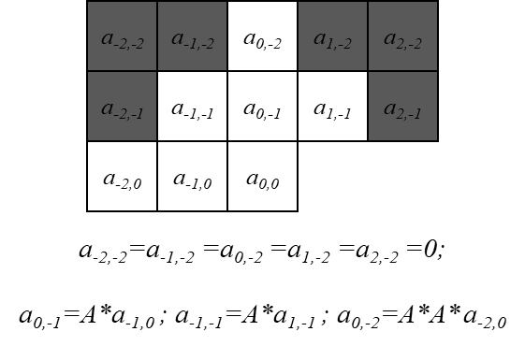
Figure 7: Coefficients allowed for the FGC autoregressive model.
The variable, A, is the pixel aspect ratio of the film grain.

Example of the autoregressive model for film grain synthesis
The following describes an example of an autoregressive model for film grain synthesis when the following properties apply:
– all colour correlation coefficients are equal to 0
– pixel aspect ratio for film grain is equal to 1
– ar_lag is less than or equal to 2
– ChromaFormatIdc is equal to 1
– fg_model_id is equal to 0.
– fg_separate_colour_description_present_flag equal is to 0.
– fg_blending_mode_id is equal to 0.
[Ed. Note: also here this uses ChromaFormatIdc that is nowhere else specified.]
[TO BE COMPLETED]

Grain pattern database generation
The variable ar_prngArray is an 82x73 array of values produced by a pseudo-random number generator
The variable ar_coeff[ ar_lag + dx ][ ar_lag + dy ] is equal to a_{dx,dy}
for ( y = 3; y < 73; y++) {
for ( x = -3; x <= 82; x++) {
for ( dy = -ar_lag; dy <= 0; dy++) {
grainDb[ x ][ y ] = 0
for ( dx = -ar_lag; dx <= ar_lag; dx++) {
if( dy == 0 && dx == 0)
break
grainDb[ x ][ y ] + =
ar_coeff[ ar_lag + dx ][ ar+lag + dy ] * ar_prngArray[ x + dx ][ y + dy ]
}
}
}
}
[ADD COLOUR PROCESS]
[TO BE COMPLETED]

Grain pattern scaling table determination
[TO BE COMPLETED]

Grain strip construction
[TO BE COMPLETED]
      - Grain blending
Inputs to this process are w, h, subX, and subY

[TO BE COMPLETED]

Use of an FCS SEI message with the example autoregressive model for film grain synthesis
The following describes the use of the FGC SEI message with the example process described in 8.2.2. [TO BE COMPLETED]

Film grain analysis
[Ed. Note: possibly describe how film grain can be removed from input video.]
[Ed. Note: General overview of common pre-processing steps: filtering, noise estimation, edge detection, etc.]
The film grain analysis process is applied on the encoder side and is a non-normative process regardless of the synthesis method and standard in use. It can be implemented as a pre-processing step or as a part of the encoding process. Ultimately, it provides indicative features of the film grain in accordance with the selected parameterized model and supported metadata. It determines film grain model parameters to be sent in the appropriate metadata mechanism, e.g., in an SEI message, to enable content-aware decoder-side film grain synthesis. The analysis process is not mandatory, and manually tuned parameters can be provided to the encoder based on an input configuration file. [Ed. Note: This seems to be talking about a specific implementation and reads odd. This could be, for example, a live based process. ] If the analysis process determines that no grain is present in the source video, the appropriate syntax element values could be set to indicate that synthesis will not be performed at the decoder side.
Figure 7 depicts a simplified framework for film grain analysis. As an input to the process, besides the source video, the denoised representation is also required. Edge and complex texture analysis is performed in order to determine a map of flat and non-flat regions in the scene. This is done since low-frequency components, such as edges and texture, can interfere with the analysis process of the noise, which also resides in low-frequencies.
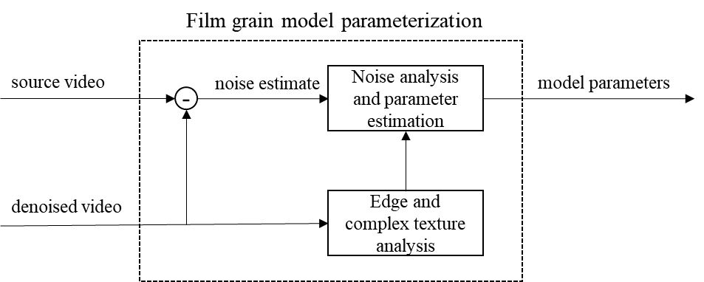
Figure 8: Film grain analysis and parameter estimation general steps.
Thus, film grain analysis consists of the following commonly implemented steps:
- a pre-processing step to produce a noise estimate (a.k.a. film grain image). It consists of denoising the video and finding the difference between source and denoised pairs. [Ed. Note: Should this be split into two components? The denoiser somehow seems independent from the difference module.]
- a pre-processing step to produce other information about the characteristics of the input video such as edge and texture analysis. [Ed. Note: Is this a pre-processing or pre-analysis step?]
- noise analysis and parameter estimation step to determine model parameters.
Noise analysis and parameter estimation depend on the selected parameterized model. Some examples of a possible implementation are provided in the following subclauses.

Frequency filtering model parameter estimation for an FGC SEI message

General
The FGC SEI message does not specify a means to determine values for the FGS model. However, example code for analyzing video to determine FGC SEI message syntax values is included in the VTM reference code and is described in this subclause.
Possible solutions for denoising the input video source include the use of motion adaptive or motion compensated temporal filtering (MCTF) methods. MCTF methods utilize motion search and motion compensation algorithms to exploit temporal redundancies and isolate the video signal from the noise signal, and therefore achieve denoising. Motion adaptive methods perform simple decisions using temporally neighboring samples to determine noise. Although they are commonly less performing, they usually also have lower complexity.
After filtering, the film grain images that represent the film grain estimates are generated by computing the difference between the original input frames and the filtered/denoised frames that correspond to the same time instance. To create a map of flat regions, one approach can be to perform analysis on three scales: the original and two subsampled resolutions, one by a factor of 2 and another by a factor of 4. [Ed. Note: is this both horizontal and vertical?] At each scale, a Canny edge detector can be used (without the classical Canny detector blurring step) followed by one morphological dilation to determine edges. The obtained maps at the subsampled scales can then be upsampled to the original resolution and combined. Additional morphological operations can be subsequently applied: Two dilations followed by one erosion can be applied to get the final map of flat regions within an input frame. The film grain image and map can then be provided to the estimation module.

Determination of cut-off frequencies
Cut-off frequencies can be estimated as follows. The film grain image is scanned block by block at 64x64 granularity, using non-overlapping blocks. Only 64x64 blocks within the flat part of an image are processed further. For each block coming from a flat region, a forward 64x64 DCT-2, as defined in VVC, can be applied. Then, each coefficient resulting from the transform is squared. Afterwards, an average 64x64 squared transformed block B_{avg} is computed over all available squared transformed blocks B_{i} (pixel-wise) as:
$B_{avg}\left(x,y\right)=\frac{1}{K}\sum_{i=0}^{K-1}{B_{i}(x,y)}$,
where K is the total number of blocks that is used for the calculations. Thereafter, the average columns B_{c} and by rows B_{r} vectors are calculated (the DC component for the first row and the first column is discarded from the computation) as follows:
$B_{c}\left(y\right)=\frac{1}{63+\left(y>0\right)?1:0}\sum_{i=\left(y>0\right)?0:1}^{63}{B_{avg}(i,y)}$ and $B_{r}\left(x\right)=\frac{1}{63+\left(x>0\right)?1:0}\sum_{i=\left(x>0\right)?0:1}^{63}{B_{avg}(x,i)}$.
The average vectors B_{c} and B_{r} are regularized to suppress peaks. The average vectors are represented as a curve and its intersection points with a total average value avg of a block B_{avg} is computed ($avg=\frac{1}{64*64}\sum_{i=0}^{64-1}{\sum_{j=0}^{64-1}{B_{avg}}(i,j)}$), as illustrated in Figure 8. The value of avg is subsequently used as a threshold for other computations. [Ed. Note: not sure if that was what was meant by avg being used as a threshold or if I changed the intent. It was hard to understand what the original statement meant].
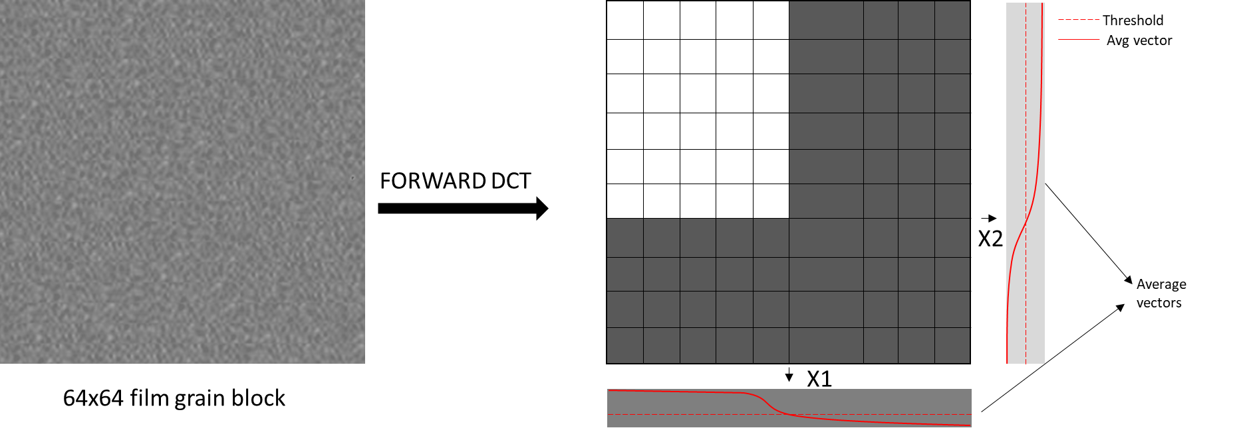
Figure 9:Cut-off frequency estimation (intersection points x1 and x2 represent estimated frequencies).
Based on the analysis of the intersection point(s), cut-off frequencies are obtained. The intersection points are chosen to represent the cut-off frequencies of the frequency-filtered film grain model. In such case, the model values are set to (according to the SMPTE RDD 5 specification):
- comp_model_value[ c ][ i ][ 1 ] = Clip3(2,14,(x1-1)>>2) and
- comp_model_value[ c ][ i ][ 2 ] = Clip3(2,14,(x2-1)>>2),
where i is the index of the interval, and c is the colour component index. If no intersection points are found, film grain is not present in the input frame.
In the current implementation, only one pair of cut-off frequencies is estimated over the full intensity interval range.

Determination of intensity intervals and grain variance
Intensity intervals (fg_intensity_interval_lower_bound[ c ][ i ], fg_intensity_interval_upper_bound[ c ][ i ]) and the corresponding grain variance values (fg_comp_model_value[ c ][ i ][ 0 ]) are determined by analyzing the film grain image, the filtered image, and the flat-region map produced during pre-processing. This leads to an estimate of a stepwise constant scaling function as illustrated in Figure 8.
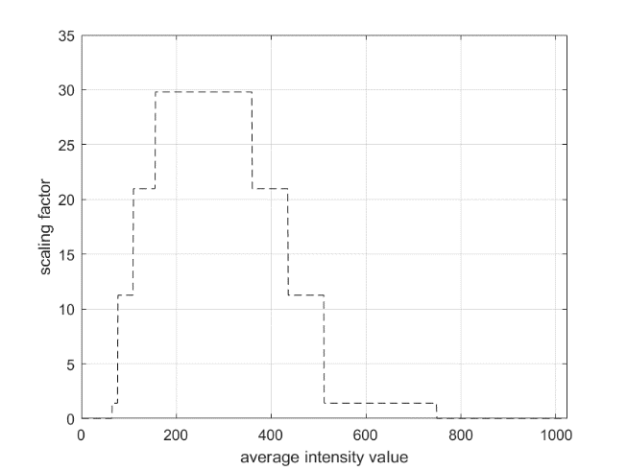
Figure 10: An example of film grain scaling function defined with fg_intensity_interval_upper_bound[ c ][ i ], fg_intensity_interval_lower_bound[ c ][ i ] and fg_comp_model_value[ c ][ i ][ 0 ].

The analysis is performed block-by-block with block size, BlockSize, which is determined based on the frames resolution as follows:
PicSizeinLumaSamples = PicHeightInLumaSamples * PicWidthInLumaSamples
if PicSizeinLumaSamples <= ( 1920 * 1080 )
BlockSize = 8
else if PicSizeinLumaSamples <= ( 3840 * 2160 )
BlockSize = 16
else
BlockSize = 32
The average intensity value of the filtered image and the variance of the film grain image are calculated for each block within a flat region of the image. Note that the points higher than 32 << (bitDepth − 8) are discarded from the calculation to limit data points to meaningful values.
The data points are used to determine intensity intervals and scaling factors (grain variance) in two steps:
- derive a scaling function by two-pass curve fitting
- quantize the fitted curve to produce a stepwise function
Two-pass curve fitting is performed as follows. First, the complete intensity dynamic range (horizontal axis) is divided (uniformly quantized) into non-overlapping intervals of size 16. If the number of points falling into an interval is greater than $N_{min}=32$, the average variance value is calculated for the interval. Next, the average points per interval are used to fit a 3rd order polynomial curve. Outliers are identified by calculating the standard deviation (std) of the difference of the points and fitted curve. Any point greater than +0.5*std and lower than -1.5*std from the curve are excluded. The process is repeated for the remaining points to produce a new parameterized 3rd-order polynomial curve.
The fitted curve is quantized using Lloyd max non-uniform quantization. The quantizer is adapted (trained) for each new set of points on-the-fly. In the current implementation, quantization is performed using 4 quantization levels.
Analysis is performed in the same way for all colour components.
[TO BE COMPLETED]

Autoregressive model parameter estimation

[TO BE COMPLETED]

Annex A
Example process for inserting, modifying, or removing an FGC SEI message from a coded bitstream
The FGC SEI message rewriter included in the VTM allows FGC SEI message parameter values to be modified in existing bitstreams without re-encoding. It also supports inserting FGC SEI messages in a VVC bitstream originally encoded without any FGC SEI messages. The bitstream with the inserted FGC SEI message has an identical MD5sum value to the bitstream having the FGC SEI message enabled during encoding. [Ed. Note: Does that not depend on the encoder used? If yes, should again the VTM be emphasized? is it really necessary information?] The tool supports three operational modes, controlled by SEIFilmGrainOption: 0-no change; 1-FGC SEI removal; 2-FGC SEI insertion; 3-FGC SEI rewriter.
- FGC SEI removal (applied on bitstreams that include FGC SEI messages) [Ed. Note: Will this remove multiple such SEI messages if present? Or can it only handle the case of one such SEI being present? I believe that is true for (2) and (3) also.]
- FGC SEI insertion (applied on bitstreams without FGC SEI message)
- FGC SEI modification (applied on bitstreams with FGC SEI message)
The two typical use cases and examples are given below:
- A bitstream (test_fg1.bit) is encoded with a pre-configured FGC SEI message (fg1.cfg), but the film grain parameters are not producing satisfactory film grain effects. One can use the tool to modify the values (fg2.cfg) of the existing FGC SEI message. Example command line:
./SEIFilmGrainAppStatic -c fg2.cfg -b test_fg1.bit -o test_fg2.bit --SEIFilmGrainOption=3

- A bitstream (test.bit) is encoded without FGC SEI message, so it cannot take advantage of the film grain synthesis. One can use the tool to easily insert the FGC SEI (fg.cfg) into the bitstream. Example command line:
./SEIFilmGrainAppStatic -c fg.cfg -b test.bit -o test_fg.bit --SEIFilmGrainOption=2

The tool manipulates the VVC bitstream at NALU level, so processing time is extremely fast (e.g., to rewrite the FGC SEI message in a 4K/8K resolution bitstream, the entire processing time is less than 0.1 sec). The basic workflow is illustrated in Figure 1.
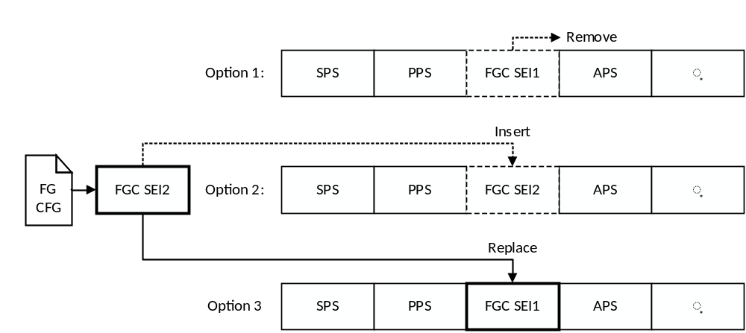
Figure A.1 Basic workflow of FGC SEI message rewriter
[Ed. Note: Option 3 is missing a colon]

Annex B
Deployment status film grain analysis and synthesis technology
- B.1 Open-source implementations
FFmpeg, OpenVVC, x264, x265, VTM, HM, etc.

