    Joint Video Experts Team (JVET)  of ITU-T SG 16 WP 3 and ISO/IEC JTC 1/SC 29/WG 11  25th Meeting, by teleconference, 12–21 January 2022 | Document: JVET-Y0043-v5

Title: |  | AHG-7 LLCC Scenarios and baseline configurations
Status: |  | Input document to JVET
Purpose: |  | Proposal
Author(s) or  Contact(s): |  |  | G. Martin-Cocher  S. Puri, T. Poirier  K. Naser  J. Xu  D. Nicholson  M. Sychev  L. Wang  S. Liu  W. Yang  J. M. Thiesse  M. Karczewicz | Email: | first.last @ interdigital.com  first.last @ interdigital.com  first.last @ interdigital.com  Lastfirst @ bytedance.com  dnicholson @ ektacom.com  Last.first @ huawei.com  limin.2.wang @ Nokia.com  shanl @ tencent.com  yangwei@ tencent.com  jean-marc.thiesse@ vitec.com  martak @ qualcomm.com
Source: |  | InterDigital, ByteDance, Ektacom, Huawei, Nokia, Tencent, VITEC, Qualcomm
_____________________________

Abstract
This contribution identifies key Low Latency Controlled Complexity (LLCC) scenarios, namely cloud gaming, game casting, video surveillance, remote control of systems, video conferencing and summarize their characteristics in terms of video formats, requirements, constraints on coding tools. This contribution proposes baseline LLCC CTCs as follow:
The VTM LLCC-1 configuration is defined as a modification of LD-P, with flat QP, GDR enabled with the GdrInterval set to 1second and a GdrPeriod = GdrInterval+ 4P frames. LMCS chroma scaling is turned OFF. QP42 is added and BD-rate calculations are proposed to be performed on QP22-37 and on QP 27-42.
For ECM, the LLCC-1 configuration is similar to the VTM LLCC-1 configuration, but instead of GDR, an IDR is set every second, until GDR will be implemented in ECM.
The VTM and ECM LLCC-2 configuration is defined as a modification of LD-B, with a maximum of 2 reference frames. QP42 is added and BD-rate calculations are proposed to be performed on QP22-37 and on QP 27-42. RPR is proposed to be enabled once per clip for class E.
The contribution further proposes baseline principals to refine these CTCs.
A reference software encoding run time to real time ratio (ET/RT ratio) principle for a hypothetical single threaded non optimised reference software is proposed as a reference point to refine the baseline LLCC CTCs. It’s initial value could be set at 1000/1 for 1080p resolution. This ratio is not proposed as an evaluation criterion for individual tools.

LLCC scenarios and requirements
While each scenario has specific requirements, low delay/LLCC will be used for higher resolutions (1080, 4K, 8K) and higher average bitrates across scenarios (6 to 20Mbps) than what is currently studied in ECM LD-P/B (and VTM).

Cloud gaming
A survey of a few cloud-gaming services (GeforceNow [1] [2] , Unity-Parsec [3], Amazon Luna [4], Vortex [5], Tencent [6], Stadia [7] Steam [8]) and their corresponding technical documents indicates that:
- Typical resolutions include 720p, 1080p, 1440p and 4k, while 8K will become more common in few years from now.
- Typical framerates range from 30fps to 120fps, while most of the game are in 60fps.
- Typical bitrates range from:
- 10 to 30 Mbps with a max at 35 to 50Mbps peak bandwidth for PC with GPUs or TVs with a LAN connection.
- 2 to 8Mbps for mobile phone, cell or wifi connection.

Key requirements:
- Lowest latency possible for the entire system. 50-80ms end to end latency for average gamer but 20ms end to end latency is perceived by a professional gamer. 5G RTT latency is 5ms.
- Low decoder complexity: should work on a variety of hardware and browser.

Example of coding features and restrictions used across various services:
- No B frames
- No multi-pass tools
- Simple (and parallel friendly) RDO/partitioning
- “Area of interest”
- Super resolution can be used.
- Small buffer sizes, AU enough.
- CBR

Game casting
For “Esport / game casting” services (Twitch [9], Nvenc [2]):
- Typical gaming casting resolutions includes 720 to 1080p
- Typical framerates range from 25 (720p) to 60 (1080p)
- Typical bitrates range from 3 and 6Mpbs.

Key requirements:
- CBR

Example of coding features and restrictions used across various services that differ from cloud gaming services:
- P frame or with B frame, number of reference frame restricted to 2
- No multi-pass tools
- CRA every 2 sec, may be via GDR

Video conferencing
For video-conferencing services (e.g. Webex [10] zoom [11] Nvenc [2]) for an individual stream:
- Typical resolution to be considered: 720p and 1080p
- Typical framerate: 30fps
- Typical bitrate: up to 6Mbps

Key requirements:
- Low latency, as the impact of transcoding and stream aggregation needs to be taken in account
- No multi-pass encoding / tools.
- Capability to change resolution.

Example of coding features and restrictions used across various services:
- Either P frame only or B frame with limit to 2 reference pictures.
- RPR, – one during the test clip is suggested.
- GDR may or may not be considered.

Video surveillance
Characteristics of video surveillance system:
- Typical resolutions include 4M ~ 8M pixel, full HD the norm. 4K as well
- Typical framerates: 25 or 30fps
- Typical bitrate is 2Mbps ~ 6Mbps for FHD, and 6Mbps ~ 12Mbps for 4K
- “Area of interest”

Key requirements:
- Low latency
- Low complexity for low-cost hardware design

Example of coding features and restrictions used across various services that differ from cloud gaming services:
- Typically IPPP, IBBB is possible but only forward prediction is allowed
- Closed GOP: Random access is a must, GDR desirable for that purpose. AU enough.
- Typical random access point at every 2s ~ 4s

Some references: Axis, Latency in live network video surveillance [12]; WesternDigital [13]

Remote control of system
Remote control of video-based systems encompasses use cases such as remote surgery, remote driving (taking over a failed system), real-time video training etc.
Characteristics of such systems:
- Typical resolutions include: 1080p, 8b-12b, 4:2:0, 4:2:2, 4:4:4 YUV, 4:4:4 RGB but can range from 360p25 to UHD.
- Typical framerates include: 60fps.
- Typical bitrates range from 300kb/s (360p) to 6Mb/s

Key requirements:
- Ultra low latency to allow control of remote system by
  - a human in the loop, typically end to end latencies between 40 and 300ms depending upon the system to control.
  - A machine in the loop with end-to-end delay of a sub picture frame duration up to 100ms
- Reduced complexity for embedded video coding, including hardware assisted software coding.
- Coding efficiency better than HEVC (30% min BD-rate gain) with no more than doubled complexity. Not necessarily better than HM but better than HEVC (e.g. x.265 medium preset) with limited complexity.

Example of coding features and restrictions used across various services that differ from cloud gaming services:
- No B frames, typically IPPP coding structure
- GDR and DU, as basic tools for reducing latency
- RPR of interest to deal with network capacity variations
- Flat QP or rate control depending upon the network constraints
  - QP ranges and bitrates depending also upon the application [14] and the related quality requirements (utility of the video for the task)
- HDR is of interest for remote control of outdoor systems such as for remote driving

Baseline LLCC CTCs
To achieve the proposed use-cases and their requirements the following baseline CTCs are proposed.
LLCC 1 CTC (modification of LD-P):

 | VTM | ECM
IPPP | Yes | Yes
Flat QP | Yes | Yes
QP values | Add QP 42  BD-rate calculations performed on QP22-37 and on QP 27-42. | Add QP 42  BD-rate calculations performed on QP22-37 and on QP 27-42.
“recovery/refresh” | GDR enabled every 1~2 second  GdrInterval (between GDR picture to associated recovery point picture) is set to 1 second  GdrPeriod (between two consecutive GDR pictures) = GdrInterval + 4 regular P pictures | IDR every 1 second to be replace by GDR when fully implemented for the LLCC-1 toolset.
Per class tools | Screen content tools for relevant classes  RPR for relevant classes.  HDR for relevant classes/sequences. | Screen content tools for relevant classes  RPR for relevant classes.  HDR for relevant classes/sequences.
Tools disabled - Trade off | Disable LMCS chroma scaling during the GDR period  Other tools TBD | LMCS chroma scaling  Other tools TBD
Disable/modify tools to approach the 1000/1 ET/RT ratio (complexity/latency) | TBD | TBD

LMCS:
Chroma residual scaling depends on the average value of top and/or left reconstructed neighbouring luma samples of the current VPDU. With GDR, there are some cases where the current CU is in the clean area but the current VPDU cross the boundary between clean and dirty region, As chroma residual scaling cannot be deactivated on a per CU basis, it needs to be deactivated if GDR is enabled.

LLCC 2 CTC for VVC and ECM (modification of LD-B)

 | VTM | ECM
IBP | Yes | Yes
QP values | Add QP 42  BD-rate calculations on QP22-37 and on QP 27-42. | Add QP 42  BD-rate calculations on QP22-37 and on QP 27-42.
Number of Reference frame | Max 2 | Max 2
“recovery/refresh” | No GDR | No GDR
Per class tools | RPR for class E. one per clip | RPR for class E, one per clip
Tools disabled - Trade off | TBD | TBD
Disable/modify tools to approach the 1000/1 ET/RT ratio (complexity/latency) | TBD | TBD

Define a suitable “tool inclusion process” in LLCC CTCs
To refine the baseline configuration proposed above, the following considerations are proposed for adding or disabling a tool in the LLCC configurations:
- Tools with an implementation that do not yet meet the LLCC conditions, should not be included in the LLCC CTCs (e.g. ALF current implementation is multi-pass). Tools could be added back when the implementation is fixed.
- Tools for which the trade-off gain/complexity in current low-delay CTC is non-optimum, for instance below a threshold.
- Tools that are either known to not be used in LLCC scenario or “deemed too complex” and disabling them will allow to approach the ET/RT ratio.
- Tools inherently iterative, multi-pass or providing delays (cross-component delays, line of delays etc.)
- It would be desirable for Tools (new or modified) that are impacted by GDR, to be provided with a GDR implementation in the LLCC1 configuration.

Reference software Encoding Time to Real-Time ratio
It is proposed to define a ratio between a non-optimised single threaded reference software Encoding Time (ET) and Real time (RT). That ET/RT ratio needs to be set in a way that configurations reaching that ratio provide realistic comparison points for real-life implementations in LLCC scenarios.

Current ET/RT ratio:
ET/RT ratio for selected LLCC scenario:
- HM 16.24 from [15]
- VTM 14 from [15]
- ECM 2.0 LD-B from [16]
- VTM 11 on Interdigital cluster.
- 3GPP SA4 results with SCM8.8 and VTM 11+SCC [17]
- ECM3 LD-B shared on the JVET reflector

Sequence(s) | HM LD-P | HM LD-B | VTM LD-P | VTM LD-B | ECM LD-P | ECM LD-B
Class E (720p): | 876/1 | 1086/1 | 2730/1 | 3774/1 | NA* | 7908/1  9024/1
Class E (720p), no QP22. |  |  | 2196/1 | 2911/1 | NA* | 5944/1  6516/1
Class F | 756/1 | 870/1 | 3324/1 | 4224/1 | NA* | 7368/1  7812/1
Class F no QP22. |  |  | 2964/1 | 3672/1 | NA* | 6312/1  6732/1
Class TGM (1080p) | NA | NA | 2601/1 | NA | NA | 27752/1  29256/1
Class TGM (1080p) no QP22. |  |  | 2244/1 | NA | NA | 25488/1  27048/1
3GPP SA4 Gaming HD | NA | 4098/1 | NA | 14454/1 | NA | NA
3GPP SA4 Gaming HD no QP 22 | NA | 3630/1 | NA | 11592/1 | NA | NA
3GPP SA4 Gaming UHD | NA | 26760/1 | NA | 70754/1 | NA | NA
3GPP SA4 Gaming UHD no QP22. | NA | 23370/1 | NA | 56978/1 | NA | NA

The table above confirms that the ET/RT ratio varies heavily based on resolution and bitrate.
*Tests on Interdigital cluster indicate that ECM LD-P ET/RT is roughly 60-70% that of LD-B and that ET/RT on different clusters have a similar order of magnitude.
There can be value at working on QPs that are adjusted to reflect industry practices.

Desired ET/RT ratio for LLCC
An ET/RT ratio of 1000/1 for a single threaded non- optimised reference software is proposed for at least 1080p resolution.
This 1000/1 ratio will still require a lot of optimisations to achieve either of a single threaded or multithreaded real-time encoder conserving the gains observed in the reference software at QP values in used. It will still allow for market differentiation between products.
When developing a codec, that ratio would allow to potentially disable complex tools that are hiding benefits of lower complexity tools, which could be used and added to the codec toolset for LLCC configurations. It could be worthwhile to consider a ratio below 1000/1 as a starting point to ensure that with tools added over time the final ratio will be near the desired ratio.

The following data points were considered:
In [18] results for single threaded VVenC encoder in LD-B for all pre-sets are “derived naively by … disabling … some bi-predictive tools for low-delay B.” and compared to single threaded VTM and HM- 16.23.
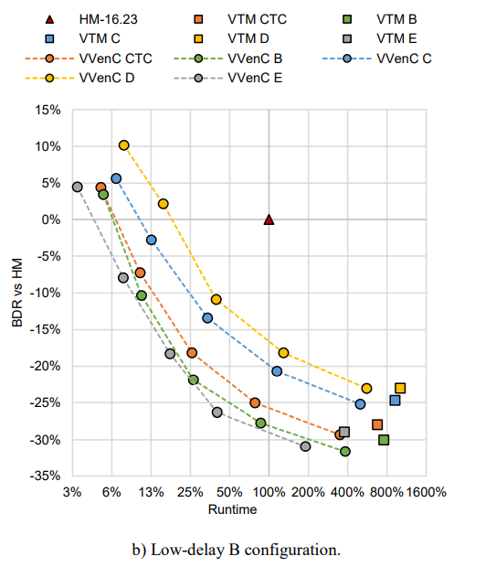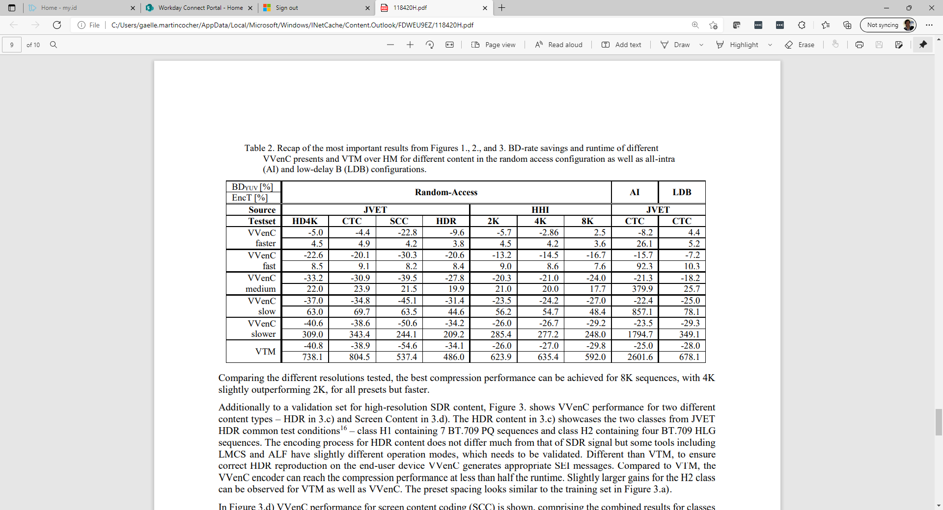

Exemplary results from Ektacom on a remote driving test sequence at 720p25fps in LD-P:
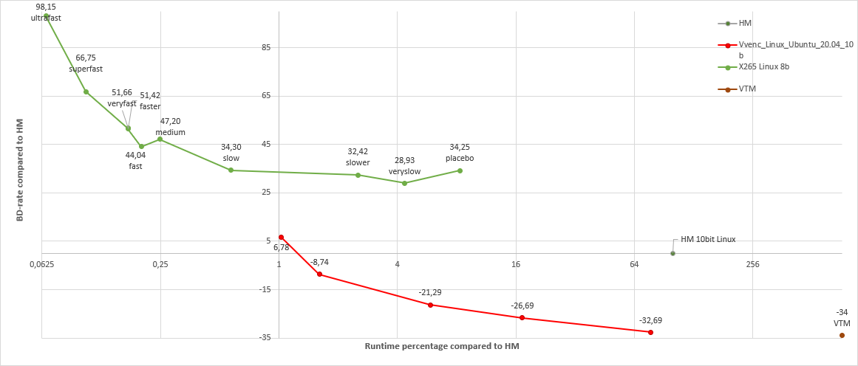
Where the medium preset of x265 corresponds to real-time encoding on Intel Core i9 9900K and where the VVenC version is V0.3.

In the latest VVenC release [19], a comparison to the x265 runtime in RA is provided:
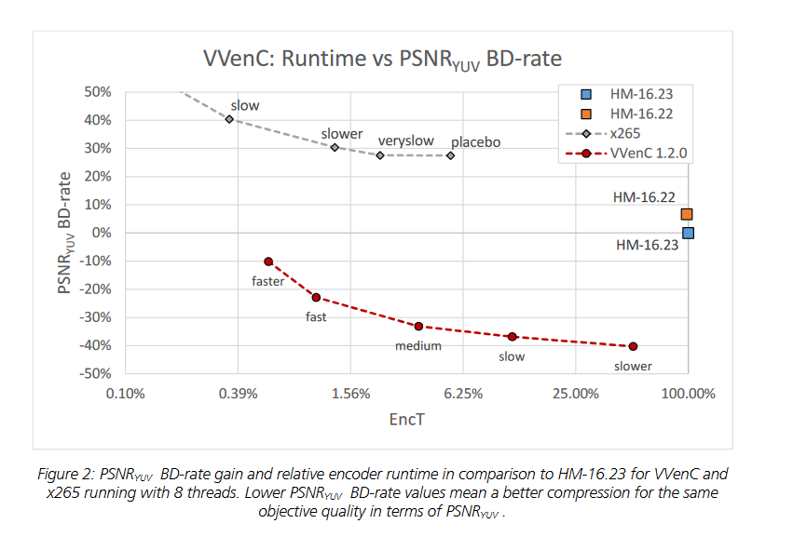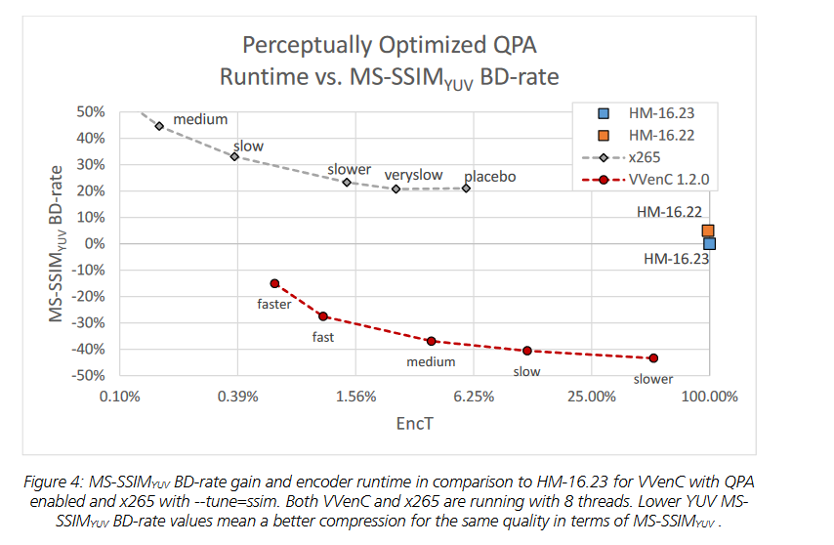

The VVC implementation Ali266 (JVET-X0104) reports real-time capability in RA in 1080p while providing 37-40% gain over x265 medium preset.

Based on the above an ET/RT ratio of 1000/1 seems to be, albeit naïve, a reasonable assumption as a starting point for LLCC CTCs for ECM and VTM for at least 1080p resolution.

Results

ECM results:
 | LLCC-2 (QP22,27,32,37) |  |  |  |  |  |  | LLCC-2 (QP27,32,37,42)
 | BD-rate Over ECM 3.1 LD-B |  |  |  |  |  |  | BD-rate Over ECM 3.1 LD-B
 | Y-PSNR | U-PSNR | V-PSNR | EncT | DecT |  |  | Y-PSNR | U-PSNR | V-PSNR | EncT | DecT
Class B | 5,12% | 6,57% | 6,73% | 78% | 100% |  | Class B | 4,39% | 5,31% | 4,85% | 79% | 102%
Class C | 9,86% | 13,39% | 13,01% | 87% | 105% |  | Class C | 9,64% | 14,53% | 13,37% | 86% | 105%
Class E | 4,57% | 4,21% | 4,21% | 76% | 108% |  | Class E | 3,55% | 2,83% | 3,42% | 78% | 105%
Overall | 6,56% | 8,25% | 8,19% | 81% | 104% |  | Overall | 5,93% | 9,41% | 8,64% | 81% | 104%
Class D | 6,69% | 8,07% | 6,92% | 85% | 102% |  | Class D | 5,65% | 6,24% | 5,41% | 83% | 100%
Class F | 9,56% | 11,14% | 11,46% | 87% | 112% |  | Class F | 8,64% | 10,44% | 10,73% | 87% | 109%
Class TGM | 9,86% | 9,83% | 9,74% | 96% | 111% |  | Class TGM | 9,70% | 9,31% | 9,41% | 95% | 109%
 | LLCC-1 (QP22,27,32,37) |  |  |  |  |  |  | LLCC-1 (QP27,32,37,42)
 | BD-rate Over ECM 3.1 LD-P |  |  |  |  |  |  | BD-rate Over ECM 3.1 LD-P
 | Y-PSNR | U-PSNR | V-PSNR | EncT | DecT |  |  | Y-PSNR | U-PSNR | V-PSNR | EncT | DecT
Class B | 9,00% | 3,43% | 2,08% | 99% | 103% |  | Class B | 11,76% | 7,31% | 6,01% | 98% | 105%
Class C | 9,49% | 3,74% | 3,29% | 96% | 99% |  | Class C | 12,09% | 5,91% | 6,66% | 94% | 99%
Class E | 28,63% | 27,27% | 25,11% | 98% | 106% |  | Class E | 36,35% | 36,30% | 34,27% | 98% | 105%
Overall | 14,07% | 9,49% | 8,24% | 98% | 102% |  | Overall | 18,02% | 14,09% | 13,29% | 97% | 103%
Class D | 9,94% | 2,23% | 3,16% | 98% | 93% |  | Class D | 13,65% | 7,14% | 8,49% | 97% | 94%
Class F | 64,87% | 65,44% | 59,43% | 110% | 113% |  | Class F | 68,47% | 69,84% | 62,28% | 109% | 110%
Class TGM | 32,16% | 31,34% | 29,21% | 121% | 113% |  | Class TGM | 33,34% | 32,54% | 30,25% | 118% | 110%

VTM results:

 | LLCC-2 (QP22,27,32,37) |  |  |  |  |  |  | LLCC-2 (QP27,32,37,42)
 | BD-rate Over VTM15 LD-B |  |  |  |  |  |  | BD-rate Over VTM15 LD-B
 | Y-PSNR | U-PSNR | V-PSNR | EncT | DecT |  |  | Y-PSNR | U-PSNR | V-PSNR | EncT | DecT
Class B | 6,13% | 8,17% | 7,91% | 84% | 99% |  | Class B | 5,00% | 6,53% | 5,70% | 82% | 97%
Class C | 8,81% | 11,80% | 11,77% | 86% | 94% |  | Class C | 8,89% | 12,12% | 12,65% | 85% | 97%
Class E | 5,71% | 4,68% | 5,98% | 86% | 101% |  | Class E | 3,84% | 2,94% | 4,05% | 87% | 105%
Overall | 6,92% | 8,51% | 8,72% | 85% | 98% |  | Overall | 6,01% | 9,02% | 8,79% | 84% | 99%
Class D | 7,11% | 9,49% | 10,98% | 90% | 108% |  | Class D | 6,62% | 8,09% | 9,71% | 88% | 109%
Class F | 8,15% | 10,43% | 10,28% | 94% | 108% |  | Class F | 7,78% | 10,27% | 10,50% | 93% | 109%
Class TGM | 10,64% | 9,87% | 9,60% | 98% | 107% |  | Class TGM | 10,43% | 9,15% | 9,10% | 97% | 109%

 | LLCC-1 (LDP) (QP22,27,32,37) |  |  |  |  |  |  | LLCC-1 (LDP) (QP27,32,37,42)
 | BD-rate Over VTM15 flat QP-IDP |  |  |  |  |  |  | BD-rate Over flat QP IDR
 | Y-PSNR | U-PSNR | V-PSNR | EncT | DecT |  |  | Y-PSNR | U-PSNR | V-PSNR | EncT | DecT
Class B | 2,87% | 9,52% | 13,75% | 96% | 97% |  | Class B | 5,13% | 12,52% | 15,92% | 98% | 100%
Class C | 3,70% | 9,82% | 10,83% | 96% | 105% |  | Class C | 5,17% | 14,08% | 15,40% | 96% | 101%
Class E | 11,65% | 22,99% | 23,28% | 101% | 102% |  | Class E | 17,45% | 28,80% | 29,11% | 102% | 104%
Overall | 5,34% | 12,99% | 15,16% | 97% | 101% |  | Overall | 8,22% | 17,11% | 19,04% | 98% | 101%
Class D | 4,57% | 12,28% | 12,25% | 98% | 103% |  | Class D | 6,83% | 19,27% | 17,82% | 101% | 104%
Class F | 12,52% | 18,57% | 19,48% | 107% | 104% |  | Class F | 14,39% | 21,60% | 23,16% | 108% | 104%
Class TGM | 8,71% | 9,39% | 9,40% | 112% | 104% |  | Class TGM | 9,45% | 10,35% | 10,29% | 113% | 104%

 | LLCC-1 (QP22,27,32,37) |  |  |  |  |  |  | LLCC-1 (QP27,32,37,42)
 | BD-rate Over VTM15 LD-P |  |  |  |  |  |  | BD-rate Over VTM15 LD-P
 | Y-PSNR | U-PSNR | V-PSNR | EncT | DecT |  |  | Y-PSNR | U-PSNR | V-PSNR | EncT | DecT
Class B | 35,62% | 76,64% | 77,07% | 162% | 142% |  | Class B | 49,74% | 97,54% | 92,40% | 172% | 138%
Class C | 38,78% | 65,43% | 58,47% | 145% | 146% |  | Class C | 50,07% | 80,35% | 72,93% | 158% | 143%
Class E | 101,18% | 174,29% | 169,26% | 174% | 140% |  | Class E | 121,13% | 189,14% | 181,55% | 169% | 127%
Overall | 53,07% | 97,32% | 93,92% | 159% | 143% |  | Overall | 67,70% | 114,71% | 108,20% | 166% | 137%
Class D | 40,31% | 85,28% | 83,50% | 149% | 158% |  | Class D | 56,33% | 111,46% | 111,23% | 166% | 155%
Class F | 137,91% | 155,83% | 143,53% | 163% | 136% |  | Class F | 147,27% | 169,44% | 157,59% | 175% | 136%
Class TGM | 51,91% | 56,74% | 52,92% | 139% | 135% |  | Class TGM | 55,24% | 61,12% | 56,10% | 150% | 136%

Proposals
It is proposed to:

- Adopt the baseline CTCs defined in section 2 as a replacement of or as an addition to current LD-P/LD-B ECM and VTM CTCs.
  - Agree to the tool inclusion process described in 3 to later decide on tools that may or may not be included in LLCC.
  - Agree to the ET/RT ratio principle described in 4.
- Request GDR implementations for relevant new or modified tools in LLCC 1 configuration (ECM).

References

[1] | "GeforceNow," [Online]. Available: https://play.geforcenow.com/mall/#/layout/settings.
[2] | "NVenc settings," [Online]. Available: https://docs.nvidia.com/video-technologies/video-codec-sdk/nvenc-video-encoder-api-prog-guide/#recommended-nvenc-settings.
[3] | "Parsec Unity," [Online]. Available: https://support.parsec.app/hc/en-us/articles/360001562772-All-Advanced-Configuration-Options.
[4] | "Amazon Luna," [Online]. Available: https://www.amazon.com/luna/landing-page.
[5] | "Vortex mobile," [Online]. Available: https://vortex.gg/pricing.
[6] | "tencent gaming," [Online]. Available: https://intl.cloud.tencent.com/act/solution/video.  "START," [Online], Available: https://start.qq.com/spec/streaming/.
[7] | "Stadia," [Online]. Available: https://support.google.com/stadia/answer/9607891?hl=en.
[8] | "steam," [Online]. Available: https://store.steampowered.com/streaming/.
[9] | "twitch," [Online]. Available: https://stream.twitch.tv/encoding/.
[10] | "webex update," [Online]. Available: https://help.webex.com/en-US/article/lqcwg9/List-of-Features-for-Webex-Meetings-41.3-to-41.6.
[11] | "zoom," [Online]. Available: https://support.zoom.us/hc/en-us/articles/4409490756749-Resolution-of-recorded-video.
[12] | "axis," [Online]. Available: https://www.axis.com/files/whitepaper/wp_latency_live_netvid_63380_external_en_1504_lo.pdf.
[13] | "WDigital," [Online]. Available: https://blog.westerndigital.com/15tb-hdd-smr-ultrastar/.
[14] | J. L. Y. G. N. T. D. N. e. a. Amine Chaabouni, "Quality assessment of MPEG4 AVC/H.264 and HEVC compressed video in a telemedicine context.," in International Conference on Image Processing ICIP'2017, Pékin, China, Sep 2017.
[15] | "JVET-X0003," [Online]. Available: https://jvet-experts.org/doc_end_user/documents/24_Teleconference/wg11/JVET-X0003-v1.zip.
[16] | " JVET-X0006," [Online]. Available: https://jvet-experts.org/doc_end_user/documents/24_Teleconference/wg11/JVET-X0006-v1.zip.
[17] | "3GPP TR26.955," [Online]. Available: https://portal.3gpp.org/desktopmodules/Specifications/SpecificationDetails.aspx?specificationId=3741.
[18] | C. S. B. B. M. A. Wieckowski, "VVenC: an open optimized VVC," in Proc. SPIE 11842, Applications of Digital Image Processing XLIV, San Diego, august 2021.
[19] | "VVenc," [Online]. Available: https://www.hhi.fraunhofer.de/fileadmin/Departments/VCA/MC/VVC/vvenc-v1.2.0-v1.pdf.

Patent rights declaration(s)
Interdigital does not have any current or pending patent rights relating to the technology described in this contribution.
ByteDance does not have any current or pending patent rights relating to the technology described in this contribution.
Ektacom does not have any current or pending patent rights relating to the technology described in this contribution.
Huawei does not have any current or pending patent rights relating to the technology described in this contribution.
Nokia does not have any current or pending patent rights relating to the technology described in this contribution.
Tencent does not have any current or pending patent rights relating to the technology described in this contribution.
VITEC does not have any current or pending patent rights relating to the technology described in this contribution.
Qualcomm does not have any current or pending patent rights relating to the technology described in this contribution.

