    Joint Video Experts Team (JVET)  of ITU-T SG 16 WP 3 and ISO/IEC JTC 1/SC 29  23rd Meeting, by teleconference, 7–16 July 2021 | Document: JVET-W0113-v3

Title: | AHG11: neural network based in-loop filter
Status: | Input document to JVET
Purpose: | Proposal
Author(s) or  Contact(s): | Liqiang Wang, Wei Jiang, Xiaozhong Xu, Shan Liu | Tel:  Email: | {liqiangwang, vwjiang, xiaozhongxu, shanl} @tencent.com
Source: | Tencent
_____________________________

Abstract
In this contribution, a neural network based in-loop filter is exploited to replace the Deblocking and SAO modules. Compared with EE1 anchor (VTM11+V0056), the proposed method reports {4.73%, 10.73, 11.51%} and {3.54%, 10.99%, 10.24%} BD-rate savings with AI and RA configurations, respectively.

In this v3 revision, some complexity computations are updated.

Introduction
In order to improve the quality of reconstructed image, neural network models are trained for I slice and B slice, separately. In the in-loop filter process, Deblock and SAO are replaced by the proposed NN filter.

Proposed method
The reconstructed image after LMCS is fed into the network. Then, the output of NN filter is processed by ALF and CCALF. In detail, as shown in Fig. 1, U and V channels are up-sampled and down-sampled in the pre-processing and post-processing, respectively.
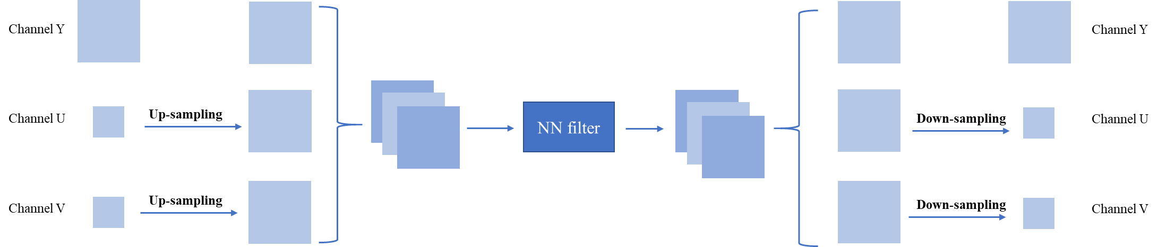
Fig. 1 the pre-processing and post-processing units

Network architecture
Fig. 2 shows the network structure of the proposed NN filter. The first and last layers are regular convolutional layers with kernel size 3. The skip layer is a regular convolutional layer with kernel size 5. The structure of residual block (ResBlock) consists of 3 regular convolutional layers, where N denotes the number of ResBlock. N is set to 8 in this contribution. In the ResBlock, the first layer is a 1x1 convolutional layer followed by a ReLU activation function, the second layer is a 1x1 convolutional layer and the third layer is 3x3 convolutional layer. As for the internal convolutional layers, the number of feature maps is set as 64.
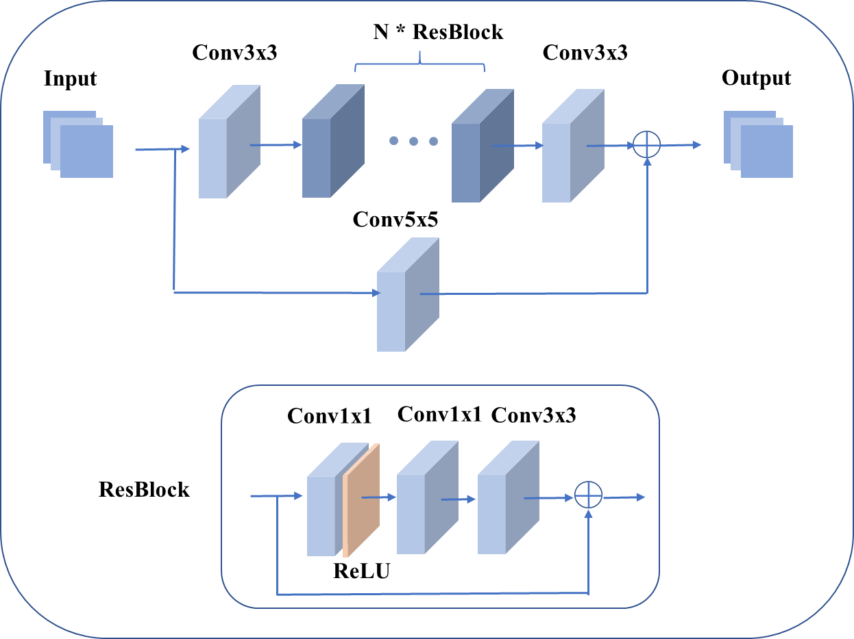
Fig. 2: Network architecture

Network information in training stage

Table 1: Network information for the NN-based video coding tool testing in training stage
Network Information in Training Stage
Mandatory | GPU Type | GPU: Tesla V100 x 8 x 16GB)
Mandatory | Framework: | PyTorch v1.5
Mandatory | Number of GPUs per Task
Mandatory | Epoch: | 40
Mandatory | Batch size: | 128Kx64
Mandatory | Loss function: | L1 30 epochs then L2 10 epochs
Mandatory | Training time: | 72h
Mandatory | Training data information: | DIV2K, BVI-DVC
Mandatory | Training configurations for generating compressed training data (if different to VTM CTC): | Disable Deblock and SAO
Optional
Optional | Number of iterations
Optional | Patch size | 128x128
Optional | Learning rate:
Optional | Optimizer:
Optional | Preprocessing:
Optional | Mini-batch selection process:
Optional | Other information:

Network information in inference stage

Table 2: Network information for the NN-based video coding tool testing in inference stage
Network Information in Inference Stage
Mandatory | HW environment:
Mandatory | GPU Type | CPU only
Mandatory | Framework: | PyTorch v1.5
Mandatory | Number of GPUs per Task | 0
Mandatory | Total Parameter Number | 596k
Mandatory | Parameter Precision (Bits) | 32
Mandatory | Memory Parameter (MB) | 2.28M/model, 10 model in all
Mandatory | Multiplay Accumulate (MAC)/pixel | 621k
Optional
Optional | Total Conv. Layers
Optional | Total FC Layers
Optional | Total Memory (MB)
Optional | Batch size: | 1
Optional | Patch size | 128x128
Optional | Changes to network configuration or weights required to generate rate points
Optional | Peak Memory Usage (Total)
Optional | Peak Memory Usage (per Model)
Optional | Border handling
Optional | Other information:

Implementation
- Deblock and SAO are disabled, and the proposed filter is placed before ALF.
- The proposed filter can be turned on/off at the CTU level and slice level.
- A scaling operation is carried out to refine the result of NN filter. The scaling factors are signaled in the slice header for each component.

Results
The anchor is VTM11+V0056[][], and the corresponding CTC results are provided in Table 3 and Table 4.

Table 3. Performance of the proposed method (RA)
 | Random access Main10
 | BD-rate Over VTM-11.0+V0056
 | Y-PSNR | U-PSNR |  | V-PSNR |  | Y-MSIM |  | U-MSIM |  | V-MSIM |  | EncT |  | DecT
Class A1 | -3.02% | -6.43% |  | -7.01% |  | -3.95% |  | -9.49% |  | -8.13% |  | 175% |  | 114554%
Class A2 | -3.70% | -12.16% |  | -8.83% |  | -3.47% |  | -12.00% |  | -6.48% |  | 170% |  | 97254%
Class B | -3.44% | -10.95% |  | -10.54% |  | -3.05% |  | -10.52% |  | -9.61% |  | 171% |  | 94209%
Class C | -3.94% | -13.61% |  | -13.33% |  | -3.03% |  | -10.54% |  | -9.76% |  | 143% |  | 89578%
Class E
Overall | -3.54% | -10.99% |  | -10.24% |  | -3.31% |  | -10.61% |  | -8.73% |  | 164% |  | 97275%
Class D | -5.83% | -15.41% |  | -16.15% |  | -3.27% |  | -11.78% |  | -11.27% |  | 138% |  | 62376%
Class F | -0.77% | -6.74% |  | -6.74% |  | -0.52% |  | -6.70% |  | -7.19% |  | 227% |  | 28503%
Class H | #VALUE! | #VALUE! |  | #VALUE! |  | #VALUE! |  | #VALUE! |  | #VALUE! |  | #DIV/0! |  | #DIV/0!

Table 4. Performance of the proposed method (AI)
 | All Intra Main10
 | BD-rate Over VTM-11.0+V0056
 | Y-PSNR | U-PSNR | V-PSNR | Y-MSIM | U-MSIM | V-MSIM | EncT | DecT
Class A1 | -4.15% | -7.35% | -8.85% | -4.78% | -8.84% | -8.97% | 230% | 60980%
Class A2 | -4.10% | -10.57% | -9.15% | -4.09% | -10.54% | -7.23% | 168% | 47767%
Class B | -4.12% | -10.89% | -11.75% | -3.70% | -11.42% | -11.60% | 162% | 42477%
Class C | -5.13% | -14.07% | -14.99% | -4.36% | -13.21% | -12.92% | 128% | 40496%
Class E | -6.39% | -9.56% | -11.47% | -5.76% | -8.77% | -11.32% | 166% | 60336%
Overall | -4.73% | -10.73% | -11.51% | -4.43% | -10.80% | -10.68% | 165% | 48263%
Class D | -5.77% | -14.48% | -16.90% | -4.43% | -14.05% | -15.21% | 126% | 36850%
Class F | -2.07% | -8.05% | -8.55% | -2.01% | -8.62% | -8.93% | 130% | 38788%
Class H | #VALUE! | #VALUE! | #VALUE! | #VALUE! | #VALUE! | #VALUE! | #DIV/0! | #DIV/0!

Conclusions
The neural network based in-loop filter is presented in this contribution, where Deblock and SAO are both replaced with the NN based filter. Good coding performance can be achieved by applying the proposed method.

References

Patent rights declaration(s)
Tencent may have current or pending patent rights relating to the technology described in this contribution and, conditioned on reciprocity, is prepared to grant licenses under reasonable and non-discriminatory terms as necessary for implementation of the resulting ITU-T Recommendation | ISO/IEC International Standard (per box 2 of the ITU-T/ITU-R/ISO/IEC patent statement and licensing declaration form).

[] https://vcgit.hhi.fraunhofer.de/jvet-ahg-nnvc/VVCSoftware_VTM/-/tree/VTM-11.0_nnvc.
[] S. Liu, A. Segall, E. Alshina, R.-L. Liao. JVET common test conditions and evaluation procedures for neural network-based video coding technology. JVET-V2016, 22nd Meeting, by teleconference, 20–28 Apr. 2021.

