    Joint Video Experts Team (JVET)  of ITU-T SG 16 WP 3 and ISO/IEC JTC 1/SC 29  23rd Meeting, by teleconference, 7–16 July 2021 | Document: JVET-W0108-v1

Title: | EE2-related: Low Complexity Sign Prediction
Status: | Input document to JVET
Purpose: | Proposal, Information
Author(s) or  Contact(s): | Cheung Auyeung, Xiang Li, Shan Liu  2747 Park Boulevard,  Palo Alto, CA 94306, U.S.A | Tel:  Email: | +1-650-798-3300  {cauyeung, xlxiangli, shanl} @tencent.com
Source: | Tencent
_____________________________

Abstract
Sign prediction is a part of ECM-1.0. It was found to be one of the hot spot in ECM-1.0. This contribution proposes a method to reduce the computation of sign prediction in ECM-1.0. Using ECM-1.0 as reference and the common test conditions in JVET-V2017, the BDR of the proposed method for AI/RA is x.xx%/y.yy% The encoder time for AI/RA is x.xx%/y.yy%,. The decoder time for AI/RA is x.xx%/y.yy%. Results for LB shall be added when available.

Introduction
Sign prediction in ECM-1.0 is based on JVET-D0031 [2]. In ECM-1.0 [1], a maximum of 8 signs of the non-zero transform coefficients in the lowest 4x4 frequency components of a TU are to be predicted.
When predicting $n$ signs of the transform coefficients in a TU, the encoder and decoder search for the $n$ signs, in the order of Gray code, which minimize a cost function of the discontinuity at the border of the current TU in spatial domain. According to JVE-D0031, each search point of the $n$ sign bits is called a hypothesis. For $n$ sign bits, there are a total of $2^{n}$ hypothesis.
As shown in Figure 1, for each reconstructed pixel $p_{0,y}$ at the LHS of the reconstructed block, a simple linear prediction using the two pixels to the left, when available, is performed to get its prediction $pred_{0.y}=(2⋅p_{-1,y}-p_{-2,y})$. The absolute difference between this prediction and the reconstructed pixel $p_{0,y}$ is added to the cost of the hypothesis.
Similar processing occurs for pixels in the top row of the reconstructed block, when it is available, to get the prediction $pred_{x,0}=(2⋅p_{x,-1}-p_{x,-2})$. The absolute difference between this prediction and the reconstructed pixel $p_{x,0}$is added to the cost of the hypothesis.
The computation of sign prediction was found to be a hot spot in ECM-1.0. This contribution is intended to lower the computation of this hot spot by reducing the complexity of the cost function.
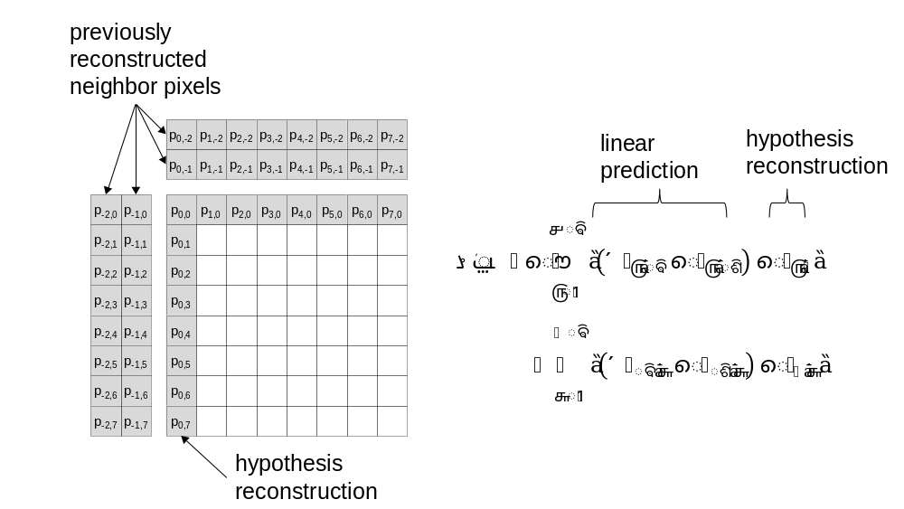
Figure 1: Calculation of the cost of a hypothesis reconstructed border when both left and top reconstructed neighbor pixels are available.

Computation reduction of sign prediction
In ECM-1.0, the computation of the cost function of sign prediction depends on the width and height of the TU. To reduce the computation of sign prediction, this contribution proposes to use only 4 samples from the top border and 4 samples from the left border in the cost function as shown in Figure 2.
For a TU with width$w$ and height $h,$the 4 top border samples are located at the following horizontal locations as shown by the lighter grey pixels in Figure 2:
$$x_{1}=w/8 \\ x_{2}=x_{1}+w/4 \\ x_{3}=x_{2}+w/4 \\ x_{4}=x_{3}+w/4$$
where $/$ represents integer division as in C. The 4 left border samples are located at the following vertical locations as shown by the darker grey pixels in Figure 2:
$$y_{1}=h-1-h/8 \\ y_{2}=y_{1}-h/4 \\ y_{3}=y_{2}-h/4 \\ y_{4}=y_{3}-h/4$$

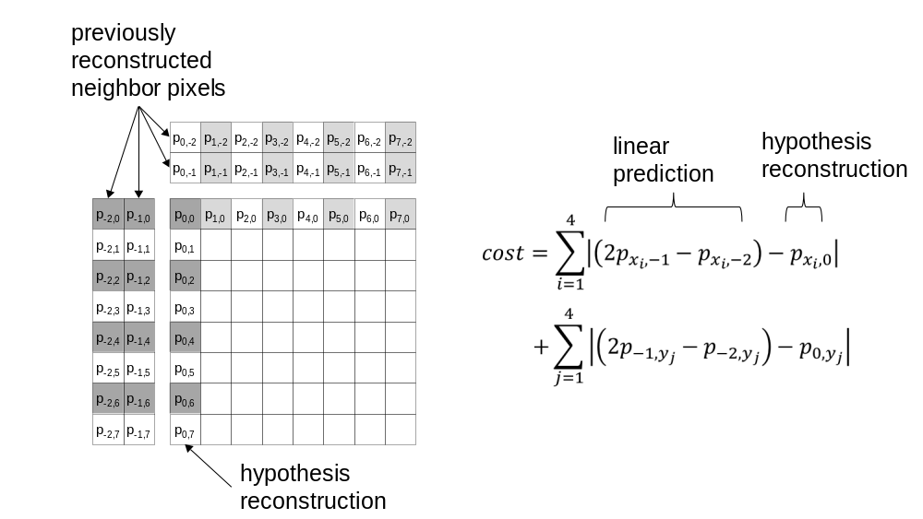
Figure 2: Proposed calculation of the cost of a hypothesis reconstructed border, when both left and top reconstructed neighbor pixels are available, using only 8 samples of linear predictions as indicated by the grey pixel locations.

Results
Using ECM-1.0 as reference and the common test conditions in JVET-V2017 [3], the BDR of the proposed method for AI/RA is x.xx%/y.yy% The encoder time for AI/RA is x.xx%/y.yy%,. The decoder time for AI/RA is x.xx%/y.yy%. Results for LB shall be added to Table 1when available.

Table 1: AI and RA test results using CTC in JVET-V2017.
 | All Intra Main10
 | Over ECM-1.0
 | Y | U | V | EncT | DecT
Class A1 | 0.04% | 0.04% | 0.07% | 99% | 98%
Class A2 | 0.05% | 0.02% | -0.03% | 98% | 97%
Class B | #VALUE! | #VALUE! | #VALUE! | #NUM! | #NUM!
Class C | 0.05% | 0.11% | 0.00% | 98% | 101%
Class E | 0.04% | -0.07% | 0.14% | 99% | 100%
Overall | #VALUE! | #VALUE! | #VALUE! | #NUM! | #NUM!
Class D | 0.02% | 0.02% | 0.11% | 98% | 97%
Class F | 0.07% | 0.20% | 0.05% | 99% | 99%
Class TGM | #VALUE! | #VALUE! | #VALUE! | #DIV/0! | #DIV/0!
 | Random Access Main 10
 | Over ECM-1.0
 | Y | U | V | EncT | DecT
Class A1 | #VALUE! | #VALUE! | #VALUE! | #NUM! | #NUM!
Class A2 | #VALUE! | #VALUE! | #VALUE! | #NUM! | #NUM!
Class B | 0.07% | -0.01% | 0.19% | 98% | 98%
Class C | 0.08% | 0.17% | 0.02% | 99% | 98%
Class E
Overall | #VALUE! | #VALUE! | #VALUE! | #NUM! | #NUM!
Class D | 0.02% | 0.17% | -0.21% | 99% | 99%
Class F | 0.11% | -0.21% | 0.04% | 99% | 99%
Class TGM | #VALUE! | #VALUE! | #VALUE! | #DIV/0! | #DIV/0!
 | Low delay B Main10
 | Over ECM-1.0
 | Y | U | V | EncT | DecT
Class A1
Class A2
Class B | #VALUE! | #VALUE! | #VALUE! | #NUM! | #NUM!
Class C | 0.05% | 0.10% | -0.03% | 98% | 97%
Class E | -0.05% | -0.57% | -1.61% | 98% | 96%
Overall | #VALUE! | #VALUE! | #VALUE! | #NUM! | #NUM!
Class D | 0.08% | 0.18% | -0.07% | 99% | 99%
Class F | #VALUE! | #VALUE! | #VALUE! | #NUM! | #NUM!
Class TGM | #VALUE! | #VALUE! | #VALUE! | #DIV/0! | #DIV/0!

References
- Vadim Seregin, Jie Chen, Semih Esenlik, Fabrice Le Leannec, Ling Li, Jacob Strom, Martin Winken, Xiaoyu Xiu, Kai Zhang, “Exploration Experiment on Enhanced Compression beyond VVC capability (EE2),” JVET-V2024-v3, 22nd Meeting, by teleconference, 20–28 Apr. 2021.
- Felix Henry and Gordon Clare, ”Residual Coefficient Sign Prediction,” JVET-D0031, 4th Meeting: Chengdu, CN, 15–21 October 2016.
- Marta Karczewicz and YanYe, “Common test conditions and evaluation procedures for enhanced compression tool testing,” JVET-V2017-v1, 22nd Meeting, by teleconference, 20–28 Apr. 2021.

Patent rights declaration(s)
Tencent may have current or pending patent rights relating to the technology described in this contribution and, conditioned on reciprocity, is prepared to grant licenses under reasonable and non-discriminatory terms as necessary for implementation of the resulting ITU-T Recommendation | ISO/IEC International Standard (per box 2 of the ITU-T/ITU-R/ISO/IEC patent statement and licensing declaration form).

