    Joint Video Experts Team (JVET)  of ITU-T SG 16 WP 3 and ISO/IEC JTC 1/SC 29  23rd Meeting, by teleconference, 7–16 July 2021 | Document: JVET-W0078

Title: | AHG9: Multiview view position SEI message
Status: | Input document to JVET
Purpose: | Proposal
Author(s) or  Contact(s): | Byeongdoo Choi  Stephan Wenger  Shan Liu | Email: | bdchoi@tencent.com
Source: | Tencent
_____________________________

Abstract
Multiview View Position (MVP) SEI message is proposed for VSEI. The MVP SEI message is useful for indicating the relative view position along a horizontal axis of 3D rendering view, especially for glassless 3D display as well as multiview-based 3D rendering. The MVP SEI message was adopted into HEVC. To adopt the same SEI message into VSEI, minor semantics changes are also proposed.

Introduction
It is proposed to inherit the Multiview View Position (MVP) SEI message from HEVC/H.265 to VSEI. The MVP SEI message is useful for indicating the relative view position along a horizontal axis of 3D rendering view, especially for glassless 3D display as well as multiview-based 3D rendering.
Figure 1 illustrates an example of reordering pictures according to multiview view position. When multiviews are presented, an information that indicates the display order from left to right needs to be signaled for providing the intended user experience.
In addition, some minor modifications of semantics in MVP SEI message are proposed, because VSEI has somewhat different shapes than HEVC. First, an SDI SEI message shall coexist with an MVP SEI message in a CVS, because multiview information is contained in the SDI SEI message in VSEI, while the multiview information can be gathered from VPS in HEVC. Second, num_views_minus1 shall be equal to NumViews. derived from the SDI SEI message instead of VPS. Third, the syntax element view_position[ i ] in MVP SEI message indicates the order of the view with ViewId instead of ViewOrderidx, because the variable ViewOrderidx is not defined in VSEI. We expect that the variable ViewId will be defined by the proposal JVET-W0077.

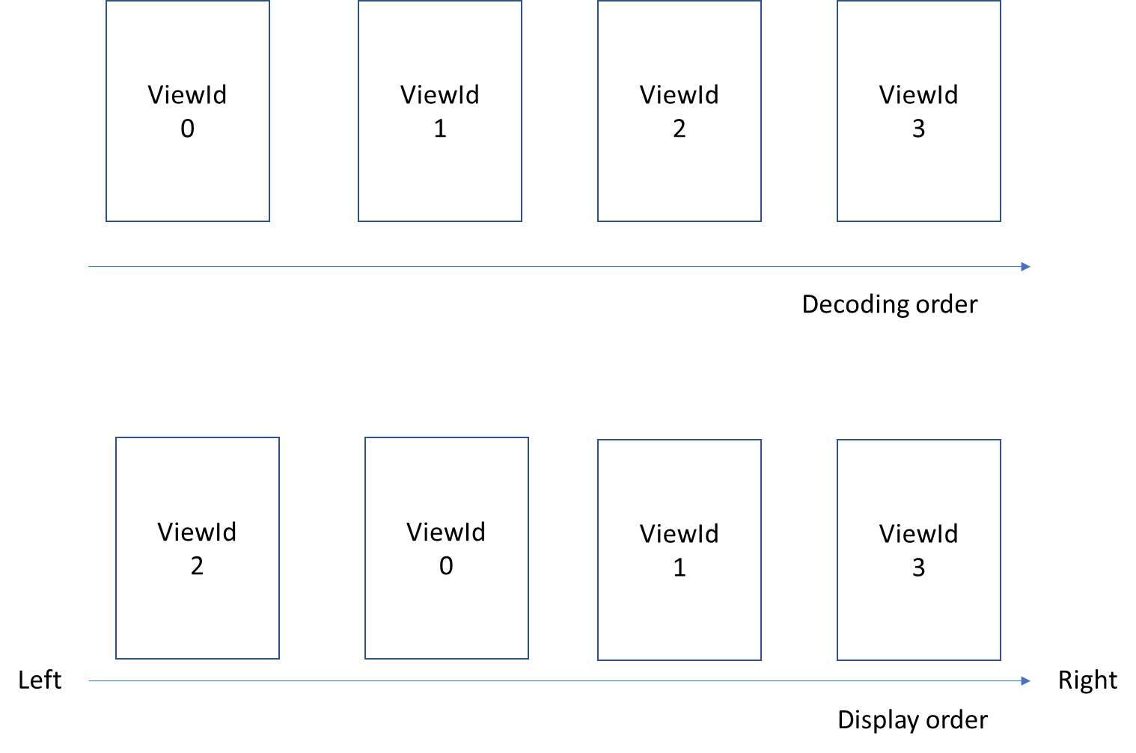
Figure 1. Example of reordering pictures according to multiview view position.

Proposes specification text
sdi_view_id_val[ i ] specifies the view identifier value of the variable ViewId of the i-th layer in the current CVS. The length of the sdi_view_id_val[ i ] syntax element is sdi_view_id_len_minus1 + 1 bits.

Multiview view position SEI message syntax

multiview_view_position( payloadSize ) { | Descriptor
num_views_minus1 | ue(v)
for( i = 0; i <= num_views_minus1; i++ )
view_position[ i ] | ue(v)
}

Multiview view position SEI message semantics
The multiview view position (MVP) SEI message specifies the relative view position along a single horizontal axis of views within a CVS. When present, the multiview view position SEI message shall be associated with an IRAP access unit. The information signalled in this SEI message applies to the entire CVS.
When a CVS does not contain an SDI SEI message, the CVS shall not contain an MVP SEI message.
num_views_minus1 plus 1 shall be equal to NumViews derived from the active VPS for the CVS. The value of num_views_minus1 shall be in the range of 0 to 62, inclusive. derived from the SDI SEI message for the CVS.
view_position[ i ] indicates the order of the view with ViewOrderIdx equal to I ViewId equal to sdi_view_id_val[ i ] among all the views from left to right for the purpose of display, with the order for the left-most view being equal to 0 and the value of the order increasing by 1 for next view from left to right. The value of view_position[ i ] shall be in the range of 0 to 62, inclusive.

Patent rights declaration(s)
Tencent may have current or pending patent rights relating to the technology described in this contribution and, conditioned on reciprocity, is prepared to grant licenses under reasonable and non-discriminatory terms as necessary for implementation of the resulting ITU-T Recommendation | ISO/IEC International Standard (per box 2 of the ITU-T/ITU-R/ISO/IEC patent statement and licensing declaration form).

