    Joint Video Experts Team (JVET)  of ITU-T SG 16 WP 3 and ISO/IEC JTC 1/SC 29  23rd Meeting, by teleconference, 7–16 July 2021 | Document: JVET-W0050

Title: | [CE2.1][CE2.2] Content Adaptive Transform Precision
Status: | Input document to JVET
Purpose: | Proposal
Author(s) or  Contact(s): | Karam Naser  Franck Galpin  Tangi Poirier  Fabrice Le Leannec | Tel:  Email: | karam.naser@InterDigital.com
Source: | InterDigital

Abstract
This contribution reports the results of the core experiment tests (CE2.1 and CE2.2) on high bit-depth and high bitrate extension. Specifically, the two tests proposes to adaptively assign the downshifts in the scaling process for transform coefficients (clause 8.7.3 of VVC) and in the transformation process for scaled transform coefficients (clause 8.7.4 of VVC) by examining the coefficients values upon dequantization and inverse transform.

For CE2.1, the following results were obtained for low QP configuration compared to VTM13.0:
- PQ AI: -0.01% -0.01% -0.01%, LDB: -0.01% 0.00% 0.02%, RA: -0.01% 0.00% 0.00%
- HLG AI: 0.00% -0.01% -0.01%, LDB: 0.01% 0.00% 0.00%, RA: 0.00% 0.00% 0.00%
- SVT AI: 0.00% -0.01% -0.01%, LDB: -0.01% -0.02% -0.02%, RA: 0.00% -0.01% -0.01%
For CE2.2, the following results where obtained:
- PQ AI: -0.01% -0.02% -0.02%, LDB: -0.01% -0.01% 0.01% RA: -0.01% -0.01 0.00%
- HLG AI: -0.01% -0.01% -0.01%, LDB: 0.00% -0.02% -0.01% RA: 0.00% -0.02% 0.01%
- SVT AI: -0.01% -0.01% -0.01%, LDB: -0.01% -0.02% -0.02% RA: -0.01% -0.02% -0.02%
Additional results are provided where the extended precision is disabled for 12 bits data and Log2TransformRange is set to 16 for 16 bits data. This is true for both test and also for VTM anchor, the following results are obtained:

For CE2.1:
- PQ AI: -0.28% -0.47% -0.48%, LDB: -0.21% -0.18% -0.20% RA: -0.21% -0.26% -0.28%
- HLG AI: -0.11% -0.22% -0.22%, LDB: -0.19% -0.24% -0.27% RA: -0.14% -0.21% -0.23%
- SVT: AI: -0.12% -0.19% -0.19%, LDB: -0.12% -0.33% -0.33% RA: XX% XX% XX %

For CE2.2:
- PQ: AI: -0.49% -0.76% -0.82%, LDB: -0.38% -0.35% -0.38% RA: -0.39% -0.48% -0.51%
- HLG AI: -0.18% -0.36% -0.38%, LDB: -0.29% -0.38% -0.42% RA: -0.23% -0.35% -0.38%
- SVT AI: -0.37% -0.43% -0.43%, LDB: -0.32% -0.50% -0.51% RA: XX% XX% XX %

Introduction

Content Adaptive Transform Precision (CATP) was proposed in the last JVET meeting (JVET-V0133), where it is currently tested under core experiment on high bit-depth and high bitrate extension of VVC. Its main idea is to dynamically assign the downshift upon dequantization and inverse transform in contrast to VTM’s fix precomputed downshifts. It is argued that these fix downshifts are too conservative and only required to avoid exceeding the intermediate buffer limit, whereas in reality smaller downshifts are required since quantized residuals have usually low magnitude due to the powerful prediction and transform mechanism in VVC. CATP is thus proposed to reduce the distortion caused by the unnecessary excessive down shifts and therefore to improve the rate-distortion performance without increasing the intermediate buffer limit.

Technical Description

In VVC decoding process, three down shifts are performed as described in Figure 1. They are performed after dequantization, after horizontal inverse transform and after vertical inverse transform. The shifts are defined as follows:

Shift1 (clause 8.7.3 of VVC):
bdShift = BitDepth + rectNonTsFlag + (1133)
( ( Log2( nTbW ) + Log2( nTbH ) ) / 2 ) − 5 + sh_dep_quant_used_flag
Shift2 is fixed to 7 (clause 8.7.4 of VVC):
g[ x ][ y ] = Clip3( CoeffMin, CoeffMax, ( e[ x ][ y ] + 64 ) >> 7 ) (1163)
And Shift 3 is (clause 8.7.4 of VVC) :
bdShift = ( nTbH > 1 && nTbW > 1 ) ? ( 20 − BitDepth ) : ( 21 − BitDepth ) (1164)

It is proposed to adaptively assign the downshift by examining the coefficients values upon dequantization. This is illustrated in the dashed part of Figure 1. That is, coefficients values are examined to determine the downshift before dequantization and inverse transform.

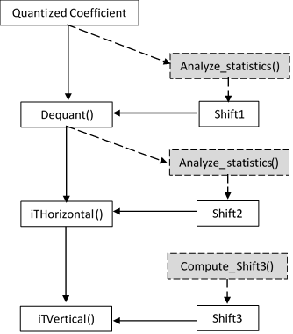

Figure 1 Down-shift in VVC. Dashed parts correspond to CATP

The relation between the new downshifts and the VTM shifts is kept unchanged.

$${Shift}_{1}+{Shift}_{2}+{Shift}_{3}={Shift}_{1_vtm}+{Shift}_{2_vtm}+{Shift}_{3_vtm}$$

Two versions of CATP are tested.

CATP0
In this method, the adaptive downshift is limited to the dequantization process only. Let M be the maximum absolute dequantized coefficient (before down shift), the first shift is computed as:

$${Shift}_{1}=ceil\left(\log_{2}\left(M\right)\right)-1-TrDynamicRange$$

The second shift is modified according to the first shift as:
$${Shift}_{2}={Shift}_{2_vtm}+\left({Shift}_{1_vtm}-{Shift}_{1}\right)$$
And the last shift is computed as:
$${Shift}_{3}={(Shift}_{1_vtm}-{Shift}_{1})+{(Shift}_{2_{vtm}}-{Shift}_{2})+{Shift}_{3_vtm}$$

CATP1

The principle of adaptive shift is further extended to mid transform shift. That is, after computed the first shift as in CATP0:

$${Shift}_{1}=ceil\left(\log_{2}\left(M\right)\right)-1-TrDynamicRange$$

The maximum coefficient after first inverse transform (before the downshift) is computed in the following way:
Let $d_{i,j}$ represent the dequantized coefficient, the inverse transform coefficient $c_{i,j}$ is computed as follows:
$$c_{i,j}=\sum_{j=0}^{N-1}{T_{k,i}}× q_{i,j}$$
Since the $M$ represents the maximum value of the dequantized coefficients, the following holds

$$\sum_{j=0}^{N-1}{T_{k,i}}× q_{i,j} ≤\sum_{j=0}^{N-1}{abs\left(T_{k,i}\right)}× abs\left(M\right)=B$$

Therefore, the value $B$ corresponds to the maximum limit of the transform coefficient, that can be pre-computed after dequantization. The second shift is computed as:

$${Shift}_{2}=ceil\left(\log_{2}\left(B\right)-TrDynamicRange\right)+{Shift}_{2_vtm}$$

And the last shift remains the same:

$${Shift}_{3}={(Shift}_{1_vtm}-{Shift}_{1})+{(Shift}_{2_{vtm}}-{Shift}_{2})+{Shift}_{3_vtm}$$

Experimental Results

Both CATP1 and CATP2 are implemented on top of VTM-13.0 and evaluation under the low QP common testing conditions for high bit-depth and high bit-rate video coding as described in CE document JVET-W0022.

The following results where obtained:

CE2.1

HDR PQ

HDR PQ |  |  | AI
 |  |  | Over VTM-13.0
 | wPsnrY | wPsnrU | wPsnrV | psnrY | psnrU | psnrV | EncT | DecT
PQ444 | -0.01% | -0.01% | -0.01% | -0.01% | 0.00% | -0.01% | 109% | 113%
PQ422 | 0.00% | -0.01% | -0.02% | 0.00% | -0.01% | -0.02% | 110% | 112%
Overall | -0.01% | -0.01% | -0.01% | -0.01% | -0.01% | -0.01% | 109% | 112%
 |  |  | LDB
 |  |  | Over VTM-13.0
 | wPsnrY | wPsnrU | wPsnrV | psnrY | psnrU | psnrV | EncT | DecT
PQ444 | -0.02% | 0.00% | 0.01% | -0.02% | -0.01% | 0.01% | 108% | 113%
PQ422 | -0.01% | 0.00% | 0.03% | -0.01% | 0.00% | 0.02% | 105% | 104%
Overall | -0.01% | 0.00% | 0.02% | -0.01% | 0.00% | 0.02% | 106% | 109%
 |  |  | RA
 |  |  | Over VTM-13.0
 | wPsnrY | wPsnrU | wPsnrV | psnrY | psnrU | psnrV | EncT | DecT
PQ444 | 0.00% | 0.00% | 0.00% | 0.00% | 0.00% | 0.00% | 104% | 104%
PQ422 | -0.01% | 0.00% | 0.00% | 0.00% | 0.00% | 0.01% | 103% | 108%
Overall | 0.00% | 0.00% | 0.00% | 0.00% | 0.00% | 0.00% | 103% | 106%
Overall PQ | -0.01% | 0.00% | 0.00% | -0.01% | 0.00% | 0.00% | 106% | 109%

HDR HLG

HDR HLG |  |  | AI
 |  |  | Over VTM-13.0
 | psnrY | psnrU | psnrV | EncT | DecT
HLG444 | 0.00% | -0.01% | -0.01% | 107% | 116%
HLG422 | -0.01% | -0.01% | -0.01% | 109% | 114%
Overall | 0.00% | -0.01% | -0.01% | 108% | 115%
 |  |  | LDB
 |  |  | Over VTM-13.0
 | psnrY | psnrU | psnrV | EncT | DecT
HLG444 | 0.01% | 0.00% | 0.00% | 97% | 95%
HLG422 | 0.01% | -0.01% | -0.01% | 103% | 107%
Overall | 0.01% | 0.00% | 0.00% | 100% | 101%
 |  |  | RA
 |  |  | Over VTM-13.0
 | psnrY | psnrU | psnrV | EncT | DecT
HLG444 | -0.01% | -0.01% | 0.01% | 104% | 106%
HLG422 | 0.00% | 0.00% | 0.02% | 105% | 111%
Overall | 0.00% | -0.01% | 0.01% | 104% | 109%
Overall HLG | 0.00% | 0.00% | 0.00% | 104% | 108%

SVT RGB

SVT RGB |  |  | AI
 |  |  | Over VTM-13.0
 | psnrG | psnrB | psnrR | EncT | DecT
SVT16 | -0.01% | -0.01% | -0.01% | 109% | 116%
SVT12 | 0.00% | -0.01% | 0.00% | 111% | 122%
Overall | 0.00% | -0.01% | -0.01% | 110% | 119%
 |  |  | LDB
 |  |  | Over VTM-13.0
 | psnrG | psnrB | psnrR | EncT | DecT
SVT16 | 0.00% | -0.03% | -0.03% | 101% | 104%
SVT12 | -0.01% | 0.00% | 0.00% | 105% | 107%
Overall | -0.01% | -0.02% | -0.02% | 103% | 105%
 |  |  | RA
 |  |  | Over VTM-13.0
 | psnrG | psnrB | psnrR | EncT | DecT
SVT16 | 0.00% | -0.02% | -0.02% | 104% | 111%
SVT12 | -0.01% | 0.00% | 0.00% | 104% | 114%
Overall | 0.00% | -0.01% | -0.01% | 104% | 112%
Overall RGB | 0.00% | -0.01% | -0.01% | 106% | 112%

CE2.2

HDR PQ

HDR PQ |  |  | AI
 |  |  | Over VTM-13.0
 | wPsnrY | wPsnrU | wPsnrV | psnrY | psnrU | psnrV | EncT | DecT
PQ444 | -0.02% | -0.02% | -0.02% | -0.02% | -0.01% | -0.02% | 109% | 114%
PQ422 | -0.01% | -0.03% | -0.03% | -0.01% | -0.02% | -0.03% | 110% | 113%
Overall | -0.01% | -0.02% | -0.02% | -0.01% | -0.02% | -0.03% | 110% | 114%
 |  |  | LDB
 |  |  | Over VTM-13.0
 | wPsnrY | wPsnrU | wPsnrV | psnrY | psnrU | psnrV | EncT | DecT
PQ444 | -0.01% | 0.00% | 0.01% | -0.01% | -0.01% | 0.01% | 108% | 113%
PQ422 | -0.01% | -0.02% | 0.02% | -0.01% | -0.01% | 0.01% | 106% | 107%
Overall | -0.01% | -0.01% | 0.01% | -0.01% | -0.01% | 0.01% | 107% | 110%
 |  |  | RA
 |  |  | Over VTM-13.0
 | wPsnrY | wPsnrU | wPsnrV | psnrY | psnrU | psnrV | EncT | DecT
PQ444 | 0.00% | 0.00% | -0.01% | 0.00% | 0.00% | -0.01% | 105% | 106%
PQ422 | -0.01% | 0.01% | 0.01% | 0.00% | 0.00% | 0.01% | 104% | 104%
Overall | -0.01% | 0.00% | 0.00% | 0.00% | 0.00% | 0.00% | 104% | 105%
Overall PQ | -0.01% | -0.01% | 0.00% | -0.01% | -0.01% | -0.01% | 107% | 110%

HDR HLG

HDR HLG |  |  | AI
 |  |  | Over VTM-13.0
 | psnrY | psnrU | psnrV | EncT | DecT
HLG444 | 0.00% | -0.01% | -0.01% | 108% | 117%
HLG422 | -0.01% | -0.01% | -0.02% | 109% | 117%
Overall | -0.01% | -0.01% | -0.01% | 109% | 117%
 |  |  | LDB
 |  |  | Over VTM-13.0
 | psnrY | psnrU | psnrV | EncT | DecT
HLG444 | 0.00% | -0.02% | 0.00% | 100% | 101%
HLG422 | 0.00% | -0.02% | -0.03% | 107% | 115%
Overall | 0.00% | -0.02% | -0.01% | 103% | 108%
 |  |  | RA
 |  |  | Over VTM-13.0
 | psnrY | psnrU | psnrV | EncT | DecT
HLG444 | -0.01% | -0.02% | -0.01% | 104% | 103%
HLG422 | -0.01% | -0.01% | -0.01% | 106% | 111%
Overall | -0.01% | -0.01% | -0.01% | 105% | 107%
Overall HLG | 0.00% | -0.02% | -0.01% | 106% | 111%

SVT RGB

SVT RGB |  |  | AI
 |  |  | Over VTM-13.0
 | psnrG | psnrB | psnrR | EncT | DecT
SVT16 | -0.01% | -0.02% | -0.02% | 108% | 118%
SVT12 | 0.00% | -0.01% | -0.01% | 111% | 123%
Overall | -0.01% | -0.01% | -0.01% | 109% | 121%
 |  |  | LDB
 |  |  | Over VTM-13.0
 | psnrG | psnrB | psnrR | EncT | DecT
SVT16 | -0.01% | -0.04% | -0.04% | 102% | 107%
SVT12 | -0.01% | 0.00% | 0.00% | 102% | 106%
Overall | -0.01% | -0.02% | -0.02% | 102% | 107%
 |  |  | RA
 |  |  | Over VTM-13.0
 | psnrG | psnrB | psnrR | EncT | DecT
SVT16 | -0.01% | -0.03% | -0.03% | 104% | 110%
SVT12 | -0.01% | 0.00% | 0.00% | 104% | 113%
Overall | -0.01% | -0.02% | -0.02% | 104% | 112%
Overall RGB | -0.01% | -0.02% | -0.02% | 105% | 113%

Additional Results described in the core experiment

The effectiveness of CATP can be assessed with reduced transform dynamic range. This is done by deactivating the Extended Precision Flag in VTM, which sets Log2TrDynamicRange to 15. For 16 bits data, Log2TrDynamicRange is set to 16 instead of 15. The reason is that for 16 bits data, some sequence exhibits a non-monotonic behaviour (Figure 2) in their rate-psnr curves, and thus leads to misleading BD-rate results.

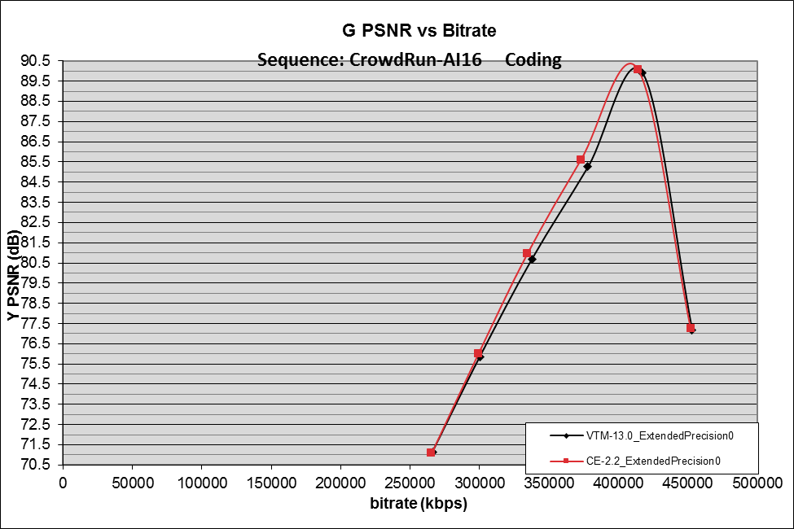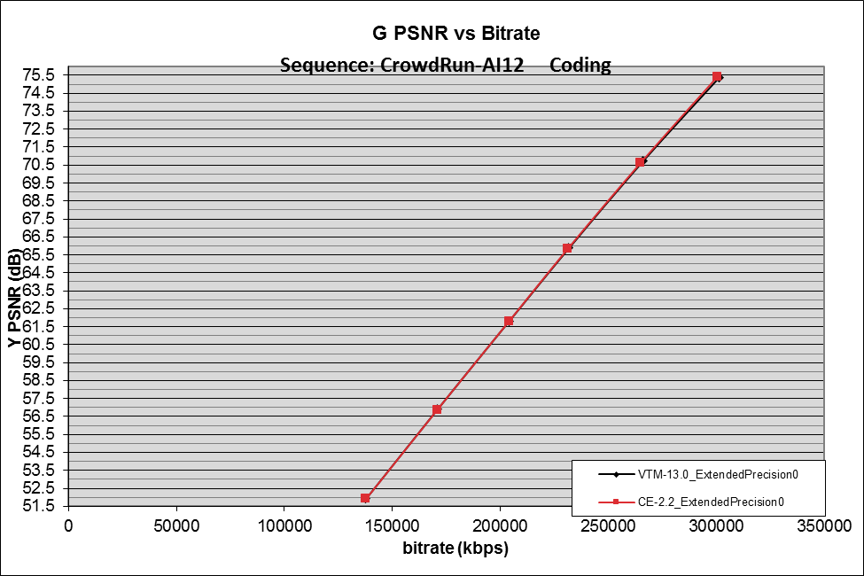

Figure 2: Rate-PSNR plot of CrowdRun sequence coded with extended precision deactivated. Left: 16 bits data, right, 12 bits data.
For both anchor and tests:
- PQ, HLG and SVT12: Log2TrDynamicRange is 15
- SVT16: Log2TrDynamicRange is 16

The following results are obtained:

CE2.1

HDR PQ

HDR PQ |  |  | AI
 |  |  | Over VTM-13.0_ExtendedPrecision0
 | wPsnrY | wPsnrU | wPsnrV | psnrY | psnrU | psnrV | EncT | DecT
PQ444 | -0.28% | -0.54% | -0.54% | -0.27% | -0.55% | -0.56% | 107% | 110%
PQ422 | -0.28% | -0.39% | -0.42% | -0.27% | -0.39% | -0.42% | 108% | 111%
Overall | -0.28% | -0.47% | -0.48% | -0.27% | -0.47% | -0.49% | 107% | 110%
 |  |  | LDB
 |  |  | Over VTM-13.0_ExtendedPrecision0
 | wPsnrY | wPsnrU | wPsnrV | psnrY | psnrU | psnrV | EncT | DecT
PQ444 | -0.23% | -0.23% | -0.27% | -0.23% | -0.23% | -0.26% | 99% | 102%
PQ422 | -0.20% | -0.14% | -0.14% | -0.20% | -0.14% | -0.14% | 103% | 106%
Overall | -0.21% | -0.18% | -0.20% | -0.21% | -0.19% | -0.20% | 101% | 104%
 |  |  | RA
 |  |  | Over VTM-13.0_ExtendedPrecision0
 | wPsnrY | wPsnrU | wPsnrV | psnrY | psnrU | psnrV | EncT | DecT
PQ444 | -0.08% | -0.10% | -0.13% | -0.08% | -0.10% | -0.12% | 105% | 109%
PQ422 | -0.17% | -0.16% | -0.15% | -0.17% | -0.15% | -0.15% | 111% | 116%
Overall | -0.12% | -0.13% | -0.14% | -0.12% | -0.12% | -0.14% | 108% | 112%
Overall PQ | -0.21% | -0.26% | -0.28% | -0.20% | -0.26% | -0.28% | 105% | 109%

HDR HLG
HDR HLG |  |  | AI
 |  |  | Over VTM-13.0_ExtendedPrecision0
 | psnrY | psnrU | psnrV | EncT | DecT
HLG444 | -0.11% | -0.23% | -0.23% | 108% | 113%
HLG422 | -0.11% | -0.20% | -0.21% | 108% | 112%
Overall | -0.11% | -0.22% | -0.22% | 108% | 113%
 |  |  | LDB
 |  |  | Over VTM-13.0_ExtendedPrecision0
 | psnrY | psnrU | psnrV | EncT | DecT
HLG444 | -0.21% | -0.29% | -0.33% | 105% | 110%
HLG422 | -0.18% | -0.20% | -0.21% | 97% | 111%
Overall | -0.19% | -0.24% | -0.27% | 101% | 110%
 |  |  | RA
 |  |  | Over VTM-13.0_ExtendedPrecision0
 | psnrY | psnrU | psnrV | EncT | DecT
HLG444 | -0.11% | -0.21% | -0.21% | 106% | 111%
HLG422 | -0.13% | -0.15% | -0.15% | 107% | 111%
Overall | -0.12% | -0.18% | -0.18% | 106% | 111%
Overall HLG | -0.14% | -0.21% | -0.23% | 105% | 111%

SVT RGB
SVT RGB |  |  | AI
 |  |  | Over VTM-13.0_ExtendedPrecision0
 | psnrG | psnrB | psnrR | EncT | DecT
SVT16 | -0.19% | -0.23% | -0.23% | 108% | 110%
SVT12 | -0.05% | -0.15% | -0.15% | 107% | 111%
Overall | -0.12% | -0.19% | -0.19% | 107% | 110%
 |  |  | LDB
 |  |  | Over VTM-13.0_ExtendedPrecision0
 | psnrG | psnrB | psnrR | EncT | DecT
SVT16 | -0.15% | -0.48% | -0.49% | 108% | 111%
SVT12 | -0.10% | -0.17% | -0.17% | 105% | 108%
Overall | -0.12% | -0.33% | -0.33% | 107% | 109%
 |  |  | RA
 |  |  | Over VTM-13.0_ExtendedPrecision0
 | psnrG | psnrB | psnrR | EncT | DecT
SVT16 | #VALUE! | #VALUE! | #VALUE! | #NUM! | #NUM!
SVT12 | -0.05% | -0.18% | -0.18% | 107% | 106%
Overall | #VALUE! | #VALUE! | #VALUE! | #NUM! | #NUM!
Overall RGB | #VALUE! | #VALUE! | #VALUE! | #NUM! | #NUM!

CE2.2

HDR PQ

HDR PQ |  |  | AI
 |  |  | Over VTM-13.0_ExtendedPrecision0
 | wPsnrY | wPsnrU | wPsnrV | psnrY | psnrU | psnrV | EncT | DecT
PQ444 | -0.50% | -0.88% | -0.94% | -0.49% | -0.90% | -0.95% | 107% | 109%
PQ422 | -0.48% | -0.65% | -0.70% | -0.47% | -0.64% | -0.70% | 108% | 111%
Overall | -0.49% | -0.76% | -0.82% | -0.48% | -0.77% | -0.82% | 107% | 110%
 |  |  | LDB
 |  |  | Over VTM-13.0_ExtendedPrecision0
 | wPsnrY | wPsnrU | wPsnrV | psnrY | psnrU | psnrV | EncT | DecT
PQ444 | -0.39% | -0.41% | -0.46% | -0.39% | -0.41% | -0.45% | 99% | 109%
PQ422 | -0.36% | -0.28% | -0.30% | -0.36% | -0.29% | -0.31% | 105% | 110%
Overall | -0.38% | -0.35% | -0.38% | -0.37% | -0.35% | -0.38% | 102% | 109%
 |  |  | RA
 |  |  | Over VTM-13.0_ExtendedPrecision0
 | wPsnrY | wPsnrU | wPsnrV | psnrY | psnrU | psnrV | EncT | DecT
PQ444 | -0.31% | -0.38% | -0.41% | -0.30% | -0.37% | -0.41% | 110% | 115%
PQ422 | -0.30% | -0.29% | -0.27% | -0.30% | -0.28% | -0.28% | 107% | 110%
Overall | -0.31% | -0.33% | -0.34% | -0.30% | -0.33% | -0.35% | 108% | 113%
Overall PQ | -0.39% | -0.48% | -0.51% | -0.38% | -0.48% | -0.52% | 106% | 111%

HDR HLG
HDR HLG |  |  | AI
 |  |  | Over VTM-13.0_ExtendedPrecision0
 | psnrY | psnrU | psnrV | EncT | DecT
HLG444 | -0.19% | -0.39% | -0.41% | 110% | 113%
HLG422 | -0.18% | -0.33% | -0.35% | 109% | 114%
Overall | -0.18% | -0.36% | -0.38% | 110% | 113%
 |  |  | LDB
 |  |  | Over VTM-13.0_ExtendedPrecision0
 | psnrY | psnrU | psnrV | EncT | DecT
HLG444 | -0.30% | -0.44% | -0.49% | 107% | 111%
HLG422 | -0.29% | -0.32% | -0.35% | 98% | 103%
Overall | -0.29% | -0.38% | -0.42% | 102% | 107%
 |  |  | RA
 |  |  | Over VTM-13.0_ExtendedPrecision0
 | psnrY | psnrU | psnrV | EncT | DecT
HLG444 | -0.20% | -0.35% | -0.39% | 106% | 111%
HLG422 | -0.21% | -0.27% | -0.28% | 106% | 107%
Overall | -0.20% | -0.31% | -0.33% | 106% | 109%
Overall HLG | -0.23% | -0.35% | -0.38% | 106% | 110%

SVT RGB

SVT RGB |  |  | AI
 |  |  | Over VTM-13.0_ExtendedPrecision0
 | psnrG | psnrB | psnrR | EncT | DecT
SVT16 | -0.63% | -0.61% | -0.62% | 107% | 112%
SVT12 | -0.11% | -0.24% | -0.24% | 107% | 113%
Overall | -0.37% | -0.43% | -0.43% | 107% | 112%
 |  |  | LDB
 |  |  | Over VTM-13.0_ExtendedPrecision0
 | psnrG | psnrB | psnrR | EncT | DecT
SVT16 | -0.46% | -0.78% | -0.79% | 107% | 108%
SVT12 | -0.17% | -0.23% | -0.23% | 107% | 110%
Overall | -0.32% | -0.50% | -0.51% | 107% | 109%
 |  |  | RA
 |  |  | Over VTM-13.0_ExtendedPrecision0
 | psnrG | psnrB | psnrR | EncT | DecT
SVT16 | #VALUE! | #VALUE! | #VALUE! | #NUM! | #NUM!
SVT12 | -0.11% | -0.23% | -0.24% | 107% | 106%
Overall | #VALUE! | #VALUE! | #VALUE! | #NUM! | #NUM!
Overall RGB | #VALUE! | #VALUE! | #VALUE! | #NUM! | #NUM!

Further results

This section provides the results with the same modification as in Section 8 for test only, whereas the anchor is VTM-13.0. This is to evaluate the BD rate change with respect to the current VTM performance.

For CE2.1

HDR PQ

HDR PQ |  |  | AI
 |  |  | Over VTM-13.0_ExtendedPrecision0
 | wPsnrY | wPsnrU | wPsnrV | psnrY | psnrU | psnrV | EncT | DecT
PQ444 | 1.04% | 1.42% | 1.56% | 1.04% | 1.44% | 1.57% | 108% | 121%
PQ422 | 0.82% | 1.02% | 1.10% | 0.82% | 1.03% | 1.10% | 109% | 119%
Overall | 0.93% | 1.22% | 1.33% | 0.93% | 1.23% | 1.34% | 109% | 120%
 |  |  | LDB
 |  |  | Over VTM-13.0_ExtendedPrecision0
 | wPsnrY | wPsnrU | wPsnrV | psnrY | psnrU | psnrV | EncT | DecT
PQ444 | 0.48% | 0.52% | 0.55% | 0.49% | 0.52% | 0.55% | 107% | 113%
PQ422 | 0.45% | 0.38% | 0.46% | 0.45% | 0.38% | 0.46% | 105% | 106%
Overall | 0.46% | 0.45% | 0.50% | 0.47% | 0.45% | 0.50% | 106% | 109%
 |  |  | RA
 |  |  | Over VTM-13.0_ExtendedPrecision0
 | wPsnrY | wPsnrU | wPsnrV | psnrY | psnrU | psnrV | EncT | DecT
PQ444 | 0.47% | 0.50% | 0.55% | 0.47% | 0.50% | 0.55% | 102% | 105%
PQ422 | 0.42% | 0.39% | 0.46% | 0.42% | 0.39% | 0.45% | 106% | 113%
Overall | 0.44% | 0.44% | 0.50% | 0.44% | 0.44% | 0.50% | 104% | 109%
Overall PQ | 0.61% | 0.71% | 0.78% | 0.62% | 0.71% | 0.78% | 106% | 113%

HDR HLG

HDR HLG |  |  | AI
 |  |  | Over VTM-13.0_ExtendedPrecision0
 | psnrY | psnrU | psnrV | EncT | DecT
HLG444 | 0.38% | 0.60% | 0.61% | 100% | 124%
HLG422 | 0.31% | 0.51% | 0.52% | 106% | 122%
Overall | 0.35% | 0.55% | 0.57% | 103% | 123%
 |  |  | LDB
 |  |  | Over VTM-13.0_ExtendedPrecision0
 | psnrY | psnrU | psnrV | EncT | DecT
HLG444 | 0.47% | 0.65% | 0.67% | 98% | 108%
HLG422 | 0.39% | 0.47% | 0.50% | 106% | 127%
Overall | 0.43% | 0.56% | 0.59% | 102% | 117%
 |  |  | RA
 |  |  | Over VTM-13.0_ExtendedPrecision0
 | psnrY | psnrU | psnrV | EncT | DecT
HLG444 | 0.43% | 0.63% | 0.67% | 103% | 105%
HLG422 | 0.32% | 0.47% | 0.53% | 105% | 113%
Overall | 0.37% | 0.55% | 0.60% | 104% | 109%
Overall HLG | 0.38% | 0.55% | 0.58% | 103% | 116%

SVT RGB

SVT RGB |  |  | AI
 |  |  | Over VTM-13.0_ExtendedPrecision0
 | psnrG | psnrB | psnrR | EncT | DecT
SVT16 | 1.63% | 1.86% | 1.87% | 113% | 119%
SVT12 | 0.19% | 0.43% | 0.44% | 113% | 128%
Overall | 0.91% | 1.15% | 1.15% | 113% | 124%
 |  |  | LDB
 |  |  | Over VTM-13.0_ExtendedPrecision0
 | psnrG | psnrB | psnrR | EncT | DecT
SVT16 | 2.11% | 1.45% | 1.48% | 101% | 125%
SVT12 | 0.42% | 0.28% | 0.28% | 106% | 114%
Overall | 1.27% | 0.87% | 0.88% | 104% | 119%
 |  |  | RA
 |  |  | Over VTM-13.0_ExtendedPrecision0
 | psnrG | psnrB | psnrR | EncT | DecT
SVT16 | #VALUE! | #VALUE! | #VALUE! | #NUM! | #NUM!
SVT12 | 0.33% | 0.29% | 0.29% | 107% | 119%
Overall | #VALUE! | #VALUE! | #VALUE! | #NUM! | #NUM!
Overall RGB | #VALUE! | #VALUE! | #VALUE! | #NUM! | #NUM!

For CE2.2

HDR PQ

HDR PQ |  |  | AI
 |  |  | Over VTM-13.0_ExtendedPrecision0
 | wPsnrY | wPsnrU | wPsnrV | psnrY | psnrU | psnrV | EncT | DecT
PQ444 | 0.82% | 1.08% | 1.17% | 0.83% | 1.10% | 1.18% | 108% | 120%
PQ422 | 0.62% | 0.77% | 0.83% | 0.62% | 0.78% | 0.83% | 110% | 118%
Overall | 0.72% | 0.93% | 1.00% | 0.73% | 0.94% | 1.01% | 109% | 119%
 |  |  | LDB
 |  |  | Over VTM-13.0_ExtendedPrecision0
 | wPsnrY | wPsnrU | wPsnrV | psnrY | psnrU | psnrV | EncT | DecT
PQ444 | 0.32% | 0.34% | 0.35% | 0.33% | 0.34% | 0.36% | 107% | 114%
PQ422 | 0.28% | 0.24% | 0.29% | 0.30% | 0.24% | 0.29% | 107% | 110%
Overall | 0.30% | 0.29% | 0.32% | 0.31% | 0.29% | 0.32% | 107% | 112%
 |  |  | RA
 |  |  | Over VTM-13.0_ExtendedPrecision0
 | wPsnrY | wPsnrU | wPsnrV | psnrY | psnrU | psnrV | EncT | DecT
PQ444 | 0.32% | 0.32% | 0.35% | 0.32% | 0.32% | 0.35% | 102% | 104%
PQ422 | 0.28% | 0.26% | 0.33% | 0.29% | 0.26% | 0.32% | 102% | 107%
Overall | 0.30% | 0.29% | 0.34% | 0.30% | 0.29% | 0.34% | 102% | 106%
Overall PQ | 0.44% | 0.50% | 0.55% | 0.45% | 0.51% | 0.56% | 106% | 112%

HDR HLG
HDR HLG |  |  | AI
 |  |  | Over VTM-13.0_ExtendedPrecision0
 | psnrY | psnrU | psnrV | EncT | DecT
HLG444 | 0.30% | 0.44% | 0.44% | 102% | 124%
HLG422 | 0.24% | 0.38% | 0.38% | 107% | 124%
Overall | 0.27% | 0.41% | 0.41% | 104% | 124%
 |  |  | LDB
 |  |  | Over VTM-13.0_ExtendedPrecision0
 | psnrY | psnrU | psnrV | EncT | DecT
HLG444 | 0.37% | 0.49% | 0.51% | 99% | 109%
HLG422 | 0.27% | 0.35% | 0.36% | 107% | 118%
Overall | 0.32% | 0.42% | 0.44% | 103% | 114%
 |  |  | RA
 |  |  | Over VTM-13.0_ExtendedPrecision0
 | psnrY | psnrU | psnrV | EncT | DecT
HLG444 | 0.34% | 0.48% | 0.50% | 104% | 105%
HLG422 | 0.24% | 0.36% | 0.41% | 105% | 110%
Overall | 0.29% | 0.42% | 0.45% | 104% | 107%
Overall HLG | 0.29% | 0.42% | 0.43% | 104% | 115%

SVT RGB
SVT RGB |  |  | AI
 |  |  | Over VTM-13.0_ExtendedPrecision0
 | psnrG | psnrB | psnrR | EncT | DecT
SVT16 | 1.19% | 1.47% | 1.48% | 112% | 121%
SVT12 | 0.13% | 0.34% | 0.34% | 113% | 131%
Overall | 0.66% | 0.90% | 0.91% | 112% | 126%
 |  |  | LDB
 |  |  | Over VTM-13.0_ExtendedPrecision0
 | psnrG | psnrB | psnrR | EncT | DecT
SVT16 | 1.79% | 1.15% | 1.17% | 101% | 123%
SVT12 | 0.35% | 0.21% | 0.22% | 107% | 115%
Overall | 1.07% | 0.68% | 0.69% | 104% | 119%
 |  |  | RA
 |  |  | Over VTM-13.0_ExtendedPrecision0
 | psnrG | psnrB | psnrR | EncT | DecT
SVT16 | #VALUE! | #VALUE! | #VALUE! | #NUM! | #NUM!
SVT12 | 0.27% | 0.23% | 0.23% | 107% | 120%
Overall | #VALUE! | #VALUE! | #VALUE! | #NUM! | #NUM!
Overall RGB | #VALUE! | #VALUE! | #VALUE! | #NUM! | #NUM!

Patent rights declaration(s)
InterDigital may have current or pending patent rights relating to the technology described in this contribution and, conditioned on reciprocity, is prepared to grant licenses under reasonable and non-discriminatory terms as necessary for implementation of the resulting ITU-T Recommendation | ISO/IEC International Standard (per box 2 of the ITU-T/ITU-R/ISO/IEC patent statement and licensing declaration form).

