    Joint Video Experts Team (JVET)  of ITU-T SG 16 WP 3 and ISO/IEC JTC 1/SC 29  21st Meeting, by teleconference, 6–15 Jan. 2021 | Document: JVET-U0100

Title: | Compression efficiency methods beyond VVC
Status: | Input document to JVET
Purpose: | Proposal
Author(s) or  Contact(s): | Yao-Jen Chang, Chun-Chi Chen, Jianle Chen, Jie Dong, Hilmi E. Egilmez, Nan Hu, Han Huang, Marta Karczewicz, Jingya Li, Bappaditya Ray, Kevin Reuze, Vadim Seregin, Nikolay Shlyakhov, Luong Pham Van, Hongtao Wang, Yan Zhang, Zhi Zhang | Tel:  Email: | vseregin@qti.qualcomm.com  martak@qti.qualcomm.com
Source: | Qualcomm Incorporated
_____________________________

Abstract
This contribution presents changes and tools in the areas of intra prediction, inter prediction, transform and coefficient coding, in-loop filtering, and entropy coding added on top of VVC standard. The implementation was done based on VTM-10.0 with added fixes related to MCTF and it demonstrates -11.50%, -12.91%, -13.19% BD rate for luma and chroma components, respectively with 243% encoder and 392% decoder run time in RA configuration using VTM CTC.

Introduction
This contribution demonstrates that compression efficiency of VVC standard can be further improved by adding new tools, some of them were proposed during VVC standardization, and extending the tools in the existing VVC design.
The modifications are split into the following categories: intra prediction, inter prediction, transform and coefficient coding, in-loop filtering, and entropy coding. Each category is described below in detail.

Intra prediction

Multi-model LM (MMLM)
CCLM included in VVC is extended by adding three Multi-model LM (MMLM) modes as proposed in JVET-D0110. In each MMLM mode, the reconstructed neighboring samples are classified into two classes using a threshold which is the average of the luma reconstructed neighboring samples. The linear model of each class is derived using the Least-Mean-Square (LMS) method. For the CCLM mode, the LMS method is also used to derive the linear model.
The smallest chroma intra prediction unit (SCIPU) constraint is removed. In addition, the VPDU constraint for reducing CCLM prediction latency is also removed.

Gradient PDPC
In VVC, for a few scenarios, PDPC may not be applied due to the unavailability of the secondary reference samples. As proposed in JVET-Q0391, in these cases, a gradient based PDPC, extended from horizontal/vertical mode, is applied. The PDPC weights (wT / wL) and nScale parameter for determining the decay in PDPC weights with respect to the distance from left/top boundary are set equal to corresponding parameters in horizontal/vertical mode, respectively. When the secondary reference sample is at a fractional sample position, bilinear interpolation is applied.

Secondary MPM
Secondary MPM lists is introduced as described in JVET-D0114.The existing primary MPM (PMPM) list consists of 6 entries and the secondary MPM (SMPM) list includes 16 entries. A general MPM list with 22 entries is constructed first, and then the first 6 entries in this general MPM list are included into the PMPM list, and the rest of entries form the SMPM list. The first entry in the general MPM list is the Planar mode. The remaining entries are composed of the intra modes of the left (L), above (A), below-left (BL), above-right (AR), and above-left (AL) neighbouring blocks as shown in Figure 1, the directional modes with added offset from the first two available directional modes of neighbouring blocks, and the default modes.
If a CU block is vertically oriented, the order of neighbouring blocks is A, L, BL, AR, AL; otherwise, it is L, A, BL, AR, AL.
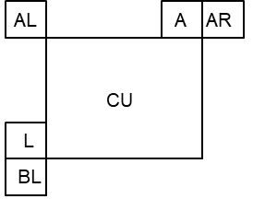
Figure 1. Neighbouring blocks (L, A, BL, AR, AL) used in the derivation of a general MPM list.
A PMPM flag is parsed first, if equal to 1 then a PMPM index is parsed to determine which entry of the PMPM list is selected, otherwise the SPMPM flag is parsed to determine whether to parse the SMPM index or the remaining modes.

Reference sample interpolation and smoothing for intra-prediction
Three modifications are proposed. First, the 4-tap cubic interpolation is replaced with a 6-tap cubic interpolation filter, as described in JVET-D0119, for the derivation of predicted samples from the reference samples. Second, for the coding blocks where a gaussian interpolation filter is applied to filter the reference samples, a 6-tap gaussian filter is applied for larger blocks (W >= 32 and H >=32) and the existing VVC 4-tap gaussian interpolation filter is applied otherwise. Third, to derive the extended intra reference samples, the 4-tap interpolation filter is used instead of the nearest neighbor rounding.

Decoder side intra mode derivation (DIMD)
When DIMD is applied, two intra modes are derived from the reconstructed neighbor samples, and those two predictors are combined with the planar mode predictor with the weights derived from the gradients as described in JVET-O0449.
Derived intra modes are included into the primary list of intra most probable modes (MPM), so the DIMD process is performed before the MPM list is constructed. The primary derived intra mode of a DIMD block is stored with a block and is used for MPM list construction of the neighboring blocks.

Inter prediction

Local illumination compensation (LIC)
LIC is an inter prediction technique to model local illumination variation between current block and its prediction block as a function of that between current block template and reference block template. The parameters of the function can be denoted by a scale α and an offset β, which forms a linear equation, that is, α*p[x]+β to compensate illumination changes, where p[x] is a reference sample pointed to by MV at a location x on reference picture. Since α and β can be derived based on current block template and reference block template, no signaling overhead is required for them, except that an LIC flag is signaled for AMVP mode to indicate the use of LIC.
The local illumination compensation that was previously proposed in JVET-O0066 was adopted in this contribution for uni-prediction inter CUs with the following modifications.
- Intra neighbor samples can be used in LIC parameter derivation;
- LIC is disabled for blocks with less than 32 luma samples;
- For both non-subblock and affine modes, LIC parameter derivation is performed based on the template block samples corresponding to the current CU, instead of partial template block samples corresponding to first top-left 16x16 unit;
- Samples of the reference block template are generated by using MC with the block MV without rounding it to integer-pel precision.

Non-adjacent spatial candidate
The non-adjacent spatial merge candidates as in JVET-L0399 are inserted after the TMVP in the regular merge candidate list. The pattern of spatial merge candidates is shown in Figure 3. The distances between non-adjacent spatial candidates and current coding block are based on the width and height of current coding block. The line buffer restriction, however, is not applied in this contribution.
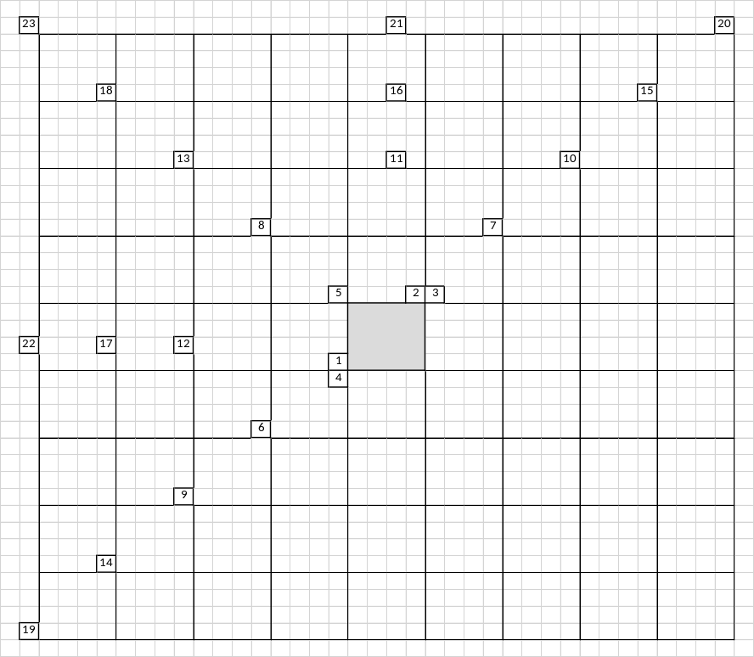
Figure 3. Spatial neighboring blocks used to derive the spatial merge candidates

Template matching (TM)
Template matching (TM) is a decoder-side MV derivation method to refine the motion information of the current CU by finding the closest match between a template (i.e., top and/or left neighbouring blocks of the current CU) in the current picture and a block (i.e., same size to the template) in a reference picture. As illustrated in Figure 4, a better MV is to be searched around the initial motion of the current CU within a [– 8, +8]-pel search range. The template matching that was previously proposed in JVET-J0021 is adopted in this contribution with two modifications: search step size is determined based on AMVR mode and TM can be cascaded with bilateral matching process in merge modes.
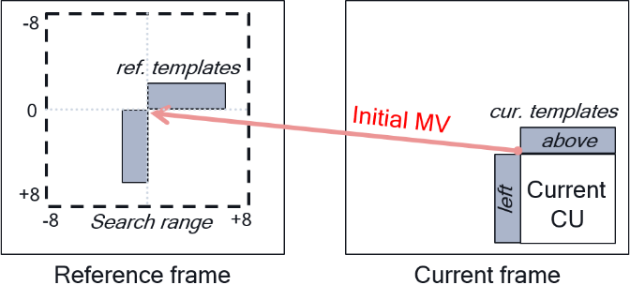
Figure 4. Template matching performs on a search area around initial MV.
In AMVP mode, an MVP candidate is determined based on template matching error to pick up the one which reaches the minimum difference between current block template and reference block template, and then TM performs only for this particular MVP candidate for MV refinement. TM refines this MVP candidate, starting from full-pel MVD precision (or 4-pel for 4-pel AMVR mode) within a [–8, +8]-pel search range by using iterative diamond search. The AMVP candidate may be further refined by using cross search with full-pel MVD precision (or 4-pel for 4-pel AMVR mode), followed sequentially by half-pel and quarter-pel ones depending on AMVR mode as specified in Table 1. This search process ensures that the MVP candidate still keeps the same MV precision as indicated by AMVR mode after TM process.
Table 1. Search patterns of AMVR and merge mode with AMVR.
Search pattern | AMVR mode |  |  |  | Merge mode
Search pattern | 4-pel | Full-pel | Half-pel | Quarter-pel | AltIF=0 | AltIF=1
4-pel diamond | v
4-pel cross | v
Full-pel diamond |  | v | v | v | v | v
Full-pel cross |  | v | v | v | v | v
Half-pel cross |  |  | v | v | v | v
Quarter-pel cross |  |  |  | v | v
1/8-pel cross |  |  |  |  | v
In merge mode, similar search method is applied to the merge candidate indicated by the merge index. As Table 1 shows, TM may perform all the way down to 1/8-pel MVD precision or skipping those beyond half-pel MVD precision, depending on whether the alternative interpolation filter (that is used when AMVR is of half-pel mode) is used according to merged motion information. Besides, when TM mode is enabled, template matching may work as an independent process or an extra MV refinement process between block-based and subblock-based bilateral matching (BM) methods, depending on whether BM can be enabled or not according to its enabling condition check.

Multi-pass decoder-side motion vector refinement
In this contribution, a multi-pass decoder-side motion vector refinement is applied. In the first pass, bilateral matching (BM) is applied to the coding block. In the second pass, BM is applied to each 16x16 subblock within the coding block. In the third pass, MV in each 8x8 subblock is refined by applying bi-directional optical flow (BDOF). The refined MVs are stored for both spatial and temporal motion vector prediction.

First pass – Block based bilateral matching MV refinement
In the first pass, a refined MV is derived by applying BM to a coding block. Similar to decoder-side motion vector refinement (DMVR), in bi-prediction operation, a refined MV is searched around the two initial MVs (MV0 and MV1) in the reference picture lists L0 and L1. The refined MVs (MV0_pass1 and MV1_pass1) are derived around the initiate MVs based on the minimum bilateral matching cost between the two reference blocks in L0 and L1.
BM performs local search to derive integer sample precision intDeltaMV. The local search applies a 3×3 square search pattern to loop through the search range [–sHor, sHor] in horizontal direction and [–sVer, sVer] in vertical direction, wherein, the values of sHor and sVer are determined by the block dimension, and the maximum value of sHor and sVer is 8.
The bilateral matching cost is calculated as: bilCost = mvDistanceCost + sadCost. When the block size cbW * cbH is greater than 64, MRSAD cost function is applied to remove the DC effect of distortion between reference blocks. When the bilCost at the center point of the 3×3 search pattern has the minimum cost, the intDeltaMV local search is terminated. Otherwise, the current minimum cost search point becomes the new center point of the 3×3 search pattern and continue to search for the minimum cost, until it reaches the end of the search range.
The existing fractional sample refinement is further applied to derive the final deltaMV. The refined MVs after the first pass is then derived as:
- MV0_pass1 = MV0 + deltaMV
- MV1_pass1 = MV1 – deltaMV

Second pass – Subblock based bilateral matching MV refinement
In the second pass, a refined MV is derived by applying BM to a 16×16 grid subblock. For each subblock, a refined MV is searched around the two MVs (MV0_pass1 and MV1_pass1), obtained on the first pass, in the reference picture list L0 and L1. The refined MVs (MV0_pass2(sbIdx2) and MV1_pass2(sbIdx2)) are derived based on the minimum bilateral matching cost between the two reference subblocks in L0 and L1.
For each subblock, BM performs full search to derive integer sample precision intDeltaMV. The full search has a search range [–sHor, sHor] in horizontal direction and [– sVer, sVer] in vertical direction, wherein, the values of sHor and sVer are determined by the block dimension, and the maximum value of sHor and sVer is 8.
The bilateral matching cost is calculated by applying a cost factor to the SATD cost between two reference subblocks, as: bilCost = satdCost * costFactor. The search area (2*sHor + 1) * (2*sVer + 1) is divided up to 5 diamond shape search regions shown on Figure 5. Diamond regions in the search area.. Each search region is assigned a costFactor, which is determined by the distance (intDeltaMV) between each search point and the starting MV, and each diamond region is processed in the order starting from the center of the search area. In each region, the search points are processed in the raster scan order starting from the top left going to the bottom right corner of the region. When the minimum bilCost within the current search region is less than a threshold equal to sbW * sbH, the int-pel full search is terminated, otherwise, the int-pel full search continues to the next search region until all search points are examined.
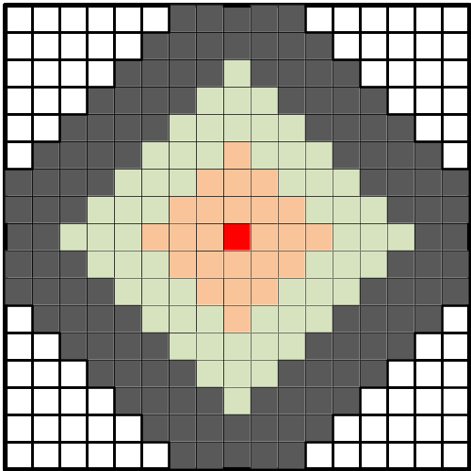
Figure 5. Diamond regions in the search area.

The existing VVC DMVR fractional sample refinement is further applied to derive the final deltaMV(sbIdx2) . The refined MVs at second pass is then derived as:
- MV0_pass2(sbIdx2) = MV0_pass1 + deltaMV(sbIdx2)
- MV1_pass2(sbIdx2) = MV1_pass1 – deltaMV(sbIdx2)

Third pass – Subblock based bi-directional optical flow MV refinement
In the third pass, a refined MV is derived by applying BDOF to an 8×8 grid subblock. For each 8×8 subblock, BDOF refinement is applied to derive scaled Vx and Vy without clipping starting from the refined MV of the parent subblock of the second pass. The derived bioMv(Vx, Vy) is rounded to 1/16 sample precision and clipped between -32 and 32.
The refined MVs (MV0_pass3(sbIdx3) and MV1_pass3(sbIdx3)) at third pass are derived as:
- MV0_pass3(sbIdx3) = MV0_pass2(sbIdx2) + bioMv
- MV1_pass3(sbIdx3) = MV0_pass2(sbIdx2) – bioMv

OBMC
When OBMC is applied, top and left boundary pixels of a CU are refined using neighboring block’s motion information with a weighted prediction as described in JVET-L0101.
Conditions of not applying OBMC are as follows:
- When OBMC is disabled at SPS level
- When current block has intra mode or IBC mode
- When current block applies LIC
- When current luma block area is smaller or equal to 32
A subblock-boundary OBMC is further proposed to apply the same blending to the top, left, bottom, and right subblock boundary pixels using neighboring subblock’s motion information. It is enabled for the subblock based coding tools:
- Affine AMVP modes;
- Affine merge modes and subblock-based temporal motion vector prediction (SbTMVP);
- Subblock-based bilateral matching.

Sample-based BDOF
In the sample-based BDOF, instead of deriving motion refinement (Vx, Vy) on a block basis, it is performed per sample.
The coding block is divided into 8×8 subblocks. For each subblock, whether to apply BDOF or not is determined by checking the SAD between the two reference subblocks against a threshold. If decided to apply BDOF to a subblock, for every sample in the subblock, a sliding 5×5 window is used and the existing BDOF process is applied for every sliding window to derive Vx and Vy. The derived motion refinement (Vx, Vy) is applied to adjust the bi-predicted sample value for the center sample of the window.

Interpolation
The 8-tap interpolation filter used in VVC is replaced with a 12-tap filter in this proposal. The proposed interpolation filter is derived from the sinc function of which the frequency response is cut off at Nyquist frequency, and cropped by a cosine window function. Table 2 gives the filter coefficients of all 16 phases. Figure 9. compares the frequency responses of the proposed interpolation filter with the VVC interpolation filter, all at half-pel phase.
Table 2. Filter coefficients of the proposed 12-tap interpolation filter
1/16 | -1 | 2 | -3 | 6 | -14 | 254 | 16 | -7 | 4 | -2 | 1 | 0
2/16 | -1 | 3 | -7 | 12 | -26 | 249 | 35 | -15 | 8 | -4 | 2 | 0
3/16 | -2 | 5 | -9 | 17 | -36 | 241 | 54 | -22 | 12 | -6 | 3 | -1
4/16 | -2 | 5 | -11 | 21 | -43 | 230 | 75 | -29 | 15 | -8 | 4 | -1
5/16 | -2 | 6 | -13 | 24 | -48 | 216 | 97 | -36 | 19 | -10 | 4 | -1
6/16 | -2 | 7 | -14 | 25 | -51 | 200 | 119 | -42 | 22 | -12 | 5 | -1
7/16 | -2 | 7 | -14 | 26 | -51 | 181 | 140 | -46 | 24 | -13 | 6 | -2
8/16 | -2 | 6 | -13 | 25 | -50 | 162 | 162 | -50 | 25 | -13 | 6 | -2
9/16 | -2 | 6 | -13 | 24 | -46 | 140 | 181 | -51 | 26 | -14 | 7 | -2
10/16 | -1 | 5 | -12 | 22 | -42 | 119 | 200 | -51 | 25 | -14 | 7 | -2
11/16 | -1 | 4 | -10 | 19 | -36 | 97 | 216 | -48 | 24 | -13 | 6 | -2
12/16 | -1 | 4 | -8 | 15 | -29 | 75 | 230 | -43 | 21 | -11 | 5 | -2
13/16 | -1 | 3 | -6 | 12 | -22 | 54 | 241 | -36 | 17 | -9 | 5 | -2
14/16 | 0 | 2 | -4 | 8 | -15 | 35 | 249 | -26 | 12 | -7 | 3 | -1
15/16 | 0 | 1 | -2 | 4 | -7 | 16 | 254 | -14 | 6 | -3 | 2 | -1

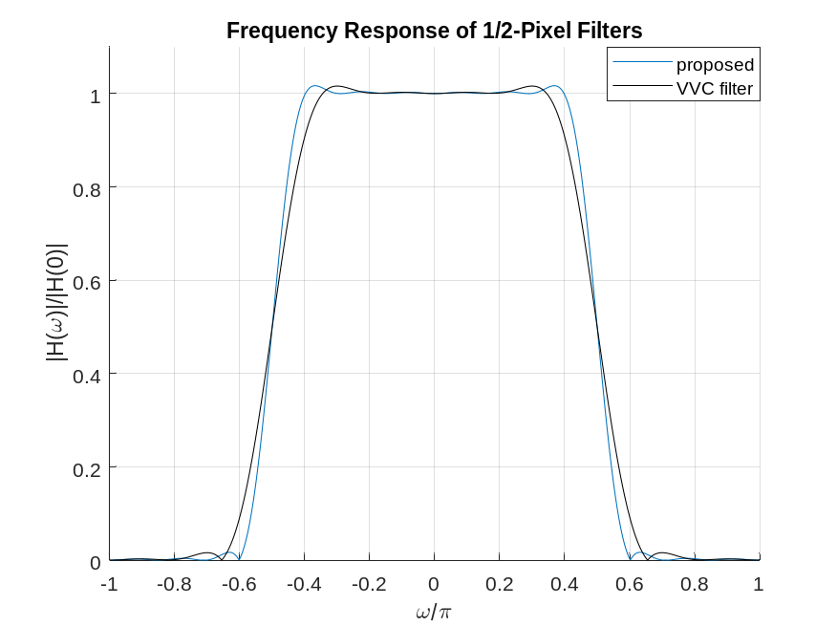
Figure 9. Frequency responses of the proposed interpolation filter and the VVC interpolation filter at half-pel phase

Multi-hypothesis prediction (MHP)
The multi-hypothesis prediction previously proposed in JVET-M0425 is adopted in this contribution. Up to two additional predictors are signalled on top of inter AMVP mode, regular merge mode, and MMVD mode. The resulting overall prediction signal is accumulated iteratively with each additional prediction signal.
$$p_{n+1}=\left(1-α_{n+1}\right)p_{n}+α_{n+1}h_{n+1}$$
The weighting factor α is specified according to the following table:
add_hyp_weight_idx | α
0 | 1/4
1 | -1/8
For inter AMVP mode, MHP is only applied if non-equal weight in BCW is selected in bi-prediction mode.

Transform and coefficient coding
The 8-state dependent quantization proposed in JVET-Q0243 is employed in this contribution.

Maximum Transform Size and Zeroing-out of Transform Coefficients
Both CTU size and maximum transform size (i.e., all MTS transform kernels) are extended to 256, where the maximum intra coded block can have a size of 128x128. The maximum CTU size is set to 256 for UHD sequences and it is set to 128, otherwise. In the primary transformation process, there is no normative zeroing out operation applied on transform coefficients. However, if LFNST is applied, the primary transform coefficients outside the LFNST region are normatively zeroed-out, yet the coefficients within the LFNST region (i.e., secondary transform coefficients) are not zeroed-out.

Secondary Transformation: Extended LFNST
The LFNST design in VVC is extended as follows:
- The number of LFNST sets (S) and candidates (C) are extended to S=35 and C=3, and the LFNST set (lfnstTrSetIdx) for a given intra mode (predModeIntra) is derived according to the following formula:
  - For predModeIntra < 2, lfnstTrSetIdx is equal to 2
  - lfnstTrSetIdx = predModeIntra, for predModeIntra in [0,34]
  - lfnstTrSetIdx = 68 – predModeIntra, for predModeIntra in [35,66]
- The 8x8 LFNST matrix size (i.e., the transform support) in VVC is extended to full 64x64, such that it is not reduced as no zeroing-out process is applied to secondary transform coefficients.

Sign prediction
Following JVET-D0031 and JVET-J0021, basic idea of the coefficient sign prediction method is for applicable transform coefficients to calculate reconstructed residual for both negative and positive sign combinations and select the hypothesis that minimizes a cost function.
To derive the best sign, the cost function is defined as discontinuity measure across block boundary shown on Figure 11. It is measured for all hypotheses, and the one with the smallest cost is selected as a predictor for coefficient signs.
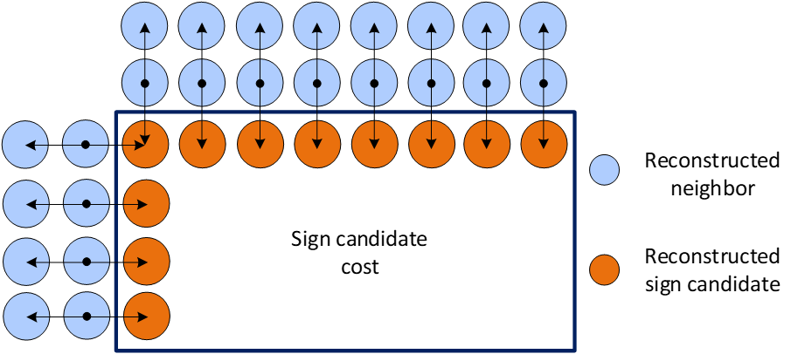
Figure 11. Discontinuity measure.
The cost function is defined as a sum of absolute second derivatives in the residual domain for the above row and left column as follows
$$cost=\sum_{x=o}^{w}{\left|\left(-R_{x,-1}+2R_{x,0}-P_{x,1}\right)-r_{x,1}\right| }+\sum_{y=o}^{h}{\left|\left(-R_{-1,y}+2R_{0,y}-P_{1,y}\right)-r_{1,y}\right| }$$
where R is reconstructed neighbors, P is prediction of the current block, and r is the residual hypothesis. The term $\left(-R_{-1}+2R_{0}-P_{1}\right)$ can be calculated only once per block and only residual hypothesis is subtracted.

Adaptive loop filter

ALF simplification removal
In this proposal, ALF gradient subsampling and ALF virtual boundary processing are removed. Block size for classification is reduced from 4x4 to 2x2. Filter size for both luma and chroma, for which ALF coefficients are signalled, is increased to 9x9.

ALF with fixed filters
To filter a luma sample, it is proposed to use three different classifiers (C₀, C₁ and C₂) and three different sets of filters (F₀, F₁ and F₂). Sets F₀ and F₁ contain fixed filters, with coefficients trained for classifiers C₀ and C₁. Coefficients of filters in F₂ are signalled. Which filter from a set F_{i} is used for a given sample is decided by a class $C_{i}$ assigned to this sample using classifier C_{i}$.$

Filtering
At first, two 13x13 diamond shape fixed filters F₀ and F₁ are applied to derive two intermediate samples $R_{0}\left(x,y\right)$ and $R_{1}\left(x,y\right)$. After that, F₂ is applied to $R_{0}\left(x,y\right)$, $R_{1}\left(x,y\right)$, and neighboring samples to derive a filtered sample as
$$\tilde{R}\left(x,y\right)=R\left(x, y\right)+\left[\sum_{i=0}^{19}{c_{i}\left(f_{i,0}+f_{i,1}\right)}\right]+\left[\sum_{i=20}^{21}{c_{i}g_{i}}\right],$$
where $f_{i,j}$ is the clipped difference between a neighboring sample and current sample $R\left(x, y\right)$ and $g_{i}$ is the clipped difference between $R_{i-20}\left(x,y\right)$ and current sample. The filter coefficients $c_{i}, i=0,…21,$ are signalled.

Classification
Based on directionality $D_{i}$ and activity ${\hat{A}}_{i}$, a class $C_{i}$ is assigned to each 2x2 block:
$$C_{i}={\hat{A}}_{i} *M_{D,i}+D_{i}$$
where $M_{D,i}$ represents the total number of directionalities $D_{i}$.
As in VVC, values of the horizontal, vertical, and two diagonal gradients are calculated for each sample using 1-D Laplacian. The sum of the sample gradients within a 4×4 window that covers the target 2×2 block is used for classifier C₀ and the sum of sample gradients within a 12×12 window is used for classifiers C₁ and C₂. The sums of horizontal, vertical and two diagonal gradients are denoted, respectively, as $g_{h}^{i}$, $g_{v}^{i}$, $g_{d1}^{i}$ and $g_{d2}^{i}$. The directionality $D_{i}$ is determined by comparing
$$r_{h,v}^{i}=\frac{max\left(g_{h}^{i}, g_{v}^{i}\right)}{min\left(g_{h}^{i}, g_{v}^{i}\right)} , { r}_{d1,d2}^{i}=\frac{max\left(g_{d1}^{i}, g_{d2}^{i}\right)}{min\left(g_{d1}^{i}, g_{d2}^{i}\right)}$$
with a set of thresholds. The directionality $D_{2}$ is derived as in VVC using thresholds 2 and 4.5. For $D_{0}$ and $D_{1}$, horizontal/vertical edge strength $E_{HV}^{i}$ and diagonal edge strength $E_{D}^{i}$ are calculated first. Thresholds $Th=[1.25, 1.5, 2, 3, 4.5, 8]$are used. Edge strength $E_{HV}^{i}$ is 0 if $r_{h,v}^{i}≤ Th[0]$; otherwise, $E_{HV}^{i}$ is the maximum integer such that $r_{h,v}^{i}>Th[E_{HV}^{i} -1].$ Edge strength $E_{D}^{i}$ is 0 if $r_{d1,d2}^{i}≤Th[0]$; otherwise, $E_{D}^{i}$ is the maximum integer such that $r_{d1,d2}^{i}>Th[E_{D}^{i} -1]$. When $r_{h,v}^{i}>r_{d1,d2}^{i}$, i.e., horizontal/vertical edges are dominant, the $D_{i}$ is derived by using Table 4 (a); otherwise, diagonal edges are dominant, the $D_{i}$ is derived by using Table 4 (b).
Table 4. Mapping of $E_{D}^{i}$ and $E_{HV}^{i}$ to $D_{i}$
(a) (b)
$E_{D}^{i}$  $$E_{HV}^{i}$$ | 0 | 1 | 2 | 3 | 4 | 5 | 6 |  | $E_{HV}^{i}$  $$E_{D}^{i}$$ | 0 | 1 | 2 | 3 | 4 | 5 | 6
0 | 0 | 0 | 0 | 0 | 0 | 0 | 0 |  | 0 | 28 | 0 | 0 | 0 | 0 | 0 | 0
1 | 1 | 2 | 0 | 0 | 0 | 0 | 0 |  | 1 | 29 | 30 | 0 | 0 | 0 | 0 | 0
2 | 3 | 4 | 5 | 0 | 0 | 0 | 0 |  | 2 | 31 | 32 | 33 | 0 | 0 | 0 | 0
3 | 6 | 7 | 8 | 9 | 0 | 0 | 0 |  | 3 | 34 | 35 | 36 | 37 | 0 | 0 | 0
4 | 10 | 11 | 12 | 13 | 14 | 0 | 0 |  | 4 | 38 | 39 | 40 | 41 | 42 | 0 | 0
5 | 15 | 16 | 17 | 18 | 19 | 20 | 0 |  | 5 | 43 | 44 | 45 | 46 | 47 | 48 | 0
6 | 21 | 22 | 23 | 24 | 25 | 26 | 27 |  | 6 | 49 | 50 | 51 | 52 | 53 | 54 | 55

To obtain ${\hat{A}}_{i}$, the sum of vertical and horizontal gradients $A_{i}$ is mapped to the range of 0 to $n$, where $n$ is equal to 4 for ${\hat{A}}_{2}$ and 15 for ${\hat{A}}_{0}$ and ${\hat{A}}_{1}$.
In an ALF_APS, up to 4 luma filter sets are signalled, each set may have up to 25 filters.

Entropy coding

Extended precision
The intermediate precision used in the arithmetic coding engine is increased, including three elements. First, the precisions for two probability states are both increased to 15 bits, in comparison to 10 bits and 14 bits in VVC. Second, the LPS range update process is modified as below,
if q >= 16384
q = 2¹⁵ – 1 – q
R_{LPS} = ((range * (q>>6)) >>9) + 1,
where range is a 9-bit variable representing the width of the current interval, q is a 15-bit variable representing the probability state of the current context model, and R_{LPS} is the updated range for LPS. This operation can also be realized by looking up a 512×256-entry in 9-bit look-up table. Third, at the encoder side, the 256-entry look-up table used for bits estimation in VTM is extended to 512 entries.

Slice-type-based window size
Since statistics are different with different slice types, it is beneficial to have a context’s probability state updated at a rate that is optimal under the given slice type. Therefore, for each context model, three window sizes are pre-defined for I-, B-, and P-slices, respectively, like the initialization parameters.
The context initialization parameters and window sizes are retrained.

Results
The described changes are implemented on top VTM-10.0 with the added fixes related to MCTF (merge request 1902). VTM-10.0 with MCTF fixes is used as the first anchor, and VTM-11.0 is used as the second anchor.
Tests are performed under CTC described in JVET-T2010.

 | All Intra Main10
 | Over VTM-10.0 GOP32 MCTF |  |  |  |  | Over VTM-11.0
 | Y | U | V | EncT | DecT | Y | U | V | EncT | DecT
Class A1 | -5.45% | -9.86% | -10.74% | 208% | 215% | -5.45% | -9.86% | -10.74% | 208% | 221%
Class A2 | -5.12% | -8.08% | -6.15% | 200% | 194% | -5.12% | -8.08% | -6.15% | 201% | 204%
Class B | -4.69% | -7.43% | -7.82% | 219% | 211% | -4.69% | -7.43% | -7.82% | 220% | 201%
Class C | -5.54% | -7.59% | -7.89% | 214% | 190% | -5.54% | -7.59% | -7.89% | 213% | 178%
Class E | -6.21% | -8.27% | -6.87% | 223% | 227% | -6.21% | -8.27% | -6.87% | 226% | 225%
Overall | -5.33% | -8.12% | -7.88% | 214% | 206% | -5.33% | -8.12% | -7.88% | 214% | 203%
Class D | -4.62% | -5.71% | -5.71% | 222% | 187% | -4.62% | -5.71% | -5.71% | 223% | 184%
Class F (optional) | -8.19% | -10.45% | -10.96% | 172% | 199% | -8.19% | -10.45% | -10.96% | 172% | 191%
 | Random Access Main 10
 | Over VTM-10.0 GOP32 MCTF |  |  |  |  | Over VTM-11.0
 | Y | U | V | EncT | DecT | Y | U | V | EncT | DecT
Class A1 | -11.40% | -13.14% | -15.81% | 262% | 392% | -11.40% | -13.21% | -15.80% | 260% | 392%
Class A2 | -12.58% | -14.30% | -14.11% | 239% | 448% | -12.58% | -14.32% | -14.10% | 242% | 452%
Class B | -10.49% | -12.01% | -11.28% | 235% | 376% | -10.49% | -12.02% | -11.26% | 238% | 395%
Class C | -12.03% | -12.83% | -12.95% | 244% | 373% | -12.03% | -12.83% | -12.95% | 246% | 390%
Class E
Overall | -11.50% | -12.91% | -13.19% | 243% | 392% | -11.50% | -12.94% | -13.19% | 245% | 404%
Class D | -13.01% | -13.17% | -12.86% | 253% | 395% | -13.01% | -13.17% | -12.86% | 255% | 410%
Class F (optional) | -10.20% | -11.78% | -11.82% | 214% | 263% | -10.20% | -11.78% | -11.82% | 216% | 276%
 | Low delay B Main10
 | Over VTM-10.0 GOP32 MCTF |  |  |  |  | Over VTM-11.0
 | Y | U | V | EncT | DecT | Y | U | V | EncT | DecT
Class A1
Class A2
Class B
Class C | -10.40% | -10.82% | -11.29% | 224% | 268% | -10.40% | -10.63% | -11.31% | 226% | 292%
Class E | -9.24% | -10.29% | -8.48% | 183% | 258% | -9.25% | -10.39% | -8.42% | 184% | 259%
Overall
Class D | -12.17% | -11.72% | -11.95% | 234% | 314% | -12.16% | -11.75% | -11.93% | 235% | 315%
Class F (optional) | -10.46% | -10.55% | -10.28% | 197% | 226% | -10.47% | -10.34% | -10.34% | 199% | 239%

Patent rights declaration(s)
Qualcomm Incorporated may have current or pending patent rights relating to the technology described in this contribution and, conditioned on reciprocity, is prepared to grant licenses under reasonable and non-discriminatory terms as necessary for implementation of the resulting ITU-T Recommendation | ISO/IEC International Standard (per box 2 of the ITU-T/ITU-R/ISO/IEC patent statement and licensing declaration form).

