    Joint Video Experts Team (JVET)  of ITU-T SG 16 WP 3 and ISO/IEC JTC 1/SC 29  21st Meeting, by teleconference, 6–15 Jan. 2021 | Document: JVET-U0073

Title: | AHG2: Errata on referencing of parameter sets
Status: | Input document to JVET
Purpose: | Proposal
Author(s) or  Contact(s): | Karsten Suehring  Robert Skupin  Yago Sanchez  Thomas Schierl | Email: | first.last@hhi.fraunhofer.de
Source: | Fraunhofer HHI
_____________________________

Abstract
In the discussion of merge request !1971 it was noted that the specification text was unclear regarding the availability of a suffix APS to the decoding process. It seems the specification text does not clearly express that a picture cannot refer to a suffix APS in the same PU. Ticket #1443 was filed for this issue. During further investigation it was found that there may be some unclarity about references to parameter sets in general. This contribution proposes text improvements to express previous meeting decisions more clearly.
v2 of this document adds a revised draft after offline discussion. Clarifications about referencing of parameter sets were added to the semantics of VPS, SPS, PPS and APS. Delayed processing of suffix APS was added to section 8.1.2.
v3 adds a further refinement of the draft text.

Introduction
The suffix APS was adopted as a way of providing ALF coefficients in ultra-low low delay environments. The encoder cannot fully analyze the encoded picture until encoding has finished. On the other hand, it may want to send out slices before the whole picture is encoded. On the decoder side the same problem exists. The decoder may not want to wait for the whole picture to arrive before starting the ALF processing. So as a compromise the suffix APS was designed as a way to provide the coefficients for being referenced by later pictures, but not the picture that the suffix APS is sent with.
With the adoption of JVET-R0201 we allowed a PU to contain both, a prefix and a suffix APS with the same APS ID, with the intention for the picture to be able to reference the prefix APS, but not the suffix APS.
The NAL unit decoding process in Section 8.2 is rather brief:
Inputs to this process are NAL units of the current picture and their associated non-VCL NAL units.
Outputs of this process are the parsed RBSP syntax structures encapsulated within the NAL units.
The decoding process for each NAL unit extracts the RBSP syntax structure from the NAL unit and then parses the RBSP syntax structure.
This seems to imply that all NAL units of a picture are parsed at the same time before decoding of the picture starts. Thus, the suffix APS would be available to the decoder before the ALF is executed.
Unlike AVC and HEVC the VVC specification uses “references” to parameter sets instead of an activation process. While the activation happened as part of the decoding process, the references are made as part of the semantics section. So, they seem to happen during parsing, which in our usual understanding would not be the correct point of time.
For instance, sending parameter sets out of order seems to be allowed, as long as all required parameter sets are available when the picture is decoded:
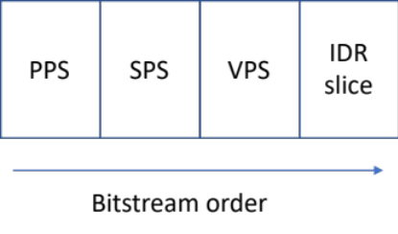
In the above example the PPS cannot reference the SPS at the time of parsing (similar for the SPS to VPS relationship).
In the following example, even different references are allowed at different points of time:
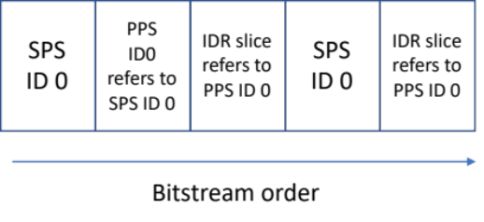
When the second SPS with ID 0 has a different content than the first one, we expect the PPS with ID 0 to refer to the updated SPS when the second CLVS is decoded.

Proposed solution
Our common understanding seems to be that the point of time that the reference is established for a specific picture, is the parsing time of the VCL NAL unit that directly or indirectly refers to the parameter set.
We also seem the assume that the reference is made to the parameter set most closely preceding the VCL NAL unit that established the reference. This would imply that a prefix APS in the same PU can be used, but not a suffix APS.
We also seem to assume, that references for a specific picture are constant after being established. That means once the reference is made, a newly arriving parameter set with the same ID will not change the value of the syntax elements used in context of the picture, e.g. if a picture A refers to a PPS A with ID 0 with a specific picture width and high, and a new PPS B with the same ID 0 but different picture width and height arrives, these new parameters do not affect the picture A in the DPB.
For adding the assumptions above, it is proposed to add the following sentence to the semantics of each syntax element that is a reference to a parameter set ID (adapted to the appropriate syntax elements). For example, for sh_alf_cc_cr_aps_id:
If multiple APS with the same value of aps_adaptation_parameter_set_id exist in the bitstream, the PH refers to the APS with aps_adaptation_parameter_set_id equal to sh_alf_cc_cr_aps_id, that most closely precedes the VCL NAL unit in decoding order, which refers to the PH.
The full specification text is attached to the contribution.
In v2 of this document improved text was added after offline discussion.

Patent rights declaration(s)
Fraunhofer HHI may have current or pending patent rights relating to the technology described in this contribution and, conditioned on reciprocity, is prepared to grant licenses under reasonable and non-discriminatory terms as necessary for implementation of the resulting ITU-T Recommendation | ISO/IEC International Standard (per box 2 of the ITU-T/ITU-R/ISO/IEC patent statement and licensing declaration form).

