    Joint Video Experts Team (JVET)  of ITU-T SG 16 WP 3 and ISO/IEC JTC 1/SC 29  21st Meeting, by teleconference, 6–15 Jan. 2021 | Document: JVET-U0041

Title: | Status Report on SDR HD and 360 Video Verification Test Preparation
Status: | Input document to JVET
Purpose: | Report
Author(s) or  Contact(s): | Mathias Wien  Vittorio Baroncini  Yan Ye | Tel:  Email: | wien@lfb.rwth-aachen.de  baroncini@gmx.com  yan.ye@alibaba-inc.com
Source: | Verification Test Coordinators
_____________________________

Abstract
This document summarizes the status of test sequence selection and rate point determination for the VVC verification test categories SDR HD and 360° video. For SDR HD low delay, a set of test sequences with conversational content has been identified and visually inspected by JVET experts. The acquisition of gaming-type test sequences in this category has not been completed yet. For SDR HD random access, an initial set of test sequences is proposed. For 360° video, test sequences and rate points for the test sequence encoded using equirectangular and cubemap projection formats are proposed.

Introduction
In the context of AHG4 activities, the verification test coordinators have assessed and discussed the available test sequences in multiple online meeting together with JVET experts. Furthermore, action has been taken to acquire more test material suitable for usage in the VVC verification tests.
This document summarizes the status for the SDR HD and 360° video categories.

SDR HD Low Delay
As discussed during the 20th JVET meeting [1], the verification tests for the SDR HD low delay category should include conversational and gaming-type content in order to properly reflect the application case for the low-delay encoder configuration.

Conversational content
A set of four test sequences for conversational applications as listed in the table below has been identified out of the available set of proposed test sequences for this purpose in JVET-T0060 and JVET-T0120 [2][3].
Test sequence | Resolution | fps | Frames | md5
Beatriz_1920x1080_50fps_8bit_420 | 1920x1080 | 50 | 500 | fe74cd5046fa033b4f743f42b29e69cd
OfficeWalkAndTalk_1920x1080_30fps_8bit_420pf | 1920x1080 | 30 | 300 | 9313b009c1f287915c9eb39a989b8f9b
OfficeWalkAtWall_1920x1080_30fps_8bit_420pf | 1920x1080 | 30 | 300 | 529c15491ea8e1eb0320244a6ff902bb
OfficeWalkCeiling_1920x1080_30fps_8bit_420pf | 1920x1080 | 30 | 300 | 265906bc8f65441fb53d167483b9f726
The sequences are available on the JVET ftp site in the /ahg/verificationtests/candidates/sdr directory.
Based on visual inspection of the verification test coordinators a GOP size of 4 pictures was suggested to be used in this test category for both HEVC and VVC. The test sequences have been encoded using the Low-Delay configurations of the VTM-10.0 software and the HM-16.22 software.
An overview of the general rate-distortion characteristics is provided in the figure below:
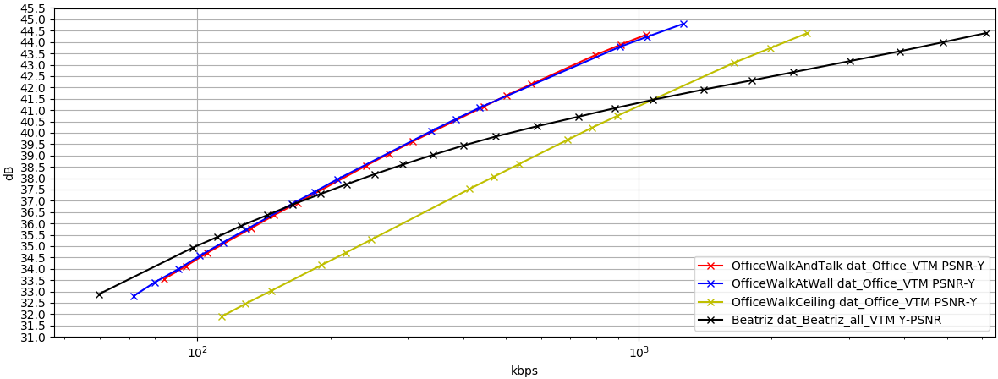
A selection of proposed QP points was generated and reviewed in a session of experts. The proposed QP settings are listed in the table below:
Sequence | HM QPs | VTM QPs
Beatriz_1920x1080_50fps_8bit_420 | 41, 37, 33, 28, 23 | 42, 38, 34, 29, 24
OfficeWalkAtWall_1920x1080_30fps_8bit_420pf | 46, 42, 38, 32, 26 | 47, 44,40, 34, 27
OfficeWalkAndTalk_1920x1080_30fps_8bit_420pf | 45, 40, 34, 30, 24 | 46, 42, 37, 32, 28
OfficeWalkCeiling_1920x1080_30fps_8bit_420pf | 45, 40, 34, 30, 24 | 46, 42, 36, 32, 26
As a next step, a dry run subjective assessment is foreseen in order to validate the selection for the final test configuration.

Gaming content
The verification test coordinators have reached out to JVET experts to acquire test sequences with gaming content which are suitable for subjective evaluation by naïve viewers.
Based on previous experience, it is noted that gaming-type video sequences often expose rapid camera movement which has been identified as a challenge for viewers, specifically since -not being the active player- they cannot control this motion.

Test sequences
An input contribution has been registered for further review by the JVET AHG meeting, which is recommended to be reviewed in the AHG meeting:
JVET-U0043 | m55697 | 2020-12-09 07:17:07 | 2020-12-09 07:28:30 | 2020-12-09 07:28:30 | Game video sequences proposal for the SDR HD low delay VVC verification test | F. Le Léannec, G. Martin-Cocher (InterDigital)

SDR HD Random Access
The SDR HD RA configuration has been added to the set of VVC verification test categories at the last meeting. A set of candidate sequences for this category is presented in the table below. The proposed sequences have mostly been used in previous subjective assessment tasks and have demonstrated their suitability for this purpose, e.g. in the context of other verification test activities in MPEG.
Test sequence | Resolution | fps | Frames
BarScene (1st part) | 1920x1080 | 60 | 600
BarScene (2nd part) | 1920x1080 | 60 | 600
DrivingPOV (1st part) | 1920x1080 | 60 | 600
DrivingPOV (2nd part) | 1920x1080 | 60 | 600
Metro | 1920x1080 | 60 | 600
RushHour | 1920x1080 | 30 | 300
Meridian1 | 1920x1080 | 60 | 600

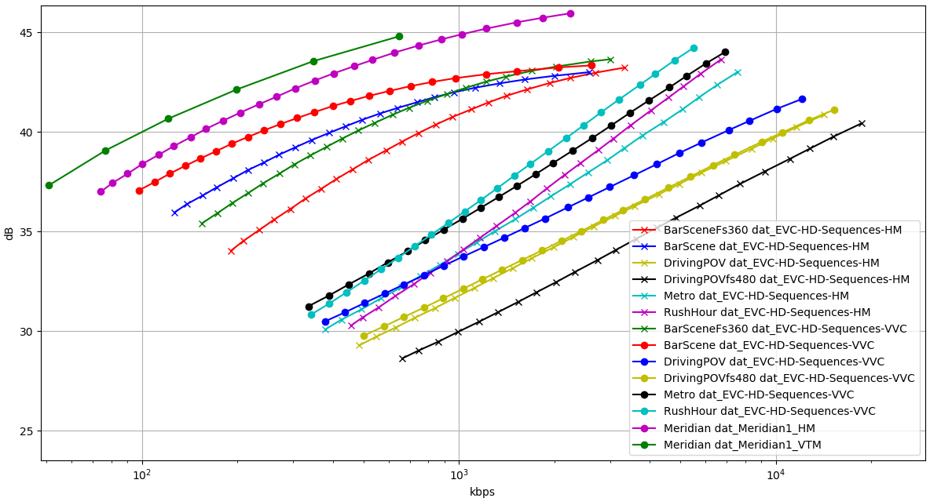
It is suggested to identify a set of proposed QP points review this in a session with JVET experts.

360° Video
The Verification Test plan for VVC includes the evaluation of 360° video content encoded with the projection format PERP for both, HEVC and VVC, and for the projection formats PCMP and GCMP for HEVC and VVC, respectively. The visual assessment is planned to be conducted using viewports with predefined paths in HD resolution, with view paths as proposed in JVET-S0146 [6].
At the October JVET meeting, an improved blending method for the cube map projection formats was proposed in JVET-T0118 [5]. The performance of this blending method was assessed for HM-16.22 and VTM-10.0 bitstreams in an expert viewing session, and was found to provide a significant improvement over the previous blending method.
An overview of the rate-distortion characteristics of the sequences is provided in the figures below. The sequences have been encoded with VTM-10.0:
CMP:
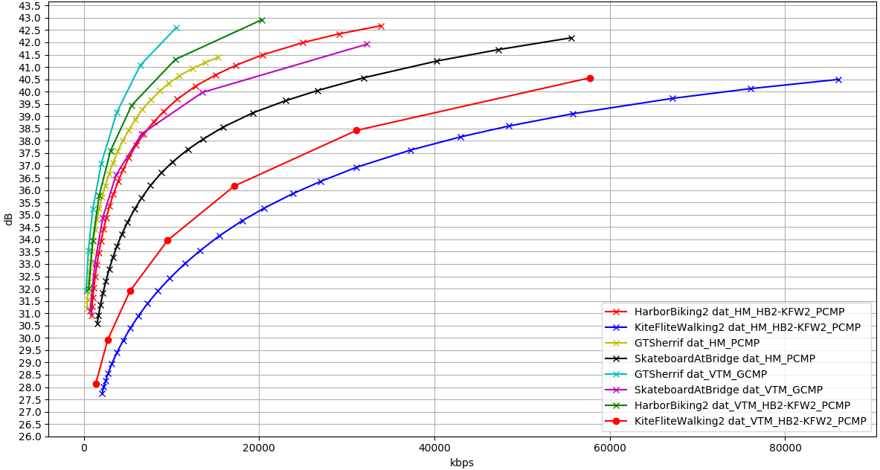
PERP:
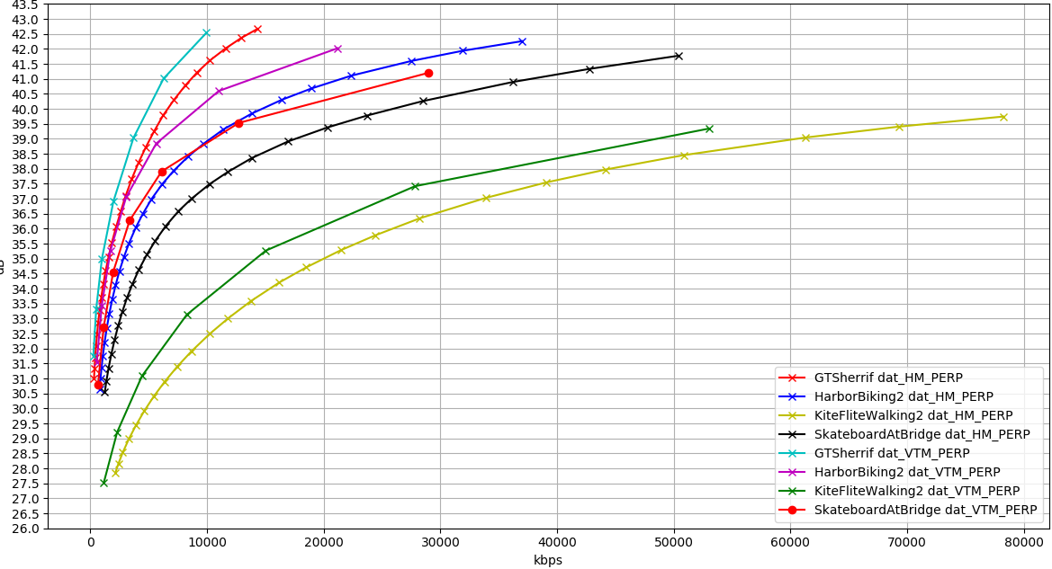
An initial set of QPs for HM and VTM resulting from this action is listed in the table below:
Sequence + Projection format | HM QPs | VTM QPs
GTSheriff CMP | 39, 35, 31, 27, 22 | 42, 38, 34, 30, 26
GTSheriff PERP | 36, 32, 28, 24, 20 | 38, 34, 30, 26, 22
HarborBiking2 CMP* | 39, 35, 31,27, 23, 20 | 42, 38, 34, 30, 26, 22
HarborBiking2 PERP | 35, 31, 27, 23, 20 | 38, 34, 30, 26, 22
KiteFliteWalking2 CMP* | 40, 36, 32, 28, 24, 20 | 42, 38, 34, 30, 26,22
KiteFliteWalking2 PERP | 40, 36, 32, 28, 24 | 42, 38, 34, 30, 26
SkateBoardAtBridge CMP | 38, 34, 30, 27, 23 | 42, 38, 34, 30, 26
SkateBoardAtBridge PERP | 39, 35, 31, 27, 24 | 42, 38, 34, 30, 26
It is noted that for some of the sequences, further QP adaptation might be required in order cover the quality range to an appropriate extent. Therefore, a dry run experiment is recommended in order to determine the finally proposed QPs.
It is noted that the expert viewing session did not include the PCMP/GCMP bitstreams for HarborBiking2 and KiteFliteWalking2. For these two sequences, the suitable quality range is to be determined by visual inspection before proceeding to a dry run experiment.

Conclusions
It is suggested to conduct dry run experiments for the proposed rate points for the available test sequences under consideration in order to assert the suitability of the corresponding quality range. It is further suggested to continue the effort on identifying gaming-type test sequences which can be used for the subjective assessment in the SDR HD LD configuration.

References
- Gary Sullivan and Jens-Rainer Ohm, “Meeting Report of the 20th JVET Meeting,” Doc. JVET-T1000, Joint Video Experts Team of VCEG and MPEG, 20th meeting, Oct. 2020.
- S. Xu, R.-L. Liao, J. Chen, Y. Ye (Alibaba), “AHG4: new video conference sequences for HD verification testing,” Doc. JVET-T0060, Joint Video Experts Team of VCEG and MPEG, 20th meeting, Oct. 2020.
- K. Andersson, M. Folkesson (Ericsson), “AHG4: Video conference sequence for HD verification testing,” Doc. JVET-T0120, Joint Video Experts Team of VCEG and MPEG, 20th meeting, Oct. 2020.
- Mathias Wien, Vittorio Baroncini, Andrew Segall, and Yan Ye, “VVC verification test plan (Draft 3),” Doc. JVET-S2009, Joint Video Experts Team of VCEG and MPEG, 19th meeting, July 2020.
- L. Lee, J.-L. Lin (MediaTek), Y. Wang, Y. He, L. Zhang (Bytedance), “AHG6: Blending with padded samples for GCMP,” Doc. JVET-T0118, Joint Video Experts Team of VCEG and MPEG, 20th meeting, Oct. 2020.
- M. Wien (RWTH), V. Baroncini (VABTECH ltd), Y. Ye (Alibaba), “Status Report on 360º video Verification Test Preparation,” Doc. JVET-S0146, Joint Video Experts Team of VCEG and MPEG, 19th meeting, July 2020.

Annex A – Encoding tasks
The encoding of the bitstreams used for this activity was kindly performed by:
Alibaba, Bytedance, Ericsson, HHI, InterDigital, Mediatek, RWTH Aachen University

