    Joint Video Experts Team (JVET)  of ITU-T SG 16 WP 3 and ISO/IEC JTC 1/SC 29/WG 11  19th Meeting: by teleconference, 22 June – 1 July 2020 | Document: JVET-S0264-v1

Title: | Performance Comparison of Screen Content Coding between HEVC and VVC
Status: | Input document to JVET
Purpose: | Information
Author(s) or  Contact(s): | Xiaozhong Xu  Shan Liu | Tel:  Email: | xiaozhongxu@tencent.com  shanl@tencent.com
Source: | Tencent
_____________________________

Abstract
This document provides coding performance comparisons between HEVC and VVC, focusing on screen content materials. The simulation results using HEVC and VVC reference software (HM, SCM and VTM) are provided and compared. It is reported that VTM-9 software achieves around 61% BD rate reductions on 4:2:0 TGM class for 3 tested conditions as compared to HM-16.20; while the gains on 4:2:0 TGM 1080p class are 14%/27%/34% for AI/RA/LDB conditions when compared to SCM-8.6. The performance differences are roughly in line with 4:2:0 results when 4:4:4 materials are tested.

Introduction
The standardization work of VVC include a few coding tools to support screen content coding (SCC), namely IBC, TSRC, BDPCM and PLT modes. In addition, non-normative hash-based ME search (HashME) is also implemented to improve efficiency in ME process. The overall performance of this standard, in terms of SCC, is of interest when compared with the preceding standards, i.e. the HEVC and its extensions on SCC. In this document, the comparison is made by performing simulations using the most recent reference software releases of each standard.

Simulation results
The reference software for HEVC [1][2] and VVC [3] are used to perform the performance evaluations of screen content coding. More specifically, HM-16.20, SCM-8.6 and VTM-9.0 are used. For 4:2:0 color format, test conditions described in SCC CE document [4] are used. For 4:4:4 color format, test conditions described in Non-4:2:0 CTC document [5] are used. In the following, results of HM-16.20 and SCM-8.6 are used as the 1st and 2nd anchor data, while results of VTM-9.0 are used as tested data.

Table 1: SCC performance comparisons between HEVC (HM and SCM) and VVC (VTM), 4:2:0 format
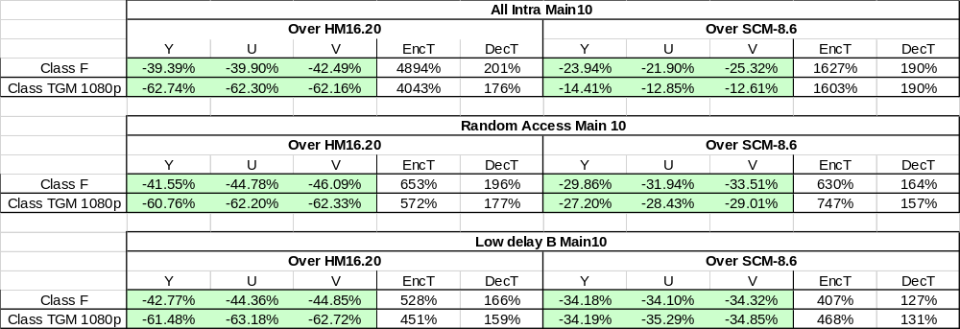

Table 2: SCC performance comparison between HEVC (HM) and VVC (VTM), 4:4:4 format
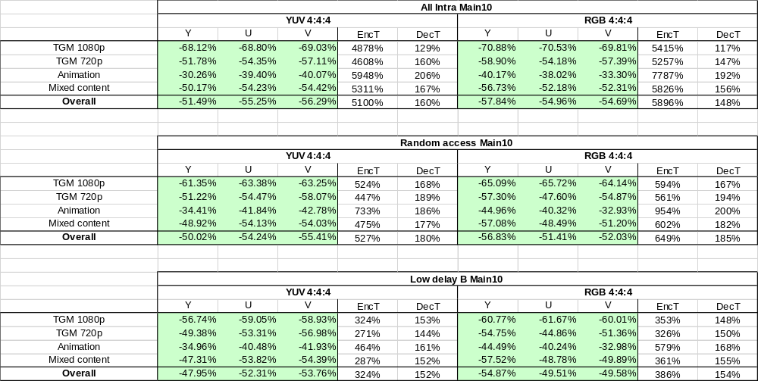

Table 3: SCC performance comparison between HEVC (SCM) and VVC (VTM), 4:4:4 format
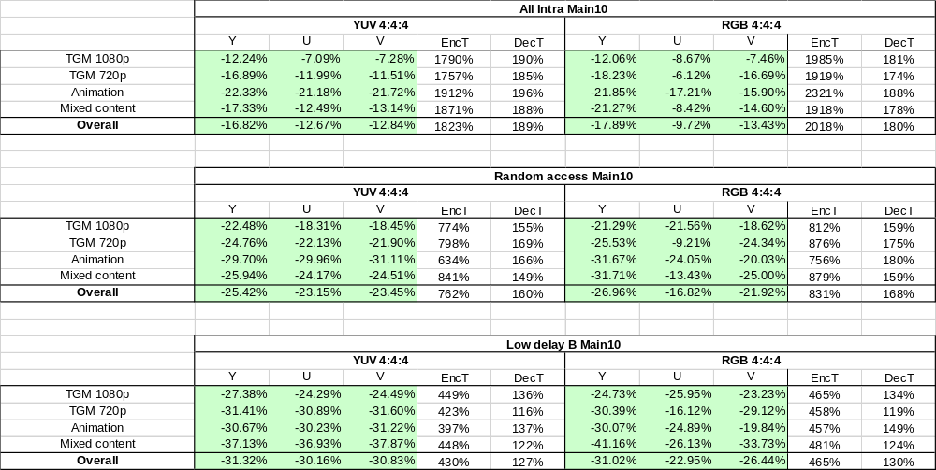
.

Conclusion
In this document, simulation results of HEVC and VVC reference software are provided. Screen content materials are tested and compared. In summary, VTM-9 software achieves around 61% BD rate reductions on TGM class for 3 tested conditions as compared to HM-16.20, while the gains are 14%/27%/34% for AI/RA/LDB conditions when compared to SCM-8.6. The performance differences are roughly in line with 4:2:0 results when 4:4:4 materials are tested.

References
- G. J. Sullivan, J.-R. Ohm, W.-J. Han, and T. Wiegand, “Overview of the high efficiency video coding (HEVC) standard,” IEEE Trans. Circuits Syst. Video Technol., vol. 22, no. 12, pp. 1649–1668, Dec. 2012.
- R Joshi, S Liu, G Sullivan, J Xu, Y Ye, “HEVC Screen Content Coding Draft Text 4”, ISO/IEC JTC1/SC29/WG11 JCTVC-U1005, Jun. 2015.
- B. Bross, J. Chen, S. Liu, Y.-K. Wang, “Versatile Video Coding (Draft 9)”, ISO/IEC JTC1/SC29/WG11 JVET-R2001, Apr. 2020.
- X. Xu, Y.-H. Chao, Y.-C. Sun, J. Xu, “Description of Core Experiment 8 (CE8): Screen Content Coding Tools”, ISO/IEC JTC1/SC29/WG11 JVET-N1028, Mar. 2019.
- Y.-H. Chao, Y.-C. Sun, J. Xu, X. Xu, “JVET common test conditions and software reference configurations for non-4:2:0 colour formats”, ISO/IEC JTC1/SC29/WG11 JVET-R2013, Apr. 2020.

