    Joint Video Experts Team (JVET)  of ITU-T SG 16 WP 3 and ISO/IEC JTC 1/SC 29/WG 11  19th Meeting: by teleconference, 22 June –1 July 2020 | Document: JVET-S0246

Title: | Results of dry run subjective assessment of SDR UHD verification test
Status: | Input document to JVET
Purpose: | Report
Author(s) or  Contact(s): | Vittorio Baroncini  Mathias Wien | Tel:  Email: | baroncini@gmx.com  wien@lfb.rwth-aachen.de
Source: | Verification Test Coordinators
_____________________________

Abstract
The draft plan for VVC verification testing (Draft 2) [JVET-R2009] includes a set of UHD SDR test sequences under consideration for use in the formal verification tests of VVC. According to the timeline of this plan, a preselection and preparation of test sequences and corresponding rate points for viewing has been carried out as described in document JVET-S0041. Out of the 13 test sequences listed in JVET-R2009, 8 test sequences were selected. The selection process and the experts viewing session subsequently conducted are described in this document. Starting from the selection described in JVET-S0041, a set of 4 test sequences were selected to run a Dry Run formal subjective assessment. A set of 5 rate points was selected for the assessment of each test sequence. The results indicate that the selected rate points cover the intended MOS range for most of the test sequences. Modifications and improvements to the set of test sequences and to the VTM and HM QP selection are suggested.

Selection of test sequences
As described in JVET-S0041, eight sequences were assessed by means of an Experts Viewing Test session. As a consequence of this remote assessment made by five experts, a set of four test sequences were selected to preform a formal subjective assessment dry run experiment, with the participation of naïve viewers. The number of rate points was increased to 5 for each test sequence to obtain a better assessment of the behaviour of each of the four test sequences. The rate points were selected such that the VTM/HM pair for a rate point would represent approximately same quality while at the same time allow for approximate rate matching of the HM rate point with the next VTM rate point. Thereby both, assessment of rate-savings at similar quality and quality improvement at similar rate is enabled.
Table 1 show the selected test sequences and the corresponding HM and VTM QPs. VTM rate points outside of the initial QP set (30,34,38,42,46) were encoded by the encoding volunteers.

Table 1 – Selected SDR UHD test sequences and rate points
No. | Test sequence | HM QPs | VTM QPs
01 | Marathon_3840x2160_30fps_8bit_420pf | 28 32 35 39 43 | 30 34 38 42 46
02 | MountainBay2_3840x2160_30fps_420_10bit | 28 30 33 36 39 | 30 33 36 39 42
03 | Netflix_DrivingPOV_4096x2160_60fps_10bit_420 | 27 31 35 39 43 | 30 34 38 42 46
09 | NeptuneFountain3_3840x2160_60fps_420_10bit | 28 39 33 36 39 | 30 33 36 39 42
The rate distortion plots for the listed QP selection are provided in Annex A to this document.

Formal subjective assessment

DSIS Test Method
The DSIS test method is described in recommendation BT 500-14; an 11 grades impairment scale was used as specified in BT 500-14. The Basic Test Cell of the DSIS method is following the below timing:
- 0,5 sec Text “A” on mid-grey background
- 10 sec Playback of uncompressed source file
- 0,5 sec Text “B” on mid-grey background
- 10 sec Playback of processed video sequence
- 4 sec Text “Vote N” on mid-grey background
Thereby, each BTC has a duration of 25 sec.

Test session design
The test was designed using a single test session, made of 43 BTCs ; the first three BTCs represent the “stabilization phase” (see rec. BT500-14 for details); the scores collected watching the first three BTCs were discarded from the final statistical analysis of the results.
The session was run two times, with different randomization orders to minimise contextual effects. This was done to try to improve the results, even though DSIS reportedly is immune to these effects.
The test was done using raw playout of the YUV files.

Laboratory set up and COVID procedures
The test was conducted and evaluated at VABTECH ltd. A total of 16 viewers (6 females and 10 males) participated to the test, aging from 18 to 23 years; all viewers were screened for visual acuity and color blindness. A post screening of the viewers was done performing a statistical analysis of each individual’s responses; no viewers was discarded.
To guarantee a safe test and rest areas, all the rooms used to run the test and to let viewers rest, were accurately cleaned (the day before) using disinfectant cleaner (based on alcohol at 70% concentration).
When viewers entered the test area, they were asked to take off the shoes and to clean their hands using a disinfectant cleaner (same used at hospital).
All viewers were wearing a protection masks for all the time they were in the testing and resting areas.
The resting areas and the test areas were wide enough to guarantee ate least 1 mt distancing arrangement.
For this reason, the test session was run twice, one on the morning and one on the afternoon, with the participation of 8 different viewers.
The test rooms were two; 2 subjects were watching the screen on each test room, seated one meter to each other and 2H from the 55” monitor; the viewing angle was not a problem for the use of OLED TV sets.
The resting room was wide enough to allow a viewers seating at the due security distance.
All viewers were monetary compensated for their participation to the test.
The scores were collected by means of paper scoring sheets.

Results

DSIS Dry Run formal subjective assessment test
The tables and graph below show the comparison of HM and VVC (with ALFon) for the test sequences listed in table 1. Note that in this section, the bitstream file size in kilobytes is reported as “Bitrate”.

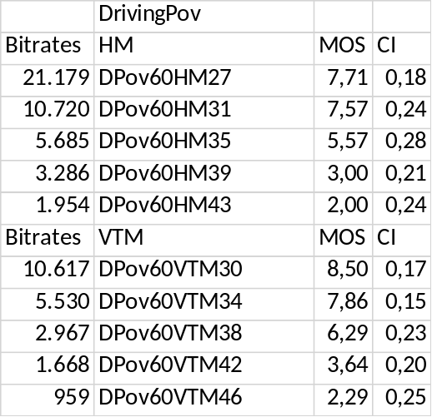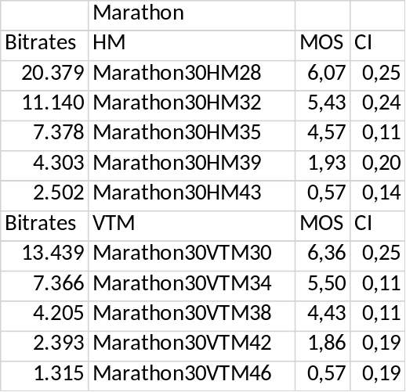

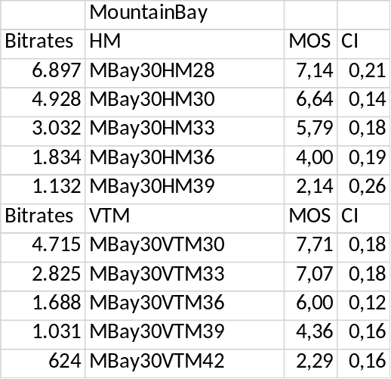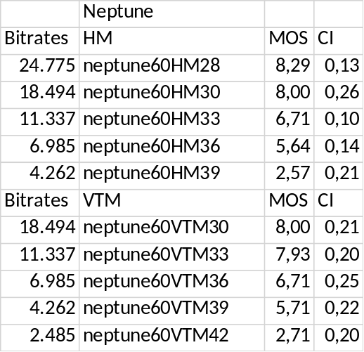

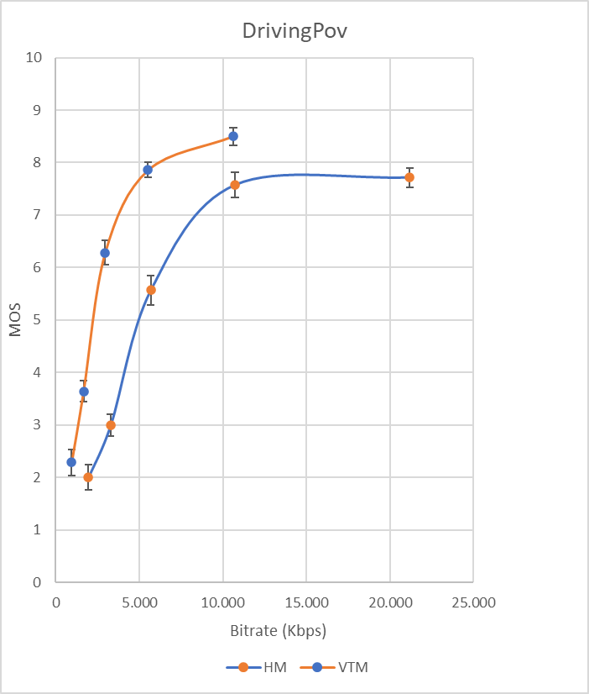

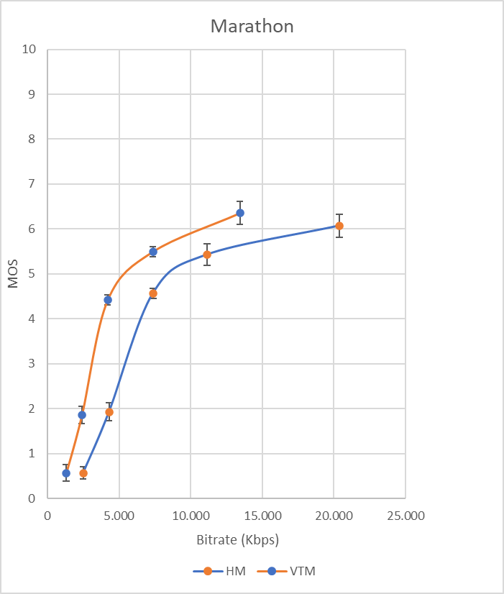

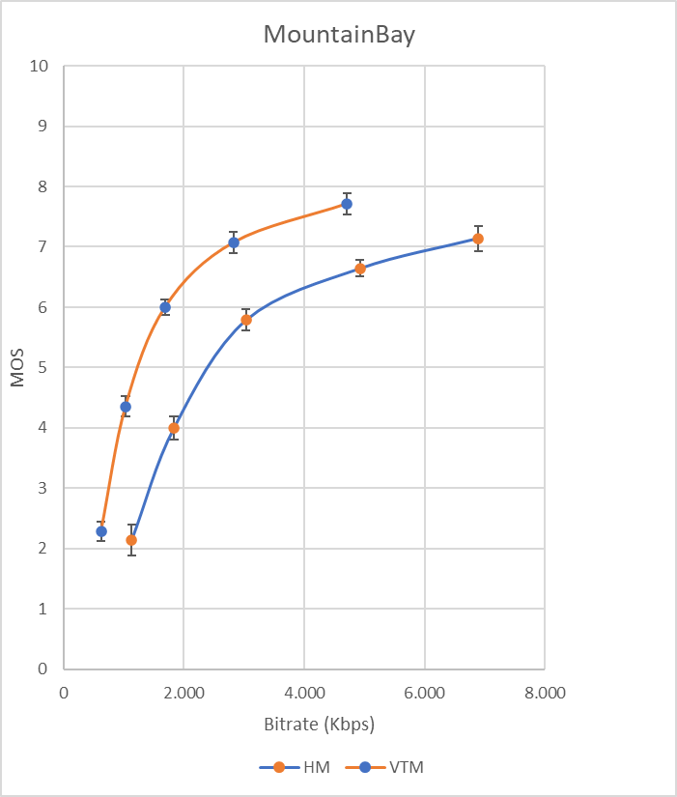

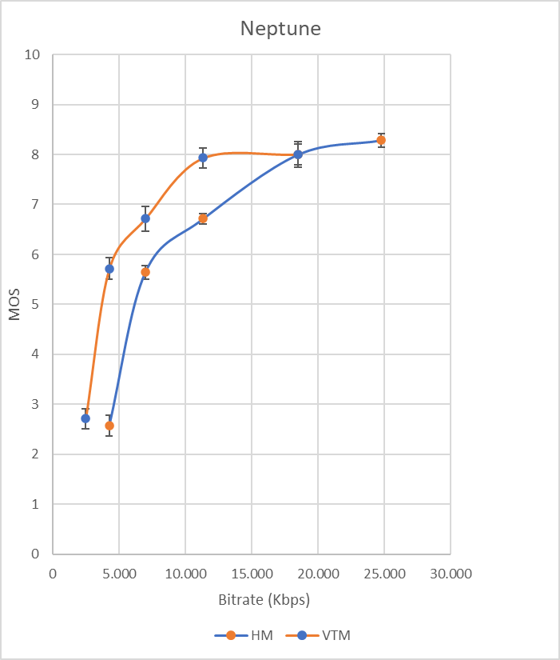

The above graphs report the MOS and the 95% CI values computed on the 16 viewers with the CI interval centered around the mean.
The DrivingPov sequence was shown in its original dimensions.

Conclusions
The results of the subjective assessment showed a rather good spread of quality given by the applied QP selection; it has to be noted that although the QP distance has been increased, the VTM mostly showed a slightly better quality than the corresponding HM rate point.
It can be observed that for a number of rate points, the bit rate savings provided by VTM is about 50% compared to the HM.
The test revealed that for the test sequence Marathon, the QP range should be shifted to lower QPs in order to allow for a better spread of the results over the entire MOS quality scale.
It is reported that the viewers agreed on increased difficulty to properly rate the test sequence NeptuneFountain when being asked for the level of difficulty of the test; this could suggest to replace it with another from the set of test sequences used for the EVP test.

ANNEX A – Rate-distortion plots

Marathon
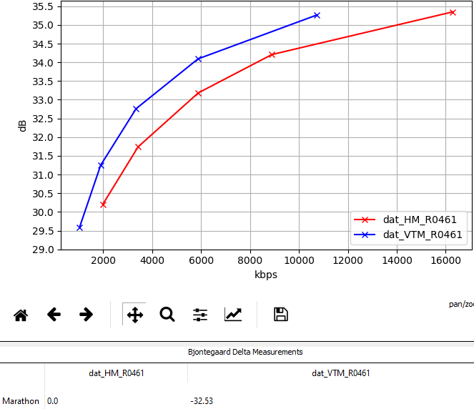

MountainBay2
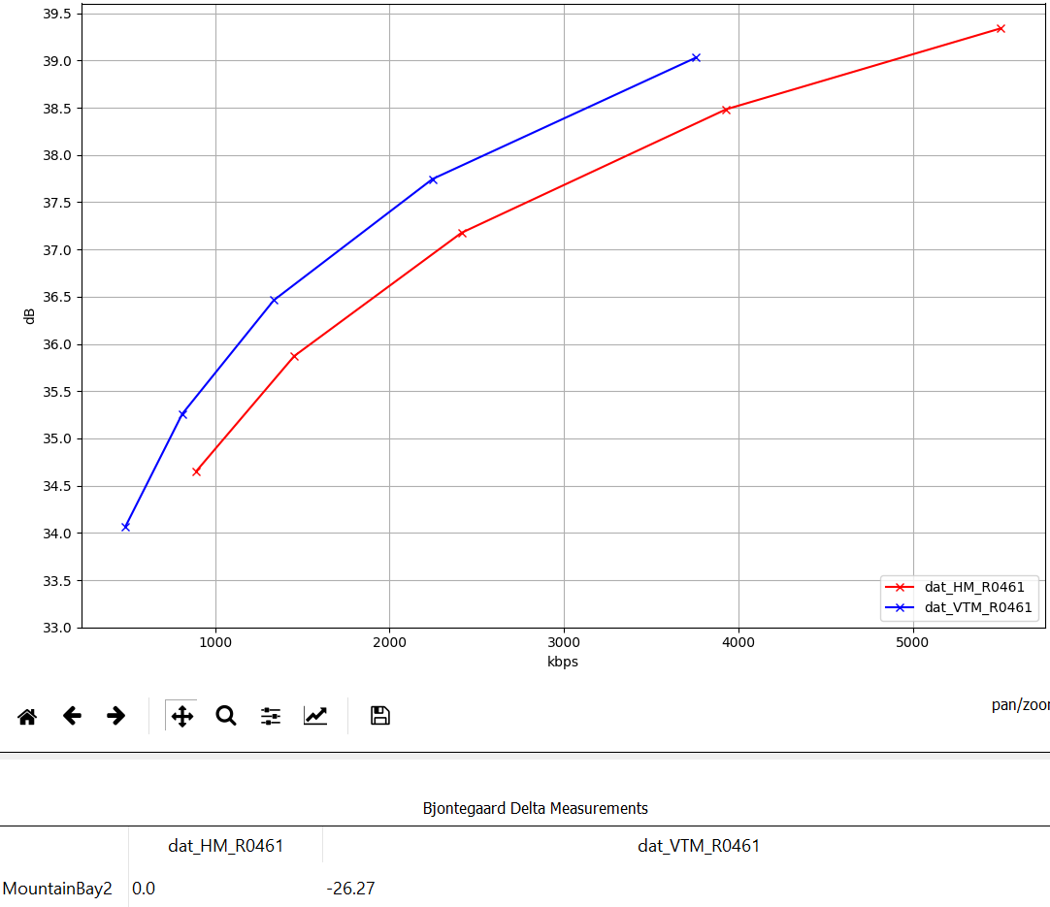

Netflix_DrivingPOV
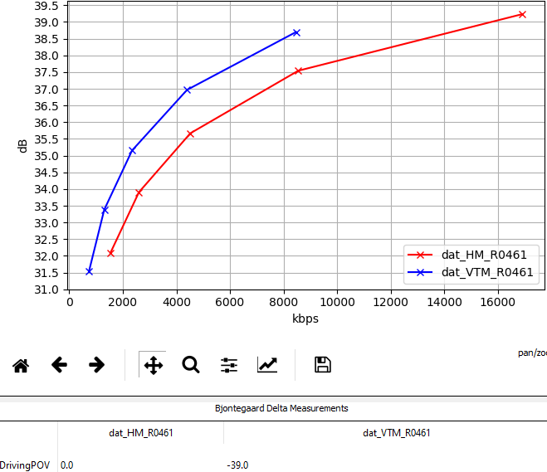

NeptuneFountain3
