    Joint Video Experts Team (JVET)  of ITU-T SG 16 WP 3 and ISO/IEC JTC 1/SC 29/WG 11  18th Meeting: by teleconference, 15–24 April 2020 | Document: JVET-R0318-v1

Title: | Alternative methods of LFNST index signaling
Status: | Input document to JVET
Purpose: | Proposal
Author(s) or  Contact(s): | Moonmo Koo  Jaehyun Lim  19 Yangjaedaero-11gil  Seocho-gu, Seoul 06772  South Korea  Mehdi Salehifar  Seung-Hwan Kim  10225 Willow Creek Rd, San Diego  CA 92131, USA | Tel:  Email: | +1-858-635-5226  moonmo.koo@lge.com  jaehyun.lim@lge.com  mehdi.salehifar@lge.com  seunghwan3.kim@lge.com
Source: | LG Electronics Inc.
_____________________________

Abstract
The adoptions on LFNST in the 17th JVET meeting had resolved complexity issues in LFNST, which led the following two features: 1) an LFNST index can be signalled in the case that Luma CBF (Coded Block Flag) is zero and Chroma coefficient distribution is compatible with LFNST in single-tree case, and 2) Chroma coefficient distribution shall be compatible with LFNST in single-tree case although LFNST is only applied to Luma in single-tree case. Here, the compatibility with LFNST indicates that coefficients should be properly zeroed-out for LFNST and at least one non-zero coefficient should exist at a position other than DC.
In this contribution, three alternative LFNST index signaling methods are proposed to remove one or all of the two features as follows:
- Method 1: Simple addition of a condition to prevent the signaling in the case of zero Luma CBF
- Method 2: Enabling Chroma LFNST in single-tree case
- Method 3: LFNST index signaling in transform_unit syntax table
Method 1 removes the first feature, and others both of the two features. And, Method 1 and Method 2 incur minimal changes of spec, but Method 3 requires the fairly amount of spec changes. The BD-rate changes of Y/U/V are summarized as follows:
- Method 1: 0.00%/0.00%/0.00% (AI), and -0.01%/-0.01%/-0.02% (RA)
- Method 2: -0.04%/-0.19%/-0.27% (RA)
- Method 3: 0.00%/0.00%/0.00% (AI), -0.01%/0.00%/-0.04% (RA), and 0.00%/0.00%/0.00% (LD)
According to the experimental results of Method 1 and Method 3, both of the two feature make little impact on coding performance. Furthermore, Method 2 increases complexity due to the Chroma LFNST in single-tree case. It is recommended that 1) no action should be taken on current LFNST index signaling if it is thought that the two features do not incur any critical issues, or 2) Method 1 or Method 2 could be adopted if more conservative approaches are preferable, or 3) Method 3 could be considered if group is not concerned about considerable spec changes.

Motivation
The adoptions [3] of the 17th JVET meeting had resolved complexity issues in LFNST, which led the following two features:

LFNST index signaling in the case of zero Luma CBF
In current VVC WD, an LFNST index can be signalled in single-tree case, when Luma CBF is zero and coefficient distribution for two Chroma components is compatible with LFNST, i.e. LFNST zeroing-out and non-zero coefficient at non-DC position. For the LFNST index to be signalled, the compatibility conditions should be satisfied for two Chroma components.

Chroma coefficient distribution in single-tree case for LFNST
In single-tree case, coefficient distribution for all three components shall be compatible with LFNST, i.e. LFNST zeroing-out and non-zero coefficient at non-DC position, in order for the LFNST index to be signalled, which can be thought of as a design feature because the compatibility conditions are required for Luma in single-tree case.
In this contribution, effects of the above two features, 1.1 and 1.2, are investigated through experiments and alternative LFNST index signaling methods free of 1.1 or 1.2 are proposed.

Proposed methods

Method 1: Simple addition of a condition to prevent the signaling in the case of zero Luma CBF
As Method 1, an additional condition for LFNST index signaling in coding_unit syntax table is proposed to prevent the aforementioned signaling case, as yellow-shaded part in Table 1. Specifically, tu_y_coded_flag[ x0 ][ y0 ] corresponds to CBF of first partition block of ISP-coded CU or that of Luma TB of non-ISP CU. Although it is guaranteed that at least one non-zero coefficient exist in an ISP-coded Luma CB, tu_y_code_flag[ x0 ][ y0 ] of the first partition block do not have to be non-zero. Therefore, ISP and non-ISP cases are treated separately in the additional condition.

Table 1 The additional condition for LFNST index signaling to prevent the signaling in the case of zero Luma CBF
coding_unit( x0, y0, cbWidth, cbHeight, cqtDepth, treeType, modeType ) {
……
if( cu_coded_flag ) {
……
LfnstDcOnly = 1
LfnstZeroOutSigCoeffFlag = 1
MtsDcOnly = 1
MtsZeroOutSigCoeffFlag = 1
transform_tree( x0, y0, cbWidth, cbHeight, treeType, chType )
lfnstWidth = ( treeType = = DUAL_TREE_CHROMA ) ? cbWidth / SubWidthC :
( ( IntraSubPartitionsSplitType = = ISP_VER_SPLIT ) ?
cbWidth / NumIntraSubPartitions : cbWidth )
lfnstHeight = ( treeType = = DUAL_TREE_CHROMA ) ? cbHeight / SubHeightC :
( ( IntraSubPartitionsSplitType = = ISP_HOR_SPLIT) ?
cbHeight / NumIntraSubPartitions : cbHeight )
lfnstNotTsFlag = ( treeType = = DUAL_TREE_CHROMA | |
transform_skip_flag[ x0 ][ y0 ][ 0 ] = = 0 ) &&
( treeType = = DUAL_TREE_LUMA | |
( transform_skip_flag[ x0 ][ y0 ][ 1 ] = = 0 &&
transform_skip_flag[ x0 ][ y0 ][ 2 ] = = 0 ) )
if( Min( lfnstWidth, lfnstHeight ) >= 4 && sps_lfnst_enabled_flag = = 1 &&
CuPredMode[ chType ][ x0 ][ y0 ] = = MODE_INTRA && lfnstNotTsFlag = = 1 &&
( treeType = = DUAL_TREE_CHROMA | | !intra_mip_flag[ x0 ][ y0 ] | |
Min( lfnstWidth, lfnstHeight ) >= 16 ) &&
Max( cbWidth, cbHeight ) <= MaxTbSizeY) {
if( ( IntraSubPartitionsSplitType != ISP_NO_SPLIT | | LfnstDcOnly = = 0 ) &&
LfnstZeroOutSigCoeffFlag = = 1 && ( treeType != SINGLE_TREE | |
IntraSubPartitionsSplitType != ISP_NO_SPLIT | | tu_y_coded_flag[ x0 ][ y0 ] ) )
lfnst_idx
}
if( treeType != DUAL_TREE_CHROMA && lfnst_idx = = 0 &&
transform_skip_flag[ x0 ][ y0 ][ 0 ] = = 0 && Max( cbWidth, cbHeight ) <= 32 &&
IntraSubPartitionsSplitType = = ISP_NO_SPLIT && cu_sbt_flag = = 0 &&
MtsZeroOutSigCoeffFlag = = 1 && MtsDcOnly = = 0 ) {
if( ( ( CuPredMode[ chType ][ x0 ][ y0 ] = = MODE_INTER &&
sps_explicit_mts_inter_enabled_flag ) | |
( CuPredMode[ chType ][ x0 ][ y0 ] = = MODE_INTRA &&
sps_explicit_mts_intra_enabled_flag ) ) )
mts_idx
}
}
}

Furthermore, Table 2 shows equivalent and more concise representation of the same signaling condition, by making a conditional, “IntraSubPartitionsSplitType != ISP_NO_SPLIT”, appear only once.

Table 2 The alternative representation of LFNST index signaling conditions to prevent the signaling in the case of zero Luma CBF
if( Min( lfnstWidth, lfnstHeight ) >= 4 && sps_lfnst_enabled_flag = = 1 &&
CuPredMode[ chType ][ x0 ][ y0 ] = = MODE_INTRA && lfnstNotTsFlag = = 1 &&
( treeType = = DUAL_TREE_CHROMA | | !intra_mip_flag[ x0 ][ y0 ] | |
Min( lfnstWidth, lfnstHeight ) >= 16 ) &&
Max( cbWidth, cbHeight ) <= MaxTbSizeY) {
if( LfnstZeroOutSigCoeffFlag = = 1 &&
( IntraSubPartitionsSplitType != ISP_NO_SPLIT | | ( LfnstDcOnly = = 0 &&
( treeType != SINGLE_TREE | | tu_y_coded_flag[ x0 ][ y0 ] ) ) )
lfnst_idx
}

Method 2: Enabling of Chroma LFNST in single-tree case
As Method 2, it is proposed that LFNST should be applied to Chroma components as well in single-tree case, where a single LFNST index is shared among Luma and Chroma components. Therefore, the signaling case introduced in section 1.1 does not happen anymore, because at least one component where LFNST is applied has non-zero coefficient whenever an LFNST index is signalled. Furthermore, the second feature in section 1.2 does not exist anymore because LFNST can be applied to both Luma and Chroma. No changes in syntax tables are required, and scaling, transformation and array construction process (section 8.7 in current VVC WD) should be modified accordingly, as shown in Table 3 and Table 4.

Table 3 The required changes in transformation process for enabling Chroma LFNST in single-tree case
lfnst_idx specifies whether and which one of the two low frequency non-separable transform kernels in a selected transform set is used. lfnst_idx equal to 0 specifies that the low frequency non-separable transform is not used in the current coding unit.
When lfnst_idx is not present, it is inferred to be equal to 0.
The variable ApplyLfnstFlag is derived as follows:
- If treeType is equal to SINGLE_TREE, the following applies:
ApplyLfnstFlag = ( lfnst_idx > 0 && cIdx = = 0 ) ? 1 : 0 (176)
- Otherwise, the following applies:
ApplyLfnstFlag = ( lfnst_idx > 0 ) ? 1 : 0 (177)
……
8.7.4 Transformation process for scaled transform coefficients
8.7.4.1 General
…..
The variable ApplyLfnstFlag is derived as follows:
ApplyLfnstFlag = ( lfnst_idx > 0 && nTbW >= 4 && nTbH >= 4 ) ? 1 : 0
When ApplyLfnstFlag is equal to 1, transform_skip_flag[ xTbY ][ yTbY ][ cIdx ] is equal to 0 and both nTbW and nTbH are greater than or equal to 4, the following applies:
……
The variables nonZeroW and nonZeroH are derived as follows:
- If ApplyLfnstFlag is equal to 1 and nTbW is greater than or equal to 4 and nTbH is greater than or equal to 4, the following applies:
nonZeroW = ( nTbW = = 4 | | nTbH = = 4 ) ? 4 : 8 (1190)
nonZeroH = ( nTbW = = 4 | | nTbH = = 4 ) ? 4 : 8 (1191)
……

Table 4 The required changes in scaling process for enabling Chroma LFNST in single-tree case
8.7.3 Scaling process for transform coefficients
……
The variable ApplyLfnstFlag is derived as follows:
ApplyLfnstFlag = ( lfnst_idx > 0 && nTbW >= 4 && nTbH >= 4 ) ? 1 : 0
For the derivation of the scaled transform coefficients d[ x ][ y ] with x = 0..nTbW − 1, y = 0..nTbH − 1, the following applies:
- The intermediate scaling factor m[ x ][ y ] is derived as follows:
- If one or more of the following conditions are true, m[ x ][ y ] is set equal to 16:
- slice_explicit_scaling_list_used_flag is equal to 0.
- transform_skip_flag[ xTbY ][ yTbY ][ cIdx ] is equal to 1.
- scaling_matrix_for_lfnst_disabled_flag is equal to 1 and ApplyLfnstFlag is equal to 1.
- Otherwise, the following applies:
……

Method 3: LFNST index signaling in transform_unit syntax table
As Method 3, it is proposed that LFNST index signaling should be performed right after parsing of only relevant components. Even with this approach, in separate tree cases, behaviors of LFNST index signaling are effectively unchanged because only Luma or Chroma components are involved in the signaling. However, in single-tree case, an LFNST index is changed to be signalled right after coefficient parsing of Luma component. Table 5 and Table 6 show how syntax tables are changed relative to current VVC WD, where cancelling lines indicate removal of the existing text.

Table 5 The coding_unit syntax table when signaling of both LFNST and MTS indices are moved to transform_unit syntax table
coding_unit( x0, y0, cbWidth, cbHeight, cqtDepth, treeType, modeType ) {
……
if( cu_coded_flag ) {
……
LfnstDcOnly = 1
LfnstZeroOutSigCoeffFlag = 1
MtsDcOnly = 1
MtsZeroOutSigCoeffFlag = 1
lfnstWidth = ( treeType = = DUAL_TREE_CHROMA ) ? cbWidth / SubWidthC :
( ( IntraSubPartitionsSplitType = = ISP_VER_SPLIT ) ?
cbWidth / NumIntraSubPartitions : cbWidth )
lfnstHeight = ( treeType = = DUAL_TREE_CHROMA ) ? cbHeight / SubHeightC :
( ( IntraSubPartitionsSplitType = = ISP_HOR_SPLIT) ?
cbHeight / NumIntraSubPartitions : cbHeight )
transform_tree( x0, y0, cbWidth, cbHeight, treeType, chType )
lfnstNotTsFlag = ( treeType = = DUAL_TREE_CHROMA | |
transform_skip_flag[ x0 ][ y0 ][ 0 ] = = 0 ) &&
( treeType = = DUAL_TREE_LUMA | |
( transform_skip_flag[ x0 ][ y0 ][ 1 ] = = 0 &&
transform_skip_flag[ x0 ][ y0 ][ 2 ] = = 0 ) )
if( Min( lfnstWidth, lfnstHeight ) >= 4 && sps_lfnst_enabled_flag = = 1 &&
CuPredMode[ chType ][ x0 ][ y0 ] = = MODE_INTRA && lfnstNotTsFlag = = 1 &&
( treeType = = DUAL_TREE_CHROMA | | !intra_mip_flag[ x0 ][ y0 ] | |
Min( lfnstWidth, lfnstHeight ) >= 16 ) &&
Max( cbWidth, cbHeight ) <= MaxTbSizeY) {
if( ( IntraSubPartitionsSplitType != ISP_NO_SPLIT | | LfnstDcOnly = = 0 ) &&
LfnstZeroOutSigCoeffFlag = = 1 )
lfnst_idx
}
if( treeType != DUAL_TREE_CHROMA && lfnst_idx = = 0 &&
transform_skip_flag[ x0 ][ y0 ][ 0 ] = = 0 && Max( cbWidth, cbHeight ) <= 32 &&
IntraSubPartitionsSplitType = = ISP_NO_SPLIT && cu_sbt_flag = = 0 &&
MtsZeroOutSigCoeffFlag = = 1 && MtsDcOnly = = 0 ) {
if( ( ( CuPredMode[ chType ][ x0 ][ y0 ] = = MODE_INTER &&
sps_explicit_mts_inter_enabled_flag ) | |
( CuPredMode[ chType ][ x0 ][ y0 ] = = MODE_INTRA &&
sps_explicit_mts_intra_enabled_flag ) ) )
mts_idx
}
}
}

Table 6 The transform_unit syntax table when signaling of both LFNST and MTS indices are moved to transform_unit syntax table
transform_unit( x0, y0, tbWidth, tbHeight, treeType, subTuIndex, chType ) {
……
allowLfnstIndex = Min( lfnstWidth, lfnstHeight ) >= 4 && sps_lfnst_enabled_flag = = 1 &&
CuPredMode[ chType ][ x0 ][ y0 ] = = MODE_INTRA &&
( treeType = = DUAL_TREE_CHROMA | | !intra_mip_flag[ x0 ][ y0 ] | |
Min( lfnstWidth, lfnstHeight ) >= 16 ) &&
Max( CbWidth[ chType ][ x0 ][ y0 ], CbHeight[ chType ][ x0 ][ y0 ] ) <= MaxTbSizeY &&
( IntraSubPartitionsSplitType = = ISP_NO_SPLIT | |
( IntraSubPartitionsSplitType != ISP_NO_SPLIT &&
subTuIndex = = NumIntraSubPartitions − 1 ) )
if( tu_y_coded_flag[ x0 ][ y0 ] && treeType != DUAL_TREE_CHROMA ) {
if( sps_transform_skip_enabled_flag && !BdpcmFlag[ x0 ][ y0 ][ 0 ] &&
tbWidth <= MaxTsSize && tbHeight <= MaxTsSize &&
( IntraSubPartitionsSplitType = = ISP_NO_SPLIT ) && !cu_sbt_flag )
transform_skip_flag[ x0 ][ y0 ][ 0 ]
if( !transform_skip_flag[ x0 ][ y0 ][ 0 ] | | slice_ts_residual_coding_disabled_flag )
residual_coding( x0, y0, Log2( tbWidth ), Log2( tbHeight ), 0 )
else
residual_ts_coding( x0, y0, Log2( tbWidth ), Log2( tbHeight ), 0 )
}
if( ( IntraSubPartitionsSplitType != ISP_NO_SPLIT | | LfnstDcOnly = = 0 ) &&
LfnstZeroOutSigCoeffFlag = = 1 && allowLfnstIndex &&
treeType ! = DUAL_TREE_CHROMA && transform_skip_flag[ x0 ][ y0 ][ 0 ] = = 0 )
lfnst_idx
if( treeType != DUAL_TREE_CHROMA && lfnst_idx = = 0 &&
transform_skip_flag[ x0 ][ y0 ][ 0 ] = = 0 &&
Max( CbWidth[ chType ][ x0 ][ y0 ], CbHeight[ chType ][ x0 ][ y0 ] ) <= 32 &&
IntraSubPartitionsSplitType = = ISP_NO_SPLIT && cu_sbt_flag = = 0 &&
MtsZeroOutSigCoeffFlag = = 1 && MtsDcOnly = = 0 ) {
if( ( ( CuPredMode[ chType ][ x0 ][ y0 ] = = MODE_INTER &&
sps_explicit_mts_inter_enabled_flag ) | |
( CuPredMode[ chType ][ x0 ][ y0 ] = = MODE_INTRA &&
sps_explicit_mts_intra_enabled_flag ) ) )
mts_idx
}
if( tu_cb_coded_flag[ xC ][ yC ] && treeType != DUAL_TREE_LUMA ) {
if( sps_transform_skip_enabled_flag && !BdpcmFlag[ x0 ][ y0 ][ 1 ] &&
wC <= MaxTsSize && hC <= MaxTsSize && !cu_sbt_flag )
transform_skip_flag[ xC ][ yC ][ 1 ]
if( !transform_skip_flag[ xC ][ yC ][ 1 ] | | slice_ts_residual_coding_disabled_flag )
residual_coding( xC, yC, Log2( wC ), Log2( hC ), 1 )
else
residual_ts_coding( xC, yC, Log2( wC ), Log2( hC ), 1 )
}
if( tu_cr_coded_flag[ xC ][ yC ] && treeType != DUAL_TREE_LUMA &&
!( tu_cb_coded_flag[ xC ][ yC ] && tu_joint_cbcr_residual_flag[ xC ][ yC ] ) ) {
if( sps_transform_skip_enabled_flag && !BdpcmFlag[ x0 ][ y0 ][ 2 ] &&
wC <= MaxTsSize && hC <= MaxTsSize && !cu_sbt_flag )
transform_skip_flag[ xC ][ yC ][ 2 ]
if( !transform_skip_flag[ xC ][ yC ][ 2 ] | | slice_ts_residual_coding_disabled_flag )
residual_coding( xC, yC, Log2( wC ), Log2( hC ), 2 )
else
residual_ts_coding( xC, yC, Log2( wC ), Log2( hC ), 2 )
}
if( LfnstDcOnly = = 0 && LfnstZeroOutSigCoeffFlag = = 1 && allowLfnstIndex &&
treeType = = DUAL_TREE_CHROMA && transform_skip_flag[ x0 ][ y0 ][ 1 ] = = 0 &&
transform_skip_flag[ x0 ][ y0 ][ 2 ] = = 0 )
lfnst_idx
}

From Table 5 and Table 6, the following aspects can be figured out:
(1) Only relevant transform skip flags are involved in signaling condition checking. A transform skip flag for Luma (transform skip flags for both Cb and Cr) shall be 0 for an LFNST index to be signalled in the case of Luma separate tree or single tree (Chroma separate tree).
(2) The LfnstDcOnly and LfnstZeroOutSigCoeffFlag are updated by only relevant components, from which two Chroma components are free of constraints for coefficient distribution that allows LFNST. In other words, Cb and Cr can have transform coefficients anywhere in each TB, irrespective of whether LFNST is applied to Luma or not.
(3) When ISP mode is selected, a Luma CB consists of 2 or 4 partition blocks, for each of which transform_unit is invoked. When it comes to the updates of LfnstDcOnly and LfnstZeroOutSigCoeffFlag, it needs to traverse all ISP partition blocks in order to check all Luma coefficient distribution. Therefore, an LFNST index is signalled in the last partition block for ISP.
(4) In Table 6, two signaling parts of LFNST index are not overlapped because the latter one is only activated in the case of Chroma separate tree.

Experimental results
The proposed methods have been implemented based on VTM 8.0 reference software according to common test conditions defined in JVET-N1010 [2].

Method 1: Simple addition of a condition to prevent the signaling in the case of zero Luma CBF

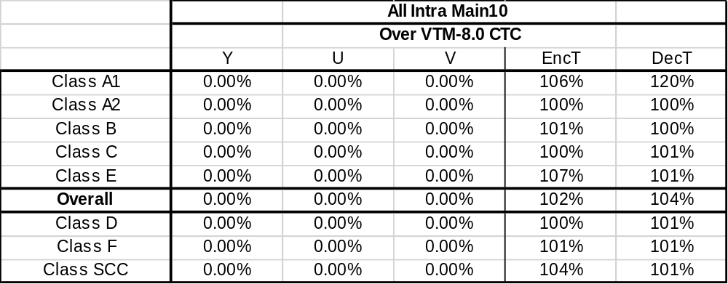

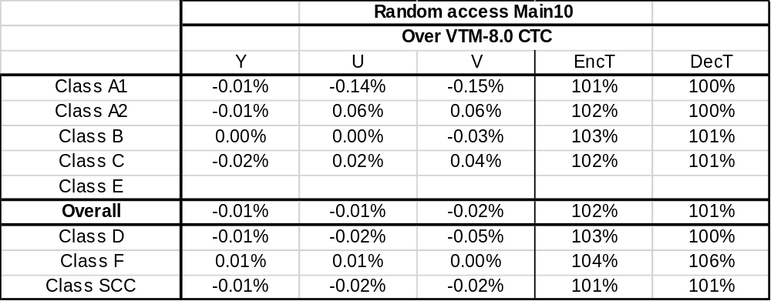

Enabling of Chroma LFNST in single-tree case

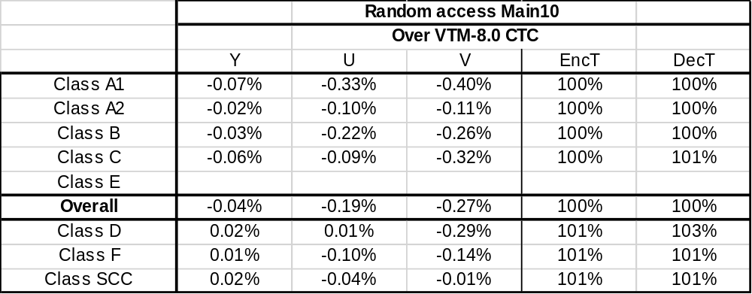

LFNST index signaling in transform_unit syntax table

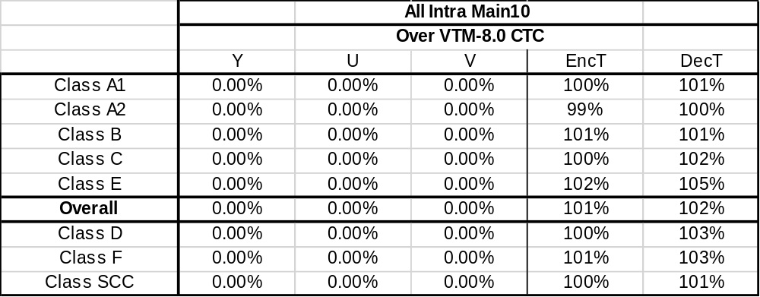

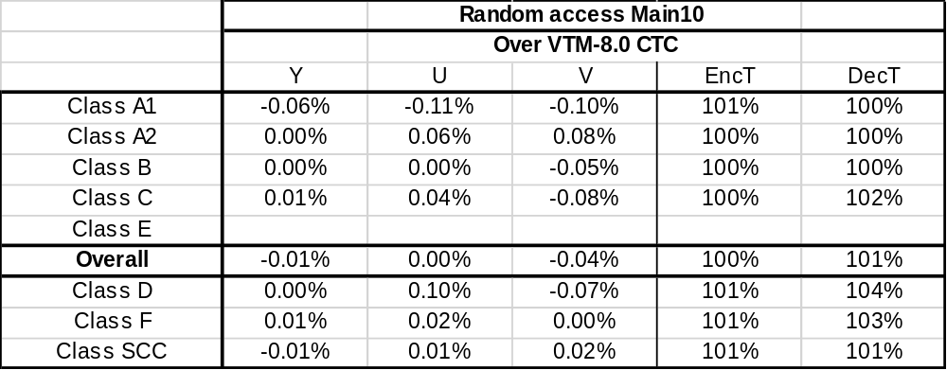

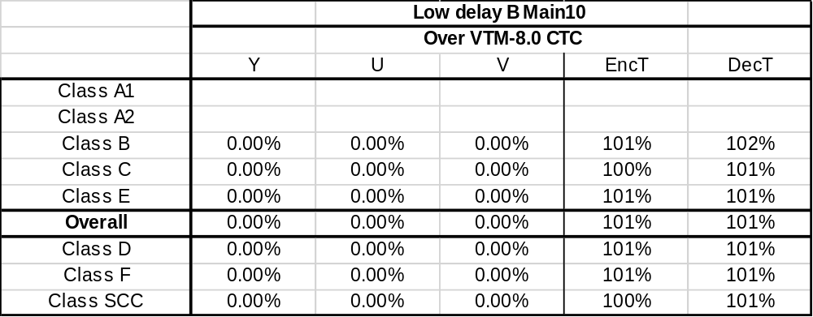

Analysis on the proposed methods
From the experimental results of 3.1 (Method 1: Simple addition of a condition to prevent the signaling in the case of zero Luma CBF), it can be figured out that the first feature makes little coding effect. However, Method 1 seems to be simple enough for removing the first feature while keeping the existing syntax table as much as possible.
Method 2 (Enabling Chroma LFNST in single-tree case) can be seen as a method to remove both of the features, 1.1 and 1.2, with minimal spec changes. However, Method 2 increases computational complexity from enabling Chroma LFNST in single-tree case, although no effective gain improvement was observed and Chroma LFNST may not impact on critical path in hardware designs.
According to the experimental results of 3.3 (Method 3: LFNST index signaling in transform_unit syntax table), it can be indirectly figured out that the second feature does not help coding performance effectively. Method 3 does not have the two features while keeping Chroma LFNST turned off in single-tree case, in contrast to Method 2, and little performance changes were observed in their experimental results. However, this method requires the fairly amount of spec text changes, which could be thought undesirable at this stage of VVC development.

Conclusion
In this contribution, alternative LFNST index signaling methods are proposed because the following two features have been introduced from the adoptions [3] in the 17th JVET meeting: 1) an LFNST index signaling could occur in the case that Luma CBF is zero and conditions of LFNST zero-out along with existence of non-zero coefficient at non-DC position for Chroma components are satisfied in single-tree case, and 2) these conditions shall also be satisfied for Chroma components although LFNST is only applied to Luma in single-tree case. From experimental results, it turned out that these two features could not be serious issues, so that strong motivations for removing them could not be easily found. However, if group thinks that one or all of the two features should be removed, the proposed methods could be options. Specifically, if more conservative approaches are preferred, Method 1 or Method 2 seems to be more appropriate. Otherwise, Method 3 can also be considered.

References
- B. Bross, J. Chen, S. Liu, and Y.-K. Wang, “Versatile Video Coding (Draft 8)”, JVET-Q2001, 17th meeting, Brussels, BE, 7–17 January 2020.
- F. Bossen, J. Boyce, K. Suehring, X. Li and V. Seregin, “JVET common test conditions and software reference configurations for SDR video”, JVET-N1010, 14th meeting, Geneva, CH, 19–27 March 2019.
- H.E. Egilmez, A. Nalci, A.K. Ramasubramonian, M. Coban, V. Seregin, M. Karczewicz, T. Hashimoto, T. Chujoh, E. Sasaki, T. Ikai, “Combination of JVET-Q0106, JVET-0686 and JVET-Q0133 for LFNST Signaling, Latency Reduction and Scaling Process”, JVET-Q0784, Brussels, BE, January 2020.

Patent rights declaration(s)
LG Electronics Inc. may have current or pending patent rights relating to the technology described in this contribution and, conditioned on reciprocity, is prepared to grant licenses under reasonable and non-discriminatory terms as necessary for implementation of the resulting ITU-T Recommendation | ISO/IEC International Standard (per box 2 of the ITU-T/ITU-R/ISO/IEC patent statement and licensing declaration form).

