    Joint Video Experts Team (JVET)  of ITU-T SG 16 WP 3 and ISO/IEC JTC 1/SC 29/WG 11  18th Meeting: by teleconference, 15–24 April 2020 | Document: JVET-R0299_v2

Title: | Additional fix for ALF virtual boundary processing
Status: | Input document to JVET
Purpose: | Proposal
Author(s) or  Contact(s): | K. Andersson,  J. Ström,  Z. Zhang,  J. Enhorn | Tel:  Email: | +46730371390  kenneth.r.andersson@ericsson.com
Source: | Ericsson
_____________________________

Abstract
At the last previous meeting, a low complexity fix for ALF virtual horizontal CTU boundary was adopted from JVET-Q0150. An alternative approach proposed in the same contribution was rejected since the increase of two luma line buffers and two chroma line buffers for each component was undesirable. This contribution proposes a combination of the two approaches in JVET-Q0150 as follows: Filtering of a row just above the virtual horizontal CTU boundary is performed as currently using the low complexity technique, i.e., not using samples below the virtual horizontal CTU boundary. When filtering a row just below the virtual horizontal CTU boundary on the other hand, this contribution proposes to change the filtering process so as to let it use also one row just above the virtual horizontal CTU boundary. This combined approach is asserted to further reduce visual artifacts from virtual horizontal CTU boundary processing. Proposal 1 of this contribution only changes the ALF filtering. It is claimed that the memory cost for proposal 1 is 60% of one 10-bit line buffers for luma samples and 60% of one 10-bit line buffer for each chroma channel for chroma samples. Proposal 2 of this contribution combines proposal 1 with an approach that avoids filtering across the virtual boundary also for SAO when filtering samples just below the virtual boundary, by employing padding. Samples just above the virtual boundary are SAO-filtered as currently. It is claimed that proposal 2 comes at no memory cost in terms of line buffers over the current draft of VVC.
The claimed benefit of the proposal is suppression of coding artifacts from virtual horizontal CTU boundary processing. The BD rate impact for luma for CTC is as follows:
Proposal 1: AI: -0.01%, RA: -0.03%, LDB: -0.09%
Proposal 2: AI: -0.01%, RA: -0.xx%. LDB: -0.xx%
Similar encoding and decoding times as the anchor are reported.

Introduction
ALF virtual horizontal CTU boundary processing in VVC defines a virtual horizontal CTU boundary 4 samples above the top row of the below CTU for luma and 2 samples above the top row of the below CTU for chroma. ALF symmetry padding is used to avoid using samples below the virtual boundary when filtering above it, and to avoid using samples above the virtual boundary when filtering below it. To avoid extreme padding when filtering the rows just above and just below the virtual boundary, the filter output is currently attenuated for those rows as described in alternative 2 in JVET-Q0150 [1].
At the last meeting, there was also a discussion about alternative 1 in the same contribution, where it was proposed to also use samples from the row just above the virtual boundary when filtering the row just below the virtual boundary, and to also use samples from the row just below the virtual boundary when filtering the row just above the virtual boundary. Alternative 1 was asserted to fix the problem completely but at the cost of 2 lines buffers for luma and 2 line buffers for each chroma component, and was therefore rejected by the meeting in favor of alternative 2.

Proposal 1
The filtering for the row just above the virtual boundary is performed as in the current VVC draft. The filtering for the row just below the virtual boundary however is changed; it now also uses the row just above the virtual boundary.
In detail, we can describe the processing as happening in two stages, an upper stage and a lower stage. In the upper stage, all processing that can be done while only having read the upper CTU is done. In the lower stage, the processing that needs information also from the lower CTU is done. Currently in VVC, this can be done as follows:
Upper stage:
- Decoding of upper CTU (lines J-P in Figure 1)
- SAO of upper CTU, except lines M-P (to SAO-filter line M is not possible since it will need line N which may change due to deblocking)
- ALF of upper CTU, except lines M-P (ALF does not need to read lines below the virtual boundary when filtering above the virtual boundary, so filtering up to and including L is possible)
Lower stage
- Decoding of lower CTU (lines Q-U in Figure 1)
- Deblocking of lines N-P of upper CTU (needs line buffers M, N, O, P of pre-deblock data)
- SAO of upper CTU, lines M-P (needs line buffer L of pre-SAO data)
- ALF of upper CTU, lines M-P
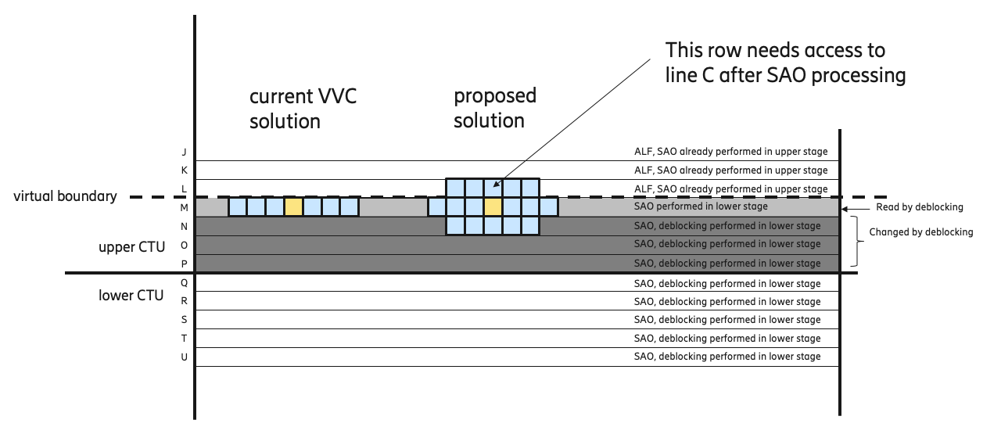
Figure 1. Left: The current VVC solution of ALF processing of samples just below the virtual horizontal CTU boundary. Right: The proposed solution, which in addition to existing line buffers also needs post-SAO samples from line C.
The proposed method carries out step 1 through 6 the same way as in the current VVC specification. The only difference is in step 7, (depicted in Figure 1), where ALF processing of lines M-P of the upper CTU takes place. In this step the proposed method also accesses line L directly above the virtual boundary. Thus the last step 7 also needs access to a line buffer of L where post-SAO data is stored. Hence, for luma, the line buffers needed for decoding are increased from
M decoded samples before SAO
N decoded samples before SAO
O decoded samples before SAO
P decoded samples before SAO
L decoded samples before SAO
to
M decoded samples before SAO
N decoded samples before SAO
O decoded samples before SAO
P decoded samples before SAO
L decoded samples before SAO
L decoded samples after SAO (new)
As an implementational detail, since a line buffer containing L before SAO is necessary both in the current draft of VVC and in the proposed solution, only the SAO offset in every sample needs to be stored in the novel line buffer in order to be able to recreate line L after SAO. Since the SAO offset is a value between -31 and 31 inclusive, at most 6 bits are needed to be stored in the line buffer. Compared to storing a 10-bit value, the extra cost is therefore 6/10 = 0.6 line buffers for the proposed scheme.
Although this increase of 0.6 line buffers is a drawback compared to the current draft of VVC, it is significantly less than the 2 line buffers needed in alternative 1 in JVET-Q0150. Furthermore, it is also still significantly less than the amount of line buffers that would be required without ALF virtual horizontal CTU boundary processing.
Specification text changes [2] high-lighted in yellow below for luma and chroma:
Table 45 – Specification of y1, y2, y3 and alfShiftY according to the vertical luma sample position y and applyAlfLineBufBoundary
Condition | alfShiftY | y1 | y2 | y3
( y = = CtbSizeY − 5 | | y = = CtbSizeY − 4 ) &&  ( applyAlfLineBufBoundary = = 1 ) | 10 | 0 | 0 | 0
( y = = CtbSizeY − 6 | | y = = CtbSizeY − 4 ) &&  ( applyAlfLineBufBoundary = = 1 ) | 7 | 1 | 1 | 1
( y = = CtbSizeY − 7 | | y = = CtbSizeY − 3 ) &&  ( applyAlfLineBufBoundary = = 1 ) | 7 | 1 | 2 | 2
Otherwise | 7 | 1 | 2 | 3

Table 46 – Specification of y1, y2 and alfShiftC according to the vertical chroma sample position y and applyAlfLineBufBoundary
Condition | alfShiftC | y1 | y2
( y = = ctbHeightC − 2 | | y = = ctbHeightC − 3 ) &&  ( applyAlfLineBufBoundary = = 1 ) | 10 | 0 | 0
( y = = ctbHeightC − 2 | | y = = ctbHeightC − 4 ) &&  ( applyAlfLineBufBoundary = = 1 ) | 7 | 1 | 1
Otherwise | 7 | 1 | 2

It is also proposed to remove the padding of row y equal to CtbSizeY-5, just above the virtual horizontal CTU boundary (line L in Figure 1), when calculating the activity metric in equations 1472 to 1474 centered on row y equal to CtbSizeY-4 (line M in Figure 1). Since the proposal allows usage of row y equal to CtbSizeY-5 (line L in Figure 1) when filtering at rows with y equal to CtbSizeY-4 or below (lines M, N, O and P in Figure 1) e.g. below the virtual boundary, we can also make use of row CtbSizeY-5 for the ALF classification.
The change to the VVC draft is high-lighted in yellow below:
8.8.5.5 ALF boundary position derivation process:
..
The variable clipTopPos is modified as follows:
If y − ( CtbSizeY − 5 ) is greater than or equal to 0, the variable clipTopPos is set equal to yCtb + CtbSizeY − 5.
..

Proposal 2
For proposal 2, ALF is filtered in the same way as for proposal 1. However, in order not to increase the total number of line buffers, SAO is changed so that it avoids accessing samples above the virtual boundary when filtering samples just below the virtual boundary, by padding from the current row. Samples just above the virtual boundary are treated as currently, i.e., SAO is then allowed to read across the virtual boundary.
Compared to proposal 1, only step 6 is changed from
- SAO of upper CTU, lines M-P (needs line buffer L of pre-SAO data)
to
- SAO of upper CTU, lines M-P, (pad row L from row M when SAO-filtering row M)

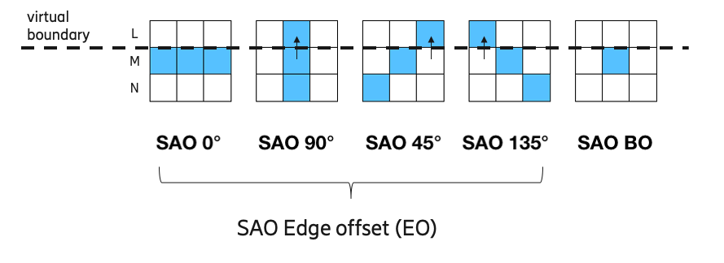
Figure 2: In proposal 2, samples above the virtual boundary (line L) are not accessed when filtering line M. Instead samples are padded from M to L as indicated by the arrows.
The padding process when SAO-filtering row M (the one immediately below the virtual boundary) is shown in Figure 2, where padding is indicated by arrows. No changes are done for SAO filtering of any other row. Since pre-SAO samples from row L are no longer needed by SAO when filtering row M, the line buffers required for proposal 2 thus become
M decoded samples before SAO
N decoded samples before SAO
O decoded samples before SAO
P decoded samples before SAO
L decoded samples before SAO
L decoded samples after SAO (new)
Hence the number of line buffers stays the same as for VVC 8, namely 5.

Results
The objective performance for the proposal is shown below in comparison to VTM-8.0 [3] using CTC [4]. The objective results show a small gain for all coding configurations. Encoding time is measured on simulations run on a cluster with machines with similar capability and is not reliable. Decoding time is measured by running test and anchor on same machine without yuv output. Encoding and decoding times are similar to those of the anchor.

Proposal 1

All intra
Over VTM-8.0
 | Y | U | V | EncT | DecT
Class A1 | -0,01% | -0,13% | -0,17% | 98% | 100%
Class A2 | 0,00% | -0,06% | -0,04% | 99% | 99%
Class B | -0,01% | -0,06% | -0,06% | 96% | 100%
Class C | -0,01% | -0,05% | -0,06% | 92% | 100%
Class E | -0,02% | -0,05% | -0,06% | 90% | 100%
Overall | -0,01% | -0,07% | -0,08% | 95% | 100%
Class D | -0,01% | -0,03% | -0,02% | 90% | 100%
Class F | -0,01% | -0,03% | -0,07% | 94% | 100%

Random access
Over VTM-8.0
 | Y | U | V | EncT | DecT
Class A1 | -0,03% | -0,22% | -0,13% | 102% | 101%
Class A2 | -0,05% | -0,05% | 0,02% | 103% | 100%
Class B | -0,02% | -0,05% | -0,12% | 94% | 100%
Class C | -0,04% | -0,07% | -0,03% | 86% | 98%
Class E
Overall | -0,03% | -0,09% | -0,07% | 95% | 100%
Class D | 0,01% | -0,04% | -0,17% | 85% | 98%
Class F | 0,03% | -0,10% | -0,13% | 89% | 99%

Low-delay B
Over VTM-8.0
Class A1
Class A2
Class B | -0,05% | 0,00% | 0,02% | 106% | 99%
Class C | -0,14% | -0,19% | -0,30% | 98% | 101%
Class E | -0,08% | 0,32% | 0,12% | 96% | 101%
Overall | -0,09% | 0,01% | -0,06% | 101% | 100%
Class D | -0,04% | -0,59% | -0,43% | 87% | 102%
Class F | -0,05% | 0,43% | -0,19% | 97% | 99%

Proposal 2

All intra
Over VTM-8.0
 | Y | U | V | EncT | DecT
Class A1 | -0.01% | -0.13% | -0.17% | 104% | 109%
Class A2 | 0.00% | -0.06% | -0.07% | 107% | 116%
Class B | -0.01% | -0.06% | -0.05% | 103% | 111%
Class C | -0.01% | -0.05% | -0.06% | 97% | 98%
Class E | -0.02% | -0.05% | -0.07% | 100% | 105%
Overall | -0.01% | -0.07% | -0.08% | 102% | 107%
Class D | 0.00% | -0.02% | -0.02% | 97% | 101%
Class F | -0.01% | -0.02% | -0.07% | 100% | 108%

Random access
Over VTM-8.0
 | Y | U | V | EncT | DecT
Class A1 | 0.00% | -0.15% | -0.12% | 112% | 117%
Class A2
Class B | -0.01% | -0.09% | -0.04% | 103% | 114%
Class C | -0.04% | -0.05% | -0.14% | 94% | 101%
Class E
Overall
Class D | 0.03% | -0.01% | 0.16% | 93% | 93%
Class F | 0.01% | -0.07% | -0.01% | 96% | 103%

Low-delay B
Over VTM-8.0
Class A1
Class A2
Class B
Class C | -0.12% | -0.26% | 0.05% | 109% | 125%
Class E | -0.04% | 0.05% | -0.46% | 107% | 119%
Overall
Class D | -0.05% | -0.95% | -0.11% | 95% | 105%
Class F

Conclusions
It is proposed to adopt proposal 1 to the VVC draft and VTM software to further improve the robustness of ALF virtual horizontal CTU boundary processing. If line buffer space is regarded to be a show-stopper we suggest adopting proposal 2, which strikes a better balance between line buffers allocated to SAO and ALF in terms of visible artifacts.

References
- K. Andersson, J. Ström, Z. Zhang, J. Enhorn, “Fix for ALF virtual boundary processing”, JVET-Q0150, Brussels, BE, 7–17 January 2020
- B. Bross, J. Chen, and S. Liu, "Versatile Video Coding (Draft 8)", Document of Joint Video Experts Team, JVET-Q2001.
- VTM-8.0, available at https://vcgit.hhi.fraunhofer.de/jvet/VVCSoftware_VTM/tags/VTM-8.0
- F. Bossen, J. Boyce, X. Li, V. Seregin, and K. Sühring, “JVET common test conditions and software reference configurations”, JVET-N1010

Patent rights declaration
Ericsson Corporation may have current or pending patent rights relating to the technology described in this contribution and, conditioned on reciprocity, is prepared to grant licenses under reasonable and non-discriminatory terms as necessary for implementation of the resulting ITU-T Recommendation | ISO/IEC International Standard (per box 2 of the ITU-T/ITU-R/ISO/IEC patent statement and licensing declaration form).

