    Joint Video Experts Team (JVET)  of ITU-T SG 16 WP 3 and ISO/IEC JTC 1/SC 29/WG 11  18th Meeting: by teleconference, 15–24 April 2020 | Document: JVET-R0288-v2

Title: | AHG16: Reference samples for ISP
Status: | Input document to JVET
Purpose: | Proposal
Author(s) or  Contact(s): | Frank Bossen | Tel:  Email: | +1 647 745 1691  fbossen@sharpsec.com
Source: | Sharp Electronics of Canada Ltd.
_____________________________

Abstract
It is asserted that during the 15th JVET meeting it was incorrectly determined that the text included in VVC draft 6 and its corresponding software is equivalent to aspect 1 of JVET-O0364 that was intended to be adopted. It is proposed to include aspect 1 of JVET-O0364 (as originally proposed) in the final VVC specification such as to facilitate implementations that use a single reference sample buffer for all blocks within a CU that exercises the ISP mode.

Introduction
Equation (334) in JVET-Q2001-vD defines a padding process for intra prediction. The original intent of JVET-O0364 was to require such padding to be performed only once per CU when ISP is used. This property holds for most cases in the current specification, but not all. The figures below illustrate the differences in padding for the last two ISP partitions in a CU. When generating a prediction for a partition other than the last, padded samples may be used, which is unintended.
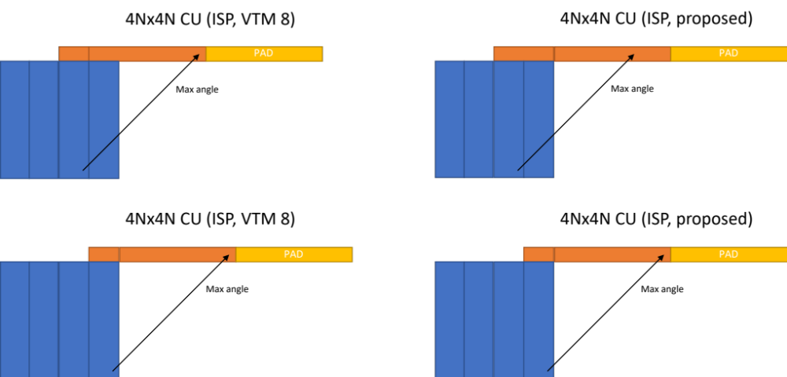

The following table contains a list of cases from a single bitstream (BasketballDrive RA QP22) where a difference occurs between the behaviour intended in JVET-O0364 and the behaviour of VTM 8.0.

CU size | TU size | Mode | Angle | Position within TU where mismatch occurs
16x4 | 16x1 | 12 | 8 | (12,0), (13,0), (14,0)
16x8 | 16x2 | 8 | 16 | (14,1)
32x4 | 32x1 | 14 | 4 | (24,0), (25,0), (26,0), (27,0), (28,0), (29,0), (30,0), (31,0)
32x8 | 32x2 | 12 | 8 | (28,1), (29,1), (30,1)
4x8 | 4x4 | 62 | 57 | (3,3)
8x16 | 4x16 | 60 | 16 | (3,14)
8x32 | 4x32 | 56 | 8 | (3,28), (3,29), (3,30)
8x4 | 4x4 | 6 | 57 | (3,3)
8x4 | 8x2 | 8 | 16 | (6,1)
8x4 | 8x2 | 9 | 14 | (7,1)
8x8 | 4x8 | 65 | 29 | (3,7)
8x8 | 8x2 | 3 | 29 | (7,1)

For example, consider the case of an 8x4 CU that gets split into two 4x4 partitions. For prediction mode 4, wide angle rules apply and both partitions in the CU are predicted from the above reference. For the sample at position (3,3), reference samples at positions (9, -1), (10, -1), (11, -1), and (12, -1) are used for prediction. In VTM 8.0, sample (12, -1) is padded from (11, -1). It shouldn’t be since the reference sample at the same position isn’t padded when predicting the last partition in the CU.

Text changes
In Section 8.4.5.1:
- For i = 0..NumIntraSubPartitions − 1, the following applies:
- The variables xPartIdx, yPartIdx, and xPartPbIdx are derived as follows:
xPartIdx = i * xPartInc (251)
yPartIdx = i * yPartInc (252)
xPartPbIdx = xPartIdx % pbFactor (253)
- When controlPara is not equal to 1 and xPartPbIdx is equal to 0, the intra sample prediction process as specified in clause 8.4.5.2 is invoked with the location ( xTbCmp, yTbCmp ) set equal to ( xTb0 + nW * xPartIdx, yTb0 + nH * yPartIdx ), the location ( xTb0, yTb0 ), the intra prediction mode predModeIntra, the transform block width nTbW and height nTbH set equal to nPbW and nH, the coding block width nCbW and height nCbH set equal to nTbW and nTbH, and the variable cIdx as inputs, and the output is an (nPbW)x(nH) array predSamples.
- When controlPara is not equal to 2, the scaling and transformation process as specified in clause 8.7.2 is invoked with the luma location ( xTbY, yTbY ) set equal to ( xTbY + nW * xPartIdx, yTbY + nH * yPartIdx ), the variable cIdx, the variable predMode set equal to MODE_INTRA the transform width nTbW and the transform height nTbH set equal to nW and nH as inputs, and the output is an (nW)x(nH) array resSamples.
- When controlPara is not equal to 1, the picture reconstruction process for a colour component as specified in clause 8.7.5 is invoked with the transform block location ( xTbComp, yTbComp ) set equal to ( xTb0 + nW * xPartIdx, yTb0 + nH * yPartIdx ), the transform block width nTbW, the transform block height nTbH set equal to nW and nH, the variable cIdx, the (nW)x(nH) array predSamples[ x ][ y ] with x = xPartPbIdx * nW..( xPartPbIdx +1 ) * nW − 1, y = 0..nH − 1, and the (nW)x(nH) array resSamples as inputs, and the output is a modified reconstructed picture before in-loop filtering.
In section 8.4.5.2:
Inputs to this process are:
- a sample location ( xTbCmp, yTbCmp ) specifying the top-left sample of the current transform block relative to the top-left sample of the current picture,
- a sample location ( xTb0, yTb0 ) specifying the top-left sample of the current coding block relative to the top-left sample of the current picture,
- a variable predModeIntra specifying the intra prediction mode,
- a variable nTbW specifying the transform block width,
- a variable nTbH specifying the transform block height,
- a variable nCbW specifying the coding block width,
- a variable nCbH specifying the coding block height,
- a variable cIdx specifying the colour component of the current block.
Outputs of this process are the predicted samples predSamples[ x ][ y ], with x = 0..nTbW − 1, y = 0..nTbH − 1.
The predicted samples predSamples[ x ][ y ] are derived as follows:
- If intra_mip_flag[ xTbComp ][ yTbComp ] is equal to 1 and cIdx is equal to 0, the matrix-based intra sample prediction process as specified in clause 8.4.5.2.1 is invoked with the location ( xTbCmp, yTbCmp ), the intra prediction mode predModeIntra, the transform block width nTbW and height nTbH as inputs, and the output is predSamples.
- Otherwise, the general intra sample prediction process as specified in clause 8.4.5.2.5 is invoked with the location ( xTbCmp, yTbCmp ), the location ( xTb0, yTb0 ), the intra prediction mode predModeIntra, the transform block width nTbW and height nTbH, the coding block width nCbW and height nCbH, and the variable cIdx as inputs, and the output is predSamples.
In section 8.4.5.2.5:
Inputs to this process are:
- a sample location ( xTbCmp, yTbCmp ) specifying the top-left sample of the current transform block relative to the top-left sample of the current picture,
- a sample location ( xTb0, yTb0 ) specifying the top-left sample of the current coding block relative to the top-left sample of the current picture,
- a variable predModeIntra specifying the intra prediction mode,
- a variable nTbW specifying the transform block width,
- a variable nTbH specifying the transform block height,
- a variable nCbW specifying the coding block width,
- a variable nCbH specifying the coding block height,
- a variable cIdx specifying the colour component of the current block.
Outputs of this process are the predicted samples predSamples[ x ][ y ], with x = 0..nTbW − 1, y = 0..nTbH − 1.
The variables refW and refH are derived as follows:

- If IntraSubPartitionsSplitType is equal to ISP_NO_SPLIT or cIdx is not equal to 0, the following applies:
refW = nTbW * 2 (306)
refH = nTbH * 2 (307)
- Otherwise ( IntraSubPartitionsSplitType is not equal to ISP_NO_SPLIT and cIdx is equal to 0 ), the following applies:
refW = nCbW + nTbW nCbW * 2 + xTb0 − xTbCmp (308)
refH = nCbH + nTbH nCbH * 2 + yTb0 − yTbCmp (309)

Results
The impact of the proposed changes on coding efficiency under CTC are summarized below.

 |  |  | All Intra
 |  |  | Over VTM-8.0
 | Y | U | V | YUV* | EncT | DecT
Class A1 | 0.00% | 0.02% | 0.00% | 0.00% | 99% | 99%
Class A2 | 0.00% | 0.00% | 0.01% | 0.00% | 99% | 99%
Class B | 0.00% | -0.02% | 0.01% | 0.00% | 99% | 100%
Class C | 0.00% | -0.02% | -0.01% | 0.00% | 99% | 100%
Class E | 0.00% | 0.01% | 0.00% | 0.00% | 99% | 100%
Overall | 0.00% | -0.01% | 0.00% | 0.00% | 99% | 100%
Class D | 0.00% | 0.04% | 0.05% | 0.01% | 99% | 101%
Class F | 0.01% | 0.02% | 0.03% | 0.01% | 100% | 99%
 |  |  | Random access
 |  |  | Over VTM-8.0
 | Y | U | V | YUV* | EncT | DecT
Class A1 | 0.00% | 0.02% | -0.01% | 0.00% | 99% | 100%
Class A2 | -0.01% | 0.00% | 0.07% | 0.00% | 96% | 99%
Class B | -0.01% | 0.00% | 0.05% | 0.00% | 97% | 99%
Class C | -0.02% | 0.10% | 0.02% | 0.00% | 99% | 99%
Class E
Overall | -0.01% | 0.03% | 0.03% | 0.00% | 98% | 99%
Class D | 0.02% | 0.04% | 0.01% | 0.02% | 99% | 99%
Class F | -0.02% | 0.03% | -0.07% | -0.02% | 99% | 100%
 |  |  | Low delay B
 |  |  | Over VTM-8.0
 | Y | U | V | YUV* | EncT | DecT
Class A1
Class A2
Class B | -0.01% | 0.19% | -0.19% | -0.01% | 99% | 100%
Class C | -0.03% | -0.26% | 0.11% | -0.04% | 100% | 101%
Class E | 0.01% | 0.09% | 0.01% | 0.02% | 102% | 104%
Overall | -0.01% | 0.01% | -0.04% | -0.01% | 100% | 101%
Class D | -0.06% | -0.58% | -0.39% | -0.14% | 102% | 103%
Class F | 0.03% | 0.58% | 0.18% | 0.10% | 103% | 102%
 |  |  | Low delay P
 |  |  | Over VTM-8.0
 | Y | U | V | YUV* | EncT | DecT
Class A1
Class A2
Class B | 0.00% | -0.07% | 0.02% | -0.01% | 97% | 99%
Class C | 0.04% | -0.20% | 0.01% | 0.02% | 98% | 99%
Class E | 0.02% | 0.15% | -0.07% | 0.02% | 97% | 98%
Overall | 0.02% | -0.06% | -0.01% | 0.01% | 97% | 98%
Class D | -0.01% | -0.71% | 0.38% | -0.04% | 97% | 97%
Class F | 0.02% | -0.29% | -0.11% | -0.02% | 100% | 99%

Patent rights declaration(s)
Sharp Labs of America may have current or pending patent rights relating to the technology described in this contribution and, conditioned on reciprocity, is prepared to grant licenses under reasonable and non-discriminatory terms as necessary for implementation of the resulting ITU-T Recommendation | ISO/IEC International Standard (per box 2 of the ITU-T/ITU-R/ISO/IEC patent statement and licensing declaration form).

