    Joint Video Experts Team (JVET)  of ITU-T SG 16 WP 3 and ISO/IEC JTC 1/SC 29/WG 11  18th Meeting: by teleconference, 15–24 April 2020 | Document: JVET-R0200

Title: | AhG9: APS information signaling in Slice Header
Status: | Input document to JVET
Purpose: | Proposal
Author(s) or  Contact(s): | Guillaume Laroche  Nael Ouedraogo  Patrice Onno  Canon Research Centre France  Rue de la Touche Lambert  35510 CESSON-SEVIGNE, FRANCE | Tel:  Email: | +33 299876800  guillaume.laroche@crf.canon.fr
Source: | Canon
_____________________________

Abstract
This contribution proposes 2 modifications:
- Move the LMCS and scaling list information at an early stage of the slice header as in the picture header
- When picture header signaled inside slice header, avoid APS related information inside slice header.
The aim of these proposed modifications is to reduce the parsing complexity for some streaming applications that need to track the APS ID in the picture header and slice header to remove unused APS.
The proposed modifications do not affect the encoding flexibility.

Problem Statement
For several streaming applications, there is a need to identify the different APS used for each picture. These streaming applications only parse the minimum data inside the different headers.
In our previous adopted contribution JVET-Q0379, the APS ID information was set at an early stage of the picture header and slice header. Thanks to these modifications, the APS ID can be determined without parsing a large amount of parameters, and the amount of variables from the PPS and SPS which need to be kept in memory is reduced.
But, there are other adoptions which affect this fast processing. The enabling of LMCS and the enabling of scaling list are signaled for each slice when they are enabled in the picture header in VTM-8.0. In opposite to VTM7.0 where they are signaled only in the picture header. As these information is close to the end of the slice header, all parameters need to be parsed to identify if LMCS and/or scaling list are enabled or not as depicted in the following figure.

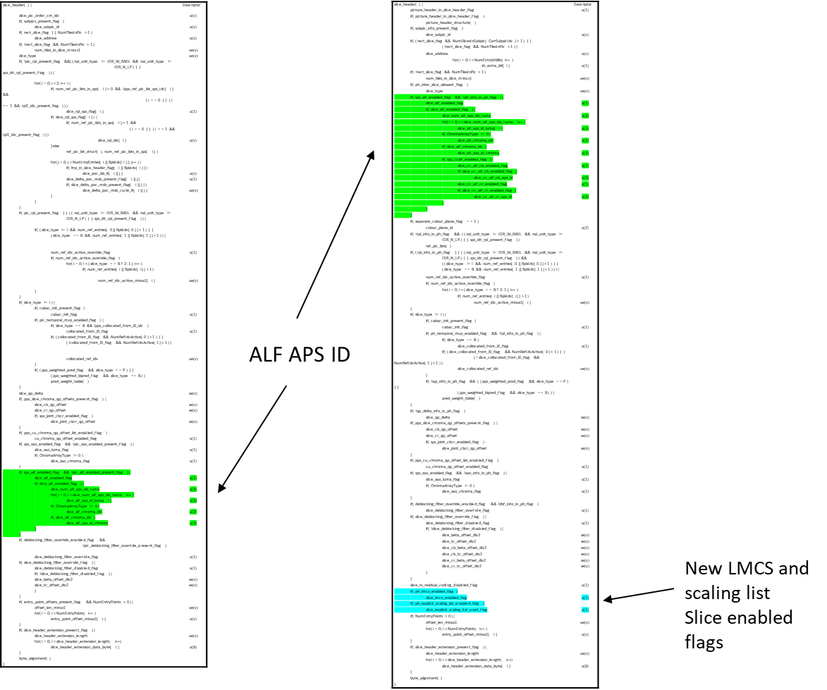
Figure 1 Slice header positions of the APS ID information for VTM-7.0 and for VTM-8.0, and Slice header position of slice_lmcs_enabled_flag and slice_explicit_scaling_list_used_flag in VTM-8.0.

The second problem is the signaling of the picture header in the slice header. When the picture header is signaled in the slice header, all parameters of the picture header should be parsed before the parsing of slice header parameters. Consequently, the parameters which give information on the APS usage in the slice header can’t be obtained without parsing all the picture headers. So, to simplify the parsing of the streaming applications, LMCS information should not be signaled in the slice header when the picture header is signaled in the slice header.

Proposals

slice_lmcs_enabled_flag and slice_explicit_scaling_list_used_flag set after ALF information
The slice_lmcs_enabled_flag and slice_explicit_scaling_list_used_flag are set just after the ALF information as depicted in the following figure.
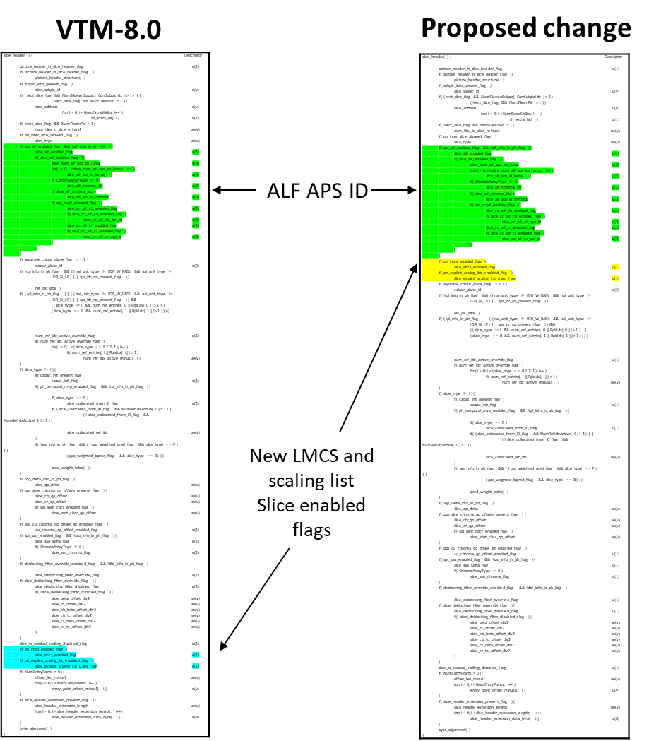
Figure 2 Slice header positions of the slice_lmcs_enabled_flag and slice_explicit_scaling_list_used_flag for VTM-8.0 and for proposed modification.

With this modification, the LMCS usage and the scaling list usage for each slice can be tracked easily compared to the current VVC specification as the LMCS and the scaling list are just after the ALF APS ID information at a similar position as it is set in the picture header.

When picture header is signaled inside slice header, avoid APS related information inside Slice header.

No slice_lmcs_enabled_flag and slice_explicit_scaling_list_used_flag when PH in SH
In the current VVC specification, the slice_lmcs_enabled_flag enables LMCS at slice level when it is enabled in the PH. In the same way, the slice_explicit_scaling_list_used_flag enables the scaling list at slice level when it is enabled in the PH. When the PH is in the SH, there is only one slice, so it is not needed to enable this tool twice and it does not give additional flexibility. Moreover, for parsing applications, all PH parameters need to be parsed before decoding this information with the current VVC specification.
To solve this issue, we proposed the following changes:
…
slice_header( ) { | Descriptor
picture_header_in_slice_header_flag | u(1)
…
if( ph_lmcs_enabled_flag && !picture_header_in_slice_header_flag )
slice_lmcs_enabled_flag | u(1)
if( ph_explicit_scaling_list_enabled_flag && !picture_header_in_slice_header_flag )
slice_explicit_scaling_list_used_flag | u(1)
…
…
slice_lmcs_enabled_flag equal to 1 specifies that luma mapping with chroma scaling is enabled for the current slice. slice_lmcs_enabled_flag equal to 0 specifies that luma mapping with chroma scaling is not enabled for the current slice. When slice_lmcs_enabled_flag is not present, and when picture_header_in_slice_header_flag is set equal to 0, it is inferred to be equal to 0. When it is not present, and when picture_header_in_slice_header_flag is set equal to 1, it is inferred to be equal to ph_lmcs_enabled_flag.
slice_explicit_scaling_list_used_flag equal to 1 specifies that the explicit scaling list, which is signalled in the referenced scaling list APS with aps_params_type equal to SCALING_APS and adaptation_parameter_set_id equal to ph_scaling_list_aps_id, is used in the scaling process for transform coefficients when decoding of the current slice. slice_explicit_scaling_list_used_flag equal to 0 specifies that no explicit scaling list is not used in the scaling process for transform coefficients when decoding of the current slice. When not present, and when picture_header_in_slice_header_flag is set equal to 0, the value of slice_explicit_scaling_list_used_flag is inferred to be equal to 0. When not present, and when picture_header_in_slice_header_flag is set equal to 1, it is inferred to be equal to ph_explicit_scaling_list_enabled_flag.

…

Clarification on the value of alf_info_in_ph_flag when PH in SH
To avoid the parsing of the APS ALF ID after all PH parameters when the PH is in the SH, the value of alf_info_in_ph_flag should be set equal to 1.
The current semantics of alf_info_in_ph_flag don’t clearly specify the value of the alf_info_in_ph_flag when the PH is in the SH even if it is forbidden to signal alf_info_in_ph_flag equal 0 when the SH contains the PH structure.
The current VTM implementation sets the value of alf_info_in_ph_flag equal to 0 when the picture header is in the slice header which is avoided by the current semantics.
To clarify that the alf_info_in_ph_flag is set equal to 1 when the PH is in the SH, we propose to modify the semantics of the alf_info_in_ph_flag as the following:
…
alf_info_in_ph_flag equal to 1 specifies that ALF information is present in the PH syntax structure and not present in slice headers referring to the PPS that do not contain a PH syntax structure. alf_info_in_ph_flag equal to 0 specifies that ALF information is not present in the PH syntax structure and may be present in slice headers referring to the PPS that do not contain a PH syntax structure. When slice headers referring to the PPS contain the PH syntax structure, it is a requirement of bitstream conformance that alf_info_in_ph_flag shall be equal to 1.
…
Please note that this restriction does not affect the encoding flexibility. Indeed, there is only one slice when the PH is in the SH, so an encoder should set the same ALF parameters in the PH or in the SH.

Conclusion
In this contribution, we propose to reduce the parsing complexity for some streaming applications that need to track the APS ID in the slice header. To obtain this fast parsing, the syntax element related to LMCS and sclaing list are set at an early stage of the slice header syntax table and the ALF, scaling list and LMCS syntax elements are not decoded when the picture header is signaled in the slice header.

Patent rights declaration(s)
Canon Research Centre France may have current or pending patent rights relating to the technology described in this contribution and, conditioned on reciprocity, is prepared to grant licenses under reasonable and non-discriminatory terms as necessary for implementation of the resulting ITU-T Recommendation | ISO/IEC International Standard (per box 2 of the ITU-T/ITU-R/ISO/IEC patent statement and licensing declaration form).

