    Joint Video Experts Team (JVET)  of ITU-T SG 16 WP 3 and ISO/IEC JTC 1/SC 29/WG 11  18th Meeting: by teleconference, 15–24 April 2020 | Document: JVET-R0184-r1

Title: | AHG9/AHG12: On reference picture wraparound for subpictures
Status: | Input document to JVET
Purpose: | Proposal
Author(s) or  Contact(s): | Seethal Paluri  Hendry  Seung Hwan Kim  10225 Willow Creek Rd,  San Diego, CA 92131, USA | Email | seethal.paluri@lge.com  dr.hendry@lge.com  seunghwan3.kim@lge.com
Source: | LG Electronics.
_____________________________

Abstract
In the current VVC working draft, reference picture wraparound for subpictures is only possible when the subpic_treated_as_pic_flag is equal to 0. This contribution asserted that the reference picture wraparound functionality could be extended for cases when subpic_treated_as_pic_flag equal to 1 with the subpicture width is equal to the picture width without having to have additional signalling. This contribution enables this functionality semantically.
In this contribution, the following is proposed:
- Allow reference picture wraparound for subpicture with subpic_treated_as_pic_flag[ i ] equal to 1 when the width of the subpicture is the same as the width of the picture, without additional signalling.
- At slice level, derive the boundaries to be applied for decoding of blocks in the slice. If the slice belongs to an independently coded subpiture, use the subpicture boundary; otherwise, use picture boundary. It is remarked that this 2nd proposal item can be considered as editorial updates.
In the first revision of this contribution, the notes and recommedation from the AHG discussion after the review of the contribution were added. Furthermore, following up the recommendation, updated VVC draft text to implement the recommendation is provided as attachment in the contribution document package.

Introduction
After the review of this contribution during AHG discussion, the following was noted and recommended:
Examples shown in Q0403 were discussed. Two examples are shown below.
Case 1
Wrap off | Wrap off
Wrap on
Wrap on
The above example would have different behaviour in different subpictures. The next figure would not.
Case 2
Wrap on
Wrap on
The second case could be used for, e.g., top-bottom stereoscopic ERP coding (or segmenting a single ERP).
Both of these are currently disallowed with subpictures treated as picture boundaries.
It was commented that we should avoid potential confusion in what is allowed and how it operates.
It was suggested to have wrap-around be a whole-picture property. This would invoke wrap-around as follows, with wrapping at the picture boundaries (thick boundaries, independent of the subpicture layout), as in case 3.
Case 3
The group seemed inclined to consider only the second of these three variations (case 2). The case just above and the case below would be prohibited:
Case 4
Wrap on
Wrap off
For signalling, wrap is in the SPS and the wrap offset is signalled in the PPS.
AHG Recommendation (cleanup): Allow case 2 (only). Revisit for text.

Based on the recommendation, we updated the VVC draft to implement the case 2 above. The kay changes in the implementation is the following constraint:
It is a requirement of bitstream conformance that when there is one or more subpicture for which subpic_treated_as_pic_flag[ i ] is equal to 1 and subpic_width_minus1[ i ] plus 1 is not equal to ( pic_width_max_in_luma_samples + CtbSizeY− 1 ) >> CtbLog2SizeY ) for i in the range of 0 to sps_num_subpics_minus1, inclusive, the value of sps_ref_wraparound_enabled_flag shall be equal to 0.

The introduction part of the original contribution starts below:
In conventional motion compensation, repetitive padding is applied to derive the value of the out-of-bound samples by copying from those nearest neighbors on the corresponding picture boundary; however, for equi-rectangular projection (ERP) format, the spherical neighbors outside of the left picture boundaries can be obtained from samples inside the right picture boundary and vice versa. Such fact makes reference picture wraparound would benefit ERP format significantly. However, the current VVC working draft only allows for reference picture wraparound to be applied to subpicture only when its value of subpic_treated_as_pic_flag[ i ] is equal to 0.
The current structure is summaried in Figure 1 below:
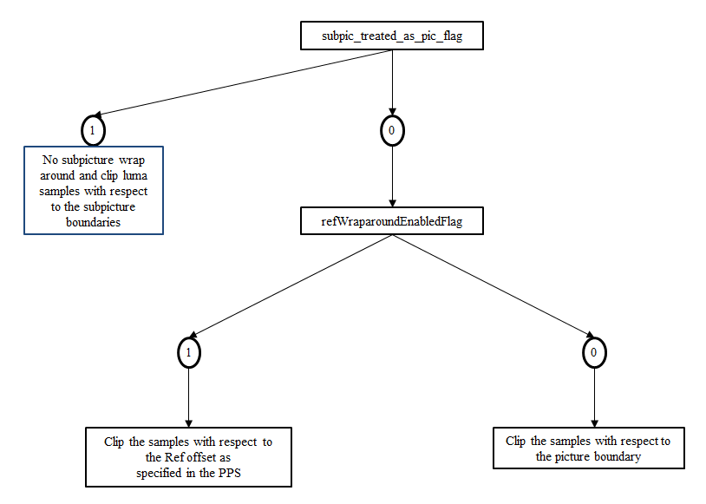
Figure 1 – Interaction between reference picture wraparound and subpicture.
In the 17th JVET meeting, there were several contributions proposed to enable reference picture wraparound for subpictures with subpic_treated_as_pic_flag[ i ] equal to 1 with some additional signalling. We asserted that reference picture for subpicture with subpic_treated_as_pic_flag[ i ] equal to 1 should have no problem to be applied when the width of the subpicture is the same as the width of the picture.
Further, we observed that in there are too many checking whether a slice belong to an independently coded subpicture or not at block level to determine the actual boundary to be used (i.e., whether to use subpicture boundary or picture boundary). This can be simplified by defining the boundaries to be used when slice header is parsed, that is, if the slice belongs to an independently coded subpture, use the subpicture boundary, otherwise, use picture boundary. These changes may be simply editorial changes.
In this contribution, we propose 2 items as follows:
- Allow reference picture wraparound for subpicture with subpic_treated_as_pic_flag[ i ] equal to 1 when the width of the subpicture is the same as the width of the picture, without additional signalling.
- At slice level, derive the boundaries to be applied for decoding of blocks in the slice. If the slice belongs to an independently coded subpiture, use the subpicture boundary; otherwise, use picture boundary.

Proposal 1

Summary
The summary of the proposal 1 is as follows:
- When reference picture wrap around is enabled for pictures in a CLVS, it also applies to slices in the independently coded subpicture (i.e., the value of subpic_treated_as_pic_flag[ i ] equal to 1) when the width of the subpicture is the same as the picture.
- A new variable namely SliceRefWraparoundEnabledFlag is defined and derived as follows:
  - Set SliceRefWraparoundEnabledFlag equal to the pps_ref_wrap_around_enabled_flag
  - If SliceRefWraparoundEnabledFlag is equal to 1 and the subpicture_treated_as_pict_flag[ i ] is equal to 1 for the current subpicture (i.e., the subpicture where the current slice belongs to) and the width of the current subpicture is not equal to the picture width then value of the SliceRefWarparoundEnabledFlag is set to be equal to 0.
  - The SliceRefWraparoundEnabledFlag is then used to enable refWraparoundEnabledFlag when the SliceRefWraparoundEnabledFlag is true and the reference picture is not scaled
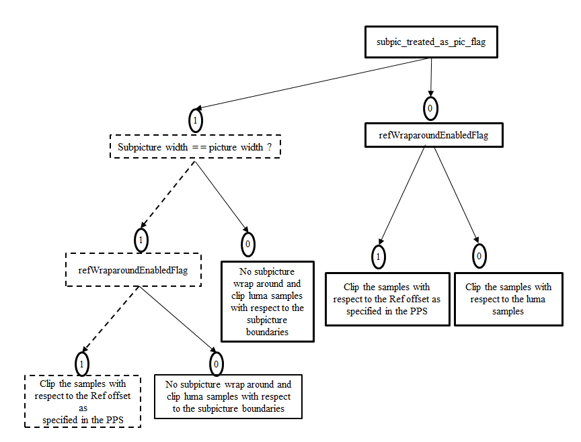
Figure 2 – Proposed design of reference picture wraparound with subpicture.

Proposed spec text changes
General slice header semantics
The variables SliceRefWraparoundEnabledFlag is derived as follows:
SliceRefWraparoundEnabledFlag = pps_ref_wraparound_enabled_flag
if( SliceRefWraparoundEnabledFlag )
if( subpic_treated_as_pic_flag[ CurrSubpicIdx ] &&
subpic_width_minus1[ CurrSubpicIdx ] + 1 < Ceil( pic_width_in_luma_samples ÷ CtbSizeY ) )
SliceRefWraparoundEnabledFlag = 0

Fractional sample bilinear interpolation process
General
The variable refWraparoundEnabledFlag is set equal to (SliceRefWraparoundEnabledFlagpps_ref_wraparound_enabled_flag && !refPicIsScaled ).

Luma sample bilinear interpolation process
The luma locations in full-sample units ( xInt_{i}, yInt_{i} ) are derived as follows for i = 0..1:
– If subpic_treated_as_pic_flag[ CurrSubpicIdx ] is equal to 1, the following applies:
xInt_{i} = Clip3( SubpicLeftBoundaryPos, SubpicRightBoundaryPos, refWraparoundEnabledFlag ?
ClipH( ( PpsRefWraparoundOffset ) * MinCbSizeY, picW, ( xInt_{L} + i ) ) : xInt_{L} + i ) (640)

Fractional sample interpolation process
General
The variable refWraparoundEnabledFlag is set equal to (SliceRefWraparoundEnabledFlag pps_ref_wraparound_enabled_flag && !refPicIsScaled ).

Luma sample interpolation filtering process
If subpic_treated_as_pic_flag[ CurrSubpicIdx ] is equal to 1, the following applies:
xInt_{i} = Clip3( SubpicLeftBoundaryPos, SubpicRightBoundaryPos, refWraparoundEnabledFlag ?
ClipH( ( PpsRefWraparoundOffset ) * MinCbSizeY, picW, xInt_{i} ) : xInt_{i} ) (959)

Luma integer sample fetching process
If subpic_treated_as_pic_flag[ CurrSubpicIdx ] is equal to 1, the following applies:
xInt = Clip3( SubpicLeftBoundaryPos, SubpicRightBoundaryPos, refWraparoundEnabledFlag ?
ClipH( ( PpsRefWraparoundOffset ) * MinCbSizeY, picW, xInt_{L} ) : xInt_{L} ) (968)

Chroma sample interpolation process
If subpic_treated_as_pic_flag[ CurrSubpicIdx ] is equal to 1, the following applies:
xInt_{i} = Clip3( SubpicLeftBoundaryPos / SubWidthC, SubpicRightBoundaryPos / SubWidthC, refWraparoundEnabledFlag ? ClipH( xOffset, picW_{C}, xInt_{i} ) : xInt_{i} ) (977)

Proposal 2

Summary
New variables are defined namely, LeftBoundaryPos, RightBoundaryPos, TopBoundaryPos and BottomBoundaryPos.These new variables indicate the positions of the boundaries to be used during decoding of blocks in the current slice. If the slice belongs to an independently coded subpicture, use subpicture’s boundary; otherwise, use picture’s boundary.

Proposed spec text changes
Slice header semantics
General slice header semantics
The variables SubpicLeftBoundaryPos, SubpicTopBoundaryPos, SubpicRightBoundaryPos, and SubpicBotBoundaryPos are derived as follows:
if( subpic_treated_as_pic_flag[ CurrSubpicIdx ] ) {
SubpicLeftBoundaryPos = subpic_ctu_top_left_x[ CurrSubpicIdx ] * CtbSizeY
SubpicRightBoundaryPos = Min( pic_width_max_in_luma_samples − 1,
( subpic_ctu_top_left_x[ CurrSubpicIdx ] +
subpic_width_minus1[ CurrSubpicIdx ] + 1 ) * CtbSizeY − 1 )
SubpicTopBoundaryPos = subpic_ctu_top_left_y[ CurrSubpicIdx ] *CtbSizeY (117)
SubpicBotBoundaryPos = Min( pic_height_max_in_luma_samples − 1,
( subpic_ctu_top_left_y[ CurrSubpicIdx ] +
subpic_height_minus1[ CurrSubpicIdx ] + 1 ) * CtbSizeY − 1 )
}

The variables SliceRefWraparoundEnabledFlag is derived as follows:
SliceRefWraparoundEnabledFlag = pps_ref_wraparound_enabled_flag
if( SliceRefWraparoundEnabledFlag )
if( subpic_treated_as_pic_flag[ CurrSubpicIdx ] &&
subpic_width_minus1[ CurrSubpicIdx ] + 1 < Ceil( pic_width_in_luma_samples ÷ CtbSizeY ) )
SliceRefWraparoundEnabledFlag = 0

The variables LeftBoundayPos, RightBoundayPos, TopBoundayPos, and BottomBoundaryPos are derived as follows.
LeftBoundaryPos = 0
RightBoundaryPos =pic_width_in_luma_samples-1
TopBoundaryPos = 0
BottomBoundaryPos = pic_height_in_luma_samples-1
if( subpic_treated_as_pic_flag[ CurrSubpicIdx ] ) {
LeftBoundaryPos = subpic_ctu_top_left_x[ CurrSubpicIdx ] * CtbSizeY
RightBoundaryPos = Min( pic_width_max_in_luma_samples − 1,
( subpic_ctu_top_left_x[ CurrSubpicIdx ] +
subpic_width_minus1[ CurrSubpicIdx ] + 1 ) * CtbSizeY − 1 )
TopBoundaryPos = subpic_ctu_top_left_y[ CurrSubpicIdx ] *CtbSizeY
BottomBoundaryPos = Min( pic_height_max_in_luma_samples − 1,
( subpic_ctu_top_left_y[ CurrSubpicIdx ] +
subpic_height_minus1[ CurrSubpicIdx ] + 1 ) * CtbSizeY − 1 )
}

Derivation process for temporal luma motion vector prediction
rightBoundaryPos = subpic_treated_as_pic_flag[ CurrSubpicIdx ] ?
SubpicRightBoundaryPos : pic_width_in_luma_samples − 1 (603)
botBoundaryPos = subpic_treated_as_pic_flag[ CurrSubpicIdx ] ?
SubpicBotBoundaryPos : pic_height_in_luma_samples − 1 (604)
If yCb >> CtbLog2SizeY is equal to yColBr >> CtbLog2SizeY, yColBr is less than or equal to BbottomBoundaryPos and xColBr is less than or equal to RrightBoundaryPos, the following applies:

Luma sample bilinear interpolation process
The luma locations in full-sample units ( xInt_{i}, yInt_{i} ) are derived as follows for i = 0..1:
– If subpic_treated_as_pic_flag[ CurrSubpicIdx ] is equal to 1, the following applies:
xInt_{i} = Clip3( SubpicLeftBoundaryPos, SubpicRightBoundaryPos, refWraparoundEnabledFlag ?
ClipH( ( PpsRefWraparoundOffset ) * MinCbSizeY, picW, ( xInt_{L} + i ) ) : xInt_{L} + i ) (640)
yInt_{i} = Clip3( SubpicTopBoundaryPos, SubpicBotBoundaryPos, yInt_{L} + i ) (641)
– Otherwise (subpic_treated_as_pic_flag[ CurrSubpicIdx ] is equal to 0), the following applies:
xInt_{i} = Clip3( 0, picW − 1, refWraparoundEnabledFlag ?
ClipH( ( PpsRefWraparoundOffset ) * MinCbSizeY, picW, ( xInt_{L} + i ) ) : xInt_{L} + i ) (642)
yInt_{i} = Clip3( 0, picH − 1, yInt_{L} + i ) (643)
xInt_{i} = Clip3(LeftBoundaryPos, RightBoundaryPos, refWraparoundEnabledFlag ?
ClipH( ( PpsRefWraparoundOffset ) * MinCbSizeY, picW, ( xInt_{L} + i ) ) : xInt_{L} + i ) (640)
yInt_{i} = Clip3( TopBoundaryPos, BottomBoundaryPos, yInt_{L} + i ) (641)

Derivation process for subblock-based temporal merging candidates
If subpic_treated_as_pic_flag[ CurrSubpicIdx ] is equal to 1, the following applies:
xColSb = Clip3( xCtb,
Min( SubpicRightBoundaryPos, xCtb + ( 1 << CtbLog2SizeY ) + 3 ), (736)
xSb + tempMv[0] )
Otherwise ( subpic_treated_as_pic_flag[ CurrSubpicIdx ] is equal to 0), the following applies:
xColSb = Clip3( xCtb,
Min( pic_width_in_luma_samples − 1, xCtb + ( 1 << CtbLog2SizeY ) + 3 ), (737)
xSb + tempMv[0] )
xColSb = Clip3( xCtb,
Min( RightBoundaryPos, xCtb + ( 1 << CtbLog2SizeY ) + 3 ), (736)
xSb + tempMv[0] )

Derivation process for constructed affine control point motion vector merging candidates
rightBoundaryPos = subpic_treated_as_pic_flag[ CurrSubpicIdx ] ? SubpicRightBoundaryPos :
pic_width_in_luma_samples – 1 (785)
botBoundaryPos = subpic_treated_as_pic_flag[ CurrSubpicIdx ] ? SubpicBotBoundaryPos :
pic_height_in_luma_samples – 1 (786)
- If yCb >> CtbLog2SizeY is equal to yColBr >> CtbLog2SizeY, yColBr is less than or equal to BottomBoundaryPos and xColBr is less than or equal to RightBoundaryPos, the following applies:

Fractional sample interpolation process
General
- The variable refWraparoundEnabledFlag is set equal to (SliceRefWraparoundEnabledFlag pps_ref_wraparound_enabled_flag && !refPicIsScaled ).

Fractional sample bilinear interpolation process
General
- The variable refWraparoundEnabledFlag is set equal to (SliceRefWraparoundEnabledFlag pps_ref_wraparound_enabled_flag && !refPicIsScaled ).

Luma sample interpolation filtering process
–If subpic_treated_as_pic_flag[ CurrSubpicIdx ] is equal to 1, the following applies:
xInt_{i} = Clip3( SubpicLeftBoundaryPos, SubpicRightBoundaryPos, refWraparoundEnabledFlag ?
ClipH( ( PpsRefWraparoundOffset ) * MinCbSizeY, picW, xInt_{i} ) : xInt_{i} ) (959)
yInt_{i} = Clip3( SubpicTopBoundaryPos, SubpicBotBoundaryPos, yInt_{i} ) (960)
–Otherwise (subpic_treated_as_pic_flag[ CurrSubpicIdx ] is equal to 0), the following applies:
xInt_{i} = Clip3( 0, picW − 1, refWraparoundEnabledFlag ?
ClipH( ( PpsRefWraparoundOffset ) * MinCbSizeY, picW, xInt_{i} ) : xInt_{i} ) (961)
yInt_{i} = Clip3( 0, picH − 1, yInt_{i} ) (962)
xInt_{i} = Clip3(LeftBoundaryPos, RightBoundaryPos, refWraparoundEnabledFlag ?
ClipH( ( PpsRefWraparoundOffset ) * MinCbSizeY, picW, xInt_{i} ) : xInt_{i} ) (959)
yInt_{i} = Clip3( TopBoundaryPos, BottomBoundaryPos, yInt_{i} ) (960)

Luma integer sample fetching process
– If subpic_treated_as_pic_flag[ CurrSubpicIdx ] is equal to 1, the following applies:
xInt = Clip3( SubpicLeftBoundaryPos, SubpicRightBoundaryPos, refWraparoundEnabledFlag ?
ClipH( ( PpsRefWraparoundOffset ) * MinCbSizeY, picW, xInt_{L} ) : xInt_{L} ) (968)
yInt = Clip3( SubpicTopBoundaryPos, SubpicBotBoundaryPos, yInt_{L} ) (969)
– Otherwise, the following applies:
xInt = Clip3( 0, picW − 1, refWraparoundEnabledFlag ? (970)
ClipH( ( PpsRefWraparoundOffset ) * MinCbSizeY, picW, xInt_{L} ) : xInt_{L} )
yInt = Clip3( 0, picH − 1, yInt_{L} ) (971)
xInt = Clip3( LeftBoundaryPos, RightBoundaryPos, refWraparoundEnabledFlag ?
ClipH( ( PpsRefWraparoundOffset ) * MinCbSizeY, picW, xInt_{L} ) : xInt_{L} ) (968)
yInt = Clip3( TopBoundaryPos, BottomBoundaryPos, yInt_{L} ) (969)

Chroma sample interpolation process
If subpic_treated_as_pic_flag[ CurrSubpicIdx ] is equal to 1, the following applies:
xInt_{i} = Clip3( SubpicLeftBoundaryPos / SubWidthC, SubpicRightBoundaryPos / SubWidthC, refWraparoundEnabledFlag ? ClipH( xOffset, picW_{C}, xInt_{i} ) : xInt_{i} ) (977)
yInt_{i} = Clip3( SubpicTopBoundaryPos / SubHeightC, SubpicBottomBoundaryPos / SubHeightC, yInt_{i} ) (978)
– Otherwise (subpic_treated_as_pic_flag[ CurrSubpicIdx ] is equal to 0), the following applies:
xInt_{i} = Clip3( 0, picW_{C} − 1, refWraparoundEnabledFlag ? ClipH( xOffset, picW_{C}, xInt_{i} ) : (979)
xInt_{C} + i − 1 )
yInt_{i} = Clip3( 0, picH_{C} − 1, yInt_{i} ) (980)

Patent rights declaration(s)
LG Electronics may have current or pending patent rights relating to the technology described in this contribution and, conditioned on reciprocity, is prepared to grant licenses under reasonable and non-discriminatory terms as necessary for implementation of the resulting ITU-T Recommendation | ISO/IEC International Standard (per box 2 of the ITU-T/ITU-R/ISO/IEC patent statement and licensing declaration form).

