    Joint Video Experts Team (JVET)  of ITU-T SG 16 WP 3 and ISO/IEC JTC 1/SC 29/WG 11  18th Meeting: by teleconference, 15–24 April 2020 | Document: JVET-R0183

Title: | AHG9: On deblocking control signalling
Status: | Input document to JVET
Purpose: | Proposal
Author(s) or  Contact(s): | Seethal Paluri  Hendry  Seung Hwan Kim  10225 Willow Creek Rd,  San Diego, CA 92131, USA | Email | seethal.paluri@lge.com  dr.hendry@lge.com  seunghwan3.kim@lge.com
Source: | LG Electronics.
_____________________________

Abstract
This contribution asserted that the current signalling for deblocking filter control is complex and may be simplified. For example, the current desgin allows the deblocking to be disabled at the PPS level and then later to be enabled either in picture header or the slice header. Such design may be confusing and make the signalling more difficult to understand.
This contribution proposed the following changes:
- Signal a flag in the PPS, i.e., pps_deblocking_enabled_flag to specify whether or not deblocking is enabled / applied to pictures that refer to the PPS.
- When deblocking is enabled (e.g., the value of pps_deblocking_enabled_flag is equal to 1, additional flags can be signalled as follows:
  - pps_deblocking_override_enabled_flag, which is an existing flag.
  - pps_deblocking_parameter_present_flag to specify whether the PPS deblocking parameter is present.

Introduction
In the latest VVV specification text (i.e., Draft 8), the deblocking tool control is asserted to be complex as it requires many layers of signalling, Additionally, the current design allows the deblocking to be disabled at the PPS level and then later be enabled at the PH or SH. Figure 1 below shows the structure.
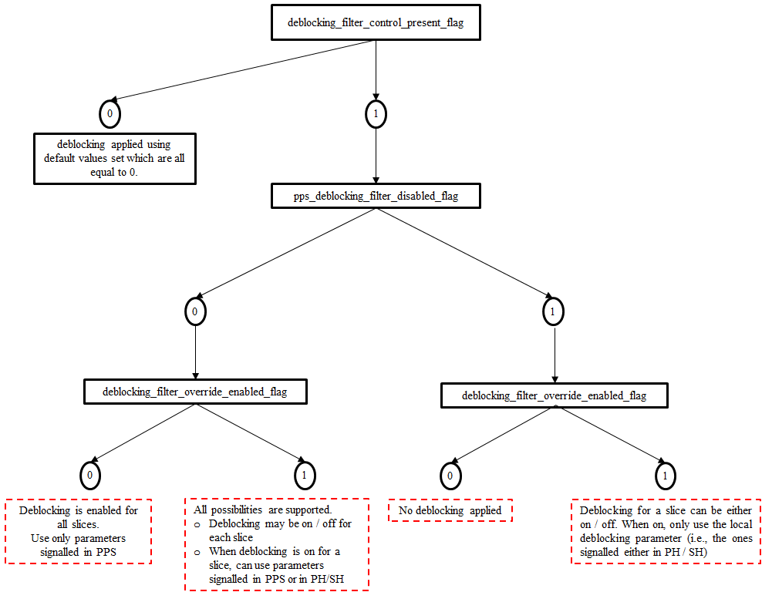
Figure 1 – Diagram of current deblocking tool control.
Such signalling design is confusing and difficult to understand. Furthermore, it is not consistant with signalling cotrol of any other tools that we observed in SPS and PPS. Normally, we would see tool enabled flag is signalled in the parameter set and when the tool is enabled, it is still possible to disable the tool for individual picture or slice. On the other hand, for deblocking it is the other way around.
For ease of understanding, we suggest that the signalling for deblocking control signalling is updated.

Proposal

Summary of the proposed changes
The following changes are proposed to address the above issues:
- Signal pps_deblocking_enabled_flag to specify whether or not deblocking is enabled / applied.
- When deblocking is enabled (e.g., the value of pps_deblocking_enabled_flag is equal to 1, additional flags can be further signalled as follows:
  - pps_deblocking_override_enabled_flag to specify if the deblocking control is present in the lower level than the parameter set itself.
  - pps_deblocking_parameter_present_flag to specify whether the parameter information that applies to all the pictures that refer to the parameter set is present.
Figure 2 below show the diagram of the proposed deblocking control.
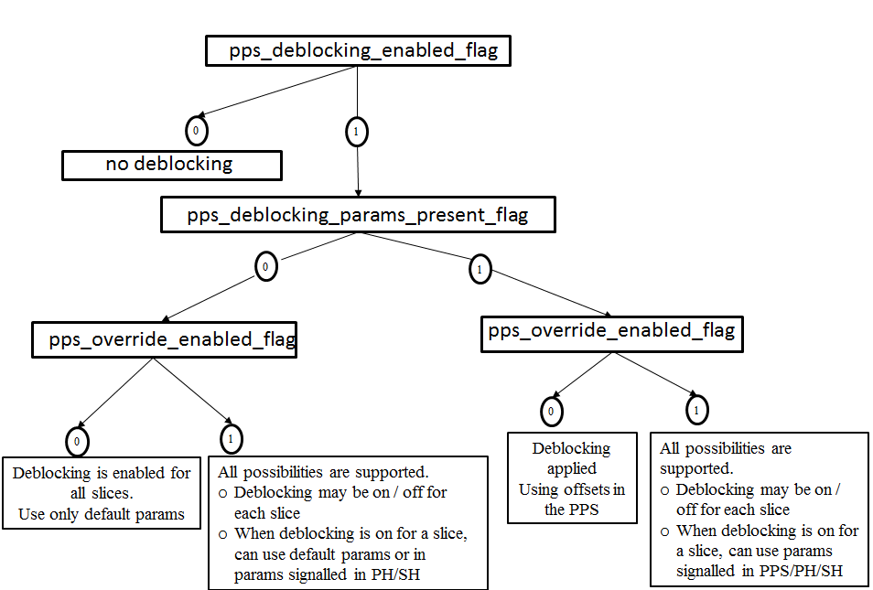
Figure 2 – Diagram of proposed deblocking tool control.

Proposed text changes
The changed texts are based on the latest VVC text in JVET-Q2001-vE/v15. Most relevant parts that have been added are highlighted in yellow, while deleted aspects are strikethrough in red fonts.

pic_parameter_set_rbsp( ) { | Descriptor
pps_pic_parameter_set_id | ue(v)
…
deblocking_filter_enabledcontrol_present_flag | u(1)
if( deblocking_filter_enabledcontrol_present_flag ) {
deblocking_filter_override_enabled_flag | u(1)
pps_deblocking_filter_disabledparams_present_flag | u(1)
if( !pps_deblocking_filter_disabled_params_present_flag ) {
pps_beta_offset_div2 | se(v)
pps_tc_offset_div2 | se(v)
pps_cb_beta_offset_div2 | se(v)
pps_cb_tc_offset_div2 | se(v)
pps_cr_beta_offset_div2 | se(v)
pps_cr_tc_offset_div2 | se(v)
}
}
if( deblocking_filter_override_enabled_flag )
dbf_info_in_ph_flag | u(1)
…
}
deblocking_filter_enabledcontrol_present_flag equal to 1 specifies that deblocking may be enabled for all slices referring to the PPS presence of deblocking filter control syntax elements in the PPS. deblocking_filter_enabledcontrol_present_flag equal to 0 specifies that deblocking is not applied to the slices referring to the PPS. the absence of deblocking filter control syntax elements in the PPS.
pps_deblocking_filter_disabledparams_present_flag equal to 1 specifies that the operation of deblocking filter offsets are present in the PPS. pps_deblocking_filter_params_present_flag equal to 0 specifies that the deblocking parameters are not present in the PPS. is not applied for slices referring to the PPS in which slice_deblocking_filter_disabled_flag is not present. pps_deblocking_filter_disabled_flag equal to 0 specifies that the operation of the deblocking filter is applied for slices referring to the PPS in which slice_deblocking_filter_disabled_flag is not present. When not present, the value of pps_deblocking_filter_disabled_params_present_flag is inferred to be equal to 0.

Patent rights declaration(s)
LG Electronics may have current or pending patent rights relating to the technology described in this contribution and, conditioned on reciprocity, is prepared to grant licenses under reasonable and non-discriminatory terms as necessary for implementation of the resulting ITU-T Recommendation | ISO/IEC International Standard (per box 2 of the ITU-T/ITU-R/ISO/IEC patent statement and licensing declaration form).

