    Joint Video Experts Team (JVET)  of ITU-T SG 16 WP 3 and ISO/IEC JTC 1/SC 29/WG 11  18th Meeting: by teleconference, 15–24 April 2020 | Document: JVET-R0128-v2

Title: | AHG16: On CCALF clipping
Status: | Input document to JVET
Purpose: | Proposal
Author(s) or  Contact(s): | Mohammed Golam Sarwer  Yan Ye, Jiancong Luo  525 Almanor Ave,  Sunnyvale, CA | Tel:  Email: | + 1 408-858-6780  m.sarwer@alibaba-inc.com
Source: | Alibaba Group
_____________________________

Abstract
In VVC CCALF process, an 8-tap filter is applied to luma sample to generate a residual correction for the chroma samples. At first, an offset value is generated from the luma samples and then the offset value is clipped. Then, the clipped offset value is added to the chroma sample to generate filtered output. Another clipping operation is performed to generate final filtered sample. This contribution proposes to remove the first clipping operation (i.e. clipping the offset value before sum) from the CCALF process. Following results are reported as compared to VTM-8.0.
- AI : 0.00% (Y), 0.00% (Cb), 0.00% (Cr)
- RA : 0.00% (Y), 0.00% (Cb), 0.00% (Cr)
- LB : 0.00% (Y), 0.00% (Cb), 0.00% (Cr)
In v2, the results of HDR sequences are added.

Introduction
In VVC draft 8, the Cross Component Adaptive Loop Filter (CCALF) was adopted [1]. Below is the part of the CCALF filtering process (extracted from VVC draft 8):
  - The variable curr is derived as follows:
curr = alfPicture_{C}[ xCtbC + x][ yCtbC + y ] (1)
  - The array of cross-component filter coefficients f[ j ] is derived as follows with j = 0..6:
f[ j ] = CcAlfCoeff[ j ] (2)
  - The variable sum is derived as follows:
sum = f[ 0 ] * ( recPicture_{L}[ h_{x} ][ v_{y - yP1} ] − recPicture_{L}[ h_{x} ][ v_{y} ] ) +
f[ 1 ] * ( recPicture_{L}[ h_{x-1} ][ v_{y} ] − recPicture_{L}[ h_{x} ][ v_{y} ] ) +
f[ 2 ] * ( recPicture_{L}[ h_{x+1} ][ v_{y} ] − recPicture_{L}[ h_{x} ][ v_{y} ] ) +
f[ 3 ] * ( recPicture_{L}[ h_{x-1} ][ v_{y+yP1} ] − recPicture_{L}[ h_{x} ][ v_{y} ] ) +
f[ 4 ] * ( recPicture_{L}[ h_{x} ][ v_{y+yP1} ] − recPicture_{L}[ h_{x} ][ v_{y} ] ) +
f[ 5 ] * ( recPicture_{L}[ h_{x+1} ][ v_{y+yP1} ] − recPicture_{L}[ h_{x} ][ v_{y} ] ) +
f[ 6 ] * ( recPicture_{L}[ h_{x} ][ v_{y + yP2} ] − recPicture_{L}[ h_{x} ][ v_{y} ] )
scaledSum = Clip3( −( 1 << ( BitDepth − 1 ) ), ( 1 << ( BitDepth − 1 ) ) − 1, ( sum + 64 ) >> 7) (3)
sum = curr + scaledSum (4)
  - The modified filtered reconstructed chroma picture sample ccAlfPicture[ xCtbC + x ][ yCtbC + y ] is derived as follows:
ccAlfPicture[ xCtbC + x ][ yCtbC + y ] = Clip3( 0, ( 1 << BitDepth ) − 1, sum ) (5)
As shown in equation (3) and (5), it is shown that clipping operation is performed twice. Figure 1 shows the illustration of clipping operations after computing the sum value in case of ALF and CCALF process. It is shown that ALF uses 1 clipping operation, however, CCALF uses 2 clipping operations.
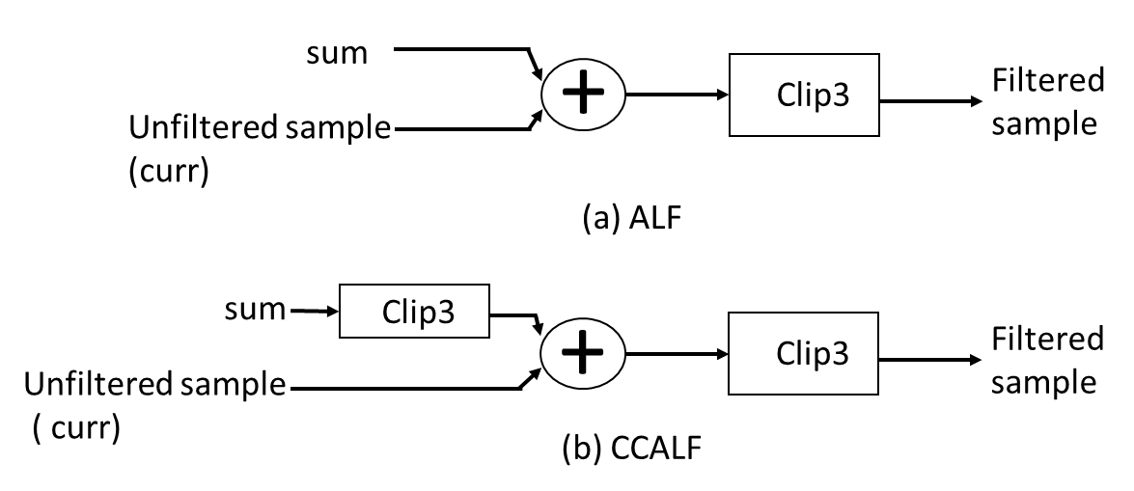
Figure 1: Illustration of clipping operations of (a) ALF and (b) CCALF
In order to identify the impact of the first clipping (clipping in equation 3) operation in CCALF process, we have counted the number of times the first clipping operation is executed under the JVET CTC. Table 1 shows the data under CTC test conditions. As shown in Table 1, it is observed that there is not any instance when first clipping operation is executed under CTC. We have further examined the filtering process of CCALF and ALF, and concluded that in worst case dynamic range of the output of the filtering process is same for both CCALF and ALF filters and no overflow is expected to occur.
Table 1: Number of times first clipping is executed
 | Total number of filtered samples | Number of filtered samples required clipping in equation 3
AI | 3836408192 | 0
RA | 9526279552 | 0
LB | 3792746368 | 0

Proposed method
Since the first clipping operation has no impact on the coding performance and given ALF does not have that clipping operation, this contribution proposes to remove the first clipping operation from the CCALF process. Following is the spec changes,
scaledSum = Clip3( −( 1 << ( BitDepth − 1 ) ), ( 1 << ( BitDepth − 1 ) ) − 1, ( sum + 64 ) >> 7) (3)
sum = curr + scaledSum (( sum + 64 ) >> 7) (4)
  - The modified filtered reconstructed chroma picture sample ccAlfPicture[ xCtbC + x ][ yCtbC + y ] is derived as follows:
ccAlfPicture[ xCtbC + x ][ yCtbC + y ] = Clip3( 0, ( 1 << BitDepth ) − 1, sum ) (5)

Simulation results
The proposed method is implemented on top of VTM-8.0. The test is conducted under CTC test conditions. Table 2 shows the simulation results of the proposed method for SDR sequences.

Table 2: simulation results of the proposed method for SDR sequences
 | All Intra Main10
 | Over VTM-8.0
 | Y | U | V | EncT | DecT
Class A1 | 0.00% | 0.00% | 0.00% | 100% | 101%
Class A2 | 0.00% | 0.00% | 0.00% | 100% | 100%
Class B | 0.00% | 0.00% | 0.00% | 100% | 100%
Class C | 0.00% | 0.00% | 0.00% | 100% | 101%
Class E | 0.00% | 0.00% | 0.00% | 100% | 100%
Overall | 0.00% | 0.00% | 0.00% | 100% | 100%
Class D | 0.00% | 0.00% | 0.00% | 101% | 101%
Class F | 0.00% | 0.00% | 0.00% | 100% | 100%
Class SCC | 0.00% | 0.00% | 0.00% | 100% | 100%
 | Random access Main10
 | Over VTM-8.0
 | Y | U | V | EncT | DecT
Class A1 | 0.00% | 0.00% | 0.00% | 100% | 100%
Class A2 | 0.00% | 0.00% | 0.00% | 100% | 100%
Class B | 0.00% | 0.00% | 0.00% | 100% | 100%
Class C | 0.00% | 0.00% | 0.00% | 100% | 100%
Class E
Overall | 0.00% | 0.00% | 0.00% | 100% | 100%
Class D | 0.00% | 0.00% | 0.00% | 101% | 102%
Class F | 0.00% | 0.00% | 0.00% | 101% | 101%
Class SCC | 0.00% | 0.00% | 0.00% | 100% | 100%
 | Low delay B Main10
 | Over VTM-8.0
 | Y | U | V | EncT | DecT
Class A1
Class A2
Class B | 0.00% | 0.00% | 0.00% | 101% | 103%
Class C | 0.00% | 0.00% | 0.00% | 100% | 100%
Class E | 0.00% | 0.00% | 0.00% | 100% | 100%
Overall | 0.00% | 0.00% | 0.00% | 100% | 101%
Class D | 0.00% | 0.00% | 0.00% | 100% | 99%
Class F | 0.00% | 0.00% | 0.00% | 100% | 101%
Class SCC | 0.00% | 0.00% | 0.00% | 100% | 101%

Table 3 shows the simulation results of the proposed method for HDR sequences.

Table 3: results of the proposed method for HDR sequences ( runtime is not reliable)
 | All Intra
 | Over VTM-8.0
 |  |  | wPSNR |  |  | PSNR
 | DE100 | PSNR-L100 | Y | U | V | Y | U | V | EncT | DecT
Class H1 | 0.00% | 0.00% | 0.00% | 0.00% | 0.00% | 0.00% | 0.00% | 0.00% | 102% | 99%
Class H2 |  |  |  |  |  | 0.00% | 0.00% | 0.00% | 100% | 100%
Overall | 0.00% | 0.00% | 0.00% | 0.00% | 0.00% | 0.00% | 0.00% | 0.00% | 101% | 99%
 | Random Access
 | Over VTM-8.0
 |  |  | wPSNR |  |  | PSNR
 | DE100 | PSNR-L100 | Y | U | V | Y | U | V | EncT | DecT
Class H1 | 0.00% | 0.00% | 0.00% | 0.00% | 0.00% | 0.00% | 0.00% | 0.00% | 101% | 98%
Class H2 |  |  |  |  |  | 0.00% | 0.00% | 0.00% | 100% | 99%
Overall | 0.00% | 0.00% | 0.00% | 0.00% | 0.00% | 0.00% | 0.00% | 0.00% | 101% | 99%
 | Low delay B
 | Over VTM-8.0
 |  |  | wPSNR |  |  | PSNR
 | DE100 | PSNR-L100 | Y | U | V | Y | U | V | EncT | DecT
Class H1 | 0.00% | 0.00% | 0.00% | 0.00% | 0.00% | 0.00% | 0.00% | 0.00% | 102% | 100%
Class H2
Overall | 0.00% | 0.00% | 0.00% | 0.00% | 0.00%

Conclusion
In this contribution, one clipping operation is removed from the CCALF process. It is asserted that, the proposed method does not impact coding performance under CTC test condition.

References
- B. Bross, J. Chen, S. Liu, “Versatile Video Coding (Draft 8)”, JVET-Q2001, Jan. 2020.

Patent rights declaration(s)
Alibaba Group may have current or pending patent rights relating to the technology described in this contribution and, conditioned on reciprocity, is prepared to grant licenses under reasonable and non-discriminatory terms as necessary for implementation of the resulting ITU-T Recommendation | ISO/IEC International Standard (per box 2 of the ITU-T/ITU-R/ISO/IEC patent statement and licensing declaration form).

