    Joint Video Experts Team (JVET)  of ITU-T SG 16 WP 3 and ISO/IEC JTC 1/SC 29/WG 11  18th Meeting: by teleconference, 15–24 April 2020 | Document: JVET-R0127

Title: | AHG15: On scaling list prediction
Status: | Input document to JVET
Purpose: | Proposal
Author(s) or  Contact(s): | Adarsh K. Ramasubramonian  Bappaditya Ray  Geert Van der Auwera  Marta Karczewicz  5775 Morehouse Dr  San Diego, CA USA | Tel:  Email: | aramasub@qti.qualcomm.com
Source: | Qualcomm Inc.
_____________________________

Abstract
This document proposes changes to the derivation of scaling list reference ID when the chroma scaling lists are not signalled. Scaling lists may be explicitly signalled, copied or predicted from other scaling lists – the scaling list used for copying or predicting is referred to as the reference scaling list. The current specification allows luma scaling lists to be copied or predicted from lists that correspond to chroma scaling lists even when the chroma lists are absent; it is asserted that this behaviour is undesirable. The document proposes to modify the reference scaling list ID derivation by skipping the absent chroma lists. It is asserted that the proposed method fixes the issue of referring absent lists; due to the small bit savings, the proposed method is argued to be preferable compared to explicit constraints or inferring default lists.

Introduction
Scaling matrices are specified using scaling lists that are signalled in the scaling list APS. A total of 28 scaling lists may be signalled; some of the scaling lists correspond to the luma component and other scaling lists correspond to the chroma components. The scaling lists may be explicitly signalled or copied or predicted from preceding scaling lists that have the same size.
For coding monochrome content or for separate colour plane coding, only the scaling lists corresponding to the luma component are required. This is controlled by the flag scaling_list_chroma_present_flag. When scaling_list_chroma_present_flag is equal to 0 (for monochrome and separate colour plane coding), the chroma scaling lists are not signalled (“absent”).
When scaling lists are copied or predicted, the syntax element scaling_list_pred_id_delta[ ] is used to identify the reference scaling list. When scaling_list_chroma_present_flag is 0, the chroma scaling lists are not explicitly signalled – yet the value of scaling_list_pred_id_delta[ ] permits referring to the “absent” chroma scaling lists. Figure 1 illustrates the various possible reference scaling lists (pointed by arrows) for a scaling list with ID 23 under the current specification. The figure shows reference scaling lists for various values of scaling_list_pred_id_delta (same as predIdDelta in the figure) for both the cases when the chroma scaling lists are present and absent. When chroma scaling lists are present (left side of the figure), the scaling list with ID 23 is allowed to predict from any scaling list with ID in the range of 8 to 22, inclusive. When chroma scaling lists are absent, the scaling list with ID is allowed to predict from the luma scaling lists (with IDs 8, 11, 14, 17, 20) and the “absent” chroma scaling list IDs (with IDs 9, 10, 12, 13, 15, 16, 18, 19, 21, 22). Referring to these “absent” lists results in ambiguity in the scaling list prediction.
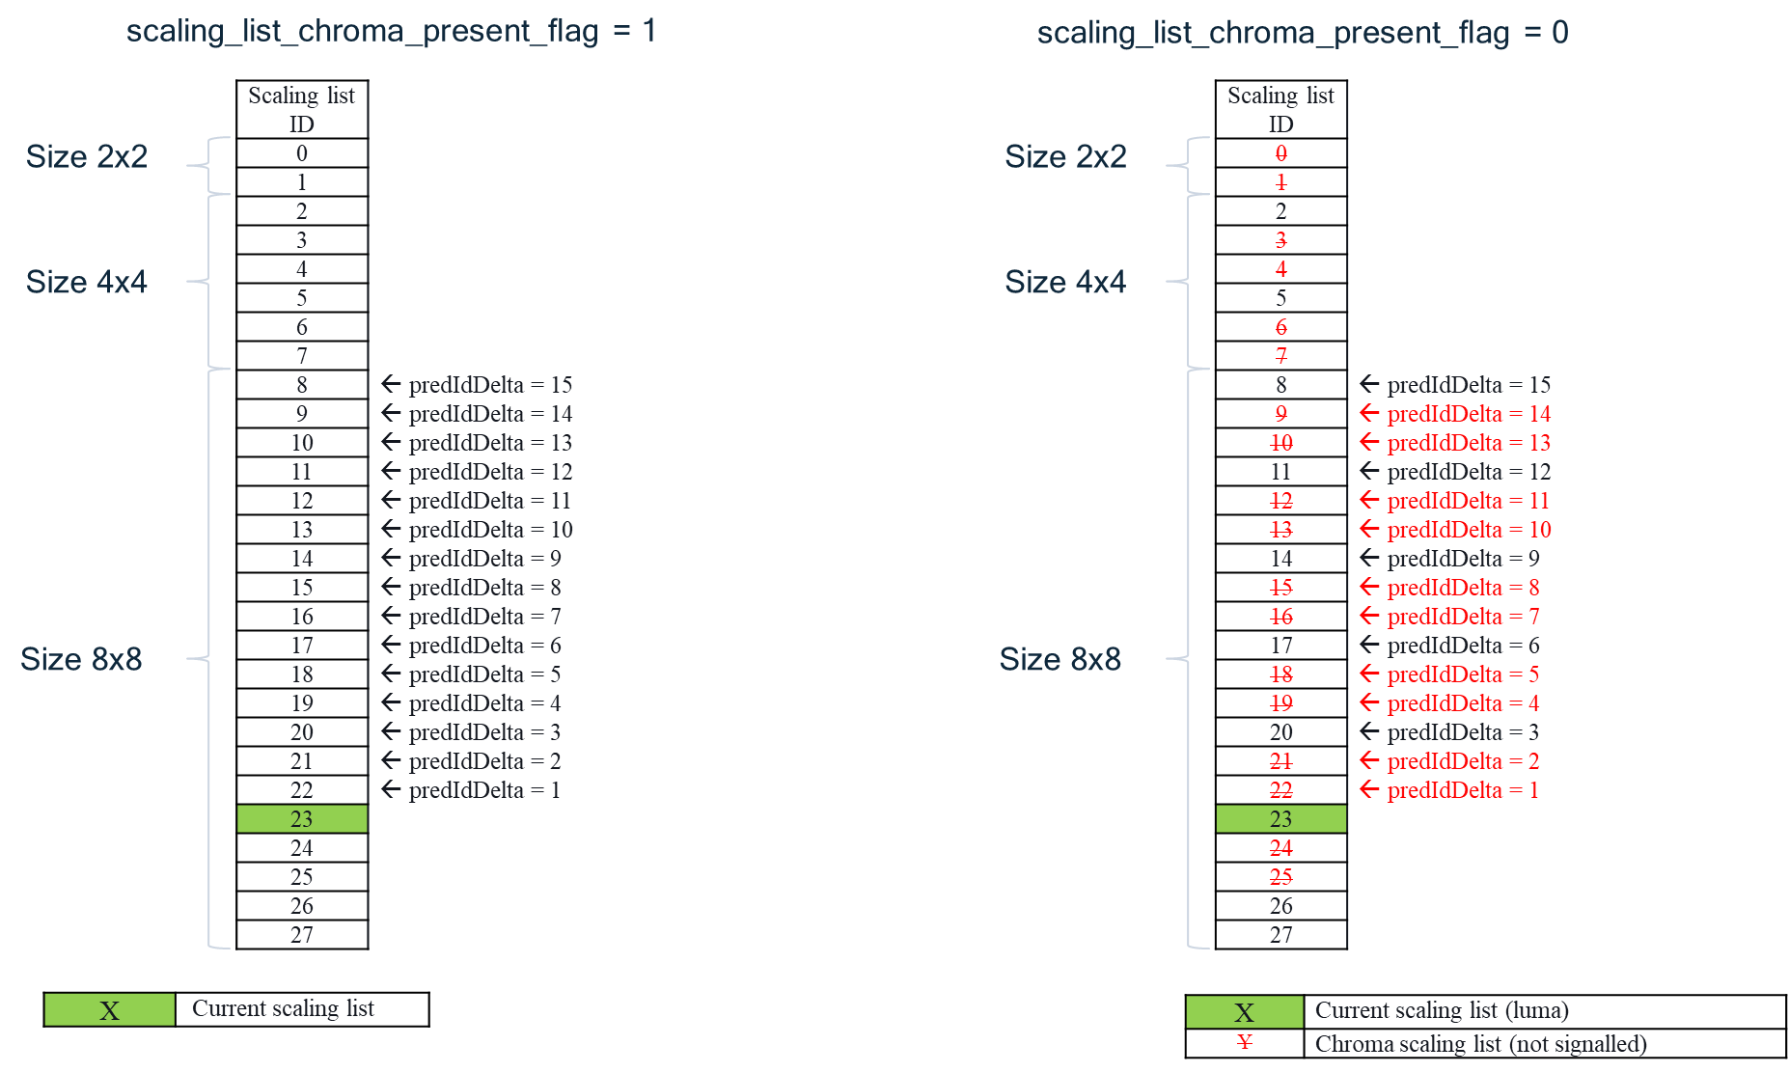
Figure 1

Proposal
In the proposal, the allowed range of scaling_list_pred_id_delta[ ] is modified such that when scaling_list_chroma_present_flag is equal to 0, only the luma scaling lists are referred to; the derivation of refId is also modified so that only the valid luma scaling list are allowed to be referred. The modifications to the semantics in Sec. 7.4.3.21 are highlighted below in yellow.
scaling_list_pred_id_delta[ id ] specifies the reference scaling list used to derive the predicted scaling matrix ScalingMatrixPred[ id ]. When not present, the value of scaling_list_pred_id_delta[ id ] is inferred to be equal to 0. The value of scaling_list_pred_id_delta[ id ] shall be in the range of 0 to maxIdDelta with maxIdDelta derived depending on id as follows:
maxIdDelta = ( id < 2 ) ? id : ( ( id < 8 ) ? ( id − 2 ) : ( id − 8 ) ) (105)
if( !scaling_list_chroma_present_flag )
maxIdDelta = ( maxIdDelta + 2 ) / 3
The variables refId and matrixSize are derived as follows:
if( scaling_list_chroma_present_flag )
refId = id − scaling_list_pred_id_delta[ id ] (106)
else
refId = id – scaling_list_pred_id_delta[ id ] * 3 + ( id = = 27 ? 2 : 0 )
matrixSize = ( id < 2 ) ? 2 : ( ( id < 8 ) ? 4 : 8 ) (107)
Figure 2 provides an illustration of how the reference scaling lists are mapped with the proposed method. There is no change in the prediction when chroma scaling lists are present. When chroma scaling lists are absent, only the luma scaling lists are allowed to be referred, thus resolving any ambiguity in the scaling list prediction.

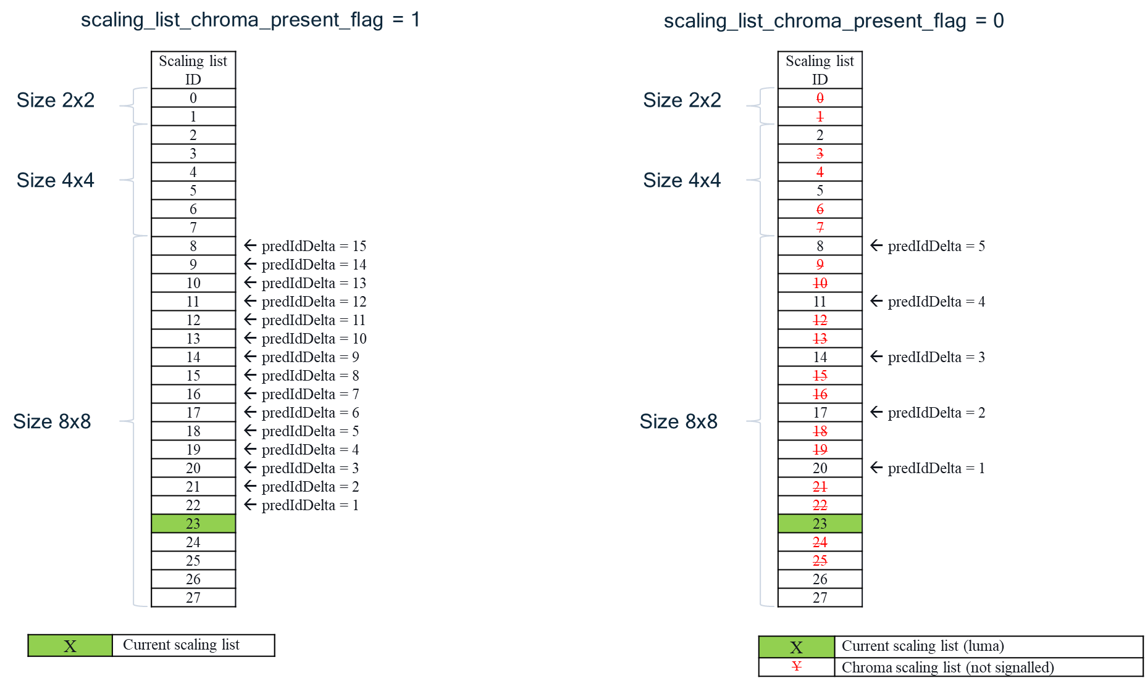
Figure 2

Discussion
Two other approaches that were suggested in the reflector are reproduced here for the sake of completeness. It is asserted that these methods are less preferable to the approach suggested above.
- Explicit constraint
One approach would be to introduce an explicit constraint that disallows the reference to the “absent” chroma scaling lists, such as the following:
When scaling_list_chroma_present_flag is equal to 0, the value of refId shall be such that refId % 3 is equal to 2 or refId is equal to 27.
The downside of this approach is the addition of conformance checks needed to ensure bitstreams satisfy this constraint. Moreover, the signalling of scaling_list_pred_id_delta[ ] is slightly less efficient than the proposed method, because of the unused codewords corresponding to the chroma scaling lists. The number of bits saved for signalling predIdDelta would depend on the value of predIdDelta and the current scaling list. For example, in Figure 2, the number of bits for predicting scaling list with ID 23 when scaling_list_chroma_present_flag equal to 0 would be as follows:

reference scaling list ID | 20 | 17 | 14 | 11 | 8
Explicit  constraint | 5  (predIdDelta=3) | 5  (predIdDelta=6) | 7  (predIdDelta=9) | 7  (predIdDelta=12) | 9  (predIdDelta=15)
Proposed method | 3  (predIdDelta=1) | 3  (predIdDelta=2) | 5  (predIdDelta=3) | 5  (predIdDelta=4) | 5  (predIdDelta=6)
Similar savings are realizable for each copied/predicted list when their predIdDelta is not equal to 0.
- Semantic inference to default lists
Another approach would be to modify the inference of some syntax elements in the APS scaling list (e.g., infer the value of scaling_list_copy_mode_flag when not present or other changes) such that default chroma scaling lists are generated when scaling_list_chroma_present_flag is equal to 0. The downside of this approach is that additional (default) lists corresponding to chroma, or additional logic to support these lists, may be needed even though these chroma scaling lists are never signalled/used. Moreover, the current signalling already provides a mechanism to predict/copy from default reference scaling list (e.g., all values equal to 16). Furthermore, like the explicit constraint, the signalling of scaling_list_pred_id_delta[ ] is slightly less efficient than the proposal, because of the unused codewords corresponding to the chroma scaling lists. The bit analysis would be similar to the discussion for the explicit constraint.

Conclusion
The proposal fixes the issue of referring to the absent chroma scaling lists by modifying the reference list ID derivation. It is proposed to adopt this fix to the VVC specification.

Patent rights declaration
Qualcomm Inc. may have current or pending patent rights relating to the technology described in this contribution and, conditioned on reciprocity, is prepared to grant licenses under reasonable and non-discriminatory terms as necessary for implementation of the resulting ITU-T Recommendation | ISO/IEC International Standard (per box 2 of the ITU-T/ITU-R/ISO/IEC patent statement and licensing declaration form).

