Joint Video Experts Team (JVET)  of ITU-T SG 16 WP 3 and ISO/IEC JTC 1/SC 29/WG 11  17th Meeting: Brussels, BE, 7–17 January 2020 | Document: JVET-Q0013

Title: | JVET AHG report: Tool reporting procedure (AHG13)
Status: | Input document to JVET
Purpose: | Report
Author(s) or  Contact(s): | Wei-Jung Chien, Jill Boyce (co-chairs)  Wei Chen, Yi-Wen Chen, Roman Chernyak, Kiho Choi, Ryoji Hashimoto, Yu-Wen Huang, Hyeongmun Jang, Ru-Ling Liao, Shan Liu (vice-chairs) | Email: | wchien@qti.qualcomm.com  jill.boyce@intel.com wei.chen@interdigital.com yiwenchen@kwai.com chernyak.roman@huawei.com kiho14.choi@samsung.com  ryoji.hashimoto.te@renesas.com yuwen.huang@mediatek.com hm.jang@lge.com  ruling.lrl@alibaba-inc.com  shanl@tencent.com
Source: | AHG13
_____________________________

Abstract
This document summarizes the activity of AHG13: “Tool reporting procedure” between the 16th meeting in Geneva, CH (1–11 Oct 2019) and the 17th Meeting in Brussels, BE (7–17 Jan. 2020). Tool on/off experimental results vs. VTM anchor are provided for the tools specified in JVET-P2005.

Mandates
The AHG was established with the following mandates:
- Prepare output document JVET-P2005, which describes the methodology of tool-off testing and a list of tools to be tested by identified testers, including non-CTC configurations as appropriate.
- Provide configurations files, bitstreams, and results of tool-on/tool-off testing.
- Maintain VTM software aspects for memory bandwidth analysis in coordination with AHG3.
- Use the tool usage counts and memory bandwidth usage to study the decoder complexity of features in on/off testing.
- Prepare a report with results of the tests.

Activities
The initial version of JVET-P2005 “Methodology and reporting template for tool testing” was provided on November 28th.
All tests described in JVET-P2005 were conducted. VTM tool tests were conducted on VTM-7.0 (or VTM-7.1 for adaptive colour transform) software with VTM configuration by switching off or on specific tool either in configuration files or macros.
The tested tools, testers, and cross-checkers are listed in the tables below.

Tools included in VTM (Tool off test vs VTM Anchor)
Table 1 List of adoptions included in VTM (Tool off test (unless specified) vs VTM anchor)

Tool Name | Acronym | Document reference(s) | AI | RA | LD | Tester | Crosscheck
Chroma separate tree | CST | JVET-N0137, JVET-P0063, JVET-P0406 | X | X | X | Tzu-Der Chuang (peter.chuang@mediatek.com) | Wei-Jung Chien (wchien@qti.qualcomm.com)
Dependent quantization* | DQ | JVET-M0173, JVET-M0251, JVET-M0470, JVET-P0170 | X | X | X | Tzu-Der Chuang (peter.chuang@mediatek.com) | Wei Chen (wei.chen@interdigital.com)
Cross-component linear model | CCLM | JVET-O1124 | X | X | X | Roman Chernyak (chernyak.roman@huawei.com) | Shan Liu (shanl; leolzhao@ tencent.com)
multiple transform set | MTS | JVET-O0294, JVET-O0474, JVET-O0541, | X | X | X | Kiho Choi (kiho14.choi@samsung.com) | Shan Liu (shanl; xinzzhao@ tencent.com)
Adaptive loop filter | ALF | JVET-O0064, JVET-O0090, JVET-O0216, JVET-O0228, JVET-O0247, JVET-O0625, JVET-O0662, JVET-O0669, JVET-P0162, JVET-P0164, JVET-P0505, JVET-P0554, JVET-P0665, JVET-P1038, | X | X | X | Wei-Jung Chien (wchien@qti.qualcomm.com) | Wei Chen (wei.chen@interdigital.com)
Affine motion model | AFF | JVET-O0070 |  | X | X | Roman Chernyak (chernyak.roman@huawei.com) | Shan Liu (shanl; guichunli@ tencent.com)
subblock-based temporal merging candidates | SbTMVP | JVET-O0163, JVET-O0220, JVET-P0385 |  | X | X | Shan Liu  (shanl; guichunli@ tencent.com) | Wei-Jung Chien (wchien@qti.qualcomm.com)
Adaptive motion vector resolution | AMVR | JVET-O0057 |  | X | X | Shan Liu (shanl; guichunli@ tencent.com) | Wei-Jung Chien (wchien@qti.qualcomm.com)
Triangular partition mode | TPM | JVET-O0265, JVET-P0530 | X | X | X | Kiho Choi (kiho14.choi@samsung.com) | Shan Liu (shanl; leolzhao@ tencent.com)
Bi-directional optical flow | BDOF | JVET-O0055, aJVET-O0304, JVET-O0570, JVET-O0594, JVET-P0091, JVET-P0519, JVET-P1023 |  | X |  | Kiho Choi (kiho14.choi@samsung.com) | Tzu-Der Chuang (peter.chuang@mediatek.com)
Combined intra/inter prediction | CIIP | JVET-O0108, JVET-O0681 |  | X | X | Kiho Choi (kiho14.choi@samsung.com) | Tzu-Der Chuang (peter.chuang@mediatek.com)
Merge with MVD | MMVD | JVET-N0127,  JVET-N0332, JVET-N0448,  JVET-N0380, JVET-P1023 |  | X | X | Kiho Choi (kiho14.choi@samsung.com) | Hyeongmun Jang (hm.jang@lge.com)
Bi-predictive with CU weights | BCW | JVET-O0366, JVET-P0280 |  | X | X | Wei Chen (wei.chen@interdigital.com) | Tzu-Der Chuang (peter.chuang@mediatek.com)
Multi-reference line prediction | MRLP | JVET-O0426, JVET-P0418 | X | X | X | Shan Liu (shanl; leolzhao@ tencent.com) | Hyeongmun Jang (hm.jang@lge.com)
Intra block copy mode | IBC | JVET-O0078, JVET-O0162, JVET-O0258, JVET-O0455, JVET-O1170, JVET-P0400, JVET-P0457, JVET-P1018 | X | X | X | Shan Liu (shanl; xiaozhongxu@ tencent.com) | Wei-Jung Chien (wchien@qti.qualcomm.com)
Intra sub-partitioning | ISP | JVET-O0106, JVET-O0341, JVET-O0502 | X | X | X | Roman Chernyak (chernyak.roman@huawei.com) | Hyeongmun Jang (hm.jang@lge.com)
Decoder motion vector refinement | DMVR | JVET-O0297, JVET-O0590, JVET-O0634 |  | X |  | Wei Chen (wei.chen@interdigital.com) | Roman Chernyak  (chernyak.roman@huawei.com)
Sub-block transform | SBT | JVET-M0140, JVET-P1026 |  | X | X | Roman Chernyak (chernyak.roman@huawei.com) | Shan Liu (shanl; xinzzhao@ tencent.com)
Luma mapping with chroma scaling | LMCS | JVET-O0272, JVET-O0428, JVET-O1109, JVET-P0254, JVET-P0371 | X | X | X | Taoran Lu (tlu@dolby.com) | Hyeongmun Jang (hm.jang@lge.com)
Symmetric motion vector difference | SMVD | JVET-O0284, JVET-O0414, JVET-O0567, JVET-O0572 |  | X |  | Yi-Wen Chen(yiwenchen@kwai.com) | Hyeongmun Jang (hm.jang@lge.com)
Quantized residual DPCM | BDPCM | JVET-O0315, JVET-O1136, JVET-P0059 | X | X | X | Ru-Ling Liao (ruling.lrl@alibaba-inc.com) | Yi-Wen Chen(yiwenchen@kwai.com)
Matrix based intra prediction | MIP | JVET-O0925, JVET-P0054, JVET-P0199, JVET-P0803 | X | X | X | Ru-Ling Liao (ruling.lrl@alibaba-inc.com) | Yi-Wen Chen(yiwenchen@kwai.com)
Low frequency non-separable transform | LFNST | JVET-O0094, JVET-O0213, JVET-O0219, JVET-O0368, JVET-O0472, JVET-O0529, JVET-P1026, JVET-P0350 | X | X | X | Ru-Ling Liao (ruling.lrl@alibaba-inc.com) | Yi-Wen Chen(yiwenchen@kwai.com)
Joint coding of chrominance residuals | JCCR | JVET-N0054 | X | X | X | Ru-Ling Liao (ruling.lrl@alibaba-inc.com) | Yi-Wen Chen(yiwenchen@kwai.com)
Sampled-adaptive offset | SAO | HEVC | X | X | X | Tzu-Der Chuang (peter.chuang@mediatek.com) | Wei Chen (wei.chen@interdigital.com)
Prediction refinement using optical flow | PROF | JVET-O0070, JVET-P0409, JVET-P0057, JVET-P0154, JVET-P0491, JVET-P0653 |  | X | X | Wei Chen (wei.chen@interdigital.com) | Ru-Ling Liao (ruling.lrl@alibaba-inc.com)
Palette coding mode** | PLT | JVET-P0077 | X | X | X | Yung-Hsuan Chao (yunghsua@qti.qualcomm.com) | Yi-Wen Chen(yiwenchen@kwai.com)
Adaptive colour transform*** | ACT | JVET-P0517 | X | X | X | Xiaoyu Xiu (xiaoyuxiu@kwai.com) | Shan Liu (shanl; xinzzhao@ tencent.com)
* Test was conducted by disabling DQ and enabling Sign Data Hiding.
** Test was conducted with test sequences and test condition defined in [1].
*** Test was conducted Test sequences and test condition are defined in [2].

Results
The results of the tests are summarized in Table 2-6 below. The attached spreadsheet provides additional data. Table 7 shows tool test results across several VTM versions. The combined BD-Rate is computed based on (BD-Rate_Y*8+ BD-Rate_U+ BD-Rate_V)/10. Scatter plots are also provided for the tested tools in random access configuration, comparing PSNR-Y based bd-rate on the Y axis vs. each of Enc runtime ratio, Dec runtime ratio, and a weighted average of Enc and Dec runtime ratio, (Enc + a*Dec)/(a+1), with a configurable weight, a. The exemplary weighting is set to 6 and can be adjusted in the spreadsheet attached to this report.
Full experimental results and configuration files can be found at the link below:
https://hevc.hhi.fraunhofer.de/svn/svn_VVCTestConfig/branches/VTM-6.0/
There was no bitrate or PSNR differences between testers and cross-checkers.
Encoder and Decoder runtime ratios provided by both the testers and cross-checkers are included in the reporting template, to identify if there were significant runtime differences.

Table 3 Simulation results in all intra configuration (AI) of VTM tool tests. (VTM anchor)
 |  |  |  | AI
Acronym | BDR-Y | BDR-U | BDR-V | Tester EncTime | Tester DecTime | XChecker EncTime | XChecker DecTime
CST | 0.35% | 9.34% | 9.26% | 152% | 103% | 154% | 103%
DQ | 1.99% | -0.66% | -0.73% | 99% | 101% | 96% | 104%
CCLM | 1.61% | 14.73% | 15.86% | 100% | 100% | 100% | 98%
MTS | 1.22% | 0.98% | 1.07% | 81% | 98% | 86% | 101%
ALF | 2.37% | 2.91% | 3.62% | 98% | 91% | 96% | 92%
MRLP | 0.32% | 0.10% | 0.14% | 98% | 101% | 98% | 101%
IBC | 0.65% | 0.62% | 0.66% | 54% | 100% | 58% | 99%
ISP | 0.52% | 0.29% | 0.26% | 85% | 98% | 85% | 98%
LMCS | 1.09% | -1.11% | -0.71% | 99% | 99% | 98% | 98%
BDPCM | 0.01% | 0.04% | -0.01% | 94% | 100% | 98% | 105%
MIP | 0.61% | 0.16% | 0.17% | 89% | 101% | 86% | 96%
LFNST | 1.20% | 0.72% | 1.03% | 111% | 101% | 107% | 98%
JCCR | 0.59% | 0.28% | 0.41% | 98% | 100% | 96% | 98%
SAO | 0.00% | 0.15% | 0.17% | 100% | 96% | 100% | 97%

Table 4 Simulation results in random access configuration (RA) of VTM tool tests. (VTM anchor)
 |  |  |  | RA
Acronym | BDR-Y | BDR-U | BDR-V | Tester EncTime | Tester DecTime | XChecker EncTime | XChecker DecTime
CST | 0.10% | 3.78% | 4.53% | 104% | 100% | 102% | 100%
DQ | 1.76% | -0.25% | -0.52% | 104% | 98% | 99% | 102%
CCLM | 1.02% | 11.85% | 13.71% | 99% | 100% | 99% | 100%
MTS | 0.70% | 0.56% | 0.72% | 90% | 100% | 93% | 100%
ALF | 4.56% | 4.93% | 4.94% | 98% | 89% | 96% | 90%
AFF | 3.01% | 2.04% | 2.00% | 81% | 96% | 82% | 97%
SbTMC | 0.46% | 0.32% | 0.36% | 101% | 101% | 101% | 100%
AMVR | 1.42% | 2.17% | 2.27% | 84% | 101% | 85% | 102%
TPM | 0.38% | 0.64% | 0.68% | 95% | 100% | 98% | 101%
BDOF | 0.76% | 0.31% | 0.27% | 98% | 97% | 101% | 94%
CIIP | 0.28% | 0.01% | 0.01% | 99% | 100% | 98% | 101%
MMVD | 0.51% | 0.47% | 0.51% | 93% | 101% | 93% | 101%
BCW | 0.40% | 0.42% | 0.45% | 94% | 100% | 98% | 99%
MRLP | 0.16% | 0.07% | 0.10% | 100% | 100% | 100% | 100%
IBC | -0.04% | 0.05% | 0.05% | 91% | 100% | 91% | 100%
ISP | 0.32% | 0.24% | 0.31% | 95% | 100% | 96% | 100%
DMVR | 0.83% | 1.08% | 1.10% | 100% | 97% | 100% | 97%
SBT | 0.40% | -0.03% | -0.01% | 95% | 100% | 95% | 100%
LMCS | 1.42% | 1.39% | 0.96% | 95% | 98% | 94% | 98%
SMVD | 0.25% | 0.25% | 0.26% | 93% | 97% | 97% | 101%
BDPCM | -0.01% | -0.04% | -0.05% | 99% | 100% | 103% | 103%
MIP | 0.33% | 0.40% | 0.52% | 95% | 100% | 92% | 97%
LFNST | 0.88% | 0.02% | 0.49% | 94% | 100% | 91% | 98%
JCCR | 0.57% | 0.04% | -0.52% | 98% | 100% | 94% | 97%
SAO | 0.08% | 0.20% | 0.33% | 100% | 98% | 100% | 98%
PROF | 0.46% | 0.16% | 0.13% | 98% | 99% | 98% | 98%

Table 5 Simulation results in low delay B configuration (LDB) of VTM tool tests. (VTM anchor)
 |  |  |  | LDB
Acronym | BDR-Y | BDR-U | BDR-V | Tester EncTime | Tester DecTime | XChecker EncTime | XChecker DecTime
CST | 0.00% | 1.34% | 2.21% | 110% | 97% | 100% | 98%
DQ | 1.56% | 0.29% | -0.05% | 109% | 99% | 100% | 102%
CCLM | 0.01% | 3.39% | 3.69% | 100% | 100% | 100% | 99%
MTS | 0.53% | 0.12% | 0.10% | 99% | 100% | 98% | 98%
ALF | 4.26% | 5.11% | 4.67% | 96% | 90% | 94% | 90%
AFF | 2.96% | 1.90% | 2.29% | 74% | 94% | 75% | 96%
SbTMC | 0.78% | 0.86% | 0.78% | 101% | 97% | 101% | 97%
AMVR | 0.60% | 0.83% | 0.67% | 86% | 100% | 87% | 101%
TPM | 0.92% | 1.29% | 1.25% | 97% | 102% | 97% | 100%
CIIP | 0.39% | 0.46% | 0.48% | 99% | 100% | 97% | 97%
MMVD | 0.45% | 0.34% | 0.36% | 96% | 100% | 95% | 100%
BCW | 0.28% | 0.17% | 0.10% | 100% | 103% | 97% | 99%
MRLP | 0.05% | -0.36% | -0.04% | 100% | 100% | 100% | 100%
IBC | -0.01% | -0.01% | -0.06% | 85% | 100% | 85% | 100%
ISP | 0.07% | -0.05% | 0.13% | 99% | 100% | 99% | 99%
SBT | 0.57% | -0.22% | -0.13% | 93% | 99% | 93% | 98%
LMCS | 0.97% | -0.59% | -0.86% | 97% | 99% | 94% | 95%
BDPCM | 0.03% | 0.28% | 0.01% | 99% | 100% | 102% | 103%
MIP | 0.17% | 0.48% | 0.49% | 95% | 103% | 103% | 99%
LFNST | 0.42% | 0.09% | -0.07% | 92% | 103% | 108% | 98%
JCCR | 0.15% | 1.92% | 2.55% | 99% | 98% | 97% | 99%
SAO | 0.09% | 0.36% | 0.93% | 101% | 99% | 100% | 96%
PROF | 0.33% | -0.03% | 0.00% | 98% | 98% | 97% | 92%

Table 7 Simulation results for screen coding tools for ClassF and ClassTGM (VTM anchor)
 |  |  |  | AI
Acronym | BDR-Y | BDR-U | BDR-V | Tester EncTime | Tester DecTime | XChecker EncTime | XChecker DecTime
IBC Class F | 15.22% | 15.16% | 15.31% | 54% | 101% | 57% | 99%
IBC Class TGM | 47.19% | 44.63% | 44.63% | 64% | 103% | 67% | 103%
BDPCM ClassF | 0.92% | 0.81% | 0.95% | 98% | 100% | 96% | 93%
BDPCM ClassTGM | 1.39% | 1.27% | 1.24% | 101% | 102%
 |  |  |  | RA
IBC Class F | 12.19% | 12.14% | 12.29% | 85% | 100% | 88% | 100%
IBC Class TGM | 22.12% | 21.66% | 22.06% | 88% | 102% | 102% | 105%
BDPCM ClassF | 0.68% | 0.66% | 0.70% | 99% | 100% | 94% | 95%
BDPCM ClassTGM | 0.70% | 0.75% | 0.78% | 100% | 101%
 |  |  |  | LD
IBC Class F | 6.04% | 6.85% | 6.63% | 84% | 101% | 86% | 99%
IBC Class TGM | 11.33% | 12.03% | 12.34% | 84% | 105% | 95% | 102%
BDPCM ClassF | 0.45% | -0.18% | 0.90% | 99% | 101% | 97% | 97%
BDPCM ClassTGM | 0.27% | 0.08% | 0.14% | 100% | 100%

Table 8 Simulation results of coding tools for color space 4:4:4 (VTM anchor)
 |  |  |  | AI
Acronym | BDR-Y | BDR-U | BDR-V | Tester EncTime | Tester DecTime | XChecker EncTime | XChecker DecTime
PLT | 11.35% | 14.77% | 15.95% | 98% | 108% | 98% | 107%
ACT on, RGB | 10.61% | 2.74% | 3.57% | 104% | 100% | 98% | 102%
 |  |  |  | RA
PLT | 7.83% | 10.48% | 11.87% | 99% | 101% | 100% | 102%
ACT on, RGB | 19.12% | 6.66% | 8.27% | 104% | 100% | 97% | 101%
 |  |  |  | LD
PLT | 3.98% | 7.23% | 8.24% | 96% | 101% | 96% | 99%
ACT on, RGB | 28.47% | 9.24% | 11.13% | 103% | 100% | 98% | 101%

Table 9 Luma sample usage and memory bandwidth results of VTM tool “off” test. (VTM anchor)
 | AI |  | RA |  |  | LDB
Acronym | Sample usage | Sample usage | Ave mem BW | Max mem BW | Sample usage | Ave mem BW | Max mem BW
CCLM | 48.72% | 3.71% |  |  | 0.80%
ALF | 99.00% | 54.96% |  |  | 51.76%
AFF |  | 19.05% |  |  | 28.61%
SBTMC |  | 11.54% |  |  | 14.55%
AMVR |  | 5.44% |  |  | 2.59%
TPM |  | 2.09% |  |  | 5.55%
BDOF |  | 44.56%
CIIP |  | 0.86% |  |  | 1.46%
MMVD |  | 6.98% |  |  | 8.42%
BCW |  | 9.83% |  |  | 8.02%
MRLP | 6.41% | 0.59% |  |  | 0.24%
DMVR |  | 39.82%
SBT |  | 2.50% |  |  | 3.91%
SMVD |  | 2.80%
MIP | 23.73% | 5.12% |  |  | 2.44%
LFNST | 9.41% | 0.86% |  |  | 0.39%
JCCR | 10.81% | 0.52% |  |  | 0.12%
SAO | 31.33% | 7.10% |  |  | 7.88%

Table 7 test results of VTM tool “off” test on various VTM versions
 |  |  | VTM RA
Abbreviation | VTM3 | VTM4 | VTM5 | VTM6 | VTM7
CST | 0.74% | 1.25% | 1.47% | 0.99% | 0.91%
DQ | 1.39% | 1.36% | 1.24% | 1.32% | 1.33%
CCLM | 4.09% | 4.20% | 4.00% | 3.33% | 3.37%
MTS | 1.25% | 0.80% | 0.36% | 0.68% | 0.69%
ALF | 3.61% | 3.73% | 4.79% | 4.65% | 4.64%
AFF | 2.42% | 2.46% | 2.38% | 2.84% | 2.81%
SbTMVP | 0.52% | 0.43% | 0.40% | 0.48% | 0.44%
AMVR | 0.98% | 1.13% | 1.14% | 1.59% | 1.58%
TPM | 0.43% | 0.43% | 0.41% | 0.39% | 0.44%
BDOF | 1.02% | 0.63% | 0.66% | 0.68% | 0.67%
CIIP | 0.43% | 0.51% | 0.31% | 0.24% | 0.23%
MMVD | 0.81% | 0.52% | 0.59% | 0.52% | 0.51%
BCW | 0.48% | 0.45% | 0.45% | 0.43% | 0.41%
MRLP | 0.24% | 0.18% | 0.16% | 0.18% | 0.15%
IBC | 0.07% | 0.00% | 0.05% | -0.01% | -0.02%
ISP |  | 0.24% | 0.12% | 0.20% | 0.31%
DMVR |  | 0.80% | 0.87% | 0.87% | 0.88%
SBT |  | 0.33% | 0.33% | 0.32% | 0.32%
LMCS |  | 0.62% | 0.57% | 1.03% | 1.37%
SMVD |  | 0.26% | 0.24% | 0.27% | 0.26%
BDPCM |  |  | -0.02% | -0.03% | -0.01%
MIP |  |  | 0.27% | 0.32% | 0.36%
LFNST |  |  | 0.75% | 0.61% | 0.76%
JCCR |  |  | 0.34% | 0.42% | 0.41%
SAO | 0.81% | 0.64% | 0.17% | 0.13% | 0.12%
PROF |  |  |  | 0.41% | 0.40%

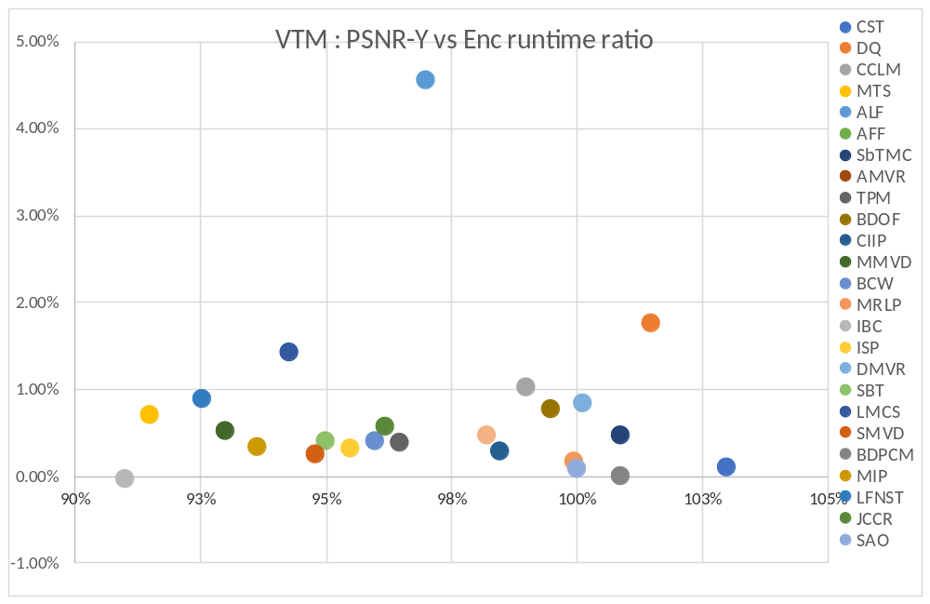
Figure 1. PSNR-Y vs encoding runtime ratio of VTM with VTM tool tests (VTM anchor)
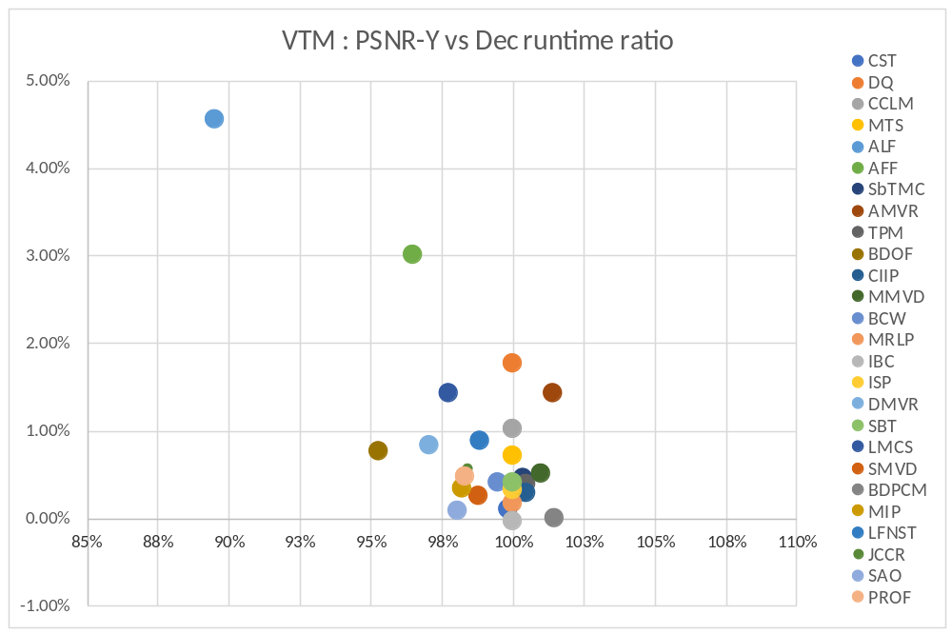
Figure 2. PSNR-Y vs decoding runtime ratio of VTM with VTM tool tests (VTM anchor)

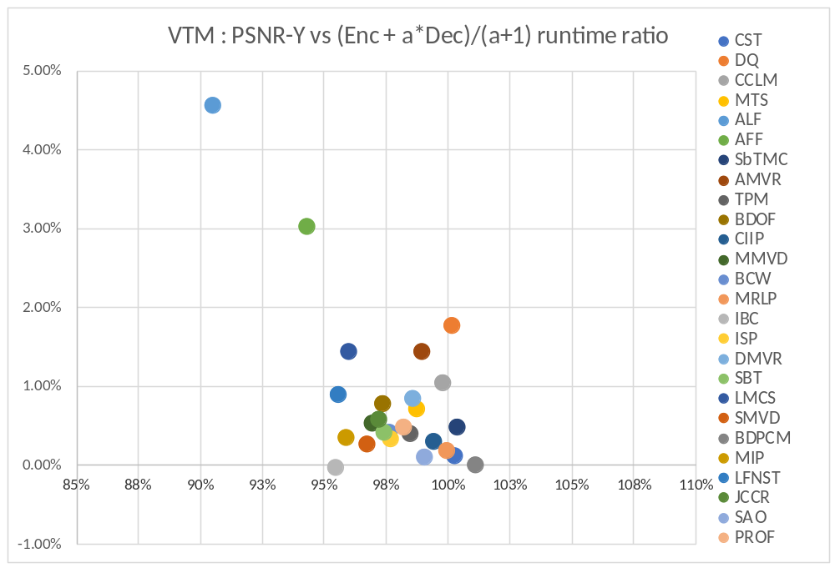
Figure 3. PSNR-Y vs weighted runtime ratio (a = 6) of VTM with VTM tool tests (VTM anchor)

Related contributions

Recommendations
The AHG recommends the following:
- Consider the reported tool test results during tool adoption decision making
- Review related contributions
- Refine list of tested tools and test methodology for the next meeting cycle
  - Consider the reported tool test results as a benchmark for CE tests
  - Consider including reporting of compute system information for testers and cross-checkers

Reference
- X. Xu, Y.-H. Chao, Y.-C. Sun, J. Xu, JVET-P2022, “Description of Core Experiment 2 (CE2): Palette Mode Coding", 16th Meeting: Geneva, CH, 1–11 Oct, 2019.
- X. Xiu, Y.-W. Chen, T.-C. Ma, H.-J. Jhu, X. Wang, “Support of adaptive color transform for 444 video coding in VVC", 16th Meeting: Geneva, CH, 1–11 Oct, 2019.

