    Joint Video Experts Team (JVET)  of ITU-T SG 16 WP 3 and ISO/IEC JTC 1/SC 29/WG 11  16th Meeting: Geneva, CH, 1–11 October 2019 | Document: JVET-P2025-v2

Title: | Description of Core Experiment 5 (CE5): Cross Component Adaptative Loop Filtering
Status: | Output Document to JVET
Purpose: | Core Experiment description
Author(s) or  Contact(s): | Ching-Yeh Chen  Andrew Segall | Tel:  Email: | chingyeh.chen@mediatek.com  asegall@sharplabs.com
Source: | CE coordinators
_____________________________

Abstract
The goal of this Core Experiment (CE) is to improve and/or enhance cross component loop filtering (CC-ALF) techniques. These CC-ALF techniques will be evaluated according to both subjective and objective metrics.

Test conditions and evaluation criteria
As decided in the 16th JVET meeting, proposals in the CE will be evaluated relative to a “CE Anchor”. The software for this anchor will correspond to VTM-7.0 combined with JVET-P1008 (Option 1), and this anchor will be provided as part of the core experiment process. Furthermore, an evaluation of the CE Anchor compared to VTM-7.0 will also be performed.
Testing will be organized into sub-tests based on design aspects of the proposal. The sub-tests will include:
- Alternative filter shapes and footprints
- Complexity reduction of the filtering process
Additionally, combinations of proposals in the different sub-tests will also be identified and studied. Evaluation of the proposals will be performed with respect to subjective quality, objective quality and complexity.

Test descriptions

Test | Description |  | Source | Proponent(s) |  | Cross-checker(s)
Common Base | Cross-component Adaptive Loop Filter as in JVET-P1008 (Option 1) |  | JVET-P1008 (Option 1) | K. Misra (Sharp)  N. Hu (Qualcomm)  P. Onno (Cannon)  J. Li (Panasonic)  J. Nam (LGE)  O. Chubach (MediaTek)
CE5-1 (Alternative Filter Shapes)
CE5-1.1 | 5x4 filter shape with 8 coefficients |  | JVET-P0106 | A. Kotra (Huawei)
CE5-1.2 | 3x2 filter shape with 6 coefficients |  | JVET-P0173 | J. Li (Panasonic)
CE5-1.3 | 3x4 filter shape with 6 coefficients |  | JVET-P0251 | Y. Zhao (Huawei)
CE5-1.4 | Joint Cb/Cr CC-ALF with one additional weight |  | JVET-P0372 | H. Yang (InterDigital)
CE5-2 (Complexity reduction of the filtering process)
CE5-2.1 | Multiplication removal with coefficient range in [-64, 64] |  | JVET-P0557 | N. Hu (Qualcomm)
CE5-2.2 | Multiplication removal with coefficient range in [-8, 8] |  | JVET-P0666 | N. Hu (Qualcomm)  X. Li (Tencent)
CE5-3 (Combination Tests)
CE5-3.1 | CE5-2.1 + 5x5 filter shape with 13 coefficients |  | JVET-P0558 | N. Hu (Qualcomm)
CE5-3.2 | CE5-1.4 + CE5-2.1  Joint Cb/Cr CC-ALF with one additional weight combined with multiplication removal with coefficient range in [-64,64] |  | Proposed during CE editing period

Detailed description of tests

CE Anchor (JVET-P1008)
The anchor for the CE test is provided in JVET-P1008 (Option 1). This method provides a CC-ALF design that has the following properties:
- Filter shape is a 3x4 diamond with 8 unique coefficients
- Filter coefficient dynamic range is limited to 6-bit signed
- Filter selection to performed at the CTU level with support for a maximum of 4 filters
- Symmetric line selection is used at virtual boundary (to better harmonize with ALF)
- Temporal layer coefficient buffers are not used (to better harmonize with the APS concept)
- Residual output is clipped to -2^{BitDepthC-1} to 2^{BitDepthC-1}-1, inclusive.
An overview of the CC-ALF process is shown in Figure C-1. As can be seen in the Figure, CC-ALF uses a linear filter to filter luma sample values and generate a residual correction for the chroma channels from the co-located filtered output. An illustration of the filter shape is provided in Figure C-2.

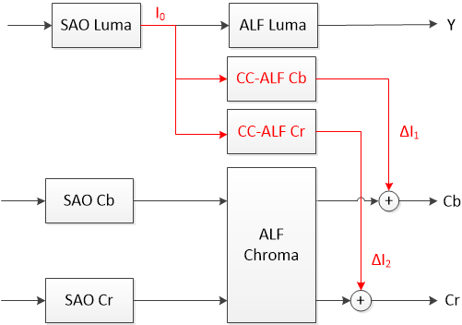
Fig. C-1: Placement of CC-ALF with respect to other loop filters

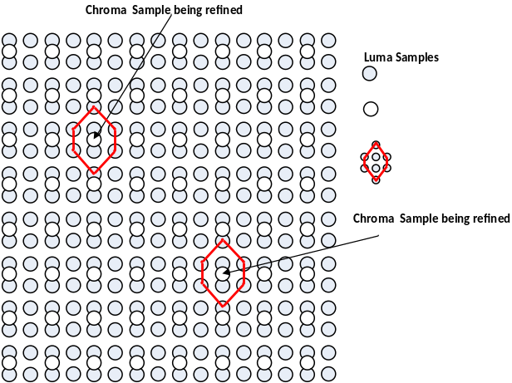
Fig. C-2: Filter support in CE Anchor
Draft text for the anchor is also available in JVET-P1008.

CE5-1: Alternative Filter Shapes

CE5-1.1: Simplifications for Cross Component Adaptive Loop Filter (JVET-P0106)
The CC-ALF filter shape is modified to have only 8 coefficients as shown in the figure below. This modified filter shape is proposed to be tested with sequences containing different chroma type.
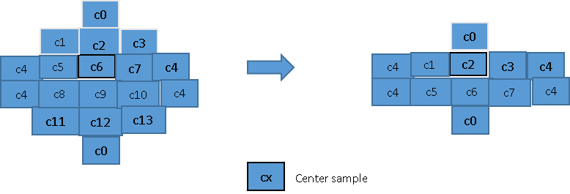

CE5-1.2: Cross component ALF simplification (JVET-P0173)
To further reduce number of operations and remove virtual boundary handling of CCALF, 6 tap filter shape is proposed as below:

f0 | f1 | f2
f3 | f4 | f5

CE5-1.3: Simplified CCALF with 6 filter coefficients (JVET-P0251)
To further reduce the complexity and align number of multiplications of CC-ALF with chroma ALF, a six-tap filter was proposed, as shown in Fig. 5-1.3-1. The six taps are a sub-set of the eight taps of JVET-P1008, and each tap is associated with a unique filter coefficient.
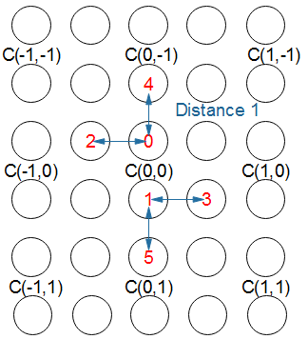
Fig. 5-1.3-1 Six-tap CC-ALF.

CE5-1.4: Joint chroma cross-component adaptive loop filtering (JVET-P0372)
Joint Chroma Cross-Component Adaptive Loop Filter (JC-CCALF) uses only one set of CCALF filter coefficients trained at the encoder to generate one filtered output as the refinement signal, which will be added directly to the Cb component, and be properly weighted and then added to the Cr component.

SAO Luma
ALF Luma
SAO Cb
SAO Cr
Joint chroma
CC ALF
ALF Cb
Y
Cb
Cr
w
ALF Cr
Fig. 5-1.4-1. JC-CCALF workflow.

CE5-2: Complexity reduction in filtering process

CE5-2.1: Multiplication removal for cross component adaptive loop filter (JVET-P0557)

Filter coefficients are restricted to have values: {-64, -32, -16, -8, -4, -2, -1, 0, 1, 2, 4, 8, 16, 32, 64}, which are signalled as {-7, -6, -5, -4, -3, -2, -1, 0, 1, 2, 3, 4, 5, 6, 7} respectively before binarization in order to reduce the signalling overhead. Fixed length codes of 3 bits are used to signal the absolute values of the coefficients. Another sign bit is signalled for non-zero coefficients.

CE5-2.2: Multiplication removal for cross component adaptive loop filter (JVET-P0666)
Filter coefficients are restricted to have values: {-8, -4, -2, -1, 0, 1, 2, 4, 8}. A bit is first signalled to indicate whether it is a zero coefficient. If not, a fixed length code of 2 bits is used to signal the absolute value of the coefficient followed by a sign bit.

CE5-3: Combination Tests

CE5-3.1: Combination of CE5-2.1 and 5x5 diamond filter used in chroma ALF (JVET-P0558)
Alternative filter shape with multiplication removal for CCALF

 |  | f0
 | f1 | f2 | f3
f4 | f5 | f6 | f7 | f8
 | f9 | f10 | f11
 |  | f12
The 5x5 diamond filter shape will be used for CCALF on top of the tests in CE5-2.1. Filter coefficients are restricted to have values: {-64, -32, -16, -8, -4, -2, -1, 0, 1, 2, 4, 8, 16, 32, 64}, which are signalled as {-7, -6, -5, -4, -3, -2, -1, 0, 1, 2, 3, 4, 5, 6, 7} respectively before binarization in order to reduce the signalling overhead. Fixed length codes of 3 bits are used to signal the absolute values of the coefficients. Another sign bit is signalled for non-zero coefficients.

CE5-3.2: Combination of CE5-1.4 and CE5-2.1

Proposed during the CE editing period, the Joint Cb/Cr CC-ALF with one additional weight method in CE5-1.4 is combined the multiplication removal with coefficient range in [-64,64] method in CE5-2.1.

Expected Gains
- Coding efficiency improvement
- Subjective picture quality preservation

Evaluation Criteria
The CE Anchor
will be compared against VTM-7.0, while all other tests will be compared against the CE Anchor. These comparisons will consist of the following:
- BD-rate
- Subjective performance
- Complexity performance
More information about each of these comparisons is provided in the sub-sections below.

BD-rate Comparison
BD-rate information shall be provided according to the JVET SDR Common Test Conditions [1]. For proposals to be tested with alternative chroma types, additional BD-rate information shall also be provided according to the JVET HDR Common Test Conditions [2].

Subjective performance evaluation

Expert viewing at the Brussels meeting may be performed for all proposals in the CE.
The main purpose of the subjective evaluation is to determine if proposals provide degraded subjective performance. The following sequences and QP points will be used in the subjective tests

:

Num | Name | Resolution | Fps | Frames | Mode | QP
SDR_01 | FoodMarket | 3840x2160p | 60fps | 600 | RA | 37, 32
SDR_02 | Campfire | 3840x2160p | 30fps | 300 | RA | 37, 32
SDR_03 | Red Kayak* | 1920x1080p | 30fps | 300 | RA | 37, 32
SDR_04 | Cactus | 1920x1080p | 50fps | 500 | LDB | 37, 32
SDR_05 | KristenAndSara | 1280x720p | 60fps | 600 | LDP | 37, 32
* First 300 frames of the RedKayak sequence shall be used.

Please note that the

length of each sequence is 10 seconds, which means that the versions of some sequences encoded for the subjective test are longer than those used in the JVET SDR Common Test Conditions [1].
Bit-streams to be used for the subjective test and md5sums of the decoded sequence results shall be uploaded to the JVET ftp folder /ce/JVET-P2025_loop_filters according to the schedule in Section 6. Proponents should also bring the decoded sequences to the Brussels meeting. Anchors will be provided by volunteers.

Complexity performance evaluation
Complexity information shall also be provided for each proposal, including:
- Decoding time versus the CE Anchor. Decoding time shall be measured on the same computer without writing output pictures to disk
- Encoding time versus the CE Anchor. Encoding times measured using cluster times are acceptable.
- Number of additional multiplications, shift, and addition per pixel for the tested CC-ALF process.

Time-line and Responsibilities
T1: 2019-Nov-1: Final CE description uploaded
T2: VTM7.0 release + 1 week: CE Anchor is released
T2: VTM7.0 release + 3 weeks: Proponents provide software and cross-checking begins
T3: 2019-Dec-17: Final version of proponent software is provided
T4: 2019-Dec-24: CE contribution documents including specification text and complete test results are uploaded to the JVET document repository. Sequences for the subjective test are uploaded to the FTP repository. (Regular document deadline – 1 week)

References
- F. Bossen, J. Boyce, X. Li, V. Seregin, K. Sühring, “JVET common test conditions and software reference configurations for SDR video”, JVET-N1010.

- A. Segall, E. François, W. Husak, S. Iwamura, D. Rusanovskyy, “JVET common test conditions and evaluation procedures for HDR/WCG video”, JVET-P2011.

