    Joint Video Experts Team (JVET)  of ITU-T SG 16 WP 3 and ISO/IEC JTC 1/SC 29/WG 11  16th Meeting: Geneva, CH, 1–11 October 2019 | Document: JVET-P0956

Title: | Crosscheck of JVET-P0485 (AHG18: Performance of CE7-1.2d and CE7-2.2 on lossless coding)
Status: | Input document to JVET
Purpose: | Report
Author(s) or  Contact(s): | Jung-Ah Choi  Jaehyun Lim  19 Yangjaedaero-11gil  Seocho-gu, Seoul 06772  South Korea | Tel:  Email: | +82-2-6912-6561  jungah.choi@lge.com
Source: | LG Electronics Inc.
_____________________________

Abstract
This contribution is a cross-check report of JVET-P0485 test scenario 2. For cross-checking, we reviewed the source code provided by proponents and conducted lossless coding tests. According to the results of experiments, the cross-check results match the results reported by the proponent.

Introduction
On top of JVET-P0082 method #1 [1], proponents replaced the current VTM-6.0 transform skip residual coding to the CE7-1.2d-alternative [2] transform skip residual coding and tested the lossless coding performance. Proponents also tested the lossless coding performance of both transform skip modification proposed in CE7-1.2d-alternative and the transform skip binarization proposed in CE7-2.2a-alternative [3].

Simulation results
The software on top of the AHG18 initial lossless software was provided by the proponents [1]. Crosscheck experiments were performed under --TransquantBypassEnable=1 --CUTransquantBypassFlagForce=1 --CostMode=lossless﻿ –InternalBitDepth=0 -qp 0. configurations. Additionally, BDPCM is turned on for all test sequences. Following tables show the results of the cross-check experiments.

Table 1: Results of method 1 (CE7-1.2d-alternative on lossless coding)
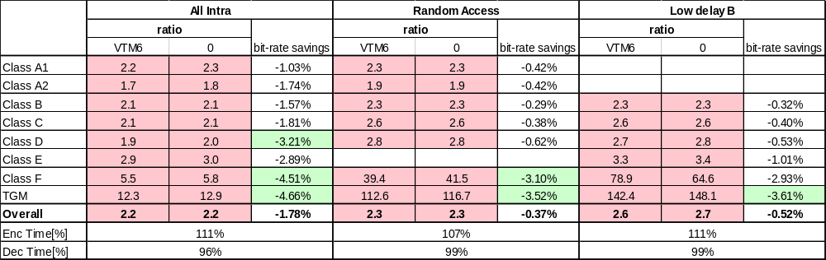
Table 2: Results of method 2 (CE7-2.2a-alternative on lossless coding)
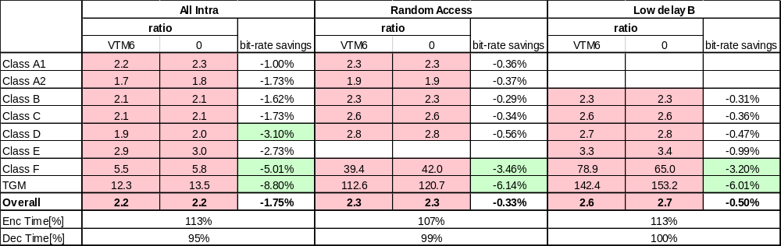

Conclusion
The cross-checker confirms that the simulation results obtained in the cross-check match the results presented in JVET-P0485 test scenario 2. The source code also matches the proponents’ description.

References
[1] Y. Chao et al., “AHG18: Performance of CE7-1.2d and CE7-2.2 on lossless coding,” JVET-P0485, ISO/IEC JTC 1/SC 29/WG 11 Joint Video Experts Team (JVET) 16th Meeting: Geneva, CH, 1–11 Oct. 2019.

