    Joint Video Experts Team (JVET)  of ITU-T SG 16 WP 3 and ISO/IEC JTC 1/SC 29/WG 11  16th Meeting: Geneva, CH, 1–11 October 2019 | Document: JVET-P0955

Title: | Cross-check of JVET-P0521 (AHG18: Disabling DMVR and BDOF for lossless coding)
Status: | Input document to JVET
Purpose: | Report
Author(s) or  Contact(s): | Jung-Ah Choi  Jaehyun Lim  19 Yangjaedaero-11gil  Seocho-gu, Seoul 06772  South Korea | Tel:  Email: | +82-2-6912-6561  jungah.choi@lge.com
Source: | LG Electronics Inc.
_____________________________

Abstract
This contribution is a cross-check report of JVET-P0521. The source code provided by proponents is carefully reviewed and tested under the lossless test conditions. According to the results of experiments, the cross-check results match the results reported by the proponent.

Introduction
In the current VTM-6.0, the DMVR and BDOF are applied in decoder side to refine the decoded picture. The proponents observed that these features do not provide better coding performance for lossless coding. In order to reduce the decoder-side complexity, proponents suggested to disable DMVR and BDOF for lossless coded blocks.

Simulation results
The software on top of the AHG18 initial lossless software was provided by the proponents [1]. Crosscheck experiments were performed under --TransquantBypassEnable=1 --CUTransquantBypassFlagForce=1 --CostMode=lossless﻿ –InternalBitDepth=0 –q 22 configurations. Following table shows the results of the cross-check experiments.

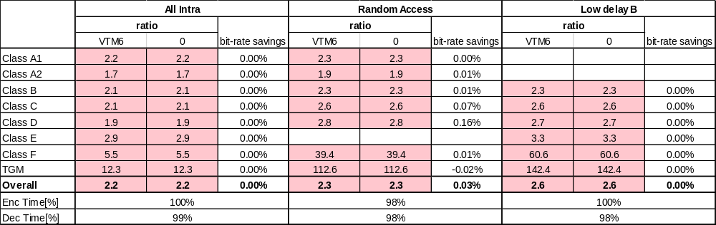

Conclusion
The cross-checker confirms that the simulation results obtained in the cross-check match the results presented in JVET-P0521. The source code also matches the proponents’ description.

References
[1] T. Ma et al., “AHG18: Disabling DMVR and BDOF for lossless coding,” JVET-P0521, ISO/IEC JTC 1/SC 29/WG 11 Joint Video Experts Team (JVET) 16th Meeting: Geneva, CH, 1–11 Oct. 2019.

