    Joint Video Experts Team (JVET)  of ITU-T SG 16 WP 3 and ISO/IEC JTC 1/SC 29/WG 11  16th Meeting: Geneva, CH, 1–11 October 2019 | Document: JVET-P0746-v1

Title: | CE4-related: Combination of JVET-P0264 and JVET-P0304 on GEO simplification
Status: | Input document to JVET
Purpose: | Proposal
Author(s) or  Contact(s): | Kevin Reuzé¹, Chun-Chi Chen², Han Huang³, Wei-Jung Chien, Vadim Seregin, Marta Karczewicz (Qualcomm)  Ru-Ling Liao⁴, Jie Chen⁵, Yan Ye, Jiancong Luo (Alibaba) | Tel:  Email: | ¹kreuz@qti.qualcomm.com ²chunchic@qti.qualcomm.com ³hanhuang@qti.qualcomm.com  ⁴ruling.lrl@alibaba-inc.com  ⁵jiechen.cj@alibaba-inc.com
Source: | Qualcomm Inc. and Alibaba Group
_____________________________

Abstract
In this contribution, a combination method of JVET-P0264 and JVET-P0304 is proposed. Firstly, the angles used in GEO is replaced with the angles which have a tangent equal to a power of two number. Secondly, the blending weights and the mask for motion field storage are derived from pre-defined masks using shift and cropped operations. With this combined method, the memory usage for GEO can be reduced to 560 bytes. It is reported that, under the CTC, the proposed method provides 0.20%/0.68%/0.46% gain for Class B/C/D in RA configuration and 0.69%/0.64%/0.84% gain for Class C/D/E in LB configuration.

Introduction
GEO as introduced in JVET-P0068 supports 140 different partitioning manners, differentiated by 32 angles (quantized between 0 and 360° with 11.25° of equal separation) and 5 edges relative to the center of a CU, in addition to TPM to split a CU into two parts. Figure 1.a shows that the 5 edges are distributed uniformly along the direction of normal vector within a CU, starting from Edge₀ that passes through the CU center. Each partition mode (i.e., a pair of an angle index and an edge index) in GEO is assigned with a pixel-adaptive weight table to blend samples on the two partitioned parts, where the weight value of a sampled ranges from 0 to 8 and is determined by the L2 distance from the center position of a pixel to the edge.
The computation of the weight value of each pixel is two-fold: (a) computing the displacement from a pixel position to a given edge and (b) mapping the computed displacement to a weight value through a pre-defined look-up table. The way to compute the displacement from a pixel position (x, y) to a given edge Edge_{i} is actually the same as computing the displacement from (x, y) to Edge₀ and subtract this displacement by the distance ρ between Edge₀ and Edge_{i}. Figure 1.b illustrates the geometric relations among (x, y) and edges. Specifically, the displacement from (x, y) to Edge_{i} can be formulated as follows:
$$\overline{PB}$$ | $$=\overline{PA}- ρ$$
 | $$=\left(\overline{PC}+\overline{CD}\right)*sin⁡(α)- ρ$$
 | $$=\left(\left(\frac{H}{2}-y\right)+\left(x-\frac{W}{2}\right)*cot⁡(α)\right)*sin⁡(α)- ρ$$
 | $$=\left(x-\frac{W}{2}\right)*\cos\left(α\right)-\left(y-\frac{H}{2}\right)*sin(α)- ρ$$
 | $$=x*\cos\left(α\right)-y*sin(α)-(ρ+\frac{W}{2}*\cos\left(α\right)-\frac{H}{2}*\sin\left(α\right))$$
 | $=x*\cos\left(α\right)+y*cos(α+\frac{π}{2})-(ρ+\frac{W}{2}*\cos\left(α\right)+\frac{H}{2}*\cos\left(α+\frac{π}{2}\right))$.

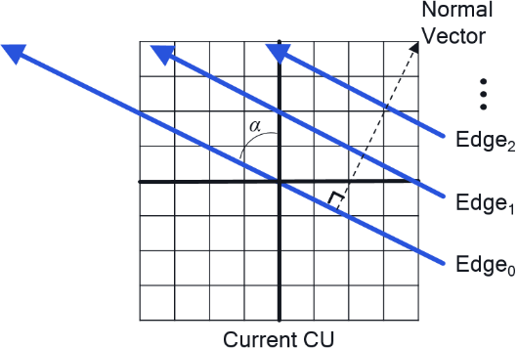 | 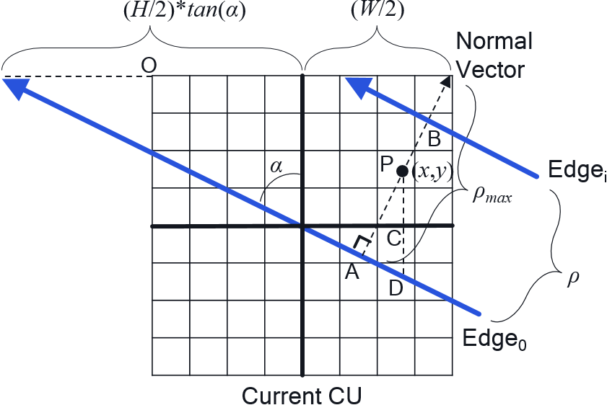
(a) | (b)
- (a) Edges supported in GEO. (b) Geometric relations between a given pixel position (x,y) and two edges.
The value of ρ is a function of the maximum length (denoted by ρ_{max}) of the normal vector and edge index i, that is:
$$ρ$$ | $$=i*(ρ_{max}-1)/N$$
 | $$=i*((\frac{H}{2}*tan(α)+\frac{W}{2})*cos⁡(α)-1)/N,$$
where N is the number of edges supported by GEO and the “1” is to prevent the last edge Edge_{N-1} from falling too close to a CU corner for some angle indices. Substituting Eq. (8) from (6), we can compute the displacement from each pixel (x,y) to a given Edge_{i}. In short, we denote $\overline{PB}$ as wIdx(x,y). The computation of $ρ$ is needed once per CU, and the computation of wIdx(x,y) is needed once per sample, in which multiplications are involved.
In some implementations, it is preferred to store the weights for each block size and partition mode instead of on-the-fly calculation. Besides, a mask for motion field storage is required. However, due to the huge number of partition modes, it may be difficult to store all the information in real implementation. Memory storage requirement for all 3 variations of GEO in CE4 is listed in the table below.
 | 140 partitioning modes | 108 partitioning modes | 80 partitioning modes
blending weights | 3,301,760 bytes | 2,547,072 bytes | 1,886,720 bytes
motion storage | 103,180 bytes | 79,596 bytes | 58,960 bytes
Overall | 3,404,940 bytes  ≈ 3.4 Mbytes | 2,626,668 bytes  ≈ 2.6 Mbytes | 1,945,680 bytes  ≈ 1.9 Mbytes

Memory reduction of GEO
To reduce the memory needed for storing the adaptive weights and the masks for motion field storage, two modifications are proposed. Firstly, the angles used by GEO are replaced with the angles having powers of 2 as tangent (proposed in JVET-P0264). Secondly, the weights for a block are derived from pre-defined mask using shift and cropped operations (proposed in JVET-P0304).

GEO using angles having power of 2 as tangent
In JVET-P0264, the angles in GEO is replaced with the angles which have powers of 2 as tangent. Since the tangent of the proposed angles is a power-of-2 number, most of multiplications in Eq. (6) can be replaced by bit-shifting. Besides, the weight values for these angles can be implemented by repeating row-by-row or column-by-column with phase shift. Thus, the Eq. (6) can be simplified as Eq. (9) or Eq. (10). The details equations derivation can be found in JVET-P0264.
$$wIdx(x,y)$$ | $=wIdx(x-tan\left(α\right),y-1)$.
 | $=wIdx(x-1,y-cot\left(α\right))$.
With the proposed angles, one row or column is needed to store per block size and per partition mode.
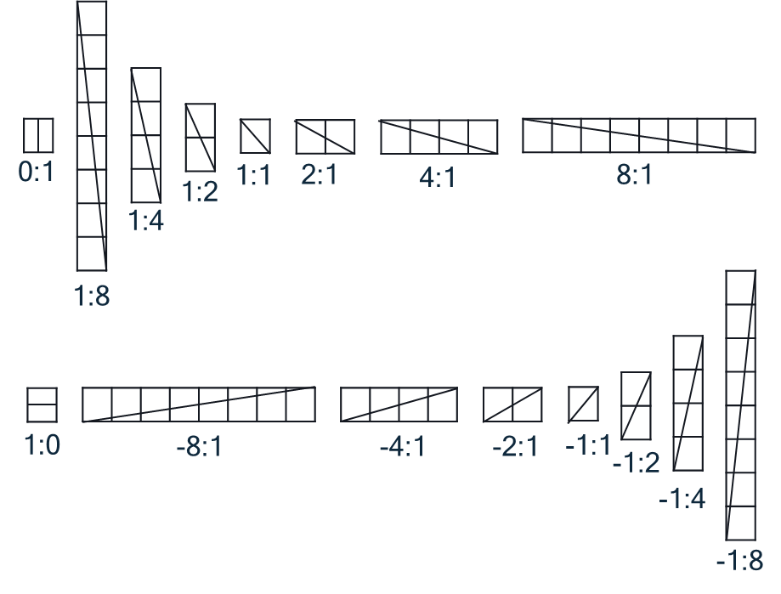
- Proposed angles for GEO along with their corresponding width:height ratio.

Weights derivation using shift and cropped operations
In JVET-P0304, it is proposed to derive the weights and the mask for motion field storage for all blocks and partition modes from two sets of pre-defined masks, one for the blending weights derivation and the other for the masks of motion field storage. There are totally 16 masks in each set. Each mask per angle is calculated using the same equations in GEO with block width and block height set to 256 and displacement set to 0. For a block of size W×H with angle $φ$ and distance $ρ$, the blending weights for the luma samples are directly cropped from the pre-defined masks with offsets calculated as follows:
- Variables offsetX and offsetY are calculated as follows:
$$offsetX=\left\{\begin{matrix}(M-W)≫1 & φ \% 16 = 8 or (φ \% 16 ≠ 0 and H ≥ W) \\ \left(\left(M-W\right)≫1\right)+φ<16 ?\left(ρ×W\right)≫3 :-(\left(ρ×W\right)≫3) & otherwise\end{matrix}\right.$$

$$offsetY=\left\{\begin{matrix}\left(\left(M-H\right)≫1\right)+φ<16 ?\left(ρ×H\right)≫3 :-(\left(ρ×H\right)≫3) & φ \% 16 = 8 or (φ \% 16 ≠ 0 and H ≥ W) \\ \left(M-H\right)≫1 & otherwise\end{matrix}\right.$$

- ${sampleWeight}_{L}\left[x\right]\left[y\right]=g_{sampleWeight}_{L}[φ \% 16][x+offsetX][y+offsetY]$.
, where $g_{sampleWeight}_{L}[]$ is the pre-defined masks for the blending weights.

Combination of two proposals
When combining the methods in JVET-P0264 and JVET-P0304, only one row/column with 28 elements is needed to store per angle. So 32×28×4 = 448 bytes are needed to store the blending weights.
The weights for luma samples are derived as follows:
- Shift = log2(max(W, H) / min(W, H))
- Variables offsetX and offsetY:
$$offsetX=\left\{\begin{matrix}(256-W)≫1 & φ \% 16 = 8 or (φ \% 16 ≠ 0 and H ≥ W) \\ \left(\left(256-W\right)≫1\right)+φ<16 ?\left(ρ×W\right)≫3 :-(\left(ρ×W\right)≫3) & otherwise\end{matrix}\right.$$

$$offsetY=\left\{\begin{matrix}\left(\left(256-H\right)≫1\right)+φ<16 ?\left(ρ×H\right)≫3 :-(\left(ρ×H\right)≫3) & φ \% 16 = 8 or (φ \% 16 ≠ 0 and H ≥ W) \\ \left(256-H\right)≫1 & otherwise\end{matrix}\right.$$
- $tmp=\left(256-\left(256≫shift\right)\right)≫1$
- The wIdx is derived as follows:
φ = 0 or φ = 16 | $$wIdx=x+offsetX-128$$
(φ ≥ 1 and φ ≤ 3) or  (φ ≥ 17 and φ ≤ 19) | $$wIdx=y+offsetY-(\left(x+offsetX-tmp\right)≪shift)$$
(φ ≥ 4 and φ ≤ 7) or  (φ ≥ 20 and φ ≤ 23) | $$wIdx=x+offsetX-(\left(y+offsetY-tmp\right)≪shift)$$
φ = 8 or φ = 24 | $$wIdx=y+offsetY-128$$
(φ ≥ 9 and φ ≤ 12) or (φ ≥ 25 and φ ≤ 28) | $$wIdx=255-(x+offsetX)-(\left(y+offsetY-tmp\right)≪shift)$$
(φ ≥ 13 and φ ≤ 15) or (φ ≥ 29 and φ ≤ 31) | $$wIdx=255-(\left(x+offsetX-tmp\right)≪shift)-\left(y+offsetY\right)$$

- ${sampleWeight}_{L}\left[x\right]\left[y\right]=blendWeight[φ][Clip3(0, 27,wIdx+10)]$.
blendWeight[32][28] = {
{ 8, 8, 8, 8, 8, 8, 8, 8, 7, 5, 3, 1, 0, 0, 0, 0, 0, 0, 0, 0, 0, 0, 0, 0, 0, 0, 0, 0, } // 0
{ 0, 1, 1, 1, 1, 2, 2, 2, 2, 3, 3, 3, 4, 4, 4, 4, 5, 5, 5, 6, 6, 6, 6, 7, 7, 7, 7, 8, } // 1
{ 0, 0, 0, 0, 0, 0, 1, 1, 2, 3, 3, 4, 4, 5, 5, 6, 7, 7, 8, 8, 8, 8, 8, 8, 8, 8, 8, 8, } // 2
{ 0, 0, 0, 0, 0, 0, 0, 1, 1, 2, 3, 5, 6, 7, 7, 8, 8, 8, 8, 8, 8, 8, 8, 8, 8, 8, 8, 8, } // 3
{ 8, 8, 8, 8, 8, 8, 8, 8, 7, 6, 4, 2, 1, 0, 0, 0, 0, 0, 0, 0, 0, 0, 0, 0, 0, 0, 0, 0, } // 4
{ 8, 8, 8, 8, 8, 8, 8, 7, 7, 6, 5, 3, 2, 1, 1, 0, 0, 0, 0, 0, 0, 0, 0, 0, 0, 0, 0, 0, } // 5
{ 8, 8, 8, 8, 8, 8, 7, 7, 6, 5, 5, 4, 4, 3, 3, 2, 1, 1, 0, 0, 0, 0, 0, 0, 0, 0, 0, 0, } // 6
{ 8, 7, 7, 7, 7, 6, 6, 6, 6, 5, 5, 5, 4, 4, 4, 4, 3, 3, 3, 2, 2, 2, 2, 1, 1, 1, 1, 0, } // 7
{ 0, 0, 0, 0, 0, 0, 0, 0, 1, 3, 5, 7, 8, 8, 8, 8, 8, 8, 8, 8, 8, 8, 8, 8, 8, 8, 8, 8, } // 8
{ 8, 7, 7, 7, 7, 6, 6, 6, 6, 5, 5, 5, 4, 4, 4, 4, 3, 3, 3, 2, 2, 2, 2, 1, 1, 1, 1, 0, } // 9
{ 8, 8, 8, 8, 8, 8, 7, 7, 6, 5, 5, 4, 4, 3, 3, 2, 1, 1, 0, 0, 0, 0, 0, 0, 0, 0, 0, 0, } // 10
{ 8, 8, 8, 8, 8, 8, 8, 7, 7, 6, 5, 3, 2, 1, 1, 0, 0, 0, 0, 0, 0, 0, 0, 0, 0, 0, 0, 0, } // 11
{ 8, 8, 8, 8, 8, 8, 8, 8, 7, 6, 4, 2, 1, 0, 0, 0, 0, 0, 0, 0, 0, 0, 0, 0, 0, 0, 0, 0, } // 12
{ 0, 0, 0, 0, 0, 0, 0, 1, 1, 2, 3, 5, 6, 7, 7, 8, 8, 8, 8, 8, 8, 8, 8, 8, 8, 8, 8, 8, } // 13
{ 0, 0, 0, 0, 0, 0, 1, 1, 2, 3, 3, 4, 4, 5, 5, 6, 7, 7, 8, 8, 8, 8, 8, 8, 8, 8, 8, 8, } // 14
{ 0, 1, 1, 1, 1, 2, 2, 2, 2, 3, 3, 3, 4, 4, 4, 4, 5, 5, 5, 6, 6, 6, 6, 7, 7, 7, 7, 8, } // 15
{ 8, 8, 8, 8, 8, 8, 8, 8, 7, 5, 3, 1, 0, 0, 0, 0, 0, 0, 0, 0, 0, 0, 0, 0, 0, 0, 0, 0, } // 16
{ 0, 1, 1, 1, 1, 2, 2, 2, 2, 3, 3, 3, 4, 4, 4, 4, 5, 5, 5, 6, 6, 6, 6, 7, 7, 7, 7, 8, } // 17
{ 0, 0, 0, 0, 0, 0, 1, 1, 2, 3, 3, 4, 4, 5, 5, 6, 7, 7, 8, 8, 8, 8, 8, 8, 8, 8, 8, 8, } // 18
{ 0, 0, 0, 0, 0, 0, 0, 1, 1, 2, 3, 5, 6, 7, 7, 8, 8, 8, 8, 8, 8, 8, 8, 8, 8, 8, 8, 8, } // 19
{ 8, 8, 8, 8, 8, 8, 8, 8, 7, 6, 4, 2, 1, 0, 0, 0, 0, 0, 0, 0, 0, 0, 0, 0, 0, 0, 0, 0, } // 20
{ 8, 8, 8, 8, 8, 8, 8, 7, 7, 6, 5, 3, 2, 1, 1, 0, 0, 0, 0, 0, 0, 0, 0, 0, 0, 0, 0, 0, } // 21
{ 8, 8, 8, 8, 8, 8, 7, 7, 6, 5, 5, 4, 4, 3, 3, 2, 1, 1, 0, 0, 0, 0, 0, 0, 0, 0, 0, 0, } // 22
{ 8, 7, 7, 7, 7, 6, 6, 6, 6, 5, 5, 5, 4, 4, 4, 4, 3, 3, 3, 2, 2, 2, 2, 1, 1, 1, 1, 0, } // 23
{ 0, 0, 0, 0, 0, 0, 0, 0, 1, 3, 5, 7, 8, 8, 8, 8, 8, 8, 8, 8, 8, 8, 8, 8, 8, 8, 8, 8, } // 24
{ 8, 7, 7, 7, 7, 6, 6, 6, 6, 5, 5, 5, 4, 4, 4, 4, 3, 3, 3, 2, 2, 2, 2, 1, 1, 1, 1, 0, } // 25
{ 8, 8, 8, 8, 8, 8, 7, 7, 6, 5, 5, 4, 4, 3, 3, 2, 1, 1, 0, 0, 0, 0, 0, 0, 0, 0, 0, 0, } // 26
{ 8, 8, 8, 8, 8, 8, 8, 7, 7, 6, 5, 3, 2, 1, 1, 0, 0, 0, 0, 0, 0, 0, 0, 0, 0, 0, 0, 0, } // 27
{ 0, 0, 0, 0, 0, 0, 0, 0, 1, 2, 4, 6, 7, 8, 8, 8, 8, 8, 8, 8, 8, 8, 8, 8, 8, 8, 8, 8, } // 28
{ 0, 0, 0, 0, 0, 0, 0, 1, 1, 2, 3, 5, 6, 7, 7, 8, 8, 8, 8, 8, 8, 8, 8, 8, 8, 8, 8, 8, } // 29
{ 0, 0, 0, 0, 0, 0, 1, 1, 2, 3, 3, 4, 4, 5, 5, 6, 7, 7, 8, 8, 8, 8, 8, 8, 8, 8, 8, 8, } // 30
{ 0, 1, 1, 1, 1, 2, 2, 2, 2, 3, 3, 3, 4, 4, 4, 4, 5, 5, 5, 6, 6, 6, 6, 7, 7, 7, 7, 8, } } // 31
The total memory requirement for blending weights is 32 * 28 * 4 = 3584 bits (448 bytes). Also, the following properties can be used to further reduce memory requirement.
- For φ > 8 and φ <=16, blendWeight[φ][i] = blendWeight[16- φ][i].
- For φ > 16 and φ < =24, blendWeight[φ][i] = blendWeight[φ-16][i].
- For φ > 24 and φ < =31 and φ != 28, blendWeight[φ][i] = blendWeight[32-φ][i].
For the masks of motion field storage, the following equations are used:
- Shift = log2(max(W, H) / min(W, H))
- Variables offsetX and offsetY:
$$offsetX=\left\{\begin{matrix}(64-(W≫2))≫1 & φ \% 16 = 8 or (φ \% 16 ≠ 0 and H ≥ W) \\ \left(\left(64-(W≫2))\right)≫1\right)+φ<16 ?\left(ρ×W\right)≫5 :-(\left(ρ×W\right)≫5) & otherwise\end{matrix}\right.$$

$$offsetY=\left\{\begin{matrix}\left(\left(64-(H≫2)\right)≫1\right)+φ<16 ?\left(ρ×H\right)≫5 :-(\left(ρ×H\right)≫5) & φ \% 16 = 8 or (φ \% 16 ≠ 0 and H ≥ W) \\ \left(64-(H≫2)\right)≫1 & otherwise\end{matrix}\right.$$
- $tmp=\left(64-\left(64≫shift\right)\right)≫1$
- The wIdx is derived as follows:
φ = 0 or φ = 16 | $$wIdx=x+offsetX-32$$
(φ ≥ 1 and φ ≤ 3) or  (φ ≥ 17 and φ ≤ 19) | $$wIdx=y+offsetY-(\left(x+offsetX-tmp\right)≪shift)$$
(φ ≥ 4 and φ ≤ 7) or  (φ ≥ 20 and φ ≤ 23) | $$wIdx=x+offsetX-(\left(y+offsetY-tmp\right)≪shift)$$
φ = 8 or φ = 24 | $$wIdx=y+offsetY-32$$
(φ ≥ 9 and φ ≤ 12) or (φ ≥ 25 and φ ≤ 28) | $$wIdx=63-(x+offsetX)-(\left(y+offsetY-tmp\right)≪shift)$$
(φ ≥ 13 and φ ≤ 15) or (φ ≥ 29 and φ ≤ 31) | $$wIdx=63-(\left(x+offsetX-tmp\right)≪shift)-\left(y+offsetY\right)$$

- $motionMask\left[x\right]\left[y\right]=maskValue[φ][Clip3(0, 13,wIdx+5)]$.
maskValue[32][14] = {
{ 0, 0, 0, 0, 0, 1, 1, 1, 1, 1, 1, 1, 1, 1 }, // 0
{ 1, 1, 1, 1, 1, 2, 2, 2, 2, 2, 2, 2, 2, 0 }, // 1
{ 1, 1, 1, 1, 1, 2, 2, 2, 2, 0, 0, 0, 0, 0 }, // 2
{ 1, 1, 1, 1, 1, 2, 2, 0, 0, 0, 0, 0, 0, 0 }, // 3
{ 0, 0, 0, 0, 0, 2, 1, 1, 1, 1, 1, 1, 1, 1 }, // 4
{ 0, 0, 0, 0, 0, 2, 2, 1, 1, 1, 1, 1, 1, 1 }, // 5
{ 0, 0, 0, 0, 0, 2, 2, 2, 2, 1, 1, 1, 1, 1 }, // 6
{ 0, 0, 0, 0, 0, 2, 2, 2, 2, 2, 2, 2, 2, 1 }, // 7
{ 1, 1, 1, 1, 1, 0, 0, 0, 0, 0, 0, 0, 0, 0 }, // 8
{ 0, 0, 0, 0, 0, 2, 2, 2, 2, 2, 2, 2, 2, 1 }, // 9
{ 0, 0, 0, 0, 0, 2, 2, 2, 2, 1, 1, 1, 1, 1 }, // 10
{ 0, 0, 0, 0, 0, 2, 2, 1, 1, 1, 1, 1, 1, 1 }, // 11
{ 0, 0, 0, 0, 0, 2, 1, 1, 1, 1, 1, 1, 1, 1 }, // 12
{ 1, 1, 1, 1, 1, 2, 2, 0, 0, 0, 0, 0, 0, 0 }, // 13
{ 1, 1, 1, 1, 1, 2, 2, 2, 2, 0, 0, 0, 0, 0 }, // 14
{ 1, 1, 1, 1, 1, 2, 2, 2, 2, 2, 2, 2, 2, 0 }, // 15
{ 0, 0, 0, 0, 0, 1, 1, 1, 1, 1, 1, 1, 1, 1 }, // 16
{ 1, 1, 1, 1, 1, 2, 2, 2, 2, 2, 2, 2, 2, 0 }, // 17
{ 1, 1, 1, 1, 1, 2, 2, 2, 2, 0, 0, 0, 0, 0 }, // 18
{ 1, 1, 1, 1, 1, 2, 2, 0, 0, 0, 0, 0, 0, 0 }, // 19
{ 0, 0, 0, 0, 0, 2, 1, 1, 1, 1, 1, 1, 1, 1 }, // 20
{ 0, 0, 0, 0, 0, 2, 2, 1, 1, 1, 1, 1, 1, 1 }, // 21
{ 0, 0, 0, 0, 0, 2, 2, 2, 2, 1, 1, 1, 1, 1 }, // 22
{ 0, 0, 0, 0, 0, 2, 2, 2, 2, 2, 2, 2, 2, 1 }, // 23
{ 1, 1, 1, 1, 1, 0, 0, 0, 0, 0, 0, 0, 0, 0 }, // 24
{ 0, 0, 0, 0, 0, 2, 2, 2, 2, 2, 2, 2, 2, 1 }, // 25
{ 0, 0, 0, 0, 0, 2, 2, 2, 2, 1, 1, 1, 1, 1 }, // 26
{ 0, 0, 0, 0, 0, 2, 2, 1, 1, 1, 1, 1, 1, 1 }, // 27
{ 1, 1, 1, 1, 1, 2, 0, 0, 0, 0, 0, 0, 0, 0 }, // 28
{ 1, 1, 1, 1, 1, 2, 2, 0, 0, 0, 0, 0, 0, 0 }, // 29
{ 1, 1, 1, 1, 1, 2, 2, 2, 2, 0, 0, 0, 0, 0 }, // 30
{ 1, 1, 1, 1, 1, 2, 2, 2, 2, 2, 2, 2, 2, 0 }} // 31
The total memory requirement for the masks of motion field storage is 32 * 14 * 2 = 896 (112 bytes). Also, the following properties can be used to further reduce memory requirement.
- For φ > 8 and φ <=16, maskValue[φ][i] = maskValue[16- φ][i].
- For φ > 16 and φ < =24, maskValue[φ][i] = maskValue[φ-16][i].
- For φ > 24 and φ < =31 and φ != 28, maskValue[φ][i] = maskValue[32-φ][i].
Overall memory requirement for the proposed method is 560 bytes.

Unification of GEO and TPM

Appling GEO weight calculation to TPM
It is proposed to align the derivation process of TPM to GEO and thus TPM mode can share the same function as GEO has to derive its weight values. With this, TPM mode becomes exactly the same as a particular GEO mode with diagonal (or anti-diagonal) split and an edge index equal to zero.

Disable SBT for GEO
It is proposed to disable SBT for GEO.

Unification of TPM and GEO design
It is proposed to unify the design of GEO and TPM from several aspects:
- Syntax structure:
For a block coded using the skip or merge mode, a flag is signaled to indicate whether the block is coded using CIIP mode or GEO mode. When the flag is false, GEO mode is used to code to block. Besides, the number of partition mode is increased by 2 since the partition mode with 45/135 degree and displacement 0 are no longer excluded from GEO mode.
- Blending and motion field storage processes:
The proposed methods described in section 2 is applied to both GEO and TPM modes.
- SBT mode is disabled for both GEO and TPM.
- GEO mode can be applied to a block whose size is not smaller than 64 luma samples.

Simulation results
The proposed modification is implemented on top of CE4-1.14 software. Four tests are evaluated:
Test 1: CE4-1.14 108 modes + memory reduction for GEO
Test 2: Test 1 + apply GEO weight calculation to TPM
Test 3: Test 1 + disable SBT for GEO
Test 4: Test 1 + unify GEO and TPM design
Table 1. Summary results of all tests
 | Random Access |  |  |  |  | Low Delay B
 | Y | U | V | EncT | DecT | Y | U | V | EncT | DecT
CE4-1.14 108 modes | -0.36% | -0.45% | -0.54% | 104% | 100% | -0.72% | -0.66% | -0.76% | 105% | 100%
Test 1 | -0.31% | -0.41% | -0.49% | 105% | 100%
Test 2
Test 3
Test 4
Table 2. Results of Test 1 (CE4-1.14 + memory reduction for GEO)
 | Random Access
 | Over VTM-6.0
 | Y | U | V | EncT | DecT
Class A1 | -0.13% | -0.22% | -0.30% | 104% | 100%
Class A2 | -0.21% | -0.26% | -0.24% | 104% | 100%
Class B | -0.20% | -0.15% | -0.31% | 105% | 100%
Class C | -0.68% | -0.98% | -1.04% | 105% | 101%
Class E
Overall | -0.31% | -0.41% | -0.49% | 105% | 100%
Class D | -0.46% | -0.65% | -0.59% | 105% | 106%
Class F | -0.28% | -0.40% | -0.33% | 103% | 102%

 | Low Delay B
 | Over VTM-6.0
 | Y | U | V | EncT | DecT
Class A1
Class A2
Class B
Class C | -0.76% | -1.02% | -1.00% | 107% | 101%
Class E | -0.99% | -0.62% | 0.08% | 105% | 100%
Overall
Class D | -0.68% | -0.93% | -0.95% | 107% | 100%
Class F
Table 3. Results of Test 2 (Test 1 + apply GEO weight calculation to TPM)
 | Random Access
 | Over VTM-6.0
 | Y | U | V | EncT | DecT
Class A1
Class A2
Class B
Class C | -0.58% | -0.95% | -0.92% | 109% | 103%
Class E
Overall
Class D | -0.44% | -0.60% | -0.63% | 109% | 109%
Class F

 | Low Delay B
 | Over VTM-6.0
 | Y | U | V | EncT | DecT
Class A1
Class A2
Class B
Class C
Class E
Overall
Class D | -0.65% | -1.17% | -1.01% | 111% | 102%
Class F
Table 3. Results of Test 3 (Test 1 + disable SBT for GEO)
 | Random Access
 | Over VTM-6.0
 | Y | U | V | EncT | DecT
Class A1 | -0.15% | -0.11% | -0.22% | 104% | 100%
Class A2
Class B | -0.19% | -0.15% | -0.30% | 105% | 100%
Class C | -0.60% | -0.93% | -1.11% | 105% | 102%
Class E
Overall
Class D | -0.39% | -0.59% | -0.54% | 105% | 107%
Class F | -0.25% | -0.38% | -0.31% | 103% | 102%

 | Low Delay B
 | Over VTM-6.0
 | Y | U | V | EncT | DecT
Class A1
Class A2
Class B
Class C | -0.72% | -0.97% | -0.91% | 106% | 101%
Class E | -0.77% | -0.56% | -0.15% | 104% | 100%
Overall
Class D | -0.61% | -0.61% | -0.81% | 106% | 100%
Class F
Table 4. Results of Test 4 (Test 1 + unify GEO and TPM design)
 | Random Access
 | Over VTM-6.0
 | Y | U | V | EncT | DecT
Class A1
Class A2
Class B | -0.12% | -0.07% | -0.23% | 103% | 100%
Class C | -0.58% | -1.04% | -0.96% | 103% | 101%
Class E
Overall
Class D | -0.45% | -0.89% | -0.62% | 104% | 106%
Class F | -0.26% | -0.41% | -0.32% | 101% | 102%

 | Low Delay B
 | Over VTM-6.0
 | Y | U | V | EncT | DecT
Class A1
Class A2
Class B
Class C | -0.55% | -0.98% | -0.65% | 104% | 102%
Class E | -0.82% | -0.15% | 0.06% | 102% | 100%
Overall
Class D | -0.49% | -0.21% | -1.00% | 105% | 100%
Class F

Conclusion
In this contribution, a combination method of JVET-P0264 and JVET-P0304 is proposed to simplify the weights derivation process for GEO. With this simplification method, the memory requirement is 560 bytes. Besides, majority of the coding gain of the original GEO design can be obtained. Considering the trade-off between complexity and coding performance, we recommend to adopt this contribution to VVC.

Patent rights declaration(s)
Qualcomm Inc may have current or pending patent rights relating to the technology described in this contribution and, conditioned on reciprocity, is prepared to grant licenses under reasonable and non-discriminatory terms as necessary for implementation of the resulting ITU-T Recommendation | ISO/IEC International Standard (per box 2 of the ITU-T/ITU-R/ISO/IEC patent statement and licensing declaration form).

Alibaba Group may have current or pending patent rights relating to the technology described in this contribution and, conditioned on reciprocity, is prepared to grant licenses under reasonable and non-discriminatory terms as necessary for implementation of the resulting ITU-T Recommendation | ISO/IEC International Standard (per box 2 of the ITU-T/ITU-R/ISO/IEC patent statement and licensing declaration form).

