    Joint Video Experts Team (JVET)  of ITU-T SG 16 WP 3 and ISO/IEC JTC 1/SC 29/WG 11  16th Meeting: Geneva, CH, 1–11 October 2019 | Document: JVET-P0622-v1

Title: | AHG13: Low Delay results for Affine, ALF and DBF (Class A included)
Status: | Input document to JVET
Purpose: | Informational
Author(s) or  Contact(s): | Sychev Maxim | Email: | Sychev.Maxim@huawei.com
Source: | Huawei Technologies Co., LTD
_____________________________

Abstract
This contribution provides tool off simulations results for low delay configurations for Affine, ALF and DeBlocking Filter.
Simulation results reportedly demonstrate the following average BD-rate performance drop when the tool is switched off for Class A on top of VTM-6.0:
Affine: 3.95% / 2.37% / 2.46% in LDB with EncT 77.88% and DecT 91.18%;
4.14% / 2.56% / 2.67% in LDB with EncT 82.6% and DecT 92.47%;
ALF: 5.41% / 2.61% / 3.67% in LDB with EncT 99.00% and DecT 76.71%;
7.53% / 3.93% / 5.15% in LDB with EncT 97.97% and DecT 76.29%;
DBF: 1.78% / 1.55% / 1.44% in LDB with EncT 100.54% and DecT 91.00%;
2.04% / 1.64% / 1.73% in LDB with EncT 100.39% and DecT 90.68%;

Introduction
Simulation results was obtained according CTC [2]. Class A1 and A2 was included into simulations.

Results

Affine Off test
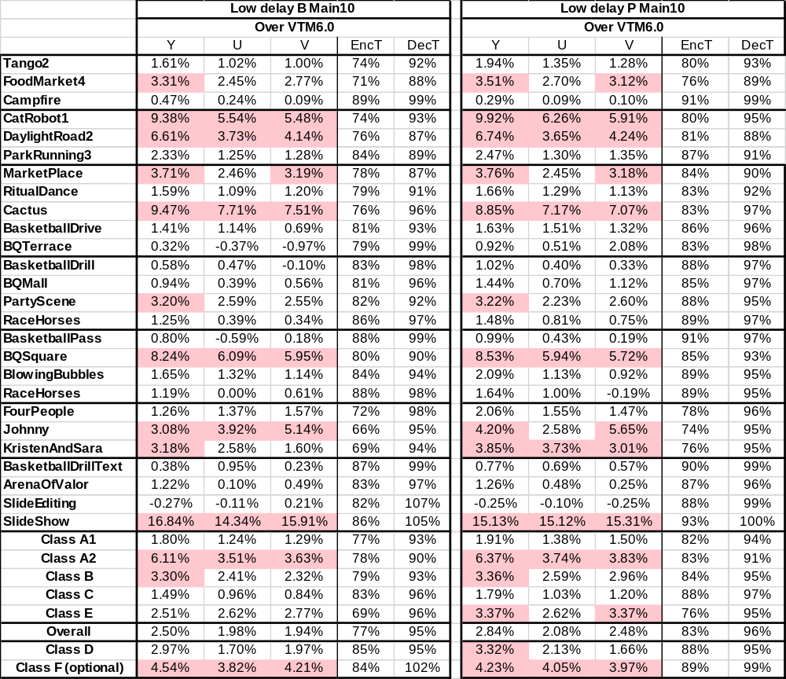

ALF Off test
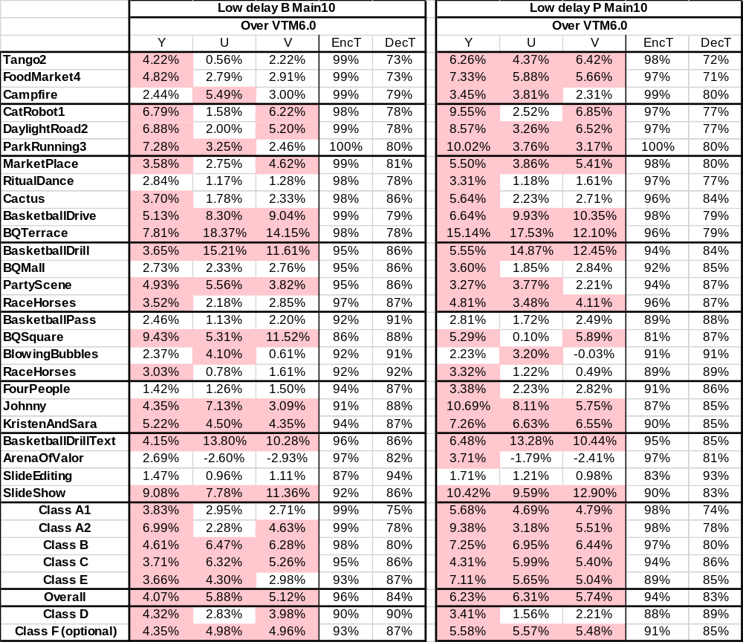

Deblocking filter Off test
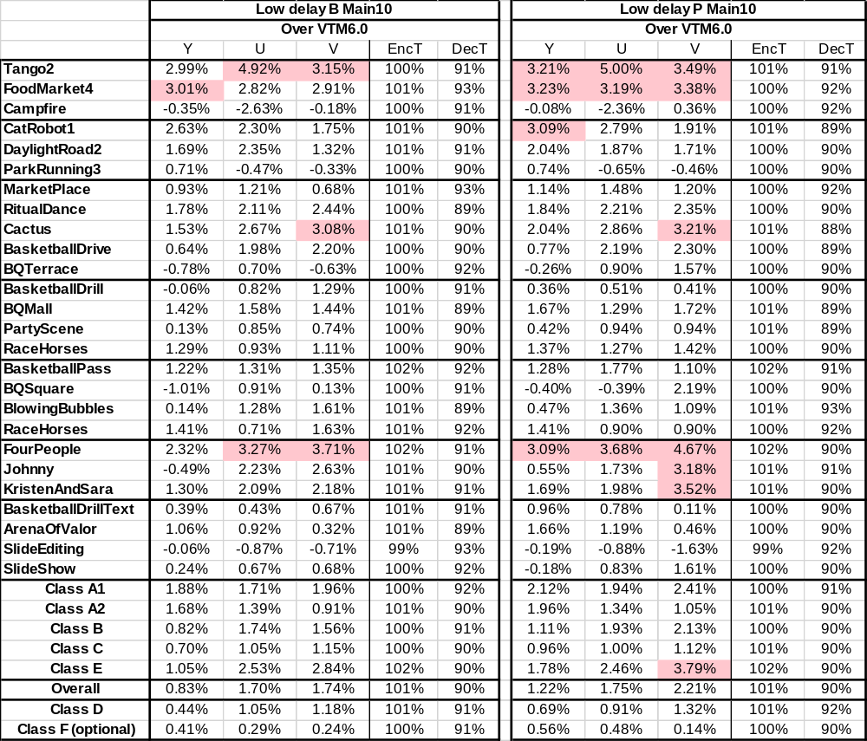

Conclusions
In this contribution, simulation results for three coding tools which could provide some propagation in low delay scenarios are provided with following BD-rate performance:
Affine: 3.95% / 2.37% / 2.46% in LDB with EncT 77.88% and DecT 91.18%;
4.14% / 2.56% / 2.67% in LDB with EncT 82.6% and DecT 92.47%;
ALF: 5.41% / 2.61% / 3.67% in LDB with EncT 99.00% and DecT 76.71%;
7.53% / 3.93% / 5.15% in LDB with EncT 97.97% and DecT 76.29%;
DBF: 1.78% / 1.55% / 1.44% in LDB with EncT 100.54% and DecT 91.00%;
2.04% / 1.64% / 1.73% in LDB with EncT 100.39% and DecT 90.68%;

References
- B. Bross, J. Chen, and S. Liu, “Versatile Video Coding (Draft 6),” Document of Joint Video Experts Team, JVET-O2001 version E
- J. Boyce, K. Suehring, X. Li and V. Seregin, “JVET common test conditions and software reference configurations for SDR video”, JVET-N1010, the 14th JVET meeting, March 2019, Geneva, CH

Patent rights declaration(s)
Huawei Technologies Co., Ltd have no current or pending patent rights relating to the information described in this contribution and, conditioned on reciprocity, is prepared to grant licenses under reasonable and non-discriminatory terms as necessary for implementation of the resulting ITU-T Recommendation | ISO/IEC International Standard (per box 2 of the ITU-T/ITU-R/ISO/IEC patent statement and licensing declaration form).

