    Joint Video Experts Team (JVET)  of ITU-T SG 16 WP 3 and ISO/IEC JTC 1/SC 29/WG 11  16th Meeting: Geneva, CH, 1–11 October 2019 | Document: JVET-P0616-v1

Title: | [AHG13] Compression performance analysis for 8K HLG sequences
Status: | Input document to JVET
Purpose: | Information
Author(s) or  Contact(s): | Shimpei Nemoto  Shunsuke Iwamura  Atsuro Ichigaya  Kimihiko Kazui | Tel:  Email: | +81-3-5494-3353  nemoto.s-fy@nhk.or.jp
Source: | NHK, Fujitsu
_____________________________

Abstract
This contribution reports on compression performance of VTM-6.1 associated with 8K HLG sequences. A total of 5 sequences have been encoded with VTM-6.1 and HM-16.20 in random access configuration. The simulation results show that the bitrate saving for 8K HLG sequences is almost equivalent to that for HLG CTC sequences. In addition to performance report of whole VTM package, for a total of 9 tools for random access configuration, individual tool-off test results vs. VTM anchor were also provided in this contribution.

Test sequences
A total of 5 sequences used for this experiment are portray content typical of broadcasting programs. For all the sequences, the number of the frames is 120. The specifications of the 8K camera used for shooting these contents and signal formats are listed Table 1 and Table 2, respectively.
The thumbnails and brief descriptions of the sequences are listed in Table 3.

Table 1. Specifications of 8K camera
Model | SONY UHC-8300
Censor | 1.25-inch 3-CMOS
Color space | ITU-R Rec. BT.2020
Frame rate | 59.94/60 Hz (progressive)

Table 2. Video signal format
Resolution | 7680x4320
Chroma format | YCbCr 4:2:2
Bit depth | 10bit
Transfer characteristics | ITU-R Rec. BT-2100-HLG

Table 3. Thumbnails and brief description of the 8K sequences
Thumbnail | Brief description
  BusStreet | Random motion in the reflection on body surface of a bus.  Fixed camera.
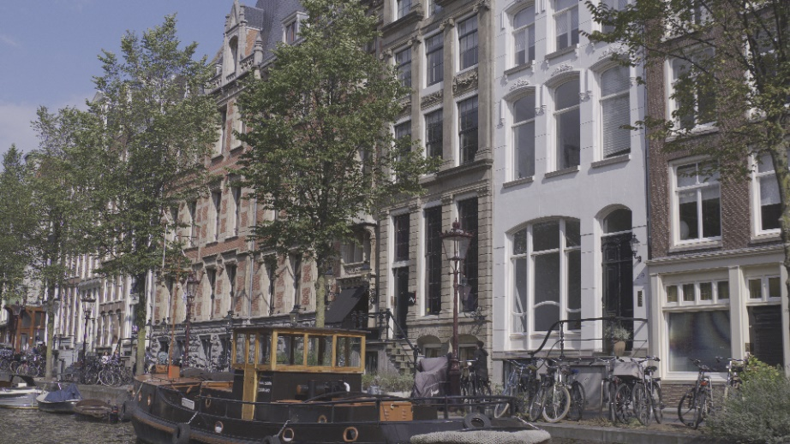  RiverSide | Camera dolly (smooth horizontal movement).  The windows show through the trees.
  Terminal | Random movement of multiple objects.  Fixed camera.
  UnderBridge | Random motion in the water surface.  Moving forward from a dark place to a light place.
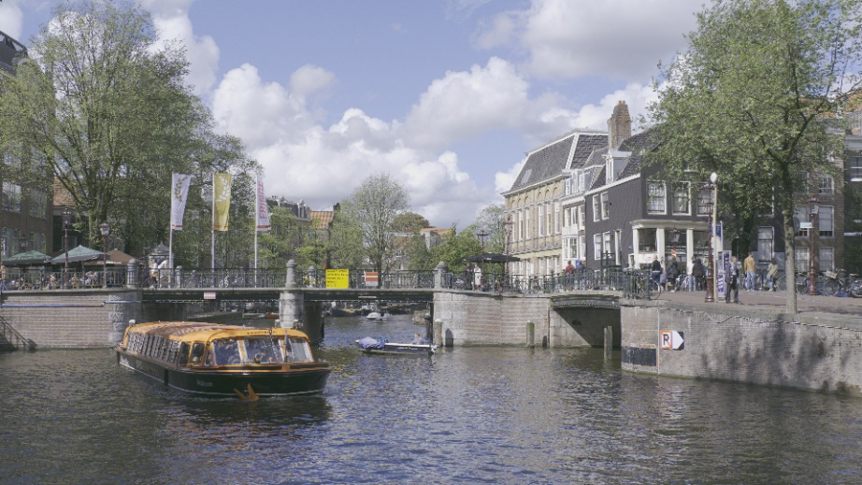  WaterBus | Random motion in the water surface.  Fixed camera.

Simulations
This section provides the results of the VTM-6.1 coding experiments over HM-16.20. Quantization parameter is set equal to {22, 27, 32, 37}. In the practical use case of broadcast, the intra period is normally set equal to approximately 0.5 second. Therefore, IntraPeriod is set equal to 32. This setting also helps to shorten the encoding run time. Table 4 depicts the obtained BD-bitrate values. It was observed that bitrate saving over HM for 8K HLG sequences denotes similar tendency to that for the HLG CTC sequences.

Table 4. BD bitrate results of VTM-6.1 over HM-16.20
 | Y | U | V | Enc | Dec
BusStreet | -33.93% | -46.99% | -50.06% | 508% | 113%
RiverSide | -27.62% | -28.52% | -29.61% | 845% | 144%
Terminal | -26.71% | -27.35% | -38.15% | 828% | 135%
UnderBridge | -28.11% | -26.20% | -29.61% | 714% | 128%
WaterBus | -21.13% | -20.45% | -28.79% | 1157% | 141%
All | -27.5% | -29.9% | -35.24% | 783% | 132%

Individual tool evaluation
To verify the efficiency of the individual coding tool adopted in VTM-6.1, tool off test for representative 5 sequences were conducted. NHK and Fujitsu collaboratively conducted the encoding experiments. We chose 9 tools in total for individual evaluation due to the limitation of computation resources for 8K coding experiments. Tools for individual evaluation were selected in consideration of the discrepancy between the tool analysis reported by previous AHG13 and JVET-O0657 which provides individual tool-off/on test results for ClassH2 HLG sequences. Table 5 depicts the assignment to anchor and each tool off test. Table 6 shows individual tool off test results.

Table 5. List of VTM/HM anchors and adoptions included in VTM (Tool off test)
Test Condition | NHK | Fujitsu
VTM-6.1 anchor | X | X
HM-16.20 anchor | X | X
VTM-6.1 (CIIP disabled) | X
VTM-6.1 (ISP disabled) |  | X
VTM-6.1 (MIP disabled) |  | X
VTM-6.1 (MMVD disabled) | X
VTM-6.1 (MRLP disabled) | X
VTM-6.1 (LFNST disabled) |  | X
VTM-6.1 (PROF disabled) | X
VTM-6.1 (SBT disabled) | X
VTM-6.1 (TPM disabled) | X

Table 6. Simulation results in RA configuration of VTM tool tests. (VTM anchor)
Tool | Y | U | V | EncT | DecT
CIIP | 0.21% | -0.14% | -0.41% | 98% | 100%
ISP | 0.20% | 0.20% | 0.21% | 97% | 103%
MIP | 0.33% | 0.12% | -0.20% | 96% | 100%
MMVD | 0.28% | 0.40% | 0.76% | 90% | 101%
MRLP | 0.19% | 0.09% | 0.13% | 100% | 100%
LFNST | 0.33% | -1.04% | 0.55% | 95% | 92%
PROF | 0.04% | -0.02% | 0.09% | 99% | 100%
SBT | 0.64% | -0.11% | -0.02% | 99% | 100%
TPM | 0.24% | 0.35% | 0.38% | 99% | 99%

Conclusion
This contribution report VTM-6.1 compression performance of 8K HLG test sequences over HM-16.20. The simulation results indicate VTM-6.1 works as expected for 8K HLG sequences. In addition to performance analysis of whole VTM package, individual tool performance analysis was also conducted. The results are similar tendency for HLG-CTC condition.

Patent rights declaration(s)
NHK and Fujitsu do not have any current or pending patent rights relating to the technology described in this contribution.

