    Joint Video Experts Team (JVET)  of ITU-T SG 16 WP 3 and ISO/IEC JTC 1/SC 29/WG 11  16th Meeting: Geneva, CH, 1–11 October 2019 | Document: JVET-P0610-v3

Title: | AHG8/AHG17: Sub-layer picture rates
Status: | Input document to JVET
Purpose: | Proposal
Author(s) or  Contact(s): | Sychev Maxim | Email: | Sychev.Maxim@huawei.com
Source: | Huawei Technologies Co., LTD
_____________________________

Abstract
This contribution presents signalling of mapping sub-layers to picture rates in video coding. Two solutions are proposed: one is a signaling parameters in Supplemental Enhancement Information (SEI) another one using and extension of the HRD parameters for signaling. More specifically, the signaling of the table is proposed that allows mapping of Temporal IDs (TID) of sub-layers with corresponded picture rates.

Introduction
A video of a given number of pictures may be partitioned into one or multiple coded video sequences (CVS). Each CVS can be decoded independently from other coded video sequences that may be contained in the same bitstream. The output order of the pictures is the order in which the pictures have been generated (e.g. recorded or rendered) and should be output for display in order of the original input sequence for the intended visual impression. In the specification, the output order is represented by the picture order count (POC), which uniquely identifies a picture within the CVS. POC distance between two successive pictures does not need to be constant throughout the CVS. It is only required to be strictly increasing along the output order.
A temporal layer concept in VVC is inherited from temporal scalability in H.265/HEVC and in H.264/AVC Annex G and available in the base specification for adaptation to variable channel bandwidth and for error resilience needs. Each picture has an associated temporal level identifier TID. With the concept of temporal layers, extracting a coded video sequence of lower temporal resolution from a given video sequence can be simply achieved by discarding all NAL units with TID larger than a selected value. As a result of such extracting the new CVS with another features is produced. In case of temporal scalability the main feature of new CVS is a picture rate (or FPS) which is reduced in respect to picture rate of parent CVS.
The specification of HEVC and VVC provide several signaling mechanisms for description of temporal dependencies between pictures such as:
- POC value with SPS parameters (sps_max_sub_layers_minus1, num_units_in_tick, time_scale …)
- HRD parameters (fixed_pic_rate_general_flag[ i ], fixed_pic_rate_within_cvs_flag[ i ]…)
- Picture Timing SEI message
- Structure of Pictures SEI message
- Video Usability Information (VUI) in HEVC (some of them moved to SPS in VVC)
The parameters TargetLayerIdList and HighestTid could be set up by external means.

Problem description
During transmission, storing or other manipulations with CVS with temporal sub-stream extraction the switching from one CVS with chosen Highest Temporal ID (HTID) to another CVS could not share the same HTID. At the time when HTID was defined according some external needs (like bandwidth adaptation or unequal error protection of temporal layers in error prone networks) the structure of the further CVS may have another temporal ID distribution as depicted on Figure 1.
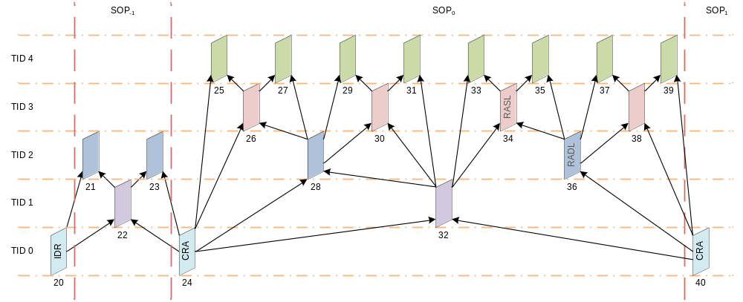
Figure 1. Switching content with temporal sub-stream extraction

In the example provided on Figure 1 during transmission server decided to restrict Temporal Layer of SOP₋₁ downward to TID = 1 (from 60 FPS to 30 FPS). The current SOP₀ have an extended GOP structure and if we continue to work within that restrictions (TID=1) then for current SOP₀ the frame rate will be dropped down to 7.5 FPS. Such behavior is unexpected by user.
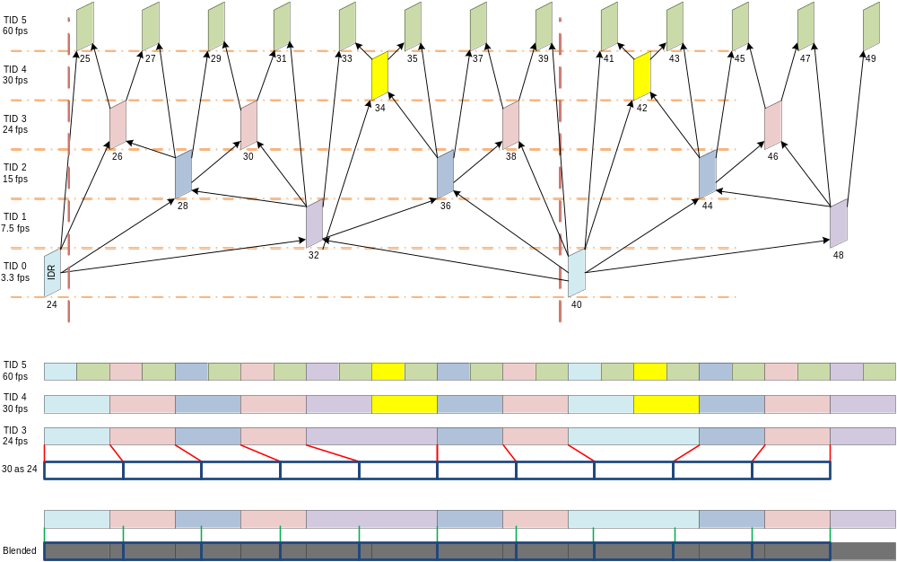
Figure 2. Supporting 24 fps by signaling average picture tick interval for corresponded temporal layer
There is an example of usage proposed solution to support embedding both 30 and 24 fps in one stream. Both Picture timing SEI and proposed average picture rate corresponded to particular TID is used in order to smooth playback of non-uniformly distributed pictures in time.
The demo with video is uploaded with this contribution. One of them contain the video with just frame repetition with corresponded judder. Another one use simple bilinear temporal blending without judder.
In order to follow the same temporal restriction the external application (network, MANE …) should perform some parsing and estimation:
- In case of SPS parameters: to get the Maximum Temporal ID (MTID) to parse picture rate corresponded to MTID and to find the TID corresponded to HTID of previous CVS. It is possible when fixed picture rate flags is equal to 1.
- In case of Picture Timing SEI message: The parsing of several messages is required because it is associated with each picture. Then to estimate picture rate according removal delays of each pictures.
- In case of SOP SEI message: The deriving and analysis of SOP is required in order to recognize appropriated TID with HTID of previous CVS.
Situation is further complicated by dynamically adaptation of SOPs TID distributions and picture timing parameters.
Most of the existing in specification mechanisms developed to support buffering, HRD, PLT and other constrains. This proposal try to provide simple possibility for next to video abstraction layer applications to match requested picture rate with existing TID distribution. Such possibility is critical for video transmission and synchronization (audio, control, other effects like 4D/5D).

Proposed methods
Only encoder control the distribution of Temporal IDs and whether structure of pictures was modified during transmission and other adaptation the temporal layers could be controlled according predefined parameters. Two approaches are proposed below: by signaling in SEI message and by additional parameters in HRD design.
In a large majority of use case scenarios the distribution of temporal layer IDs among pictures is dyadic in order to support very efficient approach of bi-directional inter prediction with hierarchical structure of pictures (SOP). For such case the signaling the corresponded flag reflected dyadic temporal IDs distribution is proposed for both solutions.

Solution A
The description is in relative to the basis text, which is the draft of VVC specification in JVET contribution JVET-O2001-vE. In other words, only the delta is described, while the texts in the basis text that are not mentioned below apply as they are. Modified text relative to the basis text is highlighted in yellow.
The new SEI message with title “Sub-Layer Picture rates SEI message” is proposed in order to provide to the external application or network the list of picture rates associated with the list of Temporal IDs.
General SEI message syntax

sei_payload( payloadType, payloadSize ) { | Descriptor
if( nal_unit_type = = PREFIX_SEI_NUT )
if( payloadType = = 0 )
buffering_period( payloadSize )
else if( payloadType = = 1 )
pic_timing( payloadSize )
else if( payloadType = = 130 )
decoding_unit_info( payloadSize )
else if( payloadType = = 145 )
dependent_rap_indication( payloadSize )
// Specified in ITU-T H.SEI | ISO/IEC 23002-7.
else if( payloadType = = 168 )
frame_field_info( payloadSize )
else if( payloadType = = 169 )
pic_rates( payloadSize )
else
reserved_sei_message( payloadSize )
else /* nal_unit_type = = SUFFIX_SEI_NUT */
if( payloadType = = 132 )
decoded_picture_hash( payloadSize )
// Specified in ITU-T H.SEI | ISO/IEC 23002-7.
else
reserved_sei_message( payloadSize )
if( more_data_in_payload( ) ) {
if( payload_extension_present( ) )
reserved_payload_extension_data | u(v)
payload_bit_equal_to_one /* equal to 1 */ | f(1)
while( !byte_aligned( ) )
payload_bit_equal_to_zero /* equal to 0 */ | f(1)
}
}

Sub-Layer Picture Rates SEI message syntax

pic_rates( payloadSize ) { | Descriptor
pr_max_sub_layers_minus1 | u(3)
pr_time_scale | u(32)
dyadic_temporal_nesting_flag | u(1)
for( i = dyadic_temporal_nesting_flag* pr_max_sub_layers_minus1; i <= pr_max_sub_layers_minus1; i++ ) {
sub_layer_num_units_in_tick[ i ] | u(32)
}
}
NOTE 3 – Persistence information for SEI messages is informatively summarized in Table 3.
pr_max_sub_layers_minus1 plus 1 specifies the maximum number of temporal sub-layers that may be present in each CVS referring to the SPS. The value of pr_max_sub_layers_minus1 shall be in the range of 0 to 6, inclusive.
It is a requirement of bitstream conformance that the value of pr_max_sub_layers_minus1 in the picture rates SEI message is equal to the value of sps_max_sub_layers_minus1 in the SPS.
pr_time_scale is the number of time units that pass in one second. For example, a time coordinate system that measures time using a 27 MHz clock has a time_scale of 27 000 000. The value of time_scale shall be greater than 0.
It is a requirement of bitstream conformance that the value of pr_time_scale in the picture rates SEI message is equal to the value of time_scale in the SPS.
dyadic_temporal_nesting_flag indicates that the Temporal IDs are distributed hierarchically with dyadic dependencies. When not present the value of dyadic_temporal_nesting_flag is inferred to be equal to 0.
sub_layer_num_units_in_tick[ i ] is the number of time units of a clock operating at the frequency pr_time_scale Hz that corresponds to the average increment (called a clock tick) of a clock tick counter. sub_layer_num_units_in_tick[ i ] shall be greater than 0. A clock tick, in units of seconds, is equal to the quotient of sub_layer_num_units_in_tick divided by pr_time_scale. For example, when the picture rate of a video signal is 25 Hz, pr_time_scale may be equal to 27 000 000 and sub_layer_num_units_in_tick may be equal to 1 080 000, and consequently a clock tick may be equal to 0.04 seconds.

When dyadic_temporal_nesting_flag is equal to 1 the values of sub_layer_num_units_in_tick[ i ] for i from 0 to pr_max_sub_layers_minus1-1 are derived as follows:
For each value of i in the range of 0 to pr_max_sub_layers_minus1-1, inclusive, the variable sub_layer_num_units_in_tick[ i ] is derived as follows:
sub_layer_num_units_in_tick[ i ] = (1)
sub_layer_num_units_in_tick[ pr_max_sub_layers_minus1 ] / 2^(pr_max_sub_layers_minus1 – i )

Table 3 – Persistence scope of SEI messages (informative)
SEI message | Persistence scope
Buffering period | The remainder of the bitstream
Picture timing | The access unit containing the SEI message
Decoding unit information | The access unit containing the SEI message
Frame-field information | The access unit containing the SEI message
Sub-Layer Picture Rates | The C(L)VS containing the SEI message

Solution B
Another possible implementation of proposed approach is signaling in HRD parameters:
Additional syntax element is proposed to include into sub_layer_hrd_parameters syntax in order to provide to the external application or network the list of picture rates associated with the list of Temporal IDs.
- 7.3.4.1 General HRD parameters syntax

general_hrd_parameters( firstSubLayer, maxNumSubLayersMinus1 ) { | Descriptor
general_nal_hrd_parameters_present_flag | u(1)
general_vcl_hrd_parameters_present_flag | u(1)
if( general_nal_hrd_parameters_present_flag | |
general_vcl_hrd_parameters_present_flag ) {
decoding_unit_hrd_params_present_flag | u(1)
if( decoding_unit_hrd_params_present_flag ) {
tick_divisor_minus2 | u(8)
decoding_unit_cbp_params_in_pic_timing_sei_flag | u(1)
}
bit_rate_scale | u(4)
cpb_size_scale | u(4)
dyadic_temporal_nesting_flag | u(1)
if( decoding_unit_hrd_params_present_flag )
cpb_size_du_scale | u(4)
}
for( i = firstSubLayer; i <= maxNumSubLayersMinus1; i++ ) {
if ( !dyadic_temporal_nesting_flag )
fixed_pic_rate_general_flag[ i ] | u(1)
if( !fixed_pic_rate_general_flag[ i ] )
fixed_pic_rate_within_cvs_flag[ i ] | u(1)
if( fixed_pic_rate_within_cvs_flag[ i ] )
elemental_duration_in_tc_minus1[ i ] | ue(v)
else
low_delay_hrd_flag[ i ] | u(1)
if( !low_delay_hrd_flag[ i ] )
hrd_cpb_cnt_minus1[ i ] | ue(v)
if( general_nal_hrd_parameters_present_flag )
sub_layer_hrd_parameters( i )
if( general_vcl_hrd_parameters_present_flag )
sub_layer_hrd_parameters( i )
}
}

- 7.3.4.2 Sub-layer HRD parameters syntax

sub_layer_hrd_parameters( subLayerId ) { | Descriptor
If ( !dyadic_temporal_nesting_flag )
sub_layer_num_units_in_tick[ i ] | u(32)
for( j = 0; j <= hrd_cpb_cnt_minus1[ subLayerId ]; j++ ) {
bit_rate_value_minus1[ subLayerId ][ j ] | ue(v)
cpb_size_value_minus1[ subLayerId ][ j ] | ue(v)
if( decoding_unit_hrd_params_present_flag ) {
cpb_size_du_value_minus1[ subLayerId ][ j ] | ue(v)
bit_rate_du_value_minus1[ subLayerId ][ j ] | ue(v)
}
cbr_flag[ subLayerId ][ j ] | u(1)
}
}

dyadic_temporal_nesting_flag indicates that the Temporal IDs are distributed hierarchically with dyadic dependencies. When not present the value of dyadic_temporal_nesting_flag is inferred to be equal to 0.
sub_layer_num_units_in_tick[ i ] is the number of time units of a clock operating at the frequency pr_time_scale Hz that corresponds to one increment (called a clock tick) of a clock tick counter (or an average increment in case of non-uniform distribution of POC within particular temporal layer). sub_layer_num_units_in_tick[ i ] shall be greater than 0. A clock tick, in units of seconds, is equal to the quotient of sub_layer_num_units_in_tick divided by time_scale. For example, when the picture rate of a video signal is 25 Hz, time_scale may be equal to 27 000 000 and sub_layer_num_units_in_tick may be equal to 1 080 000, and consequently a clock tick may be equal to 0.04 seconds.
When dyadic_temporal_nesting_flag is equal to 1 the values of sub_layer_num_units_in_tick[ i ] for i from 0 to max_sub_layers_minus1-1 are derived as follows:/,
sub_layer_num_units_in_tick[ max_sub_layers_minus1 ] is set equal to num_units_in_tick.
For each value of i in the range of 0 to max_sub_layers_minus1-1, inclusive, the variable sub_layer_num_units_in_tick[ i ] is derived as follows:
sub_layer_num_units_in_tick[ i ] = (1)
sub_layer_num_units_in_tick[ max_sub_layers_minus1 ] / 2^(max_sub_layers_minus1 – i )

Conclusions
In this contribution, two solutions are proposed for signaling sub-layer picture rates parameters: Specifying parameters in SEI message in Solution A. Signaling parameters in HRD in Solution B. Additional conditional check in signalling of HRD parameter signaling is proposed based on the value of dyadic_temporal_nesting_flag flag for solution B.
Specification text is provided for both solutions. Proposed to adopt one of the solutions. The solution A is more friendly for higher abstraction layers (MANE) while Solution B is more compact in terms of signaling and specification text. It is proposed to adopt one of them into VVC draft of the specification.

References
- B. Bross, J. Chen, and S. Liu, “Versatile Video Coding (Draft 6),” Document of Joint Video Experts Team, JVET-O2001 version E

Patent rights declaration(s)
Huawei Technologies Co., Ltd may have current or pending patent rights relating to the technology described in this contribution and, conditioned on reciprocity, is prepared to grant licenses under reasonable and non-discriminatory terms as necessary for implementation of the resulting ITU-T Recommendation | ISO/IEC International Standard (per box 2 of the ITU-T/ITU-R/ISO/IEC patent statement and licensing declaration form).

