    Joint Video Experts Team (JVET)  of ITU-T SG 16 WP 3 and ISO/IEC JTC 1/SC 29/WG 11  16th Meeting: Geneva, CH, 1–11 October 2019 | Document: JVET-P0573

Title: | AHG17/NonCE8: Support parallel decoding based on initialization for palette predictor at CTU row
Status: | Input document to JVET
Purpose: | Proposal
Author(s) or  Contact(s): | Hyeongmun Jang  Naeri Park  Junghak Nam  Seunghwan Kim  Jaehyun Lim | Email: | hm.jang@lge.com
Source: | LG Electronics Inc.
_____________________________

Abstract
The palette mode uses palette entry which is already signaled and used in previous CU in decoding order as predictor entry. In VTM 6, if one of following conditions is true, the predictor palette entry is initialized.
- The fist CTU in a brick
- entropy_coding_sync_enabled_flag is equal to 1 && CtbAddrInRs % PicWidthInCtbsY is equal to 0.
Since Palette predictor is initialized on every CTU row only when WPP is enabled, it could cause problem with implementation of parallel decoding processing on particular H/W decoder architecture. In real implementation decoder, the entropy decoding is applied in advance of the pixel reconstruction and the pixel reconstruction could be support parallel processing regardless of whether WPP is enabled in encoder side. Therefore, this contribution proposes the palette predictor initialization at first CU in CTU row as the HMVP buffer is initialized at the beginning of each CTU row regardless of WPP to support parallel decoding in real decoder implementation. The test result show as below dual-tree on and dual-tree off respectively.
- over VTM-6.0 DualITree=0 YUV444
All intra | 0.28% | -0.10% | -0.47% | 100% | 100%
Random access | -0.13% | -0.51% | -0.73% | 100% | 101%
Low delay | -0.38% | -0.34% | -0.82% | 100% | 100%
- over VTM-6.0 DualITree=1 YUV444
All intra | 0.07% | 0.21% | -0.07% | 100% | 100%
Random access | 0.04% | 0.15% | 0.12% | 100% | 102%
Low delay | -0.14% | 0.06% | -0.03% | 101% | 101%

Introduction
The palette mode is adopted in VVC Draft6 for 4:4:4 color format. If the palette mode is enabled, a flag is transmitted at the CU level whether palette mode is used. If the CU is coded by palette mode, the sample values are represented by a set of representative color value referred to as the palette. For coding of the palette, a palette predictor is maintained. For each entry in the palette predictor, a reuse flag is signaled to indicate whether it is part of the current palette in the CU. The palette predictor will be updated using the current palette. The palette predictor is initialized to 0 at the beginning of each slice for non WPP and at the beginning of each CTU row for WPP case.
The palette predictor maintenance seems similar HMVP buffer update process. For HMVP, the HMVP buffer is initialized at the beginning of each CTU row regardless of WPP to support parallel decoding in real decoder implementation.

Proposal
In order to reduce encoding/decoding time, parallel processing of the CTU rows is commonly used regardless of WPP in the real implementation. To support parallel reconstruction in decoder side, this contribution suggests to initialize the predictor palette entry at every CTU rows.
9.3.2 Initialization process
9.3.2.1 General
Outputs of this process are initialized CABAC internal variables.
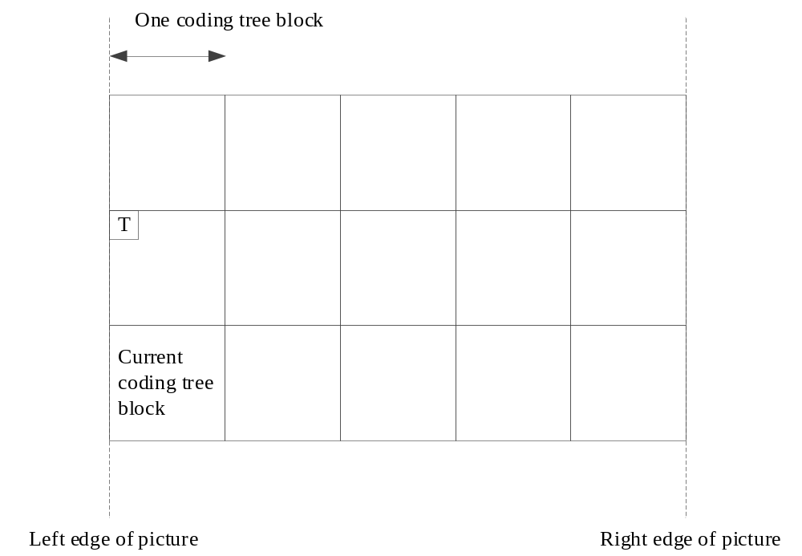
Figure 9-2 – Spatial neighbour T that is used to invoke the CTB availability derivation process relative to the current CTB (informative)
The context variables of the arithmetic decoding engine are initialized as follows:
– If the CTU is the first CTU in a brick, the initialization process for context variables is invoked as specified in clause 9.3.2.2 and the variable PredictorPaletteSize is initialized to 0.
– Otherwise, if entropy_coding_sync_enabled_flag is equal to 1 and either CtbAddrInRs % PicWidthInCtbsY is equal to 0 or BrickId[ CtbAddrInBs ] is not equal to BrickId[ CtbAddrRsToBs[ CtbAddrInRs − 1 ] ], the following applies:
– The location ( xNbT, yNbT ) of the top-left luma sample of the spatial neighbouring block T (Figure 9-2) is derived using the location ( x0, y0 ) of the top-left luma sample of the current CTB as follows:
( xNbT, yNbT ) = ( x0, y0 − CtbSizeY ) (9-3)
– The derivation process for neighbouring block availability as specified in clause 6.4.4 is invoked with the location ( xCurr, yCurr ) set equal to ( x0, y0 ), the neighbouring location ( xNbY, yNbY ) set equal to ( xNbT, yNbT ), checkPredModeY set equal to FALSE, and cIdx set equal to 0 as inputs, and the output is assigned to availableFlagT.
– The synchronization process for context variables is invoked as follows:
– If availableFlagT is equal to 1, the synchronization process for context variables as specified in clause 9.3.2.4 is invoked with TableStateIdx0Wpp, TableStateIdx1Wpp, TableMpsValWpp as inputs and the variable PredictorPaletteSize is initialized to 0.
– Otherwise, the initialization process for context variables is invoked as specified in clause 9.3.2.2 and the variable PredictorPaletteSize is initialized to 0.
– Otherwise, the initialization process for context variables is invoked as specified in clause 9.3.2.2 and the variable PredictorPaletteSize is initialized to 0.

– If CtbAddrInRs % PicWidthInCtbsY is equal to 0 or BrickId[ CtbAddrInBs ] is not equal to BrickId[ CtbAddrRsToBs[ CtbAddrInRs − 1 ] ], The variable PredictorPaletteSize[cIdx], cIdx=0..3 is initialized to 0.

Test result
 | All Intra Main10
 | over VTM-6.0 DualITree=0 YUV444
 | Y | U | V | EncT | DecT
TGM | 0.37% | 0.67% | -0.27% | 99% | 99%
TGM | 0.14% | -0.80% | -1.51% | 100% | 101%
A | 0.85% | 1.24% | 1.48% | 100% | 100%
M | -0.02% | -1.60% | -1.60% | 99% | 100%
CC | 0.00% | 0.00% | 0.00% | 99% | 99%
Overall | 0.28% | -0.10% | -0.47% | 100% | 100%
 | Random access Main10
 | Over VTM-6.0 DualITree=0 YUV444
 | Y | U | V | EncT | DecT
TGM | -0.19% | 0.05% | -0.72% | 99% | 101%
TGM | -0.36% | -0.83% | -1.18% | 100% | 101%
A | 0.04% | 0.26% | 0.39% | 100% | 102%
M | 0.00% | -1.93% | -1.77% | 99% | 101%
CC | 0.00% | -0.01% | 0.00% | 100% | 102%
Overall | -0.13% | -0.51% | -0.73% | 100% | 101%
 | Low delay B Main10
 | Over VTM-6.0 DualITree=0 YUV444
 | Y | U | V | EncT | DecT
TGM | -0.49% | -0.33% | -0.99% | 100% | 100%
TGM | -0.69% | -0.47% | -1.31% | 100% | 101%
A | 0.02% | 0.48% | 0.74% | 100% | 101%
M | -0.46% | -1.20% | -2.03% | 100% | 99%
CC | 0.00% | 0.00% | 0.00% | 100% | 101%
Overall | -0.38% | -0.34% | -0.82% | 100% | 100%

 | All Intra Main10
 | over VTM-6.0 DualITree=1 YUV444
 | Y | U | V | EncT | DecT
TGM | 0.08% | 0.23% | -0.37% | 99% | 99%
TGM | 0.32% | -0.51% | -0.61% | 100% | 101%
A | 0.24% | 0.39% | 0.31% | 100% | 100%
M | -0.42% | 1.05% | 0.63% | 99% | 101%
CC | -0.01% | 0.05% | 0.01% | 100% | 100%
Overall | 0.07% | 0.21% | -0.07% | 100% | 100%
 | Random access Main10
 | Over VTM-6.0 DualITree=1 YUV444
 | Y | U | V | EncT | DecT
TGM | 0.00% | -0.19% | -0.20% | 100% | 103%
TGM | 0.07% | -0.34% | -0.29% | 100% | 102%
A | 0.05% | 0.18% | 0.20% | 100% | 101%
M | 0.08% | 1.29% | 1.02% | 100% | 102%
CC | -0.01% | 0.03% | 0.09% | 100% | 102%
Overall | 0.04% | 0.15% | 0.12% | 100% | 102%
 | Low delay B Main10
 | Over VTM-6.0 DualITree=1 YUV444
 | Y | U | V | EncT | DecT
TGM | -0.29% | -0.62% | -0.60% | 101% | 100%
TGM | -0.11% | -0.27% | 0.13% | 101% | 100%
A | 0.15% | 0.27% | 0.07% | 101% | 102%
M | -0.35% | 0.44% | 0.46% | 101% | 102%
CC | 0.01% | -0.01% | -0.05% | 101% | 100%
Overall | -0.14% | 0.06% | -0.03% | 101% | 101%

Patent rights declaration(s)
LG Electronics Inc. may have current or pending patent rights relating to the technology described in this contribution and, conditioned on reciprocity, is prepared to grant licenses under reasonable and non-discriminatory terms as necessary for implementation of the resulting ITU-T Recommendation | ISO/IEC International Standard (per box 2 of the ITU-T/ITU-R/ISO/IEC patent statement and licensing declaration form).

