    Joint Video Experts Team (JVET)  of ITU-T SG 16 WP 3 and ISO/IEC JTC 1/SC 29/WG 11  16th Meeting: Geneva, CH, 1–11 October 2019 | Document: JVET-P0552

Title: | AHG12/Non-CE5: Extending slice boundary processing for adaptive loop filter for raster scanned slices
Status: | Input document to JVET
Purpose: | Proposal
Author(s) or  Contact(s): | Nan Hu  Vadim Seregin  Muhammed Coban  Adarsh Krishnan Ramasubramonian  Marta Karczewicz  5775 Morehouse Dr, San Diego, CA, 92121, USA | Tel:  Email: | +1(858)651-3483  nanh@qti.qualcomm.com
Source: | Qualcomm Incorporated
_____________________________

Abstract
In VVC draft 6, mirrored padding is applied to adaptive loop filter for slice boundaries when loop_filter_across_slices_enabled_flag is equal to 0. However, if raster-scan slice is used there can be some cases that are not supported depending on the slice configuration. In this document, it is proposed to extend slice boundary processing when loop_filter_across_slices_enabled_flag is equal to 0 to all slice configurations by converting non-supported cases to the existed method of the slice boundaries handling.

Introduction
In VVC draft 6, when ALF can be constrained by only using samples of the same slice and if current to-be-filtered sample needs a sample in the top and/or left coding tree unit (CTU) belong to a different slice, the mirrored padding method is applied.
However, if the current to-be-filtered sample needs a sample in a CTU in diagonal direction, current draft cannot handle this case. For example, in the picture below, when current to-be-filtered sample (in CTUd) needs a sample in its top-left CTUa, current draft will just use this outside sample.

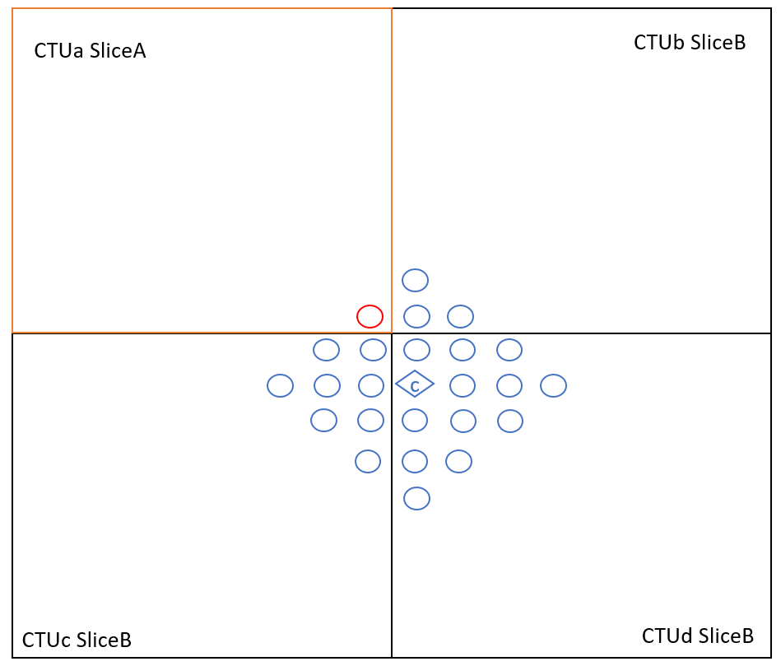
Figure 1. Diagonal sample required for ALF processing.

Proposed method
To handle all unsupported cases in VVC draft 6, it is proposed to convert such cases to a case, which is already supported, such as to treat the above CTU boundary or the left CTU boundary as a slice boundary even some samples belong to the same slice.
In Figure 2, the problem is converted into the case when the top CTU is in a different slice such that mirrored padding is applied along the top CTU boundary.
In Figure 3, the problem is converted into the case when the left CTU is in a different slice such that mirrored padding is applied along left CTU boundary.

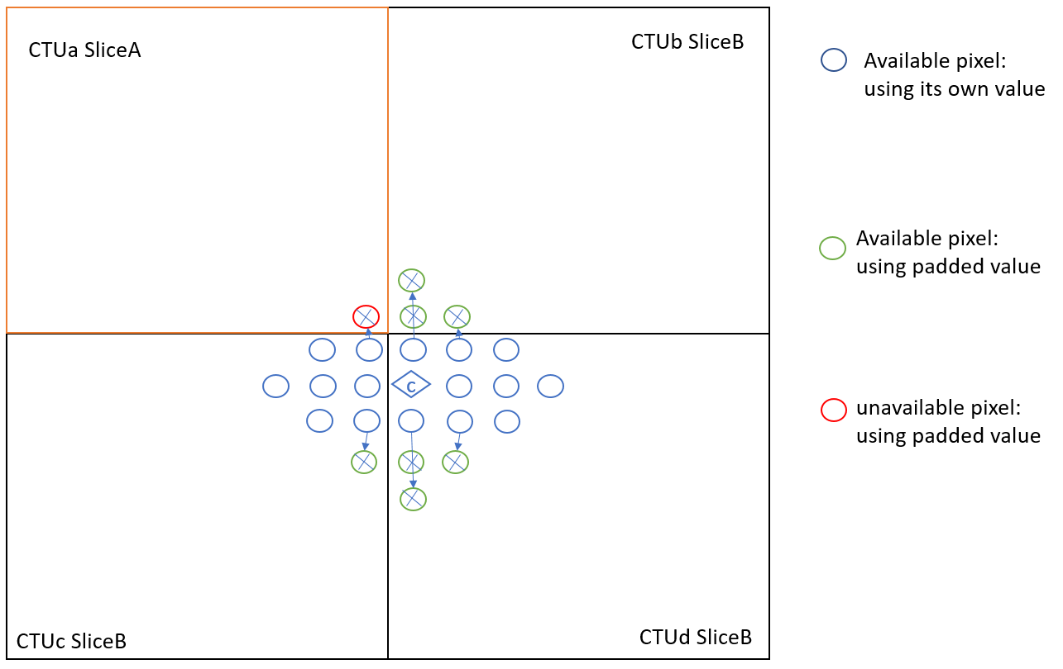
Figure 2. Mirrored padding applied along the top CTU boundary
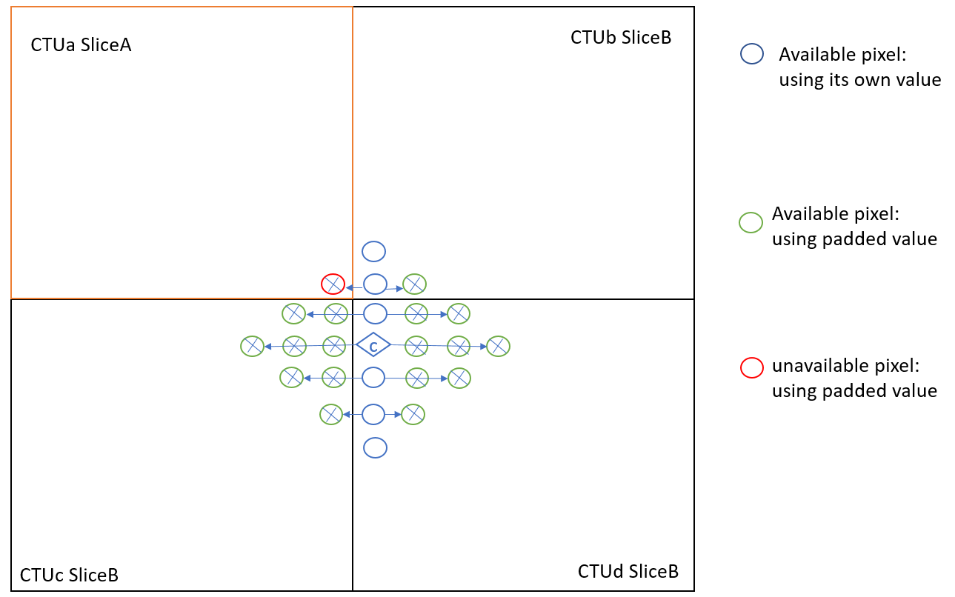
Figure 3. Mirrored padding applied along the left CTU boundary

Patent rights declaration(s)
Qualcomm Incorporated may have current or pending patent rights relating to the technology described in this contribution and, conditioned on reciprocity, is prepared to grant licenses under reasonable and non-discriminatory terms as necessary for implementation of the resulting ITU-T Recommendation | ISO/IEC International Standard (per box 2 of the ITU-T/ITU-R/ISO/IEC patent statement and licensing declaration form).

