    Joint Video Experts Team (JVET)  of ITU-T SG 16 WP 3 and ISO/IEC JTC 1/SC 29/WG 11  16th Meeting: Geneva, CH, 1–11 October 2019 | Document: JVET-P0532

Title: | CE4-related: Cleanup of applicable condition of alternative interpolation filter for half-sample position in merge mode
Status: | Input document to JVET
Purpose: | Proposal
Author(s) or  Contact(s): | Yoshitaka Kidani  Kei Kawamura  Kyohei Unno  Sei Naito  2-1-15 Ohara, Fujimino-shi, Saitama  Japan | Tel:  Email: | +81-80-6887-2592  yo-kidani@kddi.com  ki-kawamura@kddi.com  ky-unno@kddi-research.jp
Source: | KDDI Corp. (KDDI Research, Inc.)
_____________________________

Abstract
This contribution proposes an applicable condition of alternative interpolation filter for half-pel position. In the current design, the alternative interpolation filter is determined by the specific index (hpelIfIdx) and motion vector reference position. In merge mode, hpelIfIx of a current block is inherited from existing-coded blocks along with motion vector while the motion-vector reference position locates at half-pel accuracy position if hpelIfIdx is valid. The motion vector reference position, however, may shift from half-pel accuracy position if pairwise average merge mode, MMVD, or DMVR are used. This mismatch causes three problems as follows: 1) The filter applied to the current blocks will become different from that of the inherited block. 2) The mismatch of accuracy will drift to following coded blocks which inherit the hpelIfIdx and motion vector from that of the current block. 3) A bi-predicted inter block consist of blocks filtered by different characteristic’s interpolation. In this contribution, it is proposed to modify the value of hpelIfIdx if motion vector reference position is deviated from hpel position by pair-wise average merge, MMVD or DMVR. Simulation results show a overall luma BD-rate 0.02%/-0.01% for RA/LDB and no increase in running time comparing VTM-6.0.

Introduction and Problem statement
Alternative interpolation filter for half-pel (hpel) position [1] was adopted to VVC WD6 [2] and VTM6 [3] to improve coding performance in the previous meeting. In the current design, the alternative interpolation filter is determined by the specific index (hpelIfIdx) shown in Table 1.
Table 1 Specification of the luma interpolation filter coefficients f_{L}[ p ] for each 1/16 fractional sample position p. Alternative filter is applied if hpelIfIdx equals to 1.
Fractional sample position p | interpolation filter coefficients
Fractional sample position p | f_{L}[ p ][ 0 ] | f_{L}[ p ][ 1 ] | f_{L}[ p ][ 2 ] | f_{L}[ p ][ 3 ] | f_{L}[ p ][ 4 ] | f_{L}[ p ][ 5 ] | f_{L}[ p ][ 6 ] | f_{L}[ p ][ 7 ]
1 | 0 | 1 | −3 | 63 | 4 | −2 | 1 | 0
2 | −1 | 2 | −5 | 62 | 8 | −3 | 1 | 0
3 | −1 | 3 | −8 | 60 | 13 | −4 | 1 | 0
4 | −1 | 4 | −10 | 58 | 17 | −5 | 1 | 0
5 | −1 | 4 | −11 | 52 | 26 | −8 | 3 | −1
6 | −1 | 3 | −9 | 47 | 31 | −10 | 4 | −1
7 | −1 | 4 | −11 | 45 | 34 | −10 | 4 | −1
8 (hpelIfIdx = = 0) | −1 | 4 | −11 | 40 | 40 | −11 | 4 | −1
8 (hpelIfIdx = = 1) | 0 | 3 | 9 | 20 | 20 | 9 | 3 | 0
9 | −1 | 4 | −10 | 34 | 45 | −11 | 4 | −1
10 | −1 | 4 | −10 | 31 | 47 | −9 | 3 | −1
11 | −1 | 3 | −8 | 26 | 52 | −11 | 4 | −1
12 | 0 | 1 | −5 | 17 | 58 | −10 | 4 | −1
13 | 0 | 1 | −4 | 13 | 60 | −8 | 3 | −1
14 | 0 | 1 | −3 | 8 | 62 | −5 | 2 | −1
15 | 0 | 1 | −2 | 4 | 63 | −3 | 1 | 0
In merge mode, hpelIfIx of a current block is inherited from that of existing-coded blocks along with motion vector, while the motion vector reference position locates at half-pel accuracy position when hpelIfIdx is valid. The motion-vector reference position, however, may shift from half-pel accuracy position if pairwise average merge, MMVD, or DMVR are used. Figure 2 shows an example that motion-vector reference position shifts from half-pel accuracy position by pair-wise average merge mode. In pair-wise average merge mode, new motion vectors and hpelIfIdx are derived from the combination of the motion vectors in a merge list. Therefore, a new motion vector reference position shift to quarter-pel accuracy positions like Figure 1. It is noted that the both hpelIfIdx of existing-coded blocks are 1 while one block refers to integer position and the other block refers to half-pel position.
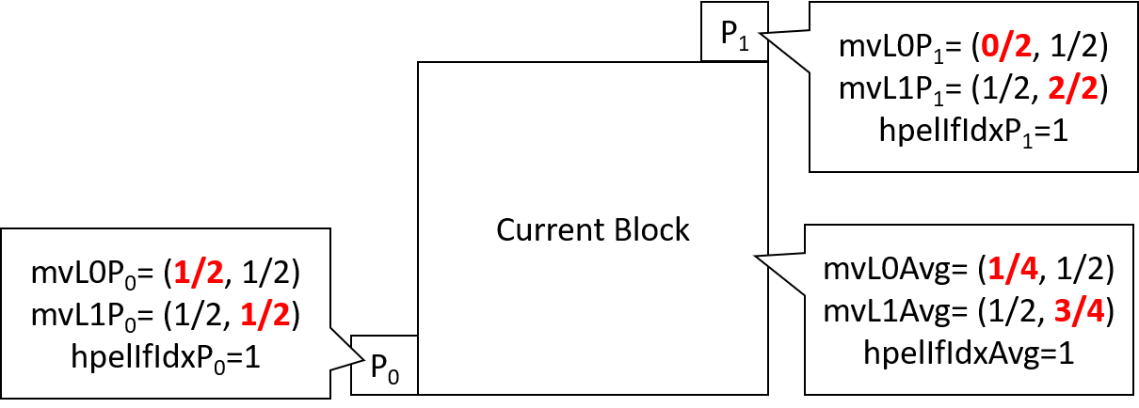
Figure 1 An example that motion vector reference position shifts from half-pel position by pair-wise average merge mode.
When MMVD or DMVR is used, same situation is occurred because MMVD and DMVR refines the motion vector reference position.
This mismatch causes three problems as follows: 1) The filter applied to the current block will become different from that of the inherited block. 2) The mismatch will drift to following-coded blocks which inherit the hpelIfIdx and motion vector from that of the current block. 3) A bi-predicted inter block consists of blocks filtered by different characteristic’s interpolation.

Proposed Method
The proposed method is to modify the value of hpelIfIdx according to the motion vector reference position when pair-wise average merge mode, MMVD, or DMVR are used. When a motion vector reference position shifts from half-pel position to quarter-pel or 1/16-pel position by pair-wise average merge, MMVD or DMVR, the hpelfIdx is modified from 1 to 0 It is noted that the hpelIfIdx inheritance for following blocks is the same as the motion vector inheritance in DMVR to avoid the dependency between blocks.

Experimental Results
The proposed method is implemented on top of the VTM6, and the simulations are run under the common test conditions [4].

Results under the common test conditions

Computing platforms
The software was compiled by the same compiler which is GCC 4.8.5 on 64-bit CentOS Linux on the different cluster PCs. Since the same coding condition utilizes the same cluster PCs, running time can be comparable within the same condition. It is noted that we disabled the function of Hyperthreading and TurboBoost for getting accurate running times.

Test results
Table 2 and Table 3 show the results of the proposal in RA and LDB condition comparing VTM-6.0.
Table 2 The simulation results of the prposed method in RA10 condition.
 | Random access Main10
 | Over VTM-6.0
 | Y | U | V | EncT | DecT
Class A1 | 0.01% | -0.01% | -0.03% | 100% | 100%
Class A2 | 0.03% | 0.08% | 0.03% | 100% | 100%
Class B | 0.02% | 0.09% | 0.01% | 100% | 100%
Class C | 0.00% | 0.04% | -0.07% | 101% | 100%
Class E
Overall | 0.02% | 0.06% | -0.01% | 100% | 100%
Class D | -0.05% | -0.01% | 0.21% | 100% | 100%
Class F | -0.01% | 0.03% | -0.01% | 100% | 101%
Table 3 The simulation results of the prposed method in LDB10 condition.
 | Low delay B Main10
 | Over VTM-6.0
 | Y | U | V | EncT | DecT
Class A1
Class A2
Class B | 0.01% | 0.00% | -0.18% | 100% | 100%
Class C | -0.03% | -0.08% | -0.01% | 100% | 101%
Class E | -0.02% | 0.20% | 0.15% | 100% | 101%
Overall | -0.01% | 0.02% | -0.04% | 100% | 101%
Class D | -0.02% | -0.14% | 0.43% | 100% | 101%
Class F | 0.01% | 0.23% | 0.02% | 100% | 101%

Conclusion
This contribution proposed the cleanup of applicable condition of alternative interpolation filter for half-pel position in merge mode. In merge mode, the alternative filter is applied when hpelIfIx is valid and the motion vector reference position locates half-pel position, while the motion vector reference position may shift from half-pel accuracy position if pairwise average merge mode, MMVD or DMVR are used. This mismatch causes three problem: 1) The different filters is applied between the current block and merge-inherited blocks. 2) The mismatch drifts to following blocks. 3) A bi-predicted inter block consists of blocks filtered by different characteristic’s interpolation. The proposed method is to modify the value of hpelIfIdx according to the motion vector reference position when pair-wise average merge mode, MMVD, DMVR are used. The simulation results show no coding loss and no increase in running time against VTM-6.0; therefore, the adopt of proposed cleanup into VVC is recommend.

Acknowledgment
We would like to thank XXX for doing crosschecking of our proposal.

References
- A. Hankel et al., “CE4: Switchable interpolation filter”, JVET-O0057, Gothenburg, SE, July 2019.
- B. Bross, J. Chen and S. Liu, “Versatile Video Coding (Draft 6)”, JVET-O2001, Gothenburg, SE, July 2019.
- J. Chen, Y. Ye and S. Kim, “Algorithm description for Versatile Video Coding and Test Model 6 (VTM 6)”, JVET-O2002, Gothenburg, SE, July 2019.
- F. Bossen, J. Boyce, X. Li, V. Seregin and K. Suehring, “JVET common test conditions and software reference configurations for SDR video”, JVET-N1010, Geneva, CH, March 2019.

Patent rights declaration(s)
KDDI Corporation may have current or pending patent rights relating to the technology described in this contribution and, conditioned on reciprocity, is prepared to grant licenses under reasonable and non-discriminatory terms as necessary for implementation of the resulting ITU-T Recommendation | ISO/IEC International Standard (per box 2 of the ITU-T/ITU-R/ISO/IEC patent statement and licensing declaration form).

