    Joint Video Experts Team (JVET)  of ITU-T SG 16 WP 3 and ISO/IEC JTC 1/SC 29/WG 11  16th Meeting: Geneva, CH, 1–11 October 2019 | Document: JVET-P0517_r1

Title: | Support of adaptive color transform for 444 video coding in VVC
Status: | Input document to JVET
Purpose: | Proposal
Author(s) or  Contact(s): | Xiaoyu Xiu, Yi-Wen Chen, Tsung-Chuan Ma, Hong-Jheng Jhu, Xianglin Wang | Tel:  Email: | 1-858-209-3851  {xiaoyuxiu, yiwenchen, tsung-chuanma, jhuhong-jheng, xianglinwang}@kwai.com
Source: | Kwai Inc.
_____________________________

In this update, the full simulation results on dualtree on and off are provided.

Abstract
In this contribution, the adaptive color transform (ACT) tool in HEVC was implemented into the VVC framework, to efficiently reduce the redundancy between three color components of prediction errors in 444 videos. Same as in HEVC, color space conversion in the proposed implementation is carried out in residual domain. Additionally, to better suit the existing VVC tools, two additional changes are proposed: 1) move the ACT enabling/disabling flag from TU-level to CU-level; 2) disable the ACT when the separate-tree partition or intra sub-partition prediction (ISP) mode is applied.
Based on the same test sequences used for HEVC SCC, simulation results reportedly show that when the separate-tree partition is off the proposed ACT implementation provides average {G, B, R} BD-rate savings {9.4%, 3.6%, 4%}, {16.7%, 8.1%, 9.5%} and {23.4%, 10.6%, 12.3%} for AI, RA and LD configurations, respectively. When the separate-tree partition is on, the corresponding {G, B, R} BD-rate savings are {11%, 4.9%, 6.7%} and {20.7%, 9.2%, 11%} for RA and LD configurations.

Introduction
In HEVC screen content coding (SCC) extension, adaptive color transform (ACT) was adopted to adaptively convert prediction residuals from one color space to YCgCo space. Two color spaces are adaptively selected by signaling one ACT flag for each transform unit (TU). When the flag is equal to one, it indicates the residuals of the TU is coded in the YCgCo space; otherwise (i.e., the flag is equal to 0), it indicates that the residuals of the TU is coded in the original color space.

Proposal
This contribution proposes to include the ACT tool in HEVC into the VVC framework to enhance the efficiency of 444 video coding. Figure 1 illustrates the decoding flowchart with the ACT be applied. As illustrated in Figure 1, the color space conversion is carried out in residual domain. Specifically, one additional decoding module, namely inverse ACT, is introduced after inverse transform to convert the residuals from YCgCo domain back to the original domain.
In the VVC, unless the maximum transform size is smaller than the width or height of one coding unit (CU), one CU leaf node is also used as the unit of transform processing. Therefore, in the proposed implementation, the ACT flag is signaled for one CU to select the color space for coding its residuals. Additionally, following the HEVC ACT design, for inter and IBC CUs, the ACT is only enabled when there is at least one non-zero coefficient in the CU. For intra CUs, the ACT is only enabled when chroma components select the same intra prediction mode of luma component, i.e., DM mode.
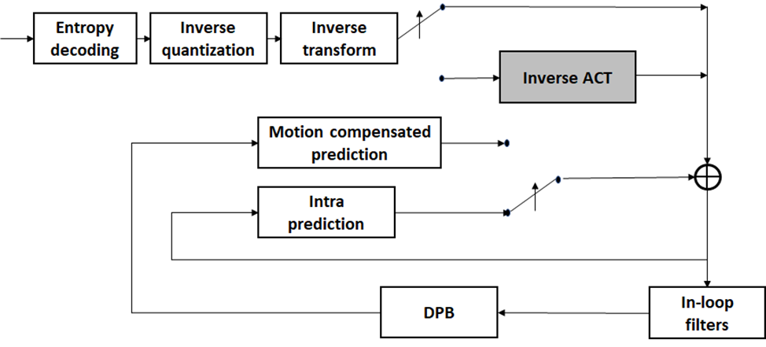
Figure 1 Illustration of decoding process with the ACT
The core transforms used for the color space conversions are kept the same as that used for the HEVC. Specifically, the following forward and inverse YCgCo color transform matrices, as described as follows, as applied.
$\left[\begin{matrix}C_{0}^{'} \\ C_{1}^{'} \\ C_{2}^{'}\end{matrix}\right]=\left[\begin{matrix}2 & 1 & 1 \\ 2 & -1 & -1 \\ 0 & -2 & 2\end{matrix}\right]\left[\begin{matrix}C_{0} \\ C_{1} \\ C_{2}\end{matrix}\right]/4$$\left[\begin{matrix}Y \\ Co \\ Cg\end{matrix}\right]=\left[\begin{matrix}1 & 2 & 1 \\ 2 & 0 & -2 \\ -1 & 2 & -1\end{matrix}\right]\left[\begin{matrix}R \\ G \\ B\end{matrix}\right]$$\left[\begin{matrix}Y \\ Co \\ Cg\end{matrix}\right]=\left[\begin{matrix}1 & 2 & 1 \\ 2 & 0 & -2 \\ -1 & 2 & -1\end{matrix}\right]\left[\begin{matrix}R \\ G \\ B\end{matrix}\right]$ $\left[\begin{matrix}C_{0} \\ C_{1} \\ C_{2}\end{matrix}\right]=\left[\begin{matrix}1 & 1 & 0 \\ 1 & -1 & -1 \\ 1 & -1 & 1\end{matrix}\right]\left[\begin{matrix}C_{0}^{'} \\ C_{1}^{'} \\ C_{2}^{'}\end{matrix}\right]$ | (1)
Additionally, to compensate the dynamic range change of residuals signals before and after color transform, the QP adjustments of (-5, -5, -3) are applied to the transform residuals.
On the other hand, as shown in (1), the forward and inverse color transforms need to access the residuals of all three components. Correspondingly, in the proposed implementation, the ACT is disabled in the following two scenarios where not all residuals of three components are available.
- Separate-tree partition: when separate-tree is applied, luma and chroma samples inside one CTU are partitioned by different structures. This results in that the CUs in the luma-tree only contains luma component and the CUs in the chroma-tree only contains two chroma components.
- Intra sub-partition prediction (ISP): the ISP sub-partition is only applied to luma while chroma signals are coded without splitting. In the current ISP design, except the last ISP sub-partitions, the other sub-partitions only contain luma component.

Simulation results
The proposed ACT was implemented on top of VTM-6.0 [1] and tested following the test conditions used by the core experiment (CE)8 [2]. In the simulation, IBC, PLT, BDPCM and inter HashME are enabled for both anchor and test. Results with separate-tree both enabled and disabled are provided.

BD-rate performance when separate-tree is disabled

 | All Intra
 | G/Y | B/U | R/V
RGB, text & graphics with motion, 1080p & 720p | -6.2% | -2.8% | -4.0%
RGB, mixed content, 1440p & 1080p | -11.6% | -5.8% | -5.7%
RGB, Animation, 720p | -8.1% | -4.5% | -2.9%
RGB, camera captured, 1080p | -11.6% | -1.4% | -3.3%
YUV, text & graphics with motion, 1080p & 720p | 0.2% | 0.1% | 0.1%
YUV, mixed content, 1440p & 1080p | 0.0% | 0.1% | 0.1%
YUV, Animation, 720p | 0.0% | 0.0% | 0.0%
YUV, camera captured, 1080p | 0.0% | 0.0% | 0.0%
Enc Time[%] | 104%
Dec Time[%] | 97%

 | Random Access
 | G/Y | B/U | R/V
RGB, text & graphics with motion, 1080p & 720p | -8.8% | -4.2% | -5.6%
RGB, mixed content, 1440p & 1080p | -18.1% | -10.4% | -10.2%
RGB, Animation, 720p | -14.5% | -8.5% | -7.9%
RGB, camera captured, 1080p | -25.3% | -9.1% | -14.5%
YUV, text & graphics with motion, 1080p & 720p | 0.1% | 0.1% | 0.2%
YUV, mixed content, 1440p & 1080p | 0.0% | 0.2% | 0.0%
YUV, Animation, 720p | 0.0% | 0.0% | -0.1%
YUV, camera captured, 1080p | 0.1% | 0.3% | 0.1%
Enc Time[%] | 104%
Dec Time[%] | 98%

 | Low delay B
 | G/Y | B/U | R/V
RGB, text & graphics with motion, 1080p & 720p | -11.9% | -6.8% | -7.8%
RGB, mixed content, 1440p & 1080p | -24.9% | -14.3% | -13.9%
RGB, Animation, 720p | -23.1% | -9.2% | -8.6%
RGB, camera captured, 1080p | -33.9% | -12.0% | -19.0%
YUV, text & graphics with motion, 1080p & 720p | 0.3% | 0.2% | 0.6%
YUV, mixed content, 1440p & 1080p | 0.1% | 1.2% | 0.5%
YUV, Animation, 720p | 0.0% | 0.4% | 0.7%
YUV, camera captured, 1080p | 0.1% | 0.2% | 0.2%
Enc Time[%] | 107%
Dec Time[%] | 101%

BD-rate performance when separate-tree is on

 | Random Access
 | G/Y | B/U | R/V
RGB, text & graphics with motion, 1080p & 720p | -4.9% | -2.6% | -3.3%
RGB, mixed content, 1440p & 1080p | -6.7% | -4.1% | -3.9%
RGB, Animation, 720p | -9.0% | -4.2% | -5.4%
RGB, camera captured, 1080p | -23.3% | -8.7% | -14.2%
YUV, text & graphics with motion, 1080p & 720p | 0.0% | 0.0% | 0.0%
YUV, mixed content, 1440p & 1080p | 0.1% | 0.3% | 0.2%
YUV, Animation, 720p | 0.1% | 0.0% | 0.1%
YUV, camera captured, 1080p | 0.1% | 0.0% | 0.0%
Enc Time[%] | 103%
Dec Time[%] | 98%

 | Low delay B
 | G/Y | B/U | R/V
RGB, text & graphics with motion, 1080p & 720p | -10.7% | -6.4% | -7.2%
RGB, mixed content, 1440p & 1080p | -16.4% | -9.8% | -9.4%
RGB, Animation, 720p | -22.1% | -8.7% | -8.2%
RGB, camera captured, 1080p | -33.7% | -11.9% | -19.0%
YUV, text & graphics with motion, 1080p & 720p | 0.3% | 0.2% | 0.4%
YUV, mixed content, 1440p & 1080p | 0.1% | 0.3% | 0.2%
YUV, Animation, 720p | 0.0% | 0.3% | 0.7%
YUV, camera captured, 1080p | 0.1% | 0.1% | -0.1%
Enc Time[%] | 106%
Dec Time[%] | 99%

Reference
- VTM-6.0, https://vcgit.hhi.fraunhofer.de/jvet/VVCSoftware_VTM/tags/VTM-6.0.
- X. Xu, Y.-C. Chao, Y.-C. Sun, J. Xu, “Description of Core Experiment 8 (CE8): 4:4:4 Screen Content Coding Tools”, JVET-O2028, July 2019, Gothenburg, Sweden.

Patent rights declaration(s)
Kwai Inc. may have current or pending patent rights relating to the technology described in this contribution and, conditioned on reciprocity, is prepared to grant licenses under reasonable and non-discriminatory terms as necessary for implementation of the resulting ITU-T Recommendation | ISO/IEC International Standard (per box 2 of the ITU-T/ITU-R/ISO/IEC patent statement and licensing declaration form).

