    Joint Video Experts Team (JVET)  of ITU-T SG 16 WP 3 and ISO/IEC JTC 1/SC 29/WG 11  16th Meeting: Geneva, CH, 1–11 October 2019 | Document: JVET-P0492

Title: | Non-CE5: Fixes of ALF sample padding
Status: | Input document to JVET
Purpose: | Proposal
Author(s) or  Contact(s): | Hongbin Liu, Li Zhang, Kai Zhang,  Yang Wang, Jizheng Xu, Yue Wang  Zijinshumayuan 4th building F9, 18 Zhongguancun Nansijie, Haidian District, 100190  Beijing, China | Tel:  Email: | +86 13911971613  liuhongbin.01@bytedance.com  lizhang.idm@bytedance.com
Source: | Bytedance Inc.
_____________________________

Abstract
In the current VVC design, when performing ALF, four boundaries of a CTU are checked to determine the invoking of sample padding. If a boundary is a slice/brick/sub-picture/360 virtual boundary and filtering across such boundary is disallowed, sample padding is applied. However, just checking the four boundaries of a CTU couldn’t cover all possible cases that padding should be applied. For example, in the case that the above-left, above-right, below-left or below-right neighboring samples of the CTU are in a different slice/brick/sub-picture from the CTU and filtering across the slice/brick/sub-picture boundary is disallowed, sample padding may also be required. This contribution proposes to fix these issues by checking more boundaries of the CTU. It is asserted that proposed method has not impact on the coding performance in CTC.

Introduction
In the current VVC design, when performing ALF, four boundaries of a CTU are checked. If a boundary is a slice/brick/sub-picture/360 virtual boundary and filtering across such boundary is disallowed, sample padding is applied. However, in the case that the above-left, above-right, below-left or below-right neighboring samples of the CTU are in a different slice/brick/sub-picture from the CTU and filtering across the slice/brick/sub-picture boundary is disallowed, sample padding may not be applied, which is incorrect. An example is shown in Figure 1, wherein the blue sample is in a different slice from the current CTU, however, it is used in the ALF.
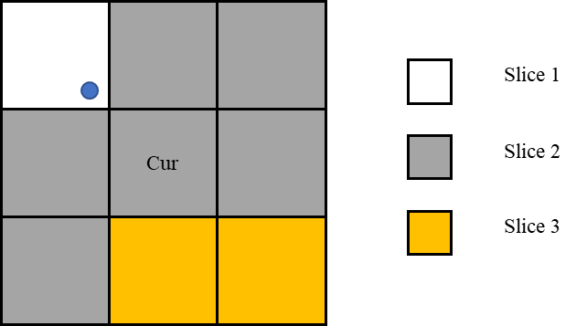
Figure 1: an example of using “unavailable” neighboring samples (the blue sample) in ALF. Cur is the current CTU.

Proposed method
To tackle the abovementioned problem, this contribution proposes to check more boundaries of the CTU to determine the invoking of sample padding. Specifically, for the above-left, above-right, below-left or below-right neighboring samples of the CTU, if they are in a different slice/brick/sub-picture from the CTU and filtering across the slice/brick/sub-picture boundary is disallowed, sample padding is applied.
It is proposed to use the top-left/top-right/bottom-left/bottom-right sample of the CTU to pad the above-left/above-right/below-left/below-right neighboring samples, respectively.

Experimental results
The proposed method is implemented on top of the reference software VTM-6.0 [2], and simulations were performed following the common test conditions [3]. The results are shown in Table 1. It can be seen that proposed method has no impact on the coding performance.
Table 1: Coding performance of proposed method.
 | AI |  |  |  |  | RA
 | Y | U | V | EncT | DecT | Y | U | V | EncT | DecT
Class A1
Class A2
Class B | 0.00% | 0.00% | 0.00% | 99% | 99% | 0.00% | 0.00% | 0.00% | 99% | 97%
Class C | 0.00% | 0.00% | 0.00% | 98% | 93% | 0.00% | 0.00% | 0.00% | 99% | 96%
Class E | 0.00% | 0.00% | 0.00% | 100% | 98%
Overall
Class D | 0.00% | 0.00% | 0.00% | 99% | 95% | 0.00% | 0.00% | 0.00% | 99% | 97%
Class F |  |  |  |  |  | 0.00% | 0.00% | 0.00% | 99% | 97%

Conclusions
This contribution proposes fix of ALF sample padding. It has no impact on the coding performance. It is recommended to adopt it into VVC.

References
- “Versatile Video Coding (Draft 6)”, B. Bross, J. Chen, S. Liu, Doc. JVET-O2001, July. 2019.
- VTM-6.0, https://vcgit.hhi.fraunhofer.de/jvet/VVCSoftware_VTM/tags/VTM-6.0.
- “JVET common test conditions and software reference configurations for SDR video”, F. Bossen, J. Boyce, X. Li, V. Seregin, K. Suehring, Doc. JVET-N1010, Mar. 2019.

Patent rights declaration(s)
Bytedance Inc. may have current or pending patent rights relating to the technology described in this contribution and, conditioned on reciprocity, is prepared to grant licenses under reasonable and non-discriminatory terms as necessary for implementation of the resulting ITU-T Recommendation | ISO/IEC International Standard (per box 2 of the ITU-T/ITU-R/ISO/IEC patent statement and licensing declaration form).

