    Joint Video Experts Team (JVET)  of ITU-T SG 16 WP 3 and ISO/IEC JTC 1/SC 29/WG 11  16th Meeting: Geneva, CH, 1–11 October 2019 | Document: JVET-P0486-v3

Title: | CE8-related: Alignment of maximum transform-skip size with maximum transform block size
Status: | Input document to JVET
Purpose: | Proposal
Author(s) or  Contact(s): | Mohammed Golam Sarwer,  Ruling Liao, Jiancong Luo, Yan Ye  525 Almanor Ave,  Sunnyvale, CA | Tel:  Email: | +1-408-858-6780  m.sarwer@alibaba-inc.com
Source: | Alibaba Group
_____________________________

Abstract
Regarding the signalling of the maximum transform skip size, it is asserted that the current signalling in VVC draft 6 allows too much flexibility, which is not only unnecessary but also burdens hardware verification and conformance testing. Therefore, this contribution proposes to either remove it and set it to the same value as the maximum TB size, or to move it from PPS to SPS and to signal just as an SPS flag indicating either 32 or 64 in the same way as the maximum TB size signalling.
In VVC draft 6, the maximum transform skip (TS) block size and maximum BDPCM block size are 32x32, whereas the maximum transform block (TB) size is 64x64. This contribution proposes to align the maximum TS and BDPCM block size with maximum TB size. In the proposed method, the maximum TS block size can be up to 64x64. For larger TS and BDPCM blocks (i.e. size > 32), it is proposed to split them into 32x32 residual unit (RU). This way, the existing VVC6 TS residual coefficient scanning method can be reused, and a decoder never has to scan residual blocks larger than 32x32. It is reported that the BD-rate impact of the proposed method is -0.02% (AI), -0.13% (RA), -0.20% (LB) for the SCC sequences under CTC test conditions.
.

Problem Statement
In VVC 6, the TS mode is allowed for block sizes that are equal to or less than 32 in each dimension. A picture parameter set (PPS) level syntax, log2_transform_skip_max_size_minus2 specifies the maximum block size used for TS mode, and is in the range of 0 to 3. The maximum value of width or height of the TS mode is computed as follows:
MaxTsSize = 1 << ( log2_transform_skip_max_size_minus2 + 2 ).
A decoder implementation needs to support all 4 possible values of log2_transform_skip_max_size_minus2. It is asserted that given the maximum TB size can have only 2 values (32 or 64), this flexibility of maximum TS block size is unnecessary and burdens the verification and conformance testing of hardware decoder implementations.
Table 1 shows the part of the PPS syntax table of VVC6. It is shown that PPS level syntax log2_transform_skip_max_size_minus2 is conditionally signalled when SPS level flag sps_transform_skip_enabled_flag is 1, which introduce parsing dependency between PPS and SPS, which is not desirable.
Table 1: part of the PPS syntax table of VVC6
pic_parameter_set_rbsp( ) { | Descriptor
if( sps_transform_skip_enabled_flag )
log2_transform_skip_max_size_minus2 | ue(v)

It is noted here that the maximum allowed CU size of BDPCM mode also restricted to maximum TS size (MaxTsSize).

Proposed methods

Signaling maximum TS size
Two alternative methods of signaling maximum TS size are proposed.

Method 1: Remove log2_transform_skip_max_size_minus2 syntax
In this method, we propose to remove the syntax log2_transform_skip_max_size_minus2 and the value of maximum transform-skip size is derived from the maximum transform block flag, sps_max_luma_transform_size_64_flag. If sps_max_luma_transform_size_64_flag is 0, the maximum TS size is 32 and if sps_max_luma_transform_size_64_flag is 1, the maximum transform-skip size is 64. Table 2, Table 3, , and Table 4 shows the related syntax table of this method.

Table 2: Part of PPS syntax table of removing log2_transform_skip_max_size_minus2
pic_parameter_set_rbsp( ) { | Descriptor
if( sps_transform_skip_enabled_flag )
log2_transform_skip_max_size_minus2 | ue(v)

Table 3: TU syntax table of method 1
if( tu_cbf_luma[ x0 ][ y0 ] && treeType != DUAL_TREE_CHROMA
&& ( tbWidth <= 32 ) && ( tbHeight <= 32 )
&& ( IntraSubPartitionsSplit[ x0 ][ y0 ] = = ISP_NO_SPLIT ) && ( !cu_sbt_flag ) ) {
if( sps_transform_skip_enabled_flag && !BdpcmFlag[ x0 ][ y0 ] &&
tbWidth <= MaxTsSize && tbHeight <= MaxTsSize )
transform_skip_flag[ x0 ][ y0 ] | ae(v)
if( ( ( CuPredMode[ chType ][ x0 ][ y0 ] = = MODE_INTER &&
sps_explicit_mts_inter_enabled_flag )
| | ( CuPredMode[ chType ][ x0 ][ y0 ] = = MODE_INTRA &&
sps_explicit_mts_intra_enabled_flag ) ) && ( !transform_skip_flag[ x0 ][ y0 ] ) && tbWidth <= 32 && tbHeight <= 32)
tu_mts_idx[ x0 ][ y0 ] | ae(v)
}

Table 4: BDPCM related syntax table of method 1
if( sps_bdpcm_enabled_flag &&
cbWidth <= MaxTsSize MaxTbSizeY && cbHeight <= MaxTsSize MaxTbSizeY)
intra_bdpcm_flag | ae(v)

Method 2: SPS flag to signal maximum TS size
In the method 2, it is proposed to signal a SPS flag indicating either maximum TS size is 32 or 64 in the same way as maximum TB size signaling.
sps_max_transform_skip_size_64_flag equal to 0 specifies that the maximum block size used for transform skip is 32. sps_max_transform_skip_size_64_flag equal to 1 specifies that the maximum block size used for transform skip is 64.
When not present, the value of sps_max_transform_skip_size_64_flag is inferred to be equal to 0.
The maximum value of width or height of the TS mode is computed as follows:
MaxTsSize = sps_max_transform_skip_size_64_? 64 : 32
sps_max_transform_skip_size_64_flag is signaled if both sps_max_luma_transform_size_64_flag and sps_transform_skip_enabled_flag are 1. Table 5 and Table 6 shows the related syntax tables of the proposed method.

Table 5: part of SPS syntax table of method 2
seq_parameter_set_rbsp( ) { | Descriptor
sps_max_luma_transform_size_64_flag | u(1)
.
.
sps_transform_skip_enabled_flag | u(1)
if( sps_transform_skip_enabled_flag){
sps_bdpcm_enabled_flag | u(1)
if (sps_max_luma_transform_size_64_flag)
sps_max_transform_skip_size_64_flag | u(1)
}
}

Table 2: Part of PPS syntax table of removing log2_transform_skip_max_size_minus2
pic_parameter_set_rbsp( ) { | Descriptor
if( sps_transform_skip_enabled_flag )
log2_transform_skip_max_size_minus2 | ue(v)

Table 6: part of TU syntax table of method 2
if( tu_cbf_luma[ x0 ][ y0 ] && treeType != DUAL_TREE_CHROMA
&& ( tbWidth <= 32 ) && ( tbHeight <= 32 )
&& ( IntraSubPartitionsSplit[ x0 ][ y0 ] = = ISP_NO_SPLIT ) && ( !cu_sbt_flag ) ) {
if( sps_transform_skip_enabled_flag && !BdpcmFlag[ x0 ][ y0 ] &&
tbWidth <= MaxTsSize && tbHeight <= MaxTsSize )
transform_skip_flag[ x0 ][ y0 ] | ae(v)
if( ( ( CuPredMode[ chType ][ x0 ][ y0 ] = = MODE_INTER &&
sps_explicit_mts_inter_enabled_flag )
| | ( CuPredMode[ chType ][ x0 ][ y0 ] = = MODE_INTRA &&
sps_explicit_mts_intra_enabled_flag ) ) && ( !transform_skip_flag[ x0 ][ y0 ] ) && tbWidth <= 32 && tbHeight <= 32)
tu_mts_idx[ x0 ][ y0 ] | ae(v)
}

Residual coding of TS and BDPCM mode with large transform unit
Regardless the signaling method, this contribution proposes to align the maximum TS and BDPCM size with the maximum TB size, i.e., if maximum TB size is 64, then the maximum TS and BDPCM size is 64 as well.
In order to re-use the existing VVC6 TS residual coding technique, the proposed method divides a large transform block into small residual unit (RU). If the width of the transform block is larger than 32, the transform block is horizontally split into 2 partitions. If the height of the transform block is larger than 32, the transform block is vertically split. If both dimensions are larger than 32, the transform block is horizontally and vertically split into 4 32x32 RUs. Then, these two or four RUs are coded. An illustration of the concept of RU is shown in Figure 1.

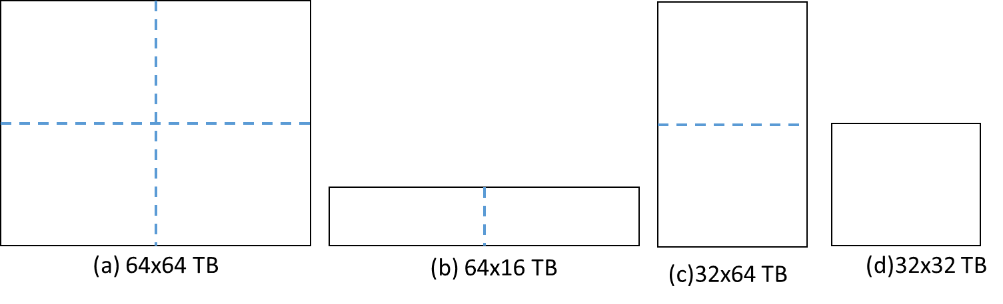
Figure 1: An illustration of RU (a) a 64x64 TB is divided into 4 32x32 RUs, (b) a 64x16 TB is divided into 2 32x16 RUs, (c) a 32x64 TB is divided into 2 32x32 RUs and (d) partition is not necessary since both the width and height are 32.

Figure 2 shows the scanning order when TB is divided into RU. In Figure 2, the 64x64 TB is divided into 4 RUs and coefficients of each RU are scanned separately (i.e. independently) within the RU following the same order as a 32x32 transform block. RUs are coded completely independently. The context models and rice parameter derivations of one RU do not depend on another RU. The maximum number of context coded bins are also allocated for each RU independently. This is in contrast to the VVC 6, where the maximum number of context coded bins is defined at the TB level.

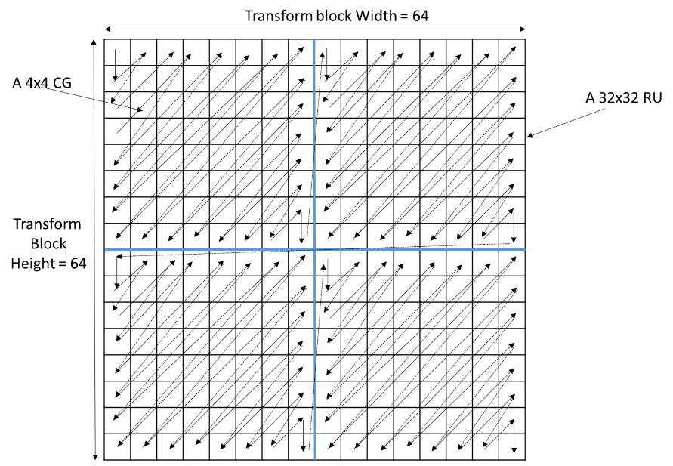
Figure 2: An example of diagonal scanning of a 64x64 TB where the TB is divided into 4 32x32 RUSimulation results
The proposed method is tested in VTM-6.0 software under both CTC and low QP (2, 7, 12, 17) test conditions. Two tests are reported. In both tests, the maximum TS and BDPCM size are aligned with max TB which is 64 in CTC test condition.
- Test 1: Whole transform block scanning (i.e. maximum 64x64 coefficient scanning)
- Test 2: Divide TB to RU (max RU size 32x32, therefore, maximum 32x32 coefficient scanning)
Table 7and Table 8 shows the results of CTC test conditions. Table 9 and Table 10 show the results under low QP conditions.

Table 7: results of test 1 (CTC QP)
 | All Intra Main10
 | Over VTM-6.0
 | Y | U | V | EncT | DecT
Class A1 | 0.00% | 0.00% | 0.02% | 100% | 101%
Class A2 | 0.00% | 0.00% | 0.00% | 100% | 101%
Class B | 0.01% | 0.00% | -0.01% | 100% | 102%
Class C | 0.00% | 0.00% | -0.01% | 100% | 104%
Class E | 0.00% | -0.01% | -0.03% | 100% | 105%
Overall | 0.00% | 0.00% | -0.01% | 100% | 103%
Class D | 0.00% | 0.00% | 0.00% | 98% | 106%
Class F | -0.04% | -0.04% | -0.10% | 101% | 102%
Class SCC | -0.02% | -0.02% | -0.02% | 101% | 101%
 | Random access Main10
 | Over VTM-6.0
 | Y | U | V | EncT | DecT
Class A1 | -0.01% | -0.05% | -0.02% | 101% | 101%
Class A2 | 0.04% | -0.02% | 0.02% | 101% | 101%
Class B | -0.02% | 0.15% | 0.01% | 101% | 102%
Class C | 0.00% | 0.05% | -0.02% | 101% | 101%
Class E
Overall | 0.00% | 0.05% | 0.00% | 101% | 101%
Class D | -0.01% | 0.05% | -0.03% | 101% | 102%
Class F | -0.06% | -0.10% | -0.02% | 101% | 103%
Class SCC | -0.15% | -0.13% | -0.14% | 103% | 102%
 | Low delay B Main10
 | Over VTM-6.0
 | Y | U | V | EncT | DecT
Class A1
Class A2
Class B | 0.03% | -0.06% | -0.22% | 101% | 101%
Class C | 0.01% | 0.13% | -0.07% | 102% | 104%
Class E | -0.02% | 0.38% | 0.89% | 102% | 103%
Overall | 0.01% | 0.11% | 0.11% | 102% | 103%
Class D | 0.04% | 0.42% | 0.03% | 101% | 108%
Class F | -0.06% | 0.35% | 0.26% | 102% | 103%
Class SCC | -0.12% | -0.09% | -0.06% | 104% | 105%

Table 8: results of test 2 ( CTC QP)
 | All Intra Main10
 | Over VTM-6.0
 | Y | U | V | EncT | DecT
Class A1 | 0.00% | 0.00% | 0.03% | 100% | 100%
Class A2 | 0.00% | 0.00% | 0.00% | 100% | 100%
Class B | 0.01% | 0.00% | -0.01% | 100% | 102%
Class C | 0.00% | 0.00% | -0.01% | 100% | 104%
Class E | 0.00% | -0.01% | -0.03% | 101% | 104%
Overall | 0.00% | 0.00% | 0.00% | 100% | 102%
Class D | 0.00% | 0.00% | 0.00% | 99% | 106%
Class F | -0.05% | -0.05% | -0.13% | 101% | 99%
Class SCC | -0.02% | -0.02% | -0.01% | 101% | 99%
 | Random access Main10
 | Over VTM-6.0
 | Y | U | V | EncT | DecT
Class A1 | 0.00% | -0.05% | -0.03% | 102% | 100%
Class A2 | 0.04% | -0.02% | 0.03% | 101% | 100%
Class B | -0.02% | 0.15% | 0.01% | 101% | 101%
Class C | 0.00% | 0.05% | -0.02% | 101% | 100%
Class E
Overall | 0.00% | 0.05% | 0.00% | 101% | 100%
Class D | -0.01% | 0.05% | -0.01% | 101% | 101%
Class F | -0.07% | -0.11% | 0.01% | 101% | 100%
Class SCC | -0.13% | -0.16% | -0.17% | 102% | 99%
 | Low delay B Main10
 | Over VTM-6.0
 | Y | U | V | EncT | DecT
Class A1
Class A2
Class B | 0.03% | 0.12% | -0.09% | 101% | 100%
Class C | 0.01% | 0.11% | 0.01% | 102% | 104%
Class E | 0.00% | 0.56% | 0.80% | 102% | 102%
Overall | 0.01% | 0.22% | 0.17% | 102% | 102%
Class D | 0.05% | 0.27% | 0.32% | 101% | 107%
Class F | 0.06% | -0.19% | 0.41% | 101% | 99%
Class SCC | -0.20% | -0.17% | -0.17% | 103% | 103%

Table 9: results of test 1 ( low QP)
 | All Intra Main10
 | Over VTM-6.0
 | Y | U | V | EncT | DecT
Class A1 | 0.00% | 0.00% | 0.00% | 100% | 101%
Class A2 | 0.00% | 0.00% | 0.00% | 100% | 101%
Class B | 0.00% | -0.01% | 0.00% | 99% | 101%
Class C | 0.00% | 0.00% | 0.00% | 98% | 102%
Class E | 0.00% | 0.00% | 0.00% | 100% | 101%
Overall | 0.00% | 0.00% | 0.00% | 99% | 101%
Class D | 0.00% | 0.00% | 0.00% | 100% | 105%
Class F | -0.01% | -0.04% | 0.03% | 100% | 99%
Class SCC | -0.02% | 0.00% | -0.02% | 99% | 99%
 | Random access Main10
 | Over VTM-6.0
 | Y | U | V | EncT | DecT
Class A1 | 0.00% | -0.01% | -0.03% | 100% | 104%
Class A2 | 0.00% | 0.00% | 0.00% | 100% | 103%
Class B | 0.01% | 0.01% | 0.00% | 100% | 105%
Class C | 0.00% | -0.01% | 0.00% | 100% | 105%
Class E
Overall | 0.00% | 0.00% | -0.01% | 100% | 104%
Class D | 0.00% | 0.01% | 0.01% | 100% | 107%
Class F | -0.11% | -0.20% | -0.21% | 101% | 110%
Class SCC | -0.06% | -0.07% | -0.07% | 102% | 115%
 | Low delay B Main10
 | Over VTM-6.0
 | Y | U | V | EncT | DecT
Class A1
Class A2
Class B | 0.00% | 0.00% | 0.00% | 101% | 102%
Class C | 0.00% | 0.00% | -0.01% | 100% | 103%
Class E | 0.01% | -0.01% | 0.06% | 100% | 104%
Overall | 0.00% | 0.00% | 0.01% | 101% | 103%
Class D | 0.00% | -0.01% | -0.05% | 100% | 105%
Class F | 0.02% | -0.03% | -0.09% | 102% | 101%
Class SCC | -0.10% | -0.09% | 0.02% | 102% | 99%

Table 10: results of test 2 ( low QP) ( results will be updated)
 | All Intra Main10
 | Over VTM-6.0
 | Y | U | V | EncT | DecT
Class A1 | 0.00% | 0.01% | 0.00% | 100% | 98%
Class A2 | 0.00% | 0.00% | 0.00% | 100% | 98%
Class B | 0.00% | -0.01% | 0.00% | 100% | 98%
Class C | 0.00% | 0.00% | 0.00% | 98% | 100%
Class E | 0.00% | 0.00% | 0.00% | 99% | 98%
Overall | 0.00% | 0.00% | 0.00% | 99% | 98%
Class D | 0.00% | 0.00% | 0.00% | 100% | 103%
Class F | 0.03% | -0.03% | 0.01% | 100% | 99%
Class SCC | -0.01% | -0.02% | -0.02% | 99% | 99%
 | Random access Main10
 | Over VTM-6.0
 | Y | U | V | EncT | DecT
Class A1 | 0.00% | -0.01% | -0.02% | 100% | 99%
Class A2
Class B | 0.01% | 0.02% | 0.00% | 100% | 101%
Class C | 0.00% | -0.01% | 0.00% | 100% | 101%
Class E
Overall
Class D | 0.00% | 0.01% | 0.01% | 101% | 103%
Class F | -0.08% | -0.18% | -0.12% | 101% | 110%
Class SCC | -0.08% | -0.10% | -0.06% | 103% | 114%
 | Low delay B Main10
 | Over VTM-6.0
 | Y | U | V | EncT | DecT
Class A1
Class A2
Class B | 0.00% | 0.01% | -0.02% | 101% | 97%
Class C | 0.00% | 0.00% | -0.01% | 101% | 100%
Class E | 0.01% | -0.01% | 0.06% | 100% | 99%
Overall | 0.00% | 0.00% | 0.00% | 101% | 98%
Class D | 0.00% | -0.01% | -0.05% | 101% | 101%
Class F | -0.01% | -0.09% | 0.02% | 102% | 100%
Class SCC | -0.21% | -0.21% | -0.13% | 103% | 98%

Conclusion
This contribution proposes to align the maximum TS and BDPCM block size to maximum transform block size. In order to remove the too many possibilities of maximum TS size signaling, it is also proposed either to remove maximum TS size signaling or to signal an SPS flag indicating either the maximum TS size is 64 or 32.

Patent rights declaration(s)
Alibaba Group may have current or pending patent rights relating to the technology described in this contribution and, conditioned on reciprocity, is prepared to grant licenses under reasonable and non-discriminatory terms as necessary for implementation of the resulting ITU-T Recommendation | ISO/IEC International Standard (per box 2 of the ITU-T/ITU-R/ISO/IEC patent statement and licensing declaration form).

