    Joint Video Experts Team (JVET)  of ITU-T SG 16 WP 3 and ISO/IEC JTC 1/SC 29/WG 11  16th Meeting: Geneva, CH, 1–11 October 2019 | Document: JVET-P0467-v2

Title: | AHG18 : Rice parameter extension
Status: | Input document to JVET
Purpose: | Proposal
Author(s) or  Contact(s): | Jungah Choi  Hyeongmun Jang  Jin Heo  Sunmi Yoo  Jaehyun Lim  19 Yangjaedaero-11gil  Seocho-gu, Seoul 06772  South Korea  Seung Hwan Kim  10225 Willow Creek Rd, San Diego  CA 92131, USA | Tel:  Email: | +82-2-6912-6561  jungah.choi@lge.com
Source: | LG Electronics Inc.
_____________________________

Abstract
This contribution introduces an extended Rice parameter based on lossless coding flag (i.e., cu_transquant_bypass_flag). The proposed method is tested with the lossless residual coding in JVET-P0466, where transform skip residual coding methods in CE7-1.2d and CE7-1.2d-alternative are used for intra and IBC modes of lossless coding. Specifically, the proposed method extends maximum Rice parameter without additional look-up table or signaling.
Overall
- Test #1: -1.11% (AI), -0.29% (RA)
- Test #2: -1.63% (AI), x.xx% (RA)
- Test #3: -1.24% (AI), -0.31% (RA)
- Test #4: -1.77% (AI), -0.39% (RA)

Proposed Method
In CE7-1.2d and CE7-1.2d with an alternative method of Rice-Golomb coding after bypass switch [1], following table of 32 entries are used for Rice parameter derivation:
auiGoRicePars[32] = {0, 0, 0, 0, 1, 1, 1, 1, 1, 1, 1, 2, 2, 2, 2, 2, 2, 2, 2, 2, 2, 2, 3, 3, 3, 3, 3, 3, 3, 3, 3, 3}
There are three types of absolute level values and the way to derive the Rice parameter is as follows:
- remainder after abs_level_gtX_flags
  - auiGoRicePars[Clip3(0, 31, sum - 8)]
- abs(level) – 1
  - auiGoRicePars[Clip3(0, 31, sum + 4)]
- abs(level)
  - auiGoRicePars[Clip3(0, 31, sum)]
Here, sum is the sum of absolute levels of two neighboring coefficients.
Although [1] includes various Rice parameter derivation, the maximum Rice parameter of all methods is bounded by 3. In order to more efficiently deal with larger coefficients which frequently occur lossless coding, the maximum Rice parameter needs to be increased. In the proposed method, Rice parameter derivation methods for abs(level) – 1 and abs(level) are modified as follows. Using this method, the Rice parameter range is extended in lossless coding and maximum Rice parameter is changed from 3 to 5.
- abs(level) – 1
  - (sum + 4) > 31? auiGoRicePars[Clip3(0, 31, sum + 4)] + (2 * cu_transquant_bypass_flag) : auiGoRicePars[Clip3(0, 31, sum + 4)]
- abs(level)
  - sum > 31? auiGoRicePars[Clip3(0, 31, sum)] + (2 * cu_transquant_bypass_flag) : auiGoRicePars[Clip3(0, 31, sum)]

In addition, we tested the following methods. Here, the Rice parameter range is extended in lossless coding and maximum Rice parameter is changed from 3 to 4.
- abs(level) – 1
  - (sum + 4) > 31? auiGoRicePars[Clip3(0, 31, sum + 4)] + cu_transquant_bypass_flag : auiGoRicePars[Clip3(0, 31, sum + 4)]
- abs(level)
  - sum > 31? auiGoRicePars[Clip3(0, 31, sum)] + cu_transquant_bypass_flag : auiGoRicePars[Clip3(0, 31, sum)]

Experimental results
The performance of the proposed method was compared with the initial lossless software of AHG18. The proposed method was implemented on top of CE7-1.2d and CE7-1.2d-alternative [1]. Following tables show performance of the proposed method.
Test #1: CE7-1.2d + Rice parameter extension to 5
Test #2: CE7-1.2d-alternative + Rice parameter extension to 5
Test #3: CE7-1.2d + Rice parameter extension to 4
Test #4: CE7-1.2d-alternative + Rice parameter extension to 4

Table I. Test result (Test #1)
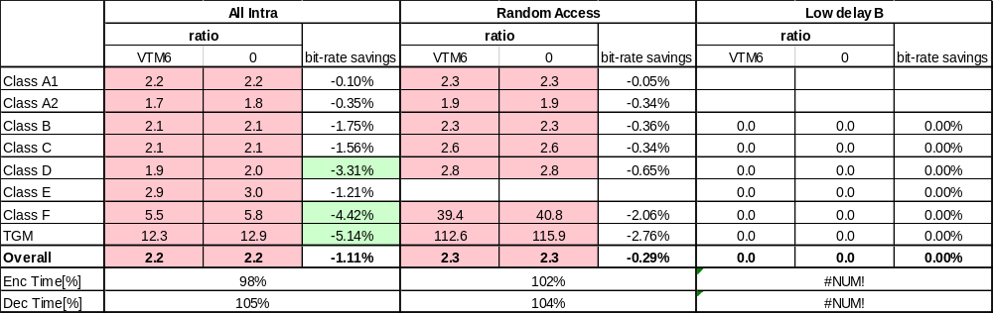

Table II. Test result (Test #2)
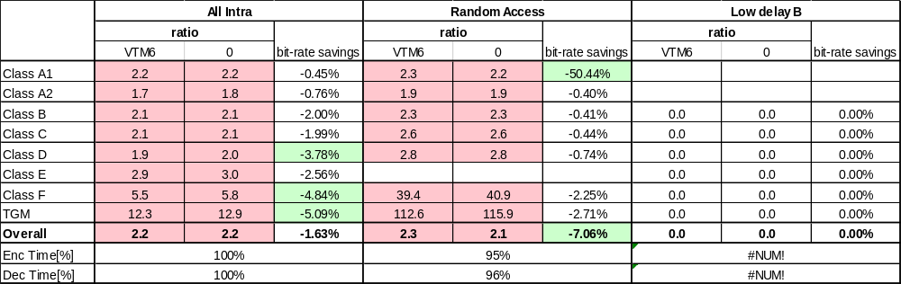

Table III. Test result (Test #3)
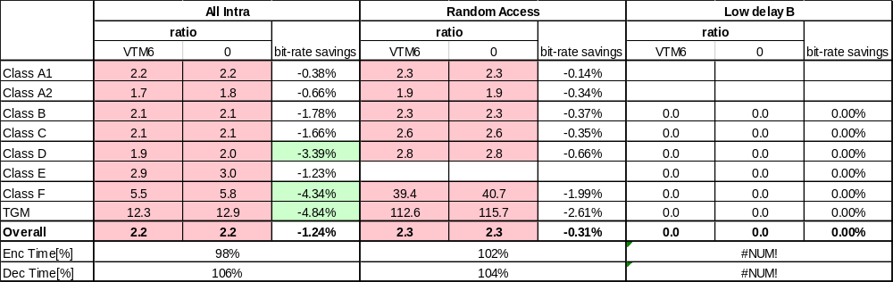

Table IV. Test result (Test #4)
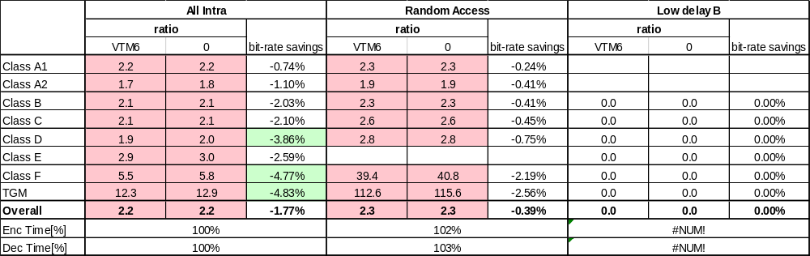

References
- M. Karczewicz et. al, “CE7: Modifications to transform-skip residual coding (CE7-1.2),” Joint Video Experts Team (JVET) of ITU-T SG 16 WP 3 and ISO/IEC JTC1/SC 29/WG 11 JVET-P0079, 16th meeting, Gevena, CH, 1-11 Oct. 2019.

Patent rights declaration(s)
LG Electronics Inc. may have current or pending patent rights relating to the technology described in this contribution and, conditioned on reciprocity, is prepared to grant licenses under reasonable and non-discriminatory terms as necessary for implementation of the resulting ITU-T Recommendation | ISO/IEC International Standard (per box 2 of the ITU-T/ITU-R/ISO/IEC patent statement and licensing declaration form).

