    Joint Video Experts Team (JVET)  of ITU-T SG 16 WP 3 and ISO/IEC JTC 1/SC 29/WG 11  16th Meeting: Geneva, CH, 1–11 October 2019 | Document: JVET-P0454-v3

Title: | Non-CE8: Constraints on IBC reference block locations
Status: | Input document to JVET
Purpose: | Proposal
Author(s) or  Contact(s): | Xiaozhong Xu  Xiang Li  Shan Liu | Tel:  Email: | xiaozhongxu@tencent.com
Source: | Tencent
_____________________________

Abstract
In this contribution, a constraint is imposed on the reference block location for IBC, such that all samples of the reference block should be in the same 64x64 grid aligned region in the current picture.
It is reported that the proposed modification avoids an encoder to generate some of the bitstreams that contain samples from disconnected areas in the decoded part of current picture, therefore reduce the efforts for conformance testing.
Simulation results reportedly show that the BD rate changes are as follows:
For method 1:
- For class F, 0.43%/0.35%/0.41% for AI/RA/LB configurations.
- For class TGM, 1.22%/0.86%/0.70% AI/RA/LB configurations.
For method 2:
- For class F, 0.17%/0.10%/0.18% for AI/RA/LB configurations.
- For class TGM, 0.42%/0.31%/0.16% AI/RA/LB configurations.
In the updated versions, the text of method 1 has been corrected and additional results for method 1 were provided when CTU size is 64x64 (non-CTC).

Problem Statement
In current VVC specification [1], the allowed reference area for a block coded in IBC mode is the reconstructed part of the current CTU and some parts of the left CTU. However, by using a virtual IBC dedicated buffer concept, a reference block can be generated using disconnected samples in the reference picture.
In addition, the 1-CTU size reference sample memory is allocated in a fashion containing 4 64x64 blocks, one of which is used to decode samples in the current 64x64 coding region while others still store previously coded samples. A rotation of memory block is required there for accessing different 64x64 blocks, which requires multiple addressing. It is preferable to limit such a behaviour.

Examples of the undesirable reference block locations are shown in Fig. 1, in which the reference samples in the block are located in a way such that i) all four 64x64 reference sample memory blocks are accessed to generate such a reference block; ii) samples in the reference block are not continuous; iii) contains both locations from current CTU and left CTU in disconnected areas.
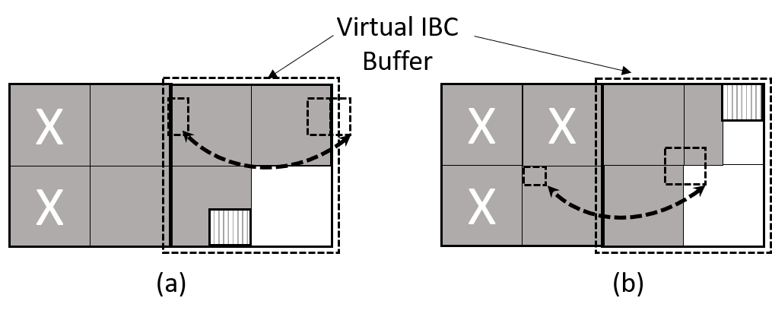
Fig. 1: examples of undesirable reference block locations

Proposed methods
In method 1,
It is proposed that a constraint is imposed on the reference block location such that all the samples should be located inside the same 64x64 region for CTC case. Or, inside the same CTU when CTU size < 128x128. The related text changes are as follows:

It is a requirement of bitstream conformance that the luma block vector bvL shall obey the following constraints:
- CtbSizeY is greater than or equal to ( ( yCb + ( bvL[ 1 ] >> 4 ) ) & ( CtbSizeY − 1 ) ) + cbHeight.
- ( xCb + ( bvL[ 0 ] >> 4 ) ) / Vsize shall be equal to ( ( xCb + ( bvL[ 0 ] >> 4 ) + cbWidth − 1 ) / Vsize.
- ( yCb + ( bvL[ 1 ] >> 4 ) ) / Vsize shall be equal to ( ( yCb + ( bvL[ 1 ] >> 4 ) + cbHeight – 1 ) / Vsize.
- IbcVirBuf[ 0 ][ ( x + (bvL[ 0 ] >> 4 ) ) & ( IbcVirBufWidth − 1 ) ][ ( y + (bvL[1] >> 4 ) ) & ( CtbSizeY − 1) ] shall not be equal to −1 for x = xCb..xCb + cbWidth − 1 and y = yCb..yCb + cbHeight − 1.

In method 2,
It is proposed to disallow horizotnal wrap-around in the virtual ibc buffer. In addition, the samples in the reference block shall not come from different CTUs, when CTU size is equal to 128x128. The related text changes are as follows:
The top-left location inside the reference block ( xRefTL, yRefTL ) in the virtual buffer IbcVirBuf is derived as follows:
( xRefTL, yRefTL ) = ( ( ( xCb + ( bvL[ 0 ] >> 4 ) ) & ( IbcBufWidthY − 1 ) ), ( ( yCb + ( bvL[ 1 ] >> 4 ) ) & ( CtbSizeY − 1 ) )) (8-889)
The location ( xCtb, yCtb ) of the top-left sample of the current coding tree block relative to the top-left sample of the current picture is derived as follows:
( xCtb, yCtb ) = ( ( xCb / CtbSizeY ) * CtbSizeY, ( yCb / CtbSizeY ) * CtbSizeY ) (8-890)
It is a requirement of bitstream conformance that the luma block vector bvL shall obey the following constraints:
- CtbSizeY is greater than or equal to yRefTL + cbHeight.
- IbcBufWidthY is greater than or equal to xRefTL + cbWidth.
- IbcVirBuf[ 0 ][ ( x + (bvL[ 0 ] >> 4 ) ) & ( IbcVirBufWidth − 1 ) ][ ( y + (bvL[1] >> 4 ) ) & ( CtbSizeY − 1) ] shall not be equal to −1 for x = xCb..xCb + cbWidth − 1 and y = yCb..yCb + cbHeight − 1.
- When CtbLog2SizeY is equal to 7, IsAvailable[ 0 ][ xCtb + xRefTL ][ yCtb + yRefTL ] and IsAvailable[ 0 ][ xCtb + xRefTL + cbWidth −1 ][ yCtb +yRefTL+ cbHeight −1 ] shall be both equal to TRUE or both equal to FALSE.

Simulation results
The proposed methods are implemented on top of VTM-6.0. The results are summarized in Table I and Table I. To put the BD rate differences in the context of VTM without IBC, Table III and IV show results of VTM-6 with IBC on and the proposed method 1 using VTM-6 with IBC off, respectively. It is asserted that the actual delta rate changes are smaller than what is shown in Table I and Table II.

Table I: Performance of proposed method 1 vs. VTM-6.0 IBC on
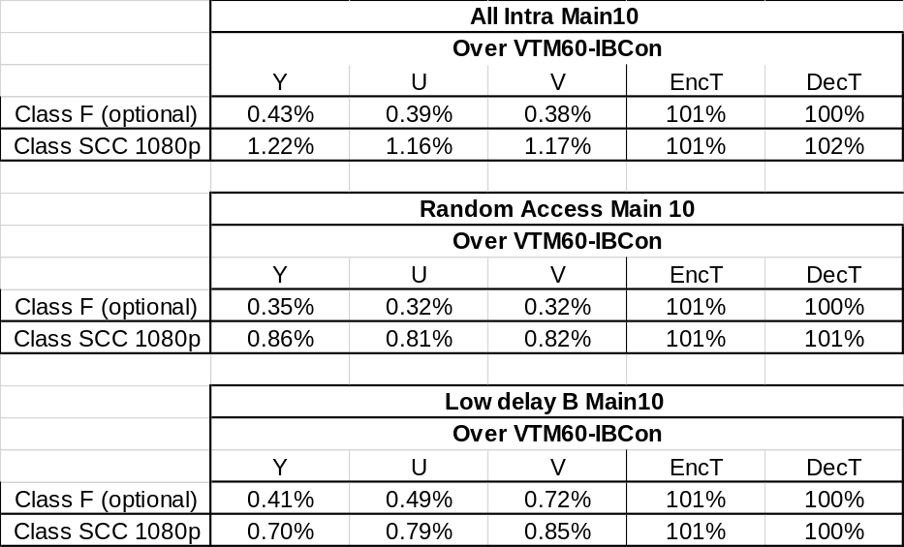

Table II: Performance of proposed method 2 vs. VTM-6.0 IBC on
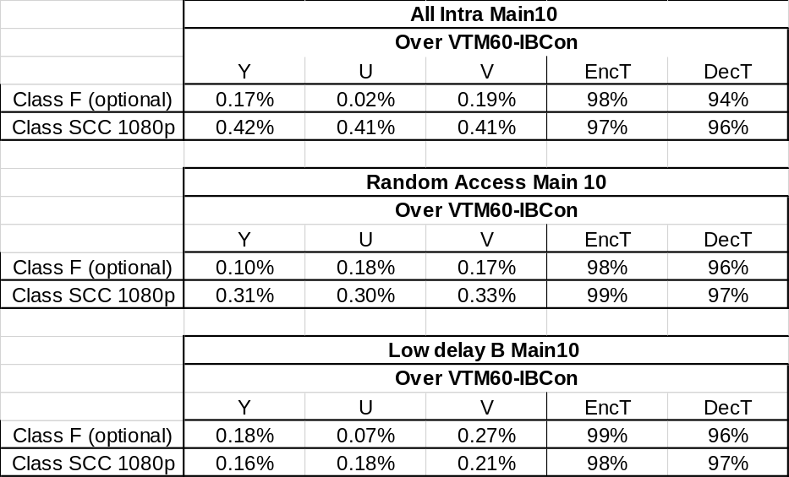
Additional results of method 1 when CTU size = 64x64 are provided in Table III.

Table III: Performance of proposed method 1 vs. VTM-6.0 IBC on when CTU size is 64
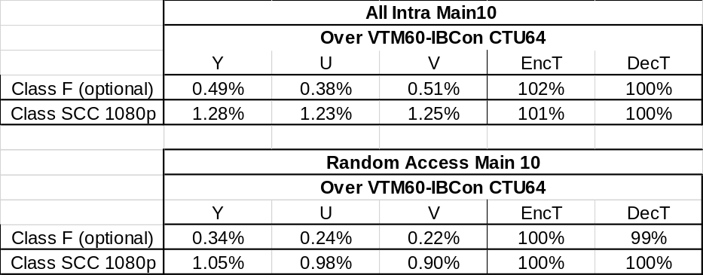

Conclusion
In this contribution, constraints are imposed on the IBC reference location such that samples of a reference block will come from the same CTU or same VPDU region. It is asserted that by doing this, the opportunity for an encoder to generate discontinued prediction block is removed.

References
[1] B. Bross, J. Chen and S. Liu, “Versatile Video Coding (Draft 6)”, JVET-O2001-vE, July. 2019

Patent rights declaration(s)
Tencent may have current or pending patent rights relating to the technology described in this contribution and, conditioned on reciprocity, is prepared to grant licenses under reasonable and non-discriminatory terms as necessary for implementation of the resulting ITU-T Recommendation | ISO/IEC International Standard (per box 2 of the ITU-T/ITU-R/ISO/IEC patent statement and licensing declaration form).

