    Joint Video Experts Team (JVET)  of ITU-T SG 16 WP 3 and ISO/IEC JTC 1/SC 29/WG 11  16th Meeting: Geneva, CH, 1–11 October 2019 | Document: JVET-P0443

Title: | Non-CE4: On DMVR early termination
Status: | Input document to JVET
Purpose: | Proposal
Author(s) or  Contact(s): | Guichun Li, XiangLi, Xiaozhong Xu, Shan Liu  2747 Park Boulevard,  Palo Alto, CA 94306, U.S.A. | Tel:  Email: | +1-650-798-3300  guichunli@tencent.com
Source: | Tencent
_____________________________

Abstract
In this contribution, it is proposed to use an alternative DMVR early termination method which utilizes the neighbouring DMVR processing unit’s MV offset information. The proposed methods were implemented on top of VTM-6.0, and simulations were conducted with common test conditions. It is reported that compared with VTM-6.0 the proposed methods have overall performance on RA: 0.03%, Enc 100%, Dec 100%, DMVR processing time 96%.

Introduction
Early termination is used for DMVR in current VTM-6.0. In the integer sample offset searching stage of DMVR, the SAD of the initial MV pair is first calculated and reduced by 1/4 of its original value. If the SAD of the initial MV pair is smaller than a threshold, the integer sample stage of DMVR is terminated, otherwise, SADs of the remaining 24 points are calculated and checked in raster scanning order. As it only considers the initial MV, this early termination process may not be always efficient.

Proposed Method
It is proposed to apply the early termination utilizing the MV offset of the above neighboring sub-PU and/or the MV offset of the left neighboring sub-PU in DMVR searching process.
For each sub-PU for DMVR processing, the zero MV offset (initial MV), the MV offset of the above neighboring sub-PU, and the MV offset of the left sub-PU (when the above and/or left neighbor sub-PUs are available) are first checked. The minimum matching cost (minCost) is scaled by a scaling factor (5/8) to calculate minCost’ = minCost * 5/8.
If the scaled matching cost value minCost’ is below a threshold (sbWidth * sbHeight), where sbWidth and sbHeight are the width and height of the current DMVR processing sub-PU, the integer sample stage of DMVR is terminated, and the corresponding MV offset is used as final MV offset.
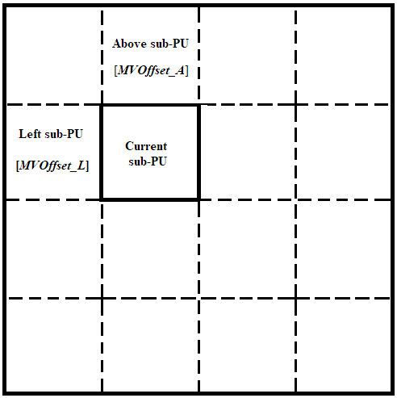
Figure 2 - DMVR processing sub-PUs

Experimental Results
The proposed method was implemented based on VTM-6.0. Since DMVR is only available in Random Access configuration, simulations were conducted on RA following JVET common test conditions. VTM-6.0 was used as anchor.
As shown in Table 3.1, it was observed that the BD-rate change of proposed method is 0.03% on RA, compared with VTM-6.0 anchor.
DMVR processing time is also measured for both VTM-6.0 anchor and the proposed method. It was observed that the proposed method reduced DMVR processing time by 4% compared with VTM-6.0.
Table 3.1 Simulation Results of Method 1
 |  |  | RA
 |  |  | Over VTM-6.0
 | Y | U | V | EncT | DecT | DMVR Time
Class A1 | 0.04% | 0.03% | 0.02% | 100% | 99% | 98%
Class A2 | 0.04% | 0.08% | 0.10% | 100% | 100% | 98%
Class B | 0.03% | 0.09% | 0.07% | 100% | 100% | 97%
Class C | 0.02% | 0.06% | 0.00% | 100% | 100% | 93%
Class E
Overall | 0.03% | 0.07% | 0.05% | 100% | 100% | 96%
Class D | 0.06% | 0.06% | 0.01% | 100% | 100% | 98%
Class F | 0.03% | 0.06% | 0.02% | 100% | 100% | 96%

Conclusion
It was observed that the proposed method has BD-rate change of 0.03% on RA configuration, and DMVR processing time is reduced by 4%.

Reference
- F. Bossen, J. Boyce, X. Li, V. Seregin, K. Sühring, “JVET common test conditions and software reference configurations,” Document of Joint Video Experts Team (JVET), JVET-N1010 Marrakech, MA, Mar 2019.
- https://vcgit.hhi.fraunhofer.de/jvet/VVCSoftware_VTM/tree/VTM-6.0

Patent rights declaration(s)
Tencent may have current or pending patent rights relating to the technology described in this contribution and, conditioned on reciprocity, is prepared to grant licenses under reasonable and non-discriminatory terms as necessary for implementation of the resulting ITU-T Recommendation | ISO/IEC International Standard (per box 2 of the ITU-T/ITU-R/ISO/IEC patent statement and licensing declaration form).

