    Joint Video Experts Team (JVET)  of ITU-T SG 16 WP 3 and ISO/IEC JTC 1/SC 29/WG 11  16th Meeting: Geneva, CH, 1–11 October 2019 | Document: JVET-P0442

Title: | Non-CE4: Unified AMVR signaling
Status: | Input document to JVET
Purpose: | Proposal
Author(s) or  Contact(s): | Guichun Li, XiangLi, Xiaozhong Xu, Shan Liu  2747 Park Boulevard,  Palo Alto, CA 94306, U.S.A. | Tel:  Email: | +1-650-798-3300  guichunli@tencent.com
Source: | Tencent
_____________________________

Abstract
In this contribution, 2 methods on the signaling of adaptive motion vector resolution (AMVR) are proposed. 1) Unified AMVR on/off signaling for normal AMVP mode, affine AMVP mode, and IBC mode; 2) Method 1 with context reduction. The proposed methods were implemented on top of VTM-6.0, and simulations were conducted with common test conditions. It is reported that the proposed methods have overall BD-rate changes as listed below:
- AI 0.00%, Enc 100%, Dec 100%; RA 0.00%, Enc 100%, Dec 100%; LB -0.02%, Enc 100%, Dec 98%;
- AI 0.00%, Enc 98%, Dec 101%; RA 0.02%, Enc 98%, Dec 98%; LB -0.02%, Enc 98%, Dec 95%.

Introduction
In current VVC working draft, a CU-level adaptive motion vector resolution (AMVR) scheme is used. AMVR allows MVD of the CU to be coded in different precision. Dependent on the mode (normal AMVP mode or affine AMVP mode) for the current CU, the MVDs of the current CU can be adaptively selected.
In current AMVR signaling design, the AMVR flag is used to indicate whether AMVR is enabled for normal AMVP mode and affine AMVP mode. If AMVR flag is true, precision bins are further signaled to indicate which precision is going to be used for normal AMVP or Affine AMVP. But in IBC mode, the precision bin indicating 1-pel/4-pel precision for normal AMVR is used to signal whether AMVR for IBC is enabled or not. The signaling process is shown in the diagram in Figure 1.
As shown in the diagram, contexts used for AMVR for normal AMVP mode and affine AMVP mode are different.
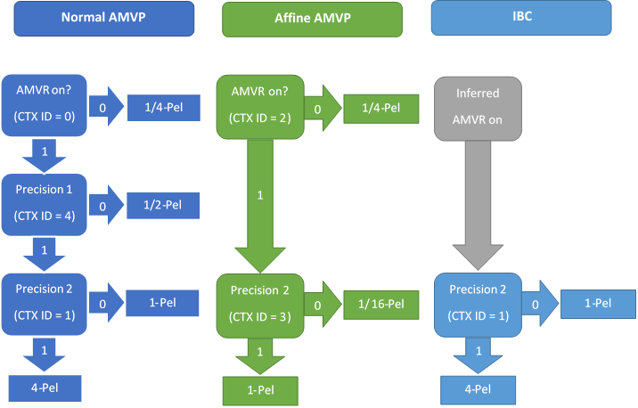
Figure 1- Signaling diagram of AMVR

Proposed Method
Two methods are proposed to unify the signaling of AMVR for normal AMVP, affine AMVP, and IBC modes.

Unified AMVR on/off flag
In the first proposed method, the signaling of the AMVR flag is unified. The IBC mode would use the same AMVR flag bin and same context as AMVR for normal AMVP mode. Diagram is shown in Figure 2.
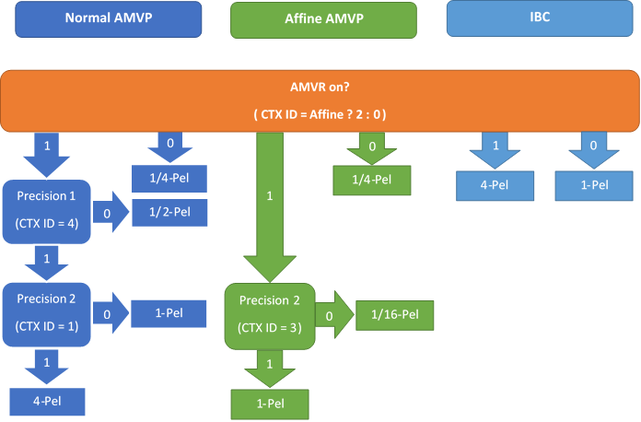
Figure 2 - Signaling diagram of Method 1

Unified AMVR on/off flag and reduced context
In addition to unifying the AMVR on/off flag, the context used for AMVR flag for normal AMVP mode and affine AMVP mode is also unified, so that one less context is needed for signaling AMVR. Diagram of the signaling method is shown in Figure 3.
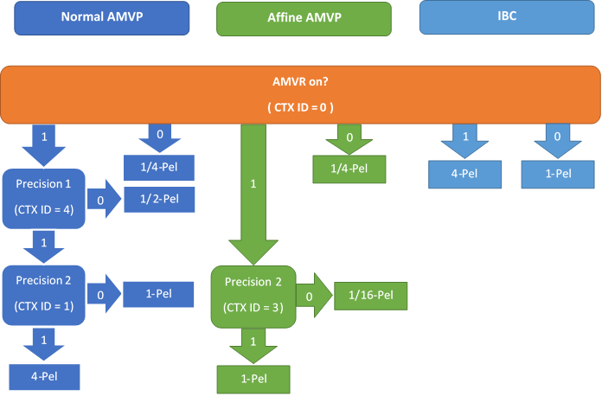
Figure 3 - Signaling Diagram of Method 2

Experimental Results
The proposed methods were implemented based on VTM-6.0. Simulations were conducted following JVET common test conditions. VTM-6.0 was used as anchor. Since the modification affects IBC mode, sequences of TGM class were also tested.

Results of Method 1
As shown in Table 3.1, it was observed that when using proposed method 1, there’s no BD-rate change on AI, and 0.00% on RA, and -0.02% on LB, compared with VTM-6.0 anchor. And on TGM class, there’s BD-rage change of -0.01% on RA, and -0.02% on LB.
Table 3.1 Simulation Results of Method 1
 |  |  | All Intra Main10
 |  |  | Over VTM-6.0
 | Y | U | V | EncT | DecT
Class A1 | 0.00% | 0.00% | 0.00% | 100% | 99%
Class A2 | 0.00% | 0.00% | 0.00% | 100% | 100%
Class B | 0.00% | 0.00% | 0.00% | 100% | 98%
Class C | 0.00% | 0.00% | 0.00% | 101% | 104%
Class E | 0.00% | 0.00% | 0.00% | 98% | 99%
Overall | 0.00% | 0.00% | 0.00% | 100% | 100%
Class D | 0.00% | 0.00% | 0.00% | 100% | 99%
Class F | 0.00% | 0.00% | 0.03% | 100% | 102%
Class TGM | 0.00% | 0.01% | 0.00% | 100% | 98%
 |  |  | Random access Main10
 |  |  | Over VTM-6.0
 | Y | U | V | EncT | DecT
Class A1 | 0.01% | 0.10% | -0.08% | 100% | 100%
Class A2 | 0.03% | 0.09% | 0.06% | 100% | 100%
Class B | -0.02% | 0.02% | 0.10% | 100% | 99%
Class C | -0.02% | 0.07% | -0.02% | 100% | 101%
Class E
Overall | 0.00% | 0.07% | 0.02% | 100% | 100%
Class D | -0.03% | 0.02% | -0.03% | 100% | 101%
Class F | 0.00% | 0.07% | 0.01% | 101% | 102%
Class TGM | -0.01% | -0.06% | -0.04% | 100% | 100%
 |  |  | Low delay B Main10
 |  |  | Over VTM-6.0
 | Y | U | V | EncT | DecT
Class A1
Class A2
Class B | 0.01% | 0.00% | 0.09% | 100% | 99%
Class C | -0.05% | 0.01% | -0.27% | 100% | 96%
Class E | -0.03% | 0.42% | 0.36% | 100% | 99%
Overall | -0.02% | 0.11% | 0.04% | 100% | 98%
Class D | 0.00% | -0.10% | 0.03% | 100% | 101%
Class F | -0.04% | -0.11% | 0.70% | 100% | 97%
Class TGM | -0.09% | -0.09% | -0.07% | 99% | 93%

Results of Method 2
As shown in Table 3.2, it was observed that when using proposed method 2, there’s no BD-rate change on AI, and 0.02% on RA, and -0.02% on LB, compared with VTM-6.0 anchor. And on TGM class, there’s BD-rage change of -0.02% on RA, and -0.09% on LB.
Table 3.2 Simulation Results of Method 2
 |  |  | All Intra Main10
 |  |  | Over VTM-6.0
 | Y | U | V | EncT | DecT
Class A1 | 0.00% | 0.00% | 0.00% | 98% | 101%
Class A2 | 0.00% | 0.00% | 0.00% | 97% | 100%
Class B | 0.00% | 0.00% | 0.00% | 98% | 101%
Class C | 0.00% | 0.00% | 0.00% | 98% | 102%
Class E | 0.00% | 0.00% | 0.00% | 98% | 102%
Overall | 0.00% | 0.00% | 0.00% | 98% | 101%
Class D | 0.00% | 0.00% | 0.00% | 98% | 102%
Class F | 0.00% | 0.00% | 0.03% | 100% | 98%
Class TGM | 0.00% | 0.01% | 0.00% | 98% | 94%
 |  |  | Random access Main10
 |  |  | Over VTM-6.0
 | Y | U | V | EncT | DecT
Class A1 | 0.01% | -0.06% | 0.01% | 98% | 99%
Class A2 | 0.06% | 0.10% | 0.07% | 98% | 99%
Class B | 0.02% | 0.07% | 0.00% | 98% | 97%
Class C | 0.00% | -0.02% | -0.07% | 99% | 98%
Class E
Overall | 0.02% | 0.03% | -0.01% | 98% | 98%
Class D | -0.04% | -0.07% | -0.02% | 99% | 100%
Class F | 0.00% | 0.08% | 0.03% | 100% | 100%
Class TGM | -0.02% | -0.07% | -0.03% | 100% | 101%
 |  |  | Low delay B Main10
 |  |  | Over VTM-6.0
 | Y | U | V | EncT | DecT
Class A1
Class A2
Class B | 0.01% | 0.00% | 0.09% | 98% | 97%
Class C | -0.05% | 0.01% | -0.27% | 98% | 91%
Class E | -0.03% | 0.42% | 0.36% | 99% | 97%
Overall | -0.02% | 0.11% | 0.04% | 98% | 95%
Class D | 0.00% | -0.10% | 0.03% | 98% | 93%
Class F | -0.04% | -0.11% | 0.70% | 100% | 100%
Class TGM | -0.09% | -0.09% | -0.07% | 100% | 99%

Conclusion
It was observed that the proposed method 1 has BD-rate change of 0.00% on AI, 0.00% on RA and -0.02% on LB; the proposed method 2 has BD-rate change of 0.00% on AI, 0.02% on RA and -0.02% on LB.

Reference
- F. Bossen, J. Boyce, X. Li, V. Seregin, K. Sühring, “JVET common test conditions and software reference configurations,” Document of Joint Video Experts Team (JVET), JVET-N1010 Marrakech, MA, Mar 2019.
- https://vcgit.hhi.fraunhofer.de/jvet/VVCSoftware_VTM/tree/VTM-6.0

Patent rights declaration(s)
Tencent may have current or pending patent rights relating to the technology described in this contribution and, conditioned on reciprocity, is prepared to grant licenses under reasonable and non-discriminatory terms as necessary for implementation of the resulting ITU-T Recommendation | ISO/IEC International Standard (per box 2 of the ITU-T/ITU-R/ISO/IEC patent statement and licensing declaration form).

