    Joint Video Experts Team (JVET)  of ITU-T SG 16 WP 3 and ISO/IEC JTC 1/SC 29/WG 11  16th Meeting: Geneva, CH, 1–11 October 2019 | Document: JVET-P0409-v3

Title: | CE1-related: Enable PROF for RPR
Status: | Input document to JVET
Purpose: | Proposal
Author(s) or  Contact(s): | Name(s)  Jie Chen  Ru-ling Liao  Jiancong Luo  Yan Ye | Tel:  Email: | jiechen.cj@alibaba-inc.com
Source: | Alibaba Group Inc.
_____________________________

Abstract
At the 15th JVET meeting in Gothenburg, reference picture resampling (RPR) (JVET-O1164) is adopted to support adaptive resolution change (ARC) in VVC. Since the existing process of prediction refinement with optical flow (PROF) does not support the case when the reference picture is of different spatial resolution with the current picture, PROF is disabled for this case in VTM-6.1. In this contribution, two alternative methods are proposed to enable PROF to support RPR.
It is reported that by enabling RPOF in CE1 anchor with the proposed method 1 and method 2, the coding performance is:
Method 1 & 3
2:1 ratio: {-0.09%, -0.05%, -0.15%} for PSNR1 and {-0.07%, -0.04%, -0.11%} for PSNR2
1.5:1 ratio: {-0.04%, 0.20 %, 0.01%} for PSNR1 and {-0.02%, 0.17%, 0.00%} for PSNR2
Method 2
2:1 ratio: {-0.11%, -0.07%, -0.09%} for PSNR1 and {-0.08%, -0.08%, -0.07%} for PSNR2
1.5:1 ratio: {-0.05%, 0.19%, 0.16%} for PSNR1 and {-0.02%, 0.14%, 0.17%} for PSNR2
In a 2nd version, full results are provided.
In a 3rd version, method 3 is provided.

Introduction
Subblock based affine motion compensation can save memory access bandwidth and reduce computation complexity compared to pixel based motion compensation, at the cost of prediction accuracy penalty. To achieve a finer granularity of motion compensation, prediction refinement with optical flow (PROF) is used to refine the subblock based affine motion compensated prediction without increasing the memory access bandwidth for motion compensation. After the subblock based affine motion compensation is performed, luma prediction sample is refined by adding a difference derived by the optical flow equation. The PROF is described as following four steps.
Step 1) The subblock-based affine motion compensation is performed to generate subblock prediction.
Step2) The spatial gradients of the subblock prediction are calculated at each sample location using a 3-tap filter [-1, 0, 1]. The subblock (i.e. 4x4) prediction is extended by one sample on each side for the gradient calculation. To avoid additional memory bandwidth and additional interpolation computation, those extended samples on the extended borders are copied from the nearest integer pixel position in the reference picture.
Step 3) The luma prediction refinement is calculated by the gradient calculated in step 2) and the difference between sample MV computed for sample location and the subblock MV of the subblock to which sample belongs.
Step 4) Finally, the luma prediction refinement calculated in step 3) is added to the subblock prediction which is obtained in step 1)
For the non-RPR case in which the reference picture has the same resolution as the current picture, extending one sample on the boundary of the prediction block is equivalent to extend one sample on the boundary of reference sample block. However, when the reference picture and current picture have different spatial resolutions, the positions of the extended samples in the reference picture needs to be calculated based on the resampling ratio. But the resampling ratio is not considered in the PROF in VVC draft 6. Therefore, in VTM 6.1 PROF is disabled when the reference picture resolution is different from the current picture resolution.

Proposed method
This contribution proposes two methods to generate the extended samples when reference picture and current picture have different spatial resolution, so that in such case RPOF can be enabled.

Proposed method 1
In the first method, we follow the current PROF design that use the nearest integer reference sample as the extended prediction sample to calculate the prediction gradient.
The prediction block is extended one sample on each side of the prediction boundary. The position of the extended sample in the reference picture is calculated by considering the reference resampling ratio, and rounded to the nearest integer. However, when the reference resampling ratio is big, the integer position in the reference picture may be located out of the area required for prediction block interpolation. To avoid accessing additional reference samples, which may increase the memory access bandwidth, the integer position in the reference picture is clipped to the area required for prediction block interpolation. And finally, the reference sample at the clipped integer position is used as the extended prediction sample to calculate the gradient of prediction block.
Figure 1 gives an example of method 1 in which the resampling ratio is 4:1. In Figure 1, the solid circles are the prediction samples and the squares are the integer reference samples. First, extend the prediction block as dotted circles and then get the nearest integer samples which are indicated with shaded squares. Finally, the nearest integer position are clipped within the reference sample area indicated by box. And the reference sample in clipped integer position is used as the extended prediction sample for gradient calculation.

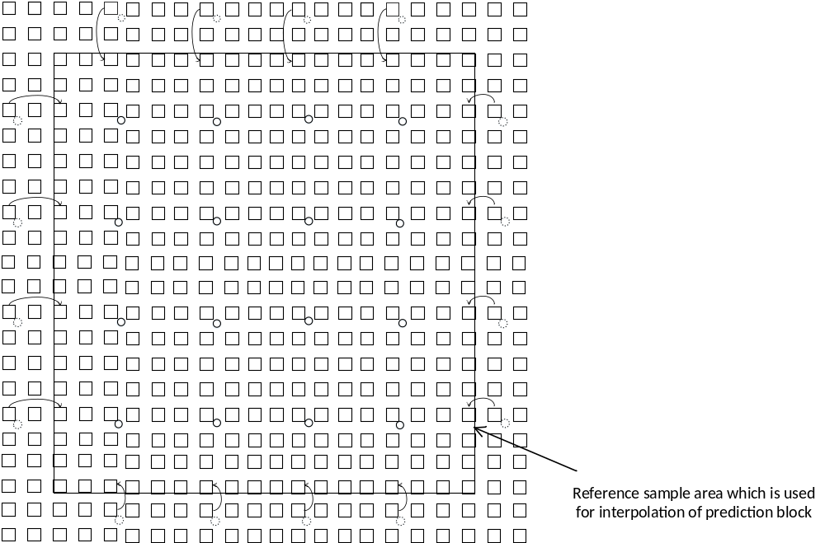
Figure 1 example of method 1

Proposed method 2
In the method 2, the extended prediction sample is copied from the adjacent prediction samples on the prediction block boundary. This method avoids the calculate of the extended sample position and the needs of clipping.
Figure 2 gives an example of method 2 in which the reference resampling ratio is 4:1. In Figure 2, the solid circles indicated by a[0], a[1], a[2] and a[3] are the prediction samples (take 2x2 prediction block as an example) and the squares are the integer reference samples. The dotted circles are the extended samples whose values are copied from the prediction boundary samples. That is, e = a[0], d = a[1], e = a[0], f = a[2]. And then the extended dotted samples are used for to calculate the gradient of predictions.
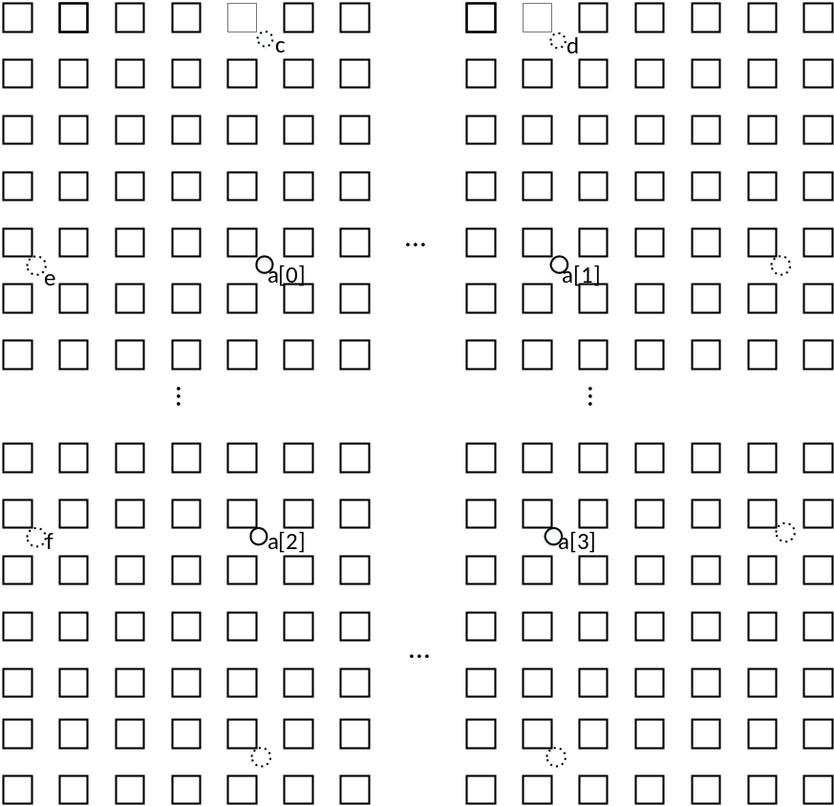
Figure 2 an example of method 2

Proposed method 3
In the method 3, in order to keep the design consistent with PROF in non-RPR case and not increase memory bandwidth at the same time, PROF can only be enabled when the resampling ratio (both of two dimension ratios) is less than or equal to 2. In this case, the nearest integer reference samples to the extended prediction samples are guaranteed to be within the reference sample area which are used for prediction block interpolation, so no clipping operation is needed. If the resampling ratio is larger than 2, PROF is not allowed.

Simulation results
With the proposed method 1 and 2, PROF is enabled on top of VTM-6.1 with the patch for CE1 applied. Test condition described in JVET-O2021 is used in the simulation. The anchor for comparison is CE1 anchor. Both results of PSNR1 (codec PSNR measured between the input of encoder and output of decoder at coding resolution by calculating MSE for each picture, accumulating MSEs for all pictures and calculating average PSNR from the accumulated MSE) and PSNR2 (end-to-end PSNR measured between the original video source and the up-sampled (if needed) decoded pictures using the existing VTM interpolation filters) are reported. The simulation results are shown in Table 1-8.

Performance of method 1 & 3
under the test condition of CE1, clipping operation of method 1 actually won’t affect the results. Thus, method 1 and method 3 have the same results under CE1 test condition.
- 2:1 ratio
Table 1: Simulation results of PSNR1 for down-sample ratio 2:1
 |  |  | Low delay B Main10
 |  |  | Over CE1 anchor
 | Y | U | V | EncT | DecT
Class A1 | - | - | - | - | -
Class A2 | - | - | - | - | -
Class B | -0.07% | 0.21% | 0.07% | 101% | 101%
Class C | -0.15% | -0.17% | -0.07% | 100% | 100%
Class E | -0.04% | -0.32% | -0.62% | 101% | 100%
Overall | -0.09% | -0.05% | -0.15% | 100% | 100%
Class D | -0.02% | -0.28% | -0.40% | 100% | 101%
Class F | -0.28% | -0.14% | -0.27% | 100% | 100%

Table 2 Simulation results of PSNR2 for down-sample ratio 2:1
 |  |  | Low delay B Main10
 |  |  | Over CE1 anchor
 | Y | U | V | EncT | DecT
Class A1 | - | - | - | - | -
Class A2 | - | - | - | - | -
Class B | -0.09% | 0.17% | 0.09% | 101% | 101%
Class C | -0.10% | -0.18% | 0.07% | 100% | 100%
Class E | 0.02% | -0.19% | -0.70% | 101% | 100%
Overall | -0.07% | -0.04% | -0.11% | 100% | 100%
Class D | -0.03% | -0.22% | -0.39% | 100% | 101%
Class F | -0.21% | -0.21% | -0.15% | 100% | 100%

- 1.5:1 ratio
Table 3 Simulation results of PSNR1 for down-sample ratio 1.5:1
 |  |  | Low delay B Main10
 |  |  | Over CE1 anchor
 | Y | U | V | EncT | DecT
Class A1 | - | - | - | - | -
Class A2 | - | - | - | - | -
Class B | -0.07% | 0.09% | -0.20% | 101% | 101%
Class C | 0.01% | -0.16% | -0.22% | 100% | 100%
Class E | -0.05% | 0.84% | 0.67% | 101% | 100%
Overall | -0.04% | 0.20% | 0.01% | 100% | 100%
Class D | 0.02% | 0.48% | -0.02% | 101% | 100%
Class F | -0.35% | -0.32% | -0.62% | 101% | 100%

Table 4 Simulation results of PSNR2 for down-sample ratio 1.5:1
 |  |  | Low delay B Main10
 |  |  | Over CE1 anchor
 | Y | U | V | EncT | DecT
Class A1 | - | - | - | - | -
Class A2 | - | - | - | - | -
Class B | -0.07% | 0.14% | -0.17% | 101% | 101%
Class C | -0.02% | -0.28% | -0.26% | 100% | 100%
Class E | 0.07% | 0.82% | 0.64% | 101% | 100%
Overall | -0.02% | 0.17% | 0.00% | 100% | 100%
Class D | 0.02% | 0.62% | -0.12% | 101% | 100%
Class F | -0.26% | -0.25% | -0.53% | 101% | 100%

Performance of method 2
- 2:1 ratio

Table 5: Simulation results of PSNR1 for down-sample ratio 2:1
 |  |  | Low delay B Main10
 |  |  | Over CE1 anchor
 | Y | U | V | EncT | DecT
Class A1 | - | - | - | - | -
Class A2 | - | - | - | - | -
Class B | -0.04% | 0.19% | 0.17% | 101% | 101%
Class C | -0.11% | -0.14% | 0.00% | 100% | 100%
Class E | -0.20% | -0.42% | -0.66% | 101% | 101%
Overall | -0.11% | -0.07% | -0.09% | 101% | 100%
Class D | 0.01% | 0.33% | -0.30% | 101% | 100%
Class F | 0.00% | 0.29% | 0.32% | 100% | 99%

Table 6 Simulation results of PSNR2 for down-sample ratio 2:1
 |  |  | Low delay B Main10
 |  |  | Over CE1 anchor
 | Y | U | V | EncT | DecT
Class A1 | - | - | - | - | -
Class A2 | - | - | - | - | -
Class B | -0.05% | 0.14% | 0.23% | 101% | 101%
Class C | -0.07% | -0.08% | -0.01% | 100% | 100%
Class E | -0.12% | -0.46% | -0.66% | 101% | 101%
Overall | -0.08% | -0.08% | -0.07% | 101% | 100%
Class D | 0.03% | 0.30% | -0.37% | 101% | 100%
Class F | 0.01% | 0.13% | 0.21% | 100% | 99%

- 1.5:1 ratio
Table 7 Simulation results of PSNR1 for down-sample ratio 1.5:1
 |  |  | Low delay B Main10
 |  |  | Over CE1 anchor
 | Y | U | V | EncT | DecT
Class A1 | - | - | - | - | -
Class A2 | - | - | - | - | -
Class B | -0.04% | 0.20% | 0.20% | 101% | 101%
Class C | -0.01% | -0.09% | -0.12% | 101% | 101%
Class E | -0.11% | 0.56% | 0.47% | 101% | 100%
Overall | -0.05% | 0.19% | 0.16% | 101% | 100%
Class D | 0.03% | 0.44% | 0.46% | 100% | 101%
Class F | 0.31% | 0.19% | 0.35% | 101% | 99%

Table 8 Simulation results of PSNR2 for down-sample ratio 1.5:1
 |  |  | Low delay B Main10
 |  |  | Over CE1 anchor
 | Y | U | V | EncT | DecT
Class A1 | - | - | - | - | -
Class A2 | - | - | - | - | -
Class B | -0.05% | 0.23% | 0.26% | 101% | 101%
Class C | -0.04% | -0.20% | -0.10% | 101% | 101%
Class E | 0.04% | 0.44% | 0.38% | 101% | 100%
Overall | -0.02% | 0.14% | 0.17% | 101% | 100%
Class D | 0.01% | 0.52% | 0.39% | 100% | 101%
Class F | 0.35% | 0.08% | 0.54% | 101% | 99%

Conclusion
In order to enable PROF when reference picture and current picture have different spatial resolutions, two methods are proposed in this contribution. Method 1 is directly extending the current PROF method, but additional scaling and clipping operations are required. Method 2 gives a simpler way to extend the prediction block by padding. And in method 3 no additional clipping operation is required which is the simplest method in the contribution. According to the test results, method 1 & 3 achieve {-0.09%, -0.05%, -0.15%} for PSNR1 and {-0.07%, -0.04%, -0.11%} for PSNR2 in 2:1 ratio and {-0.04%, -0.20 %, -0.01%} for PSNR1 and {-0.02%, 0.17 %, 0.00%} for PSNR2 in 1.5 :1 ratio. Method 2 achieves {-0.11%, -0.07%, -0.09%} for PSNR1 and {-0.08%, -0.08%, -0.07%} for PSNR2 in 2:1 ratio and {-0.05%, 0.19%, 0.16%} for PSNR1 and {-0.02%, 0.14%, 0.17%} for PSNR2 in 1.5:1 ratio.
It is suggested to adopt one of the proposed methods in this contribution in next version of VVC draft.

References
[1] M. G. Sarwer, R. -L Liao, J. Chen, J. Luo, Y. Ye, “AHG 8: JVET Common test conditions for adaptive resolution change (ARC)”, JVET-O0641, JVET 15th Meeting: Gothenburg, SE, 3–12 July 2019
[2] VVC reference software (VTM) version 6.1, available at: https://vcgit.hhi.fraunhofer.de/jvet/VVCSoftware_VTM

Patent rights declaration(s)
Alibaba Group Inc. may have current or pending patent rights relating to the technology described in this contribution and, conditioned on reciprocity, is prepared to grant licenses under reasonable and non-discriminatory terms as necessary for implementation of the resulting ITU-T Recommendation | ISO/IEC International Standard (per box 2 of the ITU-T/ITU-R/ISO/IEC patent statement and licensing declaration form).

