    Joint Video Experts Team (JVET)  of ITU-T SG 16 WP 3 and ISO/IEC JTC 1/SC 29/WG 11  16th Meeting: Geneva, CH, 1–11 October 2019 | Document: JVET-P0328

Title: | AHG10: Performance of the GOP-based temporal filter in VTM-6.1
Status: | Input document to JVET
Purpose: | Information
Author(s) or  Contact(s): | J. Enhorn  R. Sjöberg  J. Ström  P. Wennersten | Email: | jack.enhorn@ericsson.com rickard.sjoberg@ericsson.com  jacob.strom@ericsson.com  per.wennersten@ericsson.com
Source: | Ericsson
_____________________________

Abstract
The encoder-only GOP-based temporal filter proposed in JVET-O0549 was adopted in the previous meeting in Gothenburg. This contribution provides performance numbers by enabling the filter on top of VTM-6.1. The average Y/U/V BD-rates for the common test conditions (CTC) for the filter on top of VTM-6.1 are reported to be −3.91%/−6.63%/−6.56% (RA), −0.96%/−1.30%/−2.18% (LDB) and −1.48%/−1.61%/−2.23% (LDP). This can be compared to the numbers compared in JVET-O0549-v2: −3.49%/−6.96%/−6.53% (RA), −1.00%/−1.24%/−2.24% (LDB) and −1.47%/−1.95%/−2.78% (LDP).
The proponents are willing to arrange a subjective viewing at the meeting.

Background
The encoder-only GOP-based temporal filter proposed in JVET-O0549 was adopted in the previous meeting in Gothenburg. Filtering is applied to every 8th picture for random access coding and every 4th picture for low delay coding. The filter is not applied to all intra coding and therefore that test case is omitted from the results.
The overall filter strength, s_{0,} is set according to the equation below for RA:

if (POC % 16 == 0)
s₀ = 1.5
else if (POC % 8 == 0)
s₀ = 0.95
For the LD case, s₀ = 0.40
The temporal filter process includes a hierarchical motion estimation scheme to produce motion compensated reference pictures. Two reference pictures that precede the current picture in output order and additionally, for random access, two pictures that follow the current picture in output order are motion compensated relative to the current picture. A bilateral filter is then applied to calculate the resulting filtered samples. The weights in the bilateral filter depend on the temporal sample difference and on the QP value. The filtered pictures are used for encoding and the original unfiltered pictures are used for BD-rate calculations.

Subjective performance
When source sequences containing noise are encoded with VTM-6.1, we have found that the amount of noise in the low QP pictures is higher than the amount of noise in the temporally neighboring pictures. The cause of that may be the QP difference and that bi-prediction in combination with rate-distortion optimization using SSD as the error metric favors smoother reconstructed blocks. The high frequency noise elements in a source block are expensive to code, and the reduction in SSD by coding them often do not justify the bit cost. This can cause a temporal flickering effect where the amount of noise varies between pictures. This is thus a type of “intra pulsing”.
By enabling the GOP-based temporal filter, the source pictures that are encoded using low QP are filtered which results in less noise after decoding. This makes them more consistent with the neighboring pictures.
The screen shots below illustrate this temporal effect.

VTM-6.1 anchor BQTerrace QP 22
POC 511 – QP 29 | POC 512 – QP 19 | POC 513 – QP 29
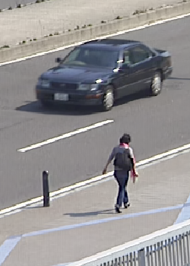 | 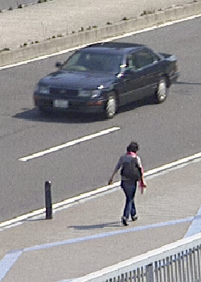 | 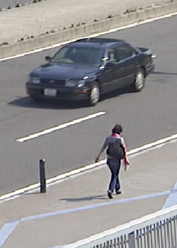

VTM-6.1 Temporal filter BQTerrace QP 22
POC 511 – QP 29 | POC 512 – QP 19 | POC 513 – QP 29
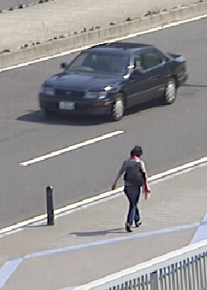 | 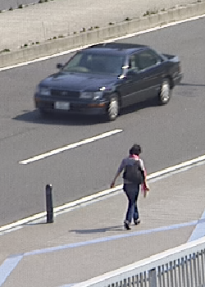 | 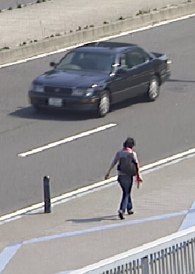

VTM-6.1 anchor Cactus QP 22
POC 191 – QP 29 | POC 192 – QP 19 | POC 193 – QP 29
 |  | 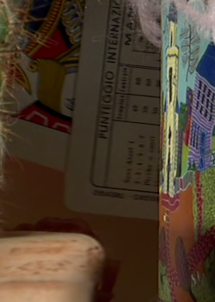

VTM-6.1 Temporal filter Cactus QP 22
POC 191 – QP 29 | POC 192 – QP 19 | POC 193 – QP 29
 |  | 

The examples were taken from random access coded BQTerrace and Cactus sequence at QP 22, cropped at same location in consecutive frames. The middle frames POC 512 and POC 192 respectively are intra pictures and the neighboring pictures are B-pictures resulting in the largest QP and noise differences. The noise differences perceived as “intra pulsing” are greatly reduced with the temporal filter.
The proponents wish to arrange subjective viewing at the meeting to further demonstrate and discuss the results.

BD-rate performance
The temporal filter was implemented in VTM-6.1 and compared according to the CTC against the VTM-6.1 anchor without modification. As seen, the benefit of the temporal filter remains over the VTM versions with a bit higher gain on random access in VTM-6.1 and similar gain on the two low delay configurations.

 | Random Access
 | Over VTM-6.1
 | Y | U | V | EncT | DecT
Class A1 | -2,34% | -6,12% | -4,71% | 93% | 93%
Class A2 | -5,04% | -9,41% | -9,62% | 92% | 98%
Class B | -5,86% | -7,86% | -8,22% | 94% | 95%
Class C | -1,82% | -3,38% | -3,57% | 98% | 96%
Class E
Overall | -3,91% | -6,63% | -6,56% | 94% | 95%
Class D | 0,27% | -3,69% | -3,44% | 99% | 97%
Class F | -0,21% | -0,72% | -0,92% | 107% | 100%

 | Low delay B
 | Over VTM-6.1
 | Y | U | V | EncT | DecT
Class A1
Class A2
Class B | -1,35% | -1,54% | -3,03% | 95% | 95%
Class C | 0,05% | -0,11% | -0,50% | 97% | 96%
Class E | -1,66% | -2,50% | -3,00% | 95% | 94%
Overall | -0,96% | -1,30% | -2,18% | 96% | 95%
Class D | 0,66% | -0,44% | -0,46% | 98% | 93%
Class F | 0,27% | 0,75% | 1,35% | 104% | 105%

 | Low delay P
 | Over VTM-6.1
 | Y | U | V | EncT | DecT
Class A1
Class A2
Class B | -2,04% | -1,96% | -3,14% | 95% | 95%
Class C | -0,15% | -0,18% | -0,43% | 95% | 96%
Class E | -2,33% | -2,93% | -3,09% | 94% | 93%
Overall | -1,48% | -1,61% | -2,23% | 95% | 95%
Class D | 0,45% | -0,17% | -0,57% | 96% | 93%
Class F | 0,23% | 0,32% | 0,45% | 97% | 96%

For comparison the following are the BD-rate results in VTM-5.0 as presented in document JVET-O0549.

 | Random access from JVET-O0549-v2
 | Over VTM-5.0
 | Y | U | V | EncT | DecT
Class A1 | -1.93% | -6.65% | -4.20% | 93% | 99%
Class A2 | -4.84% | -11.53% | -11.00% | 91% | 94%
Class B | -5.68% | -8.26% | -8.63% | 95% | 100%
Class C | -0.89% | -2.16% | -2.33% | 101% | 98%
Class E
Overall | -3.49% | -6.96% | -6.53% | 95% | 98%
Class D | -0.56% | -2.34% | -2.46% | 100% | 103%
Class F | -0.23% | -1.05% | -0.96% | 106% | 99%

 | Low delay B from JVET-O0549-v2
 | Over VTM-5.0
 | Y | U | V | EncT | DecT
Class A1
Class A2
Class B | -1.45% | -1.57% | -3.24% | 99% | 96%
Class C | 0.13% | 0.28% | -0.17% | 102% | 101%
Class E | -1.76% | -2.70% | -3.32% | 97% | 100%
Overall | -1.00% | -1.24% | -2.24% | 99% | 99%
Class D | 0.63% | -0.31% | -0.04% | 101% | 101%
Class F | 0.26% | 0.51% | 0.65% | 102% | 98%

 | Low delay P from JVET-O0549-v2
 | Over VTM-5.0
 | Y | U | V | EncT | DecT
Class A1
Class A2
Class B | -2.10% | -2.29% | -3.84% | 99% | 101%
Class C | -0.04% | -0.09% | 0.01% | 101% | 102%
Class E | -2.34% | -3.85% | -4.73% | 102% | 107%
Overall | -1.47% | -1.95% | -2.78% | 101% | 103%
Class D | 0.59% | -0.53% | -0.66% | 105% | 104%
Class F | 0.26% | 1.97% | 0.84% | 103% | 102%

Patent rights declaration(s)
Ericsson may have current or pending patent rights relating to the technology described in this contribution and, conditioned on reciprocity, is prepared to grant licenses under reasonable and non-discriminatory terms as necessary for implementation of the resulting ITU-T Recommendation | ISO/IEC International Standard (per box 2 of the ITU-T/ITU-R/ISO/IEC patent statement and licensing declaration form).

