    Joint Video Experts Team (JVET)  of ITU-T SG 16 WP 3 and ISO/IEC JTC 1/SC 29/WG 11  16th Meeting: Geneva, CH, 1–11 October 2019 | Document: JVET-P0067-v4

Title: | CE7-3.3: Context reduction for sig_coeff_flag, par_level_flag, abs_level_gtx_flag
Status: | Input document to JVET
Purpose: | Proposal
Author(s) or  Contact(s): | Y. Chen, F. Le Léannec,  T. Poirier, F.Galpin  Shih-Ta Hsiang, Tzu-Der Chuang,  Yu-Wen Huang, Shaw-Min Lei | Tel:  Email: | +33(0)256856325  +886-3-5670766  ya.chen@interdigital.com  {shih-ta.hsiang, peter.chuang, yuwen.huang, shawmin.lei}  @mediatek.com
Source: | InterDigital, MediaTek Inc.
_____________________________

Abstract
This contribution reports the results of CE7-3.3 for reducing the number of context variables for entropy coding the syntax elements sig_coeff_flag, par_level_flag and abs_level_gtx_flag. In the proposed tests, which are the combinations between CE7-3.1 and CE7-3.2, 1) the numbers of the context variables of the context subsets for entropy coding sig_coeff_flag associated with dependent quantization states 2 and 3 are further reduced; 2) the usage of the local neighborhood for the context derivation for syntax elements par_level_flag and abs_level_gtx_flag in some regions of the chroma transform blocks (TB) is removed. In CE7-3.3a, the proposed method reportedly provides 0.01%, -0.01%, and -0.06% luma BD-rates for the AI, RA, and LDB settings with the CABAC initial values retraining, respectively, versus the VTM6.0 anchor under the common test conditions (CTCs) while achieving 36 contexts reduction. In CE7-3.3b, the proposed method reportedly provides 0.02%, 0.00%, and -0.01% luma BD-rates for the AI, RA, and LDB settings with the CABAC initial values retraining, respectively, versus the VTM6.0 anchor under the common test conditions (CTCs) while achieving 42 contexts reduction.

Introduction
CABAC context modelling for regular coded bins sig_coeff_flag, par_level_flag and abs_level_gtx_flag is based on the sum of absolute values of partially reconstructed coefficients in a local neighborhood of current coefficient, as recalled here.
More precisely, the context for each regular coded bin is determined according to the following (JVET-K0072):
- significance flag (90 = 54 + 36 models): ctxIdSig = f( diag, sumAbs1, state )
- parity flag (32 = 21 + 11 models): ctxIdPar = f( diag, sumAbs1 − numSig, last )
- greaterx flag (32 = 21 + 11 models): ctxIdGtx = ctxIdPar
where:
- diag is defined as the diagonal index of the coefficient at position (x,y): diag=x+y
- sumAbs = sum of absolute values in local neighborhood (template)
- sumAbs1 = sum of partially reconstructed absolute levels after first pass
- numSig = number of transform coefficients with sig_coeff_flag == 1

In VTM-6.0, the total number of the context variables for entropy coding the syntax element sig_coeff_flag is significantly increased by allocating three separate sets of context variables for entropy coding transform coefficient levels corresponding to different dependent quantization states, indicated by the variable QState.
Besides, the local neighborhood is used for both luma and chroma transform blocks. In particular, the chroma TBs are divided into 2 regions, respectively corresponding to coefficients for which diag=0 and diag>0. In VTM-6.0, there are 96 contexts (63 for Luma and 33 for Chroma) for both the context model index for par_level_flag and abs_level_gtx_flag is listed in Table 1.

Table 1. The context model index of par_level_flag and abs_level_gtx_flag
Luma
Diagonal position | Context model index
d=0 | 16, 17,18, 19, 20
d<3 | 11, 12, 13, 14, 15
d<10 | 6, 7, 8, 9, 10
d>=10 | 1, 2, 3, 4, 5
Last non-zero coefficient | 0
Chroma
Diagonal position | Context model index
d=0 | 6, 7, 8, 9, 10
d>0 | 1, 2, 3, 4, 5
Last non-zero coefficient | 0

CE description
In the proposed tests, the number of the context variables in the context sets associated with dependent quantization states 2 and 3 are reduced. It is motivated by the observation that the context variables associated with locSumAbsPass1 > 0 in a context subset corresponding to the same transform block (TB) zone often exhibit similar probability distribution, where the variable locSumAbsPass1 is the sum of absolute values of partialy reconstructed coefficient levels from a local template.
In the proposed method, the number of the context variables is reduced to 2 from 4 for some context subsets. The 1st context variable is selected when the reconstructed variable locSumAbsPass1 is equal to 0. The 2nd context variable is selected, otherwise. Context reduction is applied to 6 context subsets in CE7-3.3a and to 9 context subsets in CE7-3.3b, respectively, as illustrated in Figure 1, where each luma block (in black) and each chroma block (in green) are divided into three zones and two zones, respectively, and separate context sets may be employed for different dependent qantization states (indicated by QState).

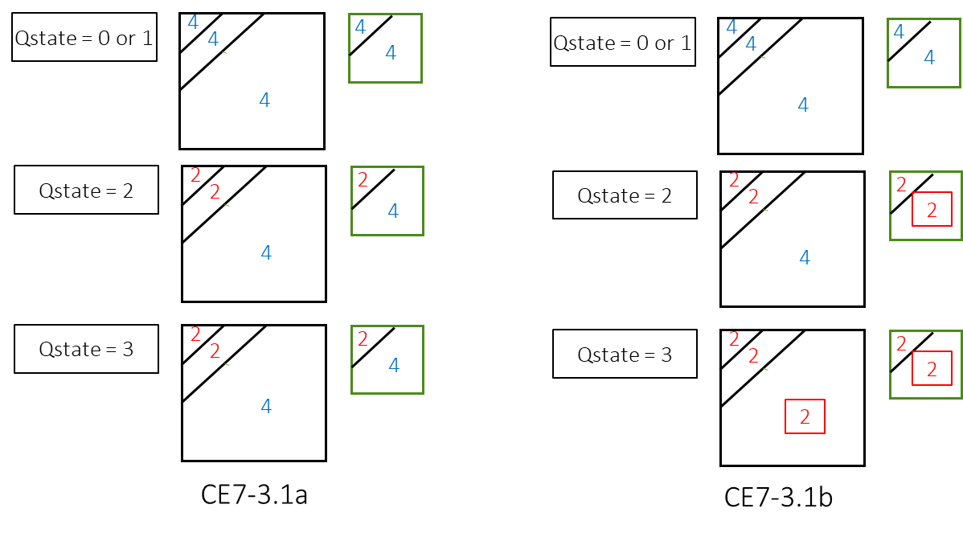
Figure 1: Illustration of the tests for context reduction for coding the syntax element sig_coeff_flag in a transform block, where the number of the context variables is reduced from 4 to 2 for some context subsets.

Moreover, in the proposed tests, the usage of the local neighbourhood for the context derivation for syntax elements par_level_flag and abs_level_gtx_flag in some regions of the chroma transform blocks (TB) is removed.
As shown in Table 2, the local neighborhoood is replaced by a single CABAC context for each of these bins, in each chroma TB region.

Table 2: proposed context model index of par_level_flag and abs_level_gtx_flag
Chroma
Diagonal position | Context model index
d=0 | 2
d>0 | 1
Last non-zero coefficient | 0

Therefore, the index of the contexts used for coding par_level_flag and abs_level_gtx_flag is determined as follows:
$$ctxInc = (diag = = 0 ? 1 : 0)$$
where diag is determined as follows based on the scan location $(xC,yC)$ of the considered coefficient:
$diag=xC+yC$ .
As a consequence, the sum of partially reconstructed coefficient in the local neighbourhood of current coefficient, denoted locSumAbsPass1 in VVC draft 6 specification, needs no more being computed for chroma TBs. Additionally, 24 contexts are removed compared to the VVC draft 6 specification with proposed method.
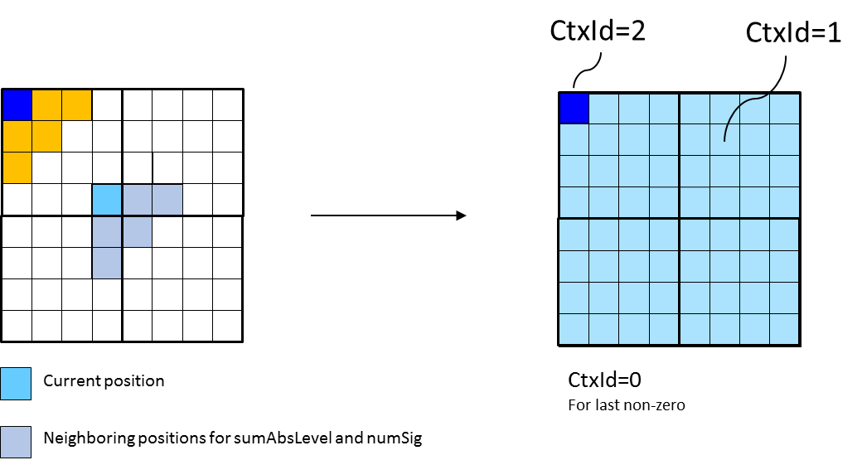
Figure 2: proposed modification in the context derivation for par_level_flag and abs_level_gtx_flag in chroma TBs, where 24 contexts are removed

Experimental results
The proposed method was integrated into the VTM6.0 reference software [4]. The coding results generated by the proposed method were evaluated against the anchor results generated by the unmodified VTM6.0 reference software under the CE7 test conditions [4]. Tables 1-4 summarize the experimental results for CE7-3.3a and CE7-3.3b, respectively, with the CABAC initial values retraining, conducted under the CTCs over standard QPs 22, 27, 32, and 37, and conducted over low QPs 2, 7, 12, and 17. Tables 5-8 summarize the experimental results for CE7-3.3a and CE7-3.3b, respectively, without the CABAC initial values retraining, conducted under the CTCs over standard QPs 22, 27, 32, and 37, and conducted over low QPs 2, 7, 12, and 17. Please note the run time results may not be accurate in the tables, and the complete results of some tests are still running. The detailed simulation results can be found in the attached spreadsheets.

Table 1: Summary of the average BD bitrate results for CE7-3.3a with the CABAC initial values retraining over standard QPs 22, 27, 32, and 37
 |  |  | All Intra Main10
 |  |  | Over VTM-6.0
 | Y | U | V | EncT | DecT
Class A1 | 0.01% | 0.23% | 0.28% | 101% | 103%
Class A2 | 0.05% | 0.25% | 0.31% | 102% | 105%
Class B | 0.00% | 0.21% | 0.20% | 102% | 103%
Class C | 0.01% | 0.12% | 0.32% | 100% | 99%
Class E | -0.01% | 0.35% | 0.28% | 99% | 93%
Overall | 0.01% | 0.22% | 0.27% | 101% | 101%
Class D | 0.00% | 0.22% | 0.28% | 100% | 91%
Class F | 0.02% | 0.09% | 0.15% | 98% | 93%
 |  |  | Random access Main10
 |  |  | Over VTM-6.0
 | Y | U | V | EncT | DecT
Class A1 | -0.04% | 0.15% | 0.26% | 102% | 103%
Class A2 | 0.03% | 0.27% | 0.25% | 101% | 105%
Class B | -0.02% | 0.38% | 0.35% | 96% | 98%
Class C | 0.00% | 0.45% | 0.51% | 108% | 109%
Class E
Overall | -0.01% | 0.33% | 0.36% | 101% | 103%
Class D | -0.04% | -0.08% | 0.36% | 107% | 105%
Class F | -0.02% | 0.21% | 0.20% | 107% | 106%
 |  |  | Low delay B Main10
 |  |  | Over VTM-6.0
 | Y | U | V | EncT | DecT
Class A1
Class A2
Class B | 0.01% | 0.54% | 0.08% | 105% | 112%
Class C | -0.04% | 0.50% | 0.16% | 98% | 96%
Class E | -0.20% | 0.43% | 0.08% | 98% | 92%
Overall | -0.06% | 0.50% | 0.11% | 101% | 101%
Class D | -0.03% | 1.08% | 0.56% | 99% | 94%
Class F | -0.07% | 0.08% | 0.61% | 101% | 105%

Table 2: Summary of the average BD bitrate results for CE7-3.3a with the CABAC initial values retraining over low QPs 2, 7, 12, and 17
 |  |  | All Intra Main10
 |  |  | Over VTM-6.0
 | Y | U | V | EncT | DecT
Class A1 | -0.02% | 0.80% | 0.77% | 98% | 99%
Class A2 | 0.15% | 0.65% | 0.60% | 100% | 104%
Class B | 0.07% | 0.55% | 0.65% | 100% | 102%
Class C | 0.12% | 0.44% | 0.46% | 104% | 104%
Class E | 0.06% | 0.63% | 0.70% | 102% | 104%
Overall | 0.08% | 0.60% | 0.63% | 101% | 103%
Class D | 0.12% | 0.46% | 0.44% | 103% | 103%
Class F | 0.16% | 0.56% | 0.55% | 98% | 98%
 |  |  | Random access Main10
 |  |  | Over VTM-6.0
 | Y | U | V | EncT | DecT
Class A1 | 0.01% | 0.29% | 0.27% | 107% | 103%
Class A2 | 0.06% | 0.29% | 0.23% | 109% | 105%
Class B | 0.02% | 0.28% | 0.24% | 102% | 104%
Class C | 0.01% | 0.36% | 0.34% | 100% | 99%
Class E
Overall | 0.02% | 0.31% | 0.27% | 104% | 103%
Class D | 0.00% | 0.47% | 0.38% | 102% | 103%
Class F | 0.10% | 0.42% | 0.53% | 99% | 96%
 |  |  | Low delay B Main10
 |  |  | Over VTM-6.0
 | Y | U | V | EncT | DecT
Class A1
Class A2
Class B | 0.01% | 0.26% | 0.19% | 95% | 94%
Class C | 0.02% | 0.28% | 0.22% | 95% | 92%
Class E | -0.02% | 0.30% | 0.21% | 93% | 91%
Overall | 0.01% | 0.28% | 0.21% | 94% | 93%
Class D | 0.00% | 0.40% | 0.30% | 94% | 88%
Class F | -0.06% | 0.39% | 0.26% | 90% | 87%

Table 3: Summary of the average BD bitrate results for CE7-3.3b with the CABAC initial values retraining over standard QPs 22, 27, 32, and 37
 |  |  | All Intra Main10
 |  |  | Over VTM-6.0
 | Y | U | V | EncT | DecT
Class A1 | 0.02% | 0.20% | 0.33% | 102% | 102%
Class A2 | 0.07% | 0.16% | 0.28% | 103% | 103%
Class B | 0.01% | 0.21% | 0.21% | 103% | 104%
Class C | 0.01% | 0.19% | 0.23% | 102% | 101%
Class E | 0.00% | 0.34% | 0.25% | 99% | 91%
Overall | 0.02% | 0.22% | 0.25% | 102% | 101%
Class D | 0.00% | 0.33% | 0.32% | 99% | 92%
Class F | 0.02% | 0.07% | 0.10% | 98% | 91%
 |  |  | Random access Main10
 |  |  | Over VTM-6.0
 | Y | U | V | EncT | DecT
Class A1 | -0.03% | 0.35% | 0.29% | 102% | 103%
Class A2 | 0.07% | 0.31% | 0.20% | 101% | 105%
Class B | -0.01% | 0.20% | 0.31% | 96% | 98%
Class C | -0.01% | 0.37% | 0.34% | 108% | 109%
Class E
Overall | 0.00% | 0.30% | 0.29% | 101% | 103%
Class D | -0.07% | 0.28% | 0.33% | 107% | 105%
Class F | 0.01% | 0.19% | 0.26% | 107% | 106%
 |  |  | Low delay B Main10
 |  |  | Over VTM-6.0
 | Y | U | V | EncT | DecT
Class A1
Class A2
Class B | 0.00% | 0.39% | 0.39% | 105% | 115%
Class C | -0.01% | 0.20% | 0.17% | 98% | 96%
Class E | -0.05% | 0.31% | 0.70% | 97% | 91%
Overall | -0.01% | 0.30% | 0.39% | 101% | 102%
Class D | 0.02% | 0.88% | 0.71% | 100% | 95%
Class F | 0.00% | 0.49% | 1.22% | 101% | 105%

Table 4: Summary of the average BD bitrate results for CE7-3.3b with the CABAC initial values retraining over low QPs 2, 7, 12, and 17
 |  |  | All Intra Main10
 |  |  | Over VTM-6.0
 | Y | U | V | EncT | DecT
Class A1 | -0.01% | 0.80% | 0.74% | 100% | 101%
Class A2 | 0.19% | 0.62% | 0.59% | 99% | 104%
Class B | 0.09% | 0.49% | 0.66% | 99% | 103%
Class C | 0.14% | 0.41% | 0.49% | 103% | 103%
Class E | 0.07% | 0.63% | 0.72% | 101% | 103%
Overall | 0.10% | 0.57% | 0.63% | 100% | 103%
Class D | 0.14% | 0.47% | 0.47% | 102% | 102%
Class F | 0.17% | 0.57% | 0.59% | 98% | 98%
 |  |  | Random access Main10
 |  |  | Over VTM-6.0
 | Y | U | V | EncT | DecT
Class A1 | 0.03% | 0.23% | 0.21% | 102% | 100%
Class A2 | 0.13% | 0.23% | 0.19% | 102% | 99%
Class B | 0.05% | 0.19% | 0.19% | 105% | 106%
Class C | 0.04% | 0.30% | 0.34% | 99% | 99%
Class E
Overall | 0.06% | 0.24% | 0.23% | 102% | 102%
Class D | 0.02% | 0.40% | 0.51% | 101% | 100%
Class F | -0.02% | 0.50% | 0.50% | 97% | 98%
 |  |  | Low delay B Main10
 |  |  | Over VTM-6.0
 | Y | U | V | EncT | DecT
Class A1
Class A2
Class B | 0.05% | 0.16% | 0.16% | 95% | 95%
Class C | 0.06% | 0.22% | 0.20% | 96% | 94%
Class E | 0.01% | 0.25% | 0.10% | 93% | 94%
Overall | 0.04% | 0.20% | 0.16% | 95% | 94%
Class D | 0.00% | 0.36% | 0.25% | 97% | 91%
Class F | 0.07% | 0.34% | 0.26% | 90% | 88%

Table 5: Summary of the average BD bitrate results for CE7-3.3a without the CABAC initial values retraining over standard QPs 22, 27, 32, and 37
 |  |  | All Intra Main10
 |  |  | Over VTM-6.0
 | Y | U | V | EncT | DecT
Class A1 | 0.01% | 0.20% | 0.25% | 101% | 101%
Class A2 | 0.06% | 0.24% | 0.26% | 102% | 102%
Class B | 0.01% | 0.14% | 0.10% | 105% | 105%
Class C | 0.01% | 0.15% | 0.14% | 108% | 105%
Class E | 0.01% | 0.18% | -0.03% | 106% | 104%
Overall | 0.02% | 0.18% | 0.14% | 105% | 104%
Class D | 0.01% | 0.19% | 0.14% | 106% | 108%
Class F | 0.02% | 0.06% | 0.08% | 102% | 100%
 |  |  | Random access Main10
 |  |  | Over VTM-6.0
 | Y | U | V | EncT | DecT
Class A1 | -0.03% | 0.12% | 0.17% | 103% | 103%
Class A2 | 0.03% | 0.09% | 0.23% | 102% | 105%
Class B | -0.01% | 0.22% | 0.20% | 96% | 97%
Class C | 0.01% | 0.29% | 0.22% | 107% | 107%
Class E
Overall | 0.00% | 0.19% | 0.21% | 101% | 102%
Class D | -0.05% | 0.12% | 0.11% | 106% | 102%
Class F | 0.01% | 0.15% | 0.24% | 107% | 105%
 |  |  | Low delay B Main10
 |  |  | Over VTM-6.0
 | Y | U | V | EncT | DecT
Class A1
Class A2
Class B | -0.01% | 0.07% | -0.12% | 102% | 105%
Class C | 0.00% | 0.15% | 0.07% | 103% | 105%
Class E | -0.11% | 0.87% | 0.71% | 98% | 91%
Overall | -0.03% | 0.30% | 0.15% | 101% | 101%
Class D | 0.06% | 0.09% | 0.17% | 98% | 92%
Class F | 0.10% | -0.01% | 0.54% | 103% | 103%

Table 6: Summary of the average BD bitrate results for CE7-3.3a without the CABAC initial values retraining over low QPs 2, 7, 12, and 17
 |  |  | All Intra Main10
 |  |  | Over VTM-6.0
 | Y | U | V | EncT | DecT
Class A1 | 0.00% | 0.79% | 0.73% | 99% | 98%
Class A2 | 0.20% | 0.58% | 0.54% | 99% | 102%
Class B | 0.09% | 0.53% | 0.61% | 98% | 100%
Class C | 0.14% | 0.44% | 0.46% | 97% | 98%
Class E | 0.07% | 0.67% | 0.74% | 100% | 102%
Overall | 0.10% | 0.59% | 0.61% | 99% | 100%
Class D | 0.15% | 0.47% | 0.46% | 102% | 99%
Class F | 0.17% | 0.55% | 0.55% | 98% | 98%
 |  |  | Random access Main10
 |  |  | Over VTM-6.0
 | Y | U | V | EncT | DecT
Class A1 | 0.02% | 0.24% | 0.22% | 110% | 100%
Class A2 | 0.09% | 0.23% | 0.20% | 107% | 99%
Class B | 0.04% | 0.20% | 0.22% | 103% | 106%
Class C | 0.05% | 0.26% | 0.27% | 100% | 98%
Class E
Overall | 0.05% | 0.23% | 0.23% | 104% | 101%
Class D | 0.07% | 0.25% | 0.36% | 101% | 99%
Class F | 0.09% | 0.45% | 0.36% | 98% | 95%
 |  |  | Low delay B Main10
 |  |  | Over VTM-6.0
 | Y | U | V | EncT | DecT
Class A1
Class A2
Class B | 0.03% | 0.19% | 0.18% | 95% | 101%
Class C | 0.05% | 0.22% | 0.19% | 95% | 92%
Class E | 0.01% | 0.07% | 0.11% | 91% | 88%
Overall | 0.03% | 0.17% | 0.17% | 94% | 94%
Class D | 0.06% | 0.22% | 0.18% | 94% | 88%
Class F | 0.08% | 0.32% | 0.21% | 92% | 88%

Table 7: Summary of the average BD bitrate results for CE7-3.3b without the CABAC initial values retraining over standard QPs 22, 27, 32, and 37
 |  |  | All Intra Main10
 |  |  | Over VTM-6.0
 | Y | U | V | EncT | DecT
Class A1 | 0.02% | 0.11% | 0.25% | 100% | 100%
Class A2 | 0.08% | 0.18% | 0.24% | 104% | 106%
Class B | 0.02% | 0.11% | 0.09% | 105% | 104%
Class C | 0.02% | 0.08% | 0.21% | 105% | 104%
Class E | 0.02% | 0.11% | 0.02% | 106% | 104%
Overall | 0.03% | 0.12% | 0.16% | 104% | 104%
Class D | 0.03% | 0.24% | 0.09% | 106% | 107%
Class F | 0.03% | 0.04% | -0.01% | 102% | 101%
 |  |  | Random access Main10
 |  |  | Over VTM-6.0
 | Y | U | V | EncT | DecT
Class A1 | 0.02% | 0.21% | 0.19% | 102% | 103%
Class A2 | 0.06% | 0.10% | 0.17% | 101% | 105%
Class B | 0.00% | 0.16% | 0.13% | 96% | 98%
Class C | -0.02% | 0.13% | 0.17% | 108% | 109%
Class E
Overall | 0.01% | 0.15% | 0.16% | 101% | 103%
Class D | -0.09% | -0.05% | 0.04% | 107% | 105%
Class F | 0.03% | -0.01% | 0.16% | 107% | 106%
 |  |  | Low delay B Main10
 |  |  | Over VTM-6.0
 | Y | U | V | EncT | DecT
Class A1
Class A2
Class B | 0.01% | 0.27% | -0.45% | 104% | 106%
Class C | -0.03% | 0.02% | 0.19% | 105% | 106%
Class E | -0.05% | 0.01% | 0.87% | 99% | 91%
Overall | -0.02% | 0.12% | 0.09% | 103% | 102%
Class D | 0.00% | -0.23% | 0.22% | 101% | 95%
Class F | 0.00% | 0.08% | 0.93% | 103% | 103%

Table 8: Summary of the average BD bitrate results for CE7-3.3b without the CABAC initial values retraining over low QPs 2, 7, 12, and 17
 |  |  | All Intra Main10
 |  |  | Over VTM-6.0
 | Y | U | V | EncT | DecT
Class A1 | 0.01% | 0.77% | 0.69% | 96% | 98%
Class A2 | 0.21% | 0.58% | 0.56% | 98% | 99%
Class B | 0.11% | 0.48% | 0.62% | 103% | 107%
Class C | 0.15% | 0.40% | 0.50% | 105% | 105%
Class E | 0.09% | 0.64% | 0.71% | 102% | 104%
Overall | 0.12% | 0.55% | 0.61% | 101% | 103%
Class D | 0.17% | 0.48% | 0.50% | 103% | 101%
Class F | 0.19% | 0.55% | 0.58% | 100% | 99%
 |  |  | Random access Main10
 |  |  | Over VTM-6.0
 | Y | U | V | EncT | DecT
Class A1 | 0.04% | 0.18% | 0.17% | 109% | 99%
Class A2 | 0.15% | 0.18% | 0.17% | 108% | 100%
Class B | 0.07% | 0.13% | 0.19% | 102% | 106%
Class C | 0.07% | 0.21% | 0.22% | 100% | 99%
Class E
Overall | 0.08% | 0.17% | 0.19% | 104% | 102%
Class D | 0.06% | 0.24% | 0.14% | 100% | 99%
Class F | 0.08% | 0.34% | 0.43% | 98% | 98%
 |  |  | Low delay B Main10
 |  |  | Over VTM-6.0
 | Y | U | V | EncT | DecT
Class A1
Class A2
Class B | 0.06% | 0.10% | 0.15% | 92% | 96%
Class C | 0.07% | 0.16% | 0.16% | 96% | 93%
Class E | 0.04% | -0.04% | 0.05% | 90% | 90%
Overall | 0.06% | 0.08% | 0.13% | 93% | 94%
Class D | 0.06% | 0.10% | 0.16% | 95% | 91%
Class F | 0.09% | 0.31% | 0.37% | 90% | 89%

Conclusions
This contribution proposes to reduce the number of context variables for entropy coding the syntax elements sig_coeff_flag, par_level_flag and abs_level_gtx_flag by 1) reducing the number of context variables in the two additional context sets associated with dependent quantization states 2 and 3; 2) removing the usage of the local neighborhood in some regions of the chroma transform blocks (TB). The experimental results reportedly show that the proposed method has negligible impact on BD rate performance while significantly reducing the number of context variables for entropy coding the syntax element sig_coeff_flag, par_level_flag and abs_level_gtx_flag.

Supplements
From the feedback of Qualcomm’s cross-check report, there are some minor mismatches of the Low QP anchor results in RA, as shown in Table 9. We are currently seeking for the discrepancy source. Here are the BD bitrate results for CE7-3.3 over Qualcomm’s Low QP anchor results in RA.
Table 9: Mismatches of the Low QP anchor results between IDCC and QCOM
 | All Intra Main10
 | Over IDCC
 | Y | U | V | EncT | DecT
Class A1 | 0.00% | 0.00% | 0.00% | 127% | 99%
Class A2 | 0.00% | 0.00% | 0.00% | 114% | 104%
Class B | 0.00% | 0.00% | 0.00% | 113% | 102%
Class C | 0.00% | 0.00% | 0.00% | 115% | 104%
Class E | 0.00% | 0.00% | 0.00% | 114% | 104%
Overall | 0.00% | 0.00% | 0.00% | 116% | 103%
Class D | 0.00% | 0.00% | 0.00% | 116% | 103%
Class F | 0.00% | 0.00% | 0.00% | 112% | 98%
 | Random Access Main 10
 | Over IDCC
 | Y | U | V | EncT | DecT
Class A1 | 0.00% | 0.00% | 0.00% | 107% | 103%
Class A2 | 0.00% | 0.00% | 0.00% | #NUM! | #NUM!
Class B | 0.00% | 0.00% | 0.00% | 102% | 104%
Class C | 0.00% | 0.00% | 0.00% | 100% | 99%
Class E
Overall | 0.00% | 0.00% | 0.00% | #NUM! | #NUM!
Class D | 0.00% | 0.02% | -0.02% | 66% | 103%
Class F | 0.00% | 0.00% | -0.01% | 99% | 96%
 | Low delay B Main10
 | Over IDCC
 | Y | U | V | EncT | DecT
Class A1
Class A2
Class B | 0.00% | 0.00% | 0.00% | 114% | 94%
Class C | 0.00% | 0.00% | 0.00% | 116% | 92%
Class E | 0.00% | 0.00% | 0.00% | 112% | 91%
Overall | 0.00% | 0.00% | 0.00% | 114% | 93%
Class D | 0.00% | 0.00% | 0.00% | 113% | 88%
Class F | 0.00% | 0.00% | 0.00% | 108% | 87%

Table 10: Summary of the average BD bitrate results for CE7-3.3a with the CABAC initial values retraining over low QPs 2, 7, 12, and 17 using Qualcomm’s Low QP anchor results in RA
 |  |  | Random access Main10
 |  |  | Over VTM-6.0
 | Y | U | V | EncT | DecT
Class A1 | 0.01% | 0.29% | 0.27% | 82% | 89%
Class A2 | 0.06% | 0.29% | 0.23% | 85% | 84%
Class B | 0.02% | 0.28% | 0.24% | 82% | 78%
Class C | 0.01% | 0.36% | 0.33% | 84% | 81%
Class E
Overall | 0.02% | 0.31% | 0.27% | 83% | 82%
Class D | 0.00% | 0.46% | 0.40% | 85% | 80%
Class F | 0.10% | 0.42% | 0.54% | 85% | 73%

Table 11: Summary of the average BD bitrate results for CE7-3.3b with the CABAC initial values retraining over low QPs 2, 7, 12, and 17 using Qualcomm’s Low QP anchor results in RA
 |  |  | Random access Main10
 |  |  | Over VTM-6.0
 | Y | U | V | EncT | DecT
Class A1 | 0.03% | 0.23% | 0.21% | 78% | 86%
Class A2 | 0.13% | 0.23% | 0.19% | 80% | 80%
Class B | 0.05% | 0.19% | 0.20% | 84% | 80%
Class C | 0.05% | 0.30% | 0.33% | 83% | 81%
Class E
Overall | 0.06% | 0.23% | 0.23% | 82% | 81%
Class D | 0.02% | 0.39% | 0.53% | 84% | 78%
Class F | -0.02% | 0.50% | 0.51% | 84% | 74%

Table 12: Summary of the average BD bitrate results for CE7-3.3a over low QPs 2, 7, 12, and 17 without the CABAC initial values retraining using Qualcomm’s Low QP anchor results in RA
 |  |  | Random access Main10
 |  |  | Over VTM-6.0
 | Y | U | V | EncT | DecT
Class A1 | 0.02% | 0.24% | 0.22% | 84% | 86%
Class A2 | 0.09% | 0.23% | 0.20% | 84% | 79%
Class B | 0.04% | 0.20% | 0.22% | 82% | 80%
Class C | 0.05% | 0.25% | 0.26% | 84% | 80%
Class E
Overall | 0.05% | 0.23% | 0.23% | 83% | 81%
Class D | 0.07% | 0.24% | 0.38% | 84% | 77%
Class F | 0.09% | 0.44% | 0.37% | 85% | 72%

Table 13: Summary of the average BD bitrate results for CE7-3.3b over low QPs 2, 7, 12, and 17 without the CABAC initial values retraining using Qualcomm’s Low QP anchor results in RA
 |  |  | Random access Main10
 |  |  | Over VTM-6.0
 | Y | U | V | EncT | DecT
Class A1 | 0.04% | 0.18% | 0.17% | 83% | 86%
Class A2 | 0.15% | 0.18% | 0.17% | 84% | 81%
Class B | 0.07% | 0.13% | 0.19% | 82% | 80%
Class C | 0.07% | 0.21% | 0.22% | 84% | 81%
Class E
Overall | 0.08% | 0.17% | 0.19% | 83% | 81%
Class D | 0.06% | 0.22% | 0.16% | 83% | 77%
Class F | 0.08% | 0.33% | 0.44% | 85% | 74%

References
- B. Bross, J. Chen, and S. Liu “Versatile Video Coding (Draft 6),” Document of Joint Video Experts Team of ITU-T SG16 WP3 and ISO/IEC JTC1/SC29/WG11, JVET-O2001, 15th Meeting: Gothenburg, SE, 3–12 July 2019.
- S.-T. Hsiang and S.-M. Lei, “CE7-related: Context reduction for entropy coding sig_coeff_flag,” Document of Joint Video Experts Team of ITU-T SG16 WP3 and ISO/IEC JTC1/SC29/WG11, JVET-O0928, 15th Meeting: Gothenburg, SE, 3–12 July 2019.
- Y. Chen, F. Le Léannec and T. Poirier, “Non-CE7: Context reduction in residual coding”, Document of Joint Video Experts Team of ITU-T SG16 WP3 and ISO/IEC JTC1/SC29/WG11, JVET-O1098, 15th Meeting: Gothenburg, SE, 3–12 July 2019.
- VTM6.0, available at https://vcgit.hhi.fraunhofer.de/jvet/VVCSoftware_VTM/tags/VTM6.0
- H. Schwarz and M. Coban, “Description of Core Experiment 7 (CE7): Quantization and coefficient coding,” Document of Joint Video Experts Team of ITU-T SG16 WP3 and ISO/IEC JTC1/SC29/WG11, JVET-O2027, 15th Meeting: Gothenburg, SE, 3–12 July 2019.

Patent rights declaration(s)
InterDigital and MediaTek Inc. may have current or pending patent rights relating to the technology described in this contribution and, conditioned on reciprocity, is prepared to grant licenses under reasonable and non-discriminatory terms as necessary for implementation of the resulting ITU-T Recommendation | ISO/IEC International Standard (per box 2 of the ITU-T/ITU-R/ISO/IEC patent statement and licensing declaration form).

