    Joint Video Experts Team (JVET)  of ITU-T SG 16 WP 3 and ISO/IEC JTC 1/SC 29/WG 11  15th Meeting: Gothenburg, SE, 3–12 July 2019 | Document: JVET-O2028-v4

Title: | Description of Core Experiment 8 (CE8): 4:4:4 Screen Content Coding Tools
Status: | Output document approved by JVET
Purpose: | Core experiment description
Author(s) or  Contact(s): | Xiaozhong Xu  Yung-Hsuan Chao  Yu-Chen Sun  Jizheng Xu | Tel:  Email: | xiaozhongxu@tencent.com  yunghsua@qti.qualcomm.com  yuchen.s@alibaba-inc.com  xujizheng@bytedance.com
Source: | CE coordinators
_____________________________

Abstract
This document defines Core Experiment 8 (CE8) on 4:4:4 screen content coding tools, to be performed for the upcoming Oct 2019 JVET meeting.

Introduction
For the 15th JVET meeting in Gothenburg, various methods for screen content coding have been proposed, which can be summarized as follows:
- Palette mode, according to JVET-O0059, JVET-O0071, JVET-O0120.
- Transform skip enabling related modifications, according to JVET-O0081.
- BDPCM enabling related modifications, according to JVET-O0166.

Accordingly, three sub-tests and one combination test are included in this CE.

Tools under test
The following tools will be considered in this CE.
Test | Tester | Document | Tool description
CE8-1.1 | Y.-C. Sun  (Alibaba) | JVET-O0059 | Palette mode neighboring pixel copy
CE8-1.2 | W. Zhu  (ByteDance) | JVET-O0071 | Palette and IBC combination
CE8-1.3 | Y.-H. Chao  (Qualcomm) | JVET-O0120 | Line-based CG Palette mode
CE8-2.1 | T. Tsukuba,  M. Ikeda, Y. Yagasaki (Sony) | JVET-O0081 | Chroma TS support with limited maximum number of TS residual context-coded bins
CE8-3.1 | F. Henry (Orange) | JVET-O0166 | (withdrawn)
CE8-4.1 | F. Henry  (Orange)  T. Tsukuba (Sony) | JVET-O0166  JVET-O0081 | Combination of CE8-3.1 and CE8-2.1

Note: In addition to 4:4:4 Testing condition with normal QP range, tests of CE8-2 and CE8-3 should be performed for low QP cases (2, 7, 12, 17) for 1st 100 frames of each sequence, which are also used in CE7 tests.

The detailed description of each tools is provided in the next section.

Description of CE tools

JVET-O0059
Palette mode with neighboring pixel copy
In this test, the method combining palette mode and neighboring pixel copy is tested. The new combined mode is disabled for small size CUs in order to reduce implementation complexity. If a CU is coded by palette mode, a flag (intra_palette) is first encoded to indicate whether the neighboring pixel copy combination is used. If the flag is turned on, a pred_dir flag is then signaled indicating whether horizontal or vertical intra prediction in used. On the decoder side, the decoder first decodes a palette and an index map. A specific index (0) is reserved to indicate the sample is reconstructed from intra prediction. When decoder reconstruct the palette coded block, samples with the index, 0, are reconstructed by the horizontal or vertical nearest samples across CU boundary, and samples with other indices are reconstructed by the colors in the palette. Figure 1 shows an example.

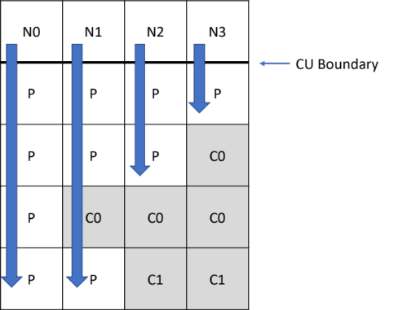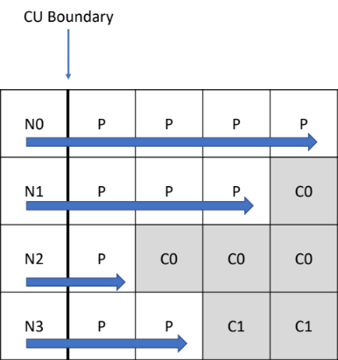
(a) vertical intra prediction combination (b) horizontal intra prediction combination
Figure 1. An example of palette mode and horizontal/vertical intra prediction combination.

JVET-O0071
In this test, a combined IBC/Palette mode is tested. A special palette index indicates that the predictor for the current sample is copied from IBC prediction. Otherwise the sample is from palette predictor.
In this test, the first available merge candidate is always employed to generate the IBC prediction. Therefore, the signalling of IBC motion information could be avoided to reduce the overhead bits.

JVET-O0120
In this CE, a line-based CG palette mode, which reduces the buffer to store index values, index maps in HEVC palette mode, is tested. A palette mode coded CU is divided into multiple line segments (line coefficient group (CG)) of m samples based on the traverse scan mode, as shown in Figure 2. The coefficient parsing, i.e., parsing the index runs, palette index values, and quantized colors, are done sequentially for each line CG.
The parsing of the palette index run in each line CG is as follows: a context coded bin (index_flag) is parsed for each sample indicating if the sample is of the same run mode as the previously scanned sample, i.e., if the previous scanned sample and the current sample are both of run type COPY_ABOVE or if the previous scanned sample and the current sample are both of run type INDEX with the same index value. If the pixel and the previous sample are of different mode, a context coded bin is parsed indicating the run type, i.e., INDEX or COPY_ABOVE. Same as the HEVC palette, decoder doesn’t have to parse run type if the sample is in the first row (horizontal traverse scan) or in the first column (vertical traverse scan) since the INDEX mode is used by default. Also, decoder doesn’t have to parse run type if the previously parsed run type is COPY_ABOVE.
The index values (for index runs of INDEX mode) and quantized escape colors are bypass coded and grouped apart from encoding/parsing of context coded bins, i.e., index_flag and run_type, to improve throughput within each line CG.
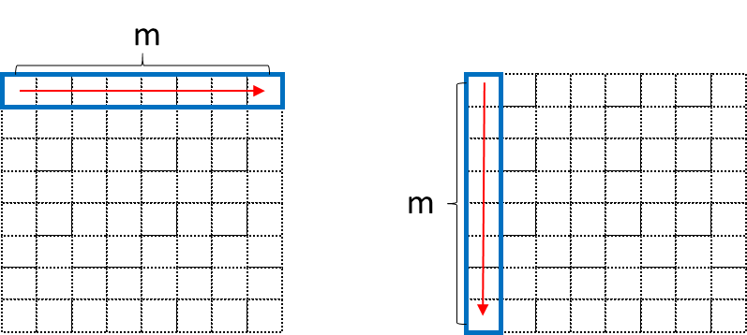
Figure 2: line CG segmentation for horizontal and vertical traverse scans

JVET-O0081

In this test, chroma transform skip (TS) is introduced and evaluated. The motivation is to unify TS and MTS signaling between luma and chroma by relocating transform_skip_flag and mts_idx into residual_coding part. One context model is added for chroma TS. No context model and no binarization are changed for the mts_idx.
In addition, TS residual coding is also applied when chroma TS is used. According to the meeting note (JVET-O_Notes_dB sec 5.8 CE:8 Screen content coding tools), there is a concern on the maximum number of context coded bins in the TS residual coding. Therefore, the maximum number of context-coded bins in TS residual coding is limited to the same maximum number of non-TS residual coding (1.75 per coefficient).

Semantics
transform_skip_flag[ x0 ][ y0 ][ cIdx ] specifies whether a transform is applied to the associated luma transform block or not. The array indices x0, y0 specify the location ( x0, y0 ) of the top-left luma sample of the considered transform block relative to the top-left luma sample of the picture. transform_skip_flag[ x0 ][ y0 ][ cIdx ] equal to 1 specifies that no transform is applied to the current luma transform block. The array index cIdx specifies an indicator for the colour component; it is equal to 0 for luma, equal to 1 for Cb and equal to 2 for Cr. transform_skip_flag[ x0 ][ y0 ][ cIdx ] equal to 0 specifies that the decision whether transform is applied to the current transform block or not depends on other syntax elements. When transform_skip_flag[ x0 ][ y0 ][ cIdx ] is not present, it is inferred to be equal to 0.

mts_idx[ x0 ][ y0 ][ cIdx ] specifies which transform kernels are applied to the residual samples along the horizontal and vertical direction of the associated luma transform block. The array indices x0, y0 specify the location ( x0, y0 ) of the top-left luma sample of the considered transform block relative to the top-left luma sample of the picture. The array index cIdx specifies an indicator for the colour component; it is equal to 0 for luma, equal to 1 for Cb and equal to 2 for Cr.
When mts_idx[ x0 ][ y0 ][ cIdx ] is not present, it is inferred to be equal to 0.
If ChromaArrayType is larger than 0, mts_idx[ x0 ][ y0 ][ 1] and mts_idx[ x0 ][ y0 ][ 2] shall be equal to 0.

JVET-O0166
In this CE test, BDPCM is added to chroma components.
In this test the use of BDPCM and Transform skip on the chroma components is to be tested as a straightforward evolution of the current luma-only BDPCM.
If sps_bdpcm_enable_flag is 1, a further syntax element sps_bdpcm_chroma_enable_flag is added to the SPS.
The flags have the following behaviour, as indicated in table 1

sps_bdpcm_enable_flag | sps_bdpcm_chroma_enable_flag | behaviour
0 | not written | BPDCM is not used in the sequence
1 | 0 | BDPCM is available for luma only
1 | 1 | BDPCM is available for luma and chroma

When BDPCM is available for luma only, the current behaviour is unchanged.
When BDPCM is also available for chroma, a bdpcm_chroma_flag is sent for each chroma block. This indicates whether BDPCM is used on the chroma blocks. When it is on, BDPCM is used for both chroma components, and an additional bdpcm_dir_chroma flag is coded, indicating the prediction direction used for both chroma components.
The deblocking filter is de-activated on a border between two Block-DPCM blocks, since neither of the blocks uses the transform stage usually responsible for blocking artifacts. This deactivation happens independently for luma and chroma components. A bdpcm deblocking bugfix (ticket #295) was also applied for the test as part of these bdpcm-chroma deblocking changes.

CE tests
The following tests will be evaluated and studied in this CE.
Test | Tester | Document | Tool description | Cross checker
CE8-1.1 | Y.-C. Sun  (Alibaba) | JVET-O0059 | Palette mode and simplified intra mode combination | W. Zhu  (ByteDance)
CE8-1.2 | W. Zhu  (ByteDance) | JVET-O0071 | Palette mode and IBC combination | Y.-C. Sun  (Alibaba)
CE8-1.3 | Y.-H. Chao  (Qualcomm) | JVET-O0120 | Line-based CG Palette mode | F. Henry (Orange)
CE8-2.1 | T. Tsukuba, M. Ikeda, Y. Yagasaki (Sony) | JVET-O0081 | Chroma TS support with limited maximum number of TS residual context-coded bins | F. Henry (Orange)
CE8-3.1 | F. Henry (Orange) | JVET-O0166 | (withdrawn) | T. Tsukuba (Sony)
CE8-4.1 | F. Henry  (Orange)  T. Tsukuba  (Sony) | JVET-O0166  JVET-O0081 | Combination of CE8-3.1 and CE8-2.1 | Y.-H. Chao (Qualcomm)

Software
It is agreed that VTM version VTM-6.0 shall be used for these experiments, as specified in the corresponding output document from this meeting. The following anchors are considered for tests in this CE:
- The proposed methods in this CE shall be tested for Standard QPs (37, 32, 27, 22) of AI, RA, and LDB configurations according to the test condition listed below. IBC, PLT, BDPCM and HashME are enabled.
- CE tests are required for YUV4:4:4 format, with AI, RA, and LDB configurations. The test sequences used for the tests are listed later in this document. IBC, PLT, BDPCM and HashME shall be enabled in the anchor.
- For YUV4:4:4 sequences, tests for both dual-tree enabled (--DualITree=1) and disabled (--DualITree=0) are required.
- For transform skip (TS) related tests and BDPCM related test, additional tests for low QPs required. Currently, according to the information from CE7, the suggested testing conditions are QPs (2, 7, 12, 17) with only the first 100 frames (AI, RA, and LDB configurations) with the same starting frame as in normal QP case.

Test configurations
The mandatory common test conditions (CTC) as specified in the JVET-O2010 document shall be followed to perform the simulations in this CE. IBC, PLT, BDPCM and HashME shall be enabled.
For test on YUV4:4:4 sequences, results with both dual tree disabled (--DualITree=0) and enabled (--DualITree=1) should be provided.
For CE8-2 and CE8-3 related tests, additional results with low QP settings should be provided, as noted earlier in this document.

Test sequences

The following test sequences in YUV4:4:4 format (based on JCTVC-U1015 + AOV4:4:4 + GlassHalf4:4:4) shall be used when providing results for YUV4:4:4 tests. IBC, PLT, BDPCM and HashME are enabled for all YUV4:4:4 sequences.

Category | Sequence name | Resolution | Bit depth | Frame rate | Frames to be encoded
TGM | sc_flyingGraphics_1920x1080_60_8bit*  sc_desktop_1920x1080_60_8bit  sc_console_1920x1080_60_8bit  ChineseEditing_1920x1080_60_8bit | 1920x1080  1920x1080  1920x1080  1920x1080 | 8  8  8  8 | 60  60  60  60 | 0-299*  0-599  0-599  0-599
TGM | sc_web_browsing_1280x720_30_8bit  sc_map_1280x720_60_8bit  sc_programming_1280x720_60_8bit  sc_SlideShow_1280x720_20_8bit | 1280x720  1280x720  1280x720  1280x720 | 8  8  8  8 | 30  60  60  20 | 0-299  0-599  0-599  0-499
A | ArenaOfValor_1920x1080_60_8bit_444  sc_robot_1280x720_30_8bit  Glasshalf_3840x2160_24p_10b_444 | 1920x1080  1280x720  3840x2160 | 8  8  10 | 60  30  24 | 0-599  0-299  0-239
M | Basketball_Screen_2560x1440_60p_8b444*  MissionControlClip2_2560x1440_60p_8444*  MissionControlClip3_1920x1080_60p_8b444 | 2560x1440  2560x1440  1920x1080 | 8  8  8 | 60  60  60 | 322-621*  120-419*  0-599
CC | EBURainFruits_1920x1080_50_10bit*  Kimono1_1920x1080_24_10bit* | 1920x1080  1920x1080 | 10  10 | 50  24 | 0-249*  0-119*
*Note that the frames used are different from the original number of frames in the sequence
TGM: Text and graphics with motion; M: mixed content; A: animation; CC: camera-captured content

YUV4:4:4 Test sequences are available from the following locations (please contact JCT-VC/JVET chairs for login information):
- ArenaOfValor YUV4:4:4: ftp.ient.rwth-aachen.de.
- GlassHalf YUV4:4:4: ftp.ient.rwth-aachen.de.
- Other YUV4:4:4 sequences: ftp://hevc@ftp.tnt.uni-hannover.de/testsequences/FrExt-candidate-sequences/upload/screen_content/ScExt-TestSequences

When the random access configuration is used, the period for intra random access frames for each test sequence needs to be specified, as follows:
IntraPeriod: Specifies the intra refresh period in the random access configuration. The intra refresh period is dependent on the frame rate of the test sequence. A value 16 shall be used for test sequences with a frame rate equal to 20fps, 32 for 24fps, 32 for 30fps, 48 for 50fps, and 64 for 60fps.

Coding Performance Measurements
Measure impact on bitrate/PSNR using provided data (4 points, BD-rate).

Complexity Considerations
To provide an indicative assessment of complexity, the following numbers should be provided:
- Encoding time (compared to the default configuration).
- Decoding time (compared to the default configuration).

Timeline
T0: Release of VTM software: Aug. 17, 2019
T1: Final CE description upload: Aug. 2, 2019
T2: Release of individual test software and crosscheck begins, T2 = T0 + 2 week: Aug 31, 2019
T3: CE software frozen: Sept. 10, 2019 (T2+1week, or 3 weeks before next JVET meeting, whichever is later)
T4: CE proposal document uploaded (regular document upload deadline – 1 week), Sept. 17, 2019
T5: CE summary report and regular document upload deadline, Sept. 24, 2019
Note: The 16th JVET meeting will be from Tue. 1 – Fri. 11 Oct. 2019, in Geneva, CH.

Participant list

References
- JVET-O0059
- JVET-O0071
- JVET-O0120
- JVET-O0081
- JVET-O0166
- JVET-O2010

