    Joint Video Experts Team (JVET)  of ITU-T SG 16 WP 3 and ISO/IEC JTC 1/SC 29/WG 11  15th Meeting: Gothenburg, SE, 3–12 July 2019 | Document: JVET-O0803-v3

Title: | Non-CE5: Unified design for longer tap deblocking line buffer reduction
Status: | Input document to JVET
Purpose: | Proposal
Author(s) or  Contact(s): | Anand Meher Kotra  Semih Esenlik  Biao Wang  Han Gao  Elena Alshina | Tel:  Email: | anand.meher.kotra@huawei.com
Source: | Huawei Technologies. Co., Ltd
_____________________________

Abstract
In VTM-5.0, to reduce line buffer requirement for the longer tap filter at horizontal CTU boundaries, for the Luma component an asymmetric filter which only modifies 3 samples from the top CU, and 7 samples from the bottom CU is employed, whereas for the Chroma deblocking, the longer tap filter is completely switched off at the CTU boundaries. Since a potential “large block” blocking artifact could occur at the horizontal Chroma CTU boundary, the current proposal reportedly employs a longer tap asymmetric filter which modifies 1 sample from the top CTU but can still modify up to 3 samples from the bottom CTU to more effectively remove the blocking artifact.
The objective results, over VTM5.0 Anchor for CTC configuration are as follows

Config. | Y | U | V | EncT | DecT
AI | 0.00% | 0.00% | 0.00% | 101% | 101%
RA | 0.00% | -0.06% | -0.04% | 101% | 102%
LDB | 0.02% | 0.00% | -0.10% | 101% | 102%
LDP | 0.00% | 0.18% | -0.05% | 101% | 102%

Subjective evaluation showed that the quality is slightly better when compared to the Anchor and reportedly the subjective benefits are better for 4:2:2 and 4:4:4 content.

Introduction
VTM-5.0 [1] uses longer tap deblocking filter to effectively remove blocking artifacts belonging to larger blocks. To reduce line buffer requirements, as depicted in Figure1 below, for the Luma deblocking, at the horizontal CTU edge boundary, longer tap filter uses as asymmetric filter which modifies 3 samples from the top CU and modifies 7 samples from the bottom CU. For the Chroma deblocking, the longer tap filter is switched off and it can only use normal Chroma filter which can only modify a maximum of 1 sample on either side of the edge.
The current proposal targets to unify the design of Luma and Chroma deblocking at the horizontal CTU boundaries and moreover also targets to improve the subjective quality for larger blocks at the horizontal Chroma CTU boundaries

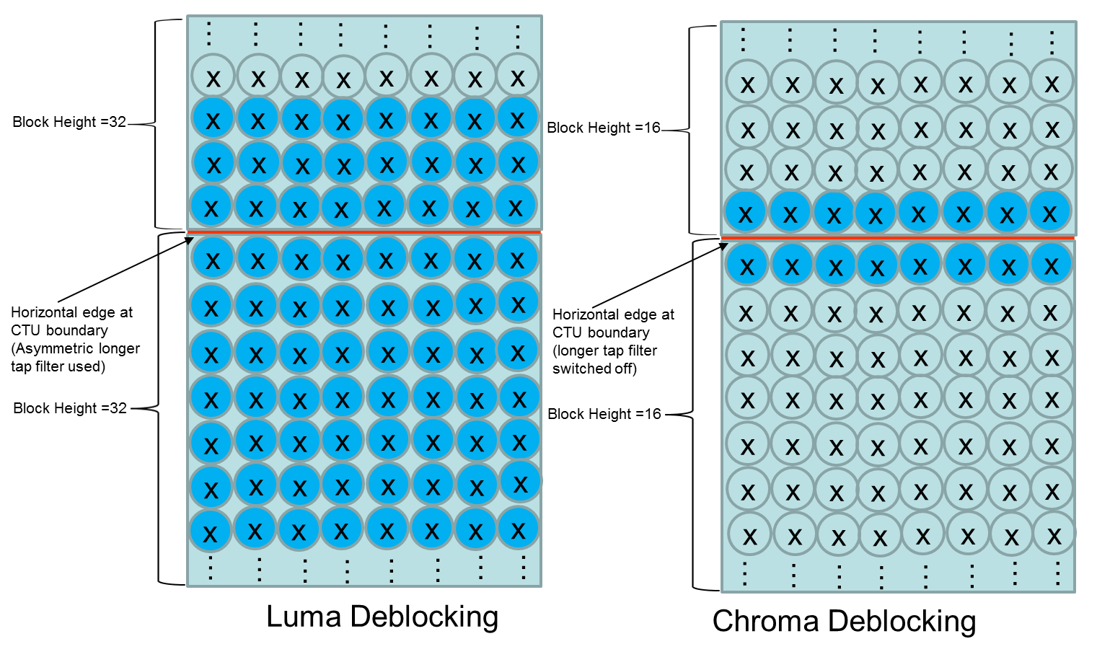
Figure1. In VTM-5.0, Chroma longer tap filter is switched off at the horizontal CTU boundaries

Proposed Solution
The proposed solution uses an asymmetric filter also for the Chroma deblocking (similar to Luma deblocking), which modifies 1 sample from the top CTU, but can modify upto 3 samples from the bottom CTU as shown in Fig.2 below. Since more samples are modified, the filter reportedly can remove the blocking artifacts more efficiently when compared to using normal Chroma filter which only modifies 1 sample on either side of the edge.
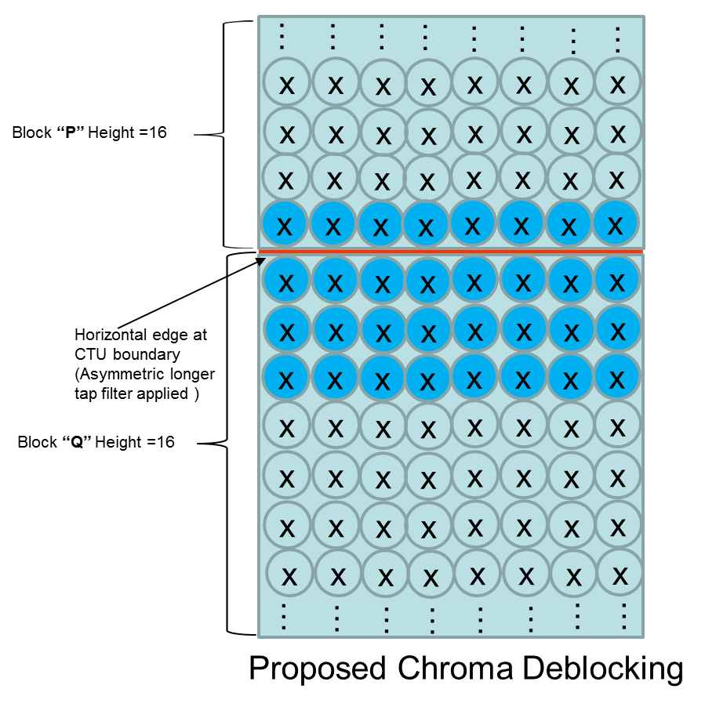
Figure 2. Asymmetric longer tap Chroma deblocking filter used at horizontal Chroma CTU boundaries
For the longer tap filter decision, the original filter equations are as follows:
dp0 = Abs( p_{2,0} − 2 * p_{1,0} + p_{0,0} ) (8-1092)
dp1 = Abs( p_{2,1} − 2 * p_{1,1} + p_{0,1} ) (8-1093)
dq0 = Abs( q_{2,0} − 2 * q_{1,0} + q_{0,0} ) (8-1094)
dq1 = Abs( q_{2,1} − 2 * q_{1,1} + q_{0,1} ) (8-1095)
At the horizontal CTU boundaries the modified longer tap filter decisions are as follows: (p_{2,0,} p_{2,1} are simply replaced with p_{1,0} and p_{1,1})
dp0 = Abs( p_{21,0} − 2 * p_{1,0} + p_{0,0} ) (8-1092)
dp1 = Abs( p_{21,1} − 2 * p_{1,1} + p_{0,1} ) (8-1093)
dq0 = Abs( q_{2,0} − 2 * q_{1,0} + q_{0,0} ) (8-1094)
dq1 = Abs( q_{2,1} − 2 * q_{1,1} + q_{0,1} ) (8-1095)
The original longer tap filtering equations for Chroma longer tap deblocking are as follows:
p₀′ = Clip3( p₀ − t_{C}, p₀ + t_{C}, ( p₃ + p₂ + p₁ + 2 * p₀ + q₀ + q₁ + q₂ + 4 ) >> 3 ) (8-1151)
p₁′ = Clip3( p₁ − t_{C}, p₁ + t_{C}, ( 2 * p₃ + p₂ + 2 * p₁ + p₀ + q₀ + q₁ + 4 ) >> 3 ) (8-1152)
p₂′ = Clip3( p₂ − t_{C}, p₂ + t_{C}, ( 3 * p₃ + 2 * p₂ + p₁ + p₀ + q₀ + 4 ) >> 3 ) (8-1153)
q₀′ = Clip3( q₀ − t_{C}, q₀ + t_{C}, ( p₂ + p₁ + p₀ + 2 * q₀ + q₁ + q₂ + q₃ + 4 ) >> 3 ) (8-1154)
q₁′ = Clip3( q₁ − t_{C}, q₁ + t_{C}, ( p₁ + p₀ + q₀ + 2 * q₁ + q₂ + 2 * q₃ + 4 ) >> 3 ) (8-1155)
q₂′= Clip3( q₂ − t_{C}, q₂ + t_{C}, ( p₀ + q₀ + q₁ + 2 * q₂ + 3 * q₃ + 4 ) >> 3 ) (8-1156)
At the horizontal CTU boundaries the modified longer tap deblocking equations are as follows:
p₀′ = Clip3( p₀ − t_{C}, p₀ + t_{C}, ( p₃ + p₂ + 3 * p₁ + 2 * p₀ + q₀ + q₁ + q₂ + 4 ) >> 3 ) (8-1151)
p₁′ = Clip3( p₁ − t_{C}, p₁ + t_{C}, ( 2 * p₃ + p₂ + 2 * p₁ + p₀ + q₀ + q₁ + 4 ) >> 3 ) (8-1152)
p₂′ = Clip3( p₂ − t_{C}, p₂ + t_{C}, ( 3 * p₃ + 2 * p₂ + p₁ + p₀ + q₀ + 4 ) >> 3 ) (8-1153)
q₀′ = Clip3( q₀ − t_{C}, q₀ + t_{C}, ( p₂ + 2 * p₁ + p₀ + 2 * q₀ + q₁ + q₂ + q₃ + 4 ) >> 3 ) (8-1154)
q₁′ = Clip3( q₁ − t_{C}, q₁ + t_{C}, ( p₁ + p₀ + q₀ + 2 * q₁ + q₂ + 2 * q₃ + 4 ) >> 3 ) (8-1155)
q₂′= Clip3( q₂ − t_{C}, q₂ + t_{C}, ( p₀ + q₀ + q₁ + 2 * q₂ + 3 * q₃ + 4 ) >> 3 ) (8-1156)
The filtering equations can be just be derived by padding the unavailable samples with the outermost available sample on the P side.
Subjective evaluation showed that the quality is slightly better when compared to the Anchor and reportedly the subjective benefits are better for 4:2:2 and 4:4:4 content.

Complexity evaluation
Complexity of the proposal is evaluated based on the following criteria described in the CE5 document, JVET-N1025 [3].
Luma deblocking complexity:
No changes are done for the Luma filter.
Chroma deblocking complexity:
- At horizontal CTU boundaries, additionally samples q1 and q2 are filtered if longer tap filter is evaluated to be true.

Simulation Results
The test is implemented on top of VTM-5.0 [1] and the simulation is performed under common test conditions as described in JVET-N1010 [2].

Results with CTC

 | All Intra Main10
 | Over VTM 5.0
 | Y | U | V | EncT | DecT
Class A1 | 0.00% | -0.03% | -0.02% | 100% | 100%
Class A2 | 0.00% | 0.02% | 0.01% | 101% | 102%
Class B | 0.00% | 0.01% | 0.03% | 101% | 102%
Class C | 0.00% | 0.00% | -0.01% | 100% | 100%
Class E | 0.00% | -0.03% | -0.03% | 100% | 100%
Overall | 0.00% | 0.00% | 0.00% | 101% | 101%
Class D | 0.00% | 0.00% | 0.00% | 100% | 100%
Class F | 0.00% | 0.00% | -0.01% | 101% | 102%
 | Random Access Main 10
 | Over VTM 5.0
 | Y | U | V | EncT | DecT
Class A1 | 0.01% | -0.14% | -0.01% | 101% | 101%
Class A2 | 0.01% | -0.02% | -0.02% | 101% | 102%
Class B | 0.01% | -0.05% | -0.08% | 101% | 101%
Class C | -0.01% | -0.02% | -0.02% | 101% | 102%
Class E
Overall | 0.00% | -0.06% | -0.04% | 101% | 102%
Class D | -0.01% | -0.07% | 0.12% | 101% | 102%
Class F | 0.01% | 0.07% | -0.02% | 100% | 101%
 | Low delay B Main10
 | Over VTM 5.0
 | Y | U | V | EncT | DecT
Class A1
Class A2
Class B | 0.00% | 0.04% | 0.13% | 101% | 103%
Class C | 0.01% | -0.13% | -0.32% | 101% | 102%
Class E | 0.08% | 0.10% | -0.20% | 101% | 101%
Overall | 0.02% | 0.00% | -0.10% | 101% | 102%
Class D | -0.03% | -0.22% | 0.64% | 100% | 101%
Class F | 0.00% | 0.12% | 0.38% | 101% | 101%
 | Low delay P Main10
 | Over VTM 5.0
 | Y | U | V | EncT | DecT
Class A1
Class A2
Class B | -0.02% | -0.26% | -0.19% | 101% | 102%
Class C | 0.00% | 0.00% | 0.18% | 101% | 101%
Class E | 0.04% | 1.15% | -0.10% | 101% | 102%
Overall | 0.00% | 0.18% | -0.05% | 101% | 102%
Class D | 0.04% | -0.68% | 0.65% | 101% | 103%
Class F | 0.01% | 0.42% | 0.33% | 101% | 101%

Results with ALF=0

 | All Intra Main10
 | Over VTM 5.0
 | Y | U | V | EncT | DecT
Class A1 | 0.00% | -0.12% | -0.08% | 100% | 100%
Class A2 | 0.00% | 0.00% | 0.00% | 100% | 101%
Class B | 0.00% | -0.01% | 0.01% | 100% | 100%
Class C | 0.00% | 0.00% | -0.01% | 101% | 102%
Class E | 0.00% | -0.04% | -0.06% | 101% | 100%
Overall | 0.00% | -0.03% | -0.02% | 101% | 101%
Class D | 0.00% | 0.00% | 0.00% | 101% | 100%
Class F | 0.00% | -0.01% | -0.02% | 100% | 101%
 | Random Access Main 10
 | Over VTM 5.0
 | Y | U | V | EncT | DecT
Class A1 | -0.01% | -0.12% | -0.26% | 101% | 101%
Class A2 | 0.00% | 0.09% | 0.02% | 101% | 101%
Class B | 0.01% | -0.05% | 0.00% | 100% | 101%
Class C | 0.00% | 0.02% | -0.10% | 100% | 101%
Class E
Overall | 0.00% | -0.02% | -0.07% | 100% | 101%
Class D | 0.02% | -0.01% | -0.03% | 100% | 101%
Class F | 0.00% | 0.00% | 0.00% | 100% | 101%
 | Low delay B Main10
 | Over VTM 5.0
 | Y | U | V | EncT | DecT
Class A1
Class A2
Class B | 0.03% | -0.19% | -0.53% | 101% | 100%
Class C | -0.01% | -0.03% | -0.04% | 100% | 100%
Class E | 0.03% | -0.53% | -0.24% | 100% | 101%
Overall | 0.02% | -0.22% | -0.29% | 100% | 100%
Class D | 0.03% | 0.11% | -0.06% | 101% | 101%
Class F | -0.02% | -0.01% | -0.24% | 100% | 100%
 | Low delay P Main10
 | Over VTM 5.0
 | Y | U | V | EncT | DecT
Class A1
Class A2
Class B | -0.03% | -0.45% | -0.67% | 101% | 101%
Class C | 0.04% | -0.27% | -0.21% | 100% | 100%
Class E | 0.04% | 0.23% | 0.27% | 100% | 101%
Overall | 0.01% | -0.22% | -0.28% | 101% | 100%
Class D | 0.02% | 0.24% | 0.15% | 100% | 101%
Class F | 0.04% | -0.42% | -0.66% | 100% | 100%

Few subjective examples are included in the power point presentation attached with the version (v2) of the contribution package.

Conclusion
The current contribution proposes to use a longer tap asymmetric filter to remove larger block artifacts occurring at horizontal CTU boundaries for Chroma. The proposed design unifies the way horizontal CTU boundaries are treated in both Luma and Chroma deblocking i.e. by using an asymmetric filter which allows to modify more samples from the bottom block in order to remove the blocking artifact more efficiently. There is no major BD-Rate difference expected and the subjective quality should be reportedly be better especially for 4:2:2 and 4:4:4 content. Specification text changes are attached along with the contribution.

References
- Versatile Video Coding (Draft 5), Document JVET-N1001_v7, B. Bross, J. Chen, S. Liu
- “JVET common test conditions and software reference configurations”, JVET-N1010

Patent rights declaration(s)
Huawei Technologies Co., Ltd may have current or pending patent rights relating to the technology described in this contribution and, conditioned on reciprocity, is prepared to grant licenses under reasonable and non-discriminatory terms as necessary for implementation of the resulting ITU-T Recommendation | ISO/IEC International Standard (per box 2 of the ITU-T/ITU-R/ISO/IEC patent statement and licensing declaration form).

