    Joint Video Experts Team (JVET)  of ITU-T SG 16 WP 3 and ISO/IEC JTC 1/SC 29/WG 11  15th Meeting: Gothenburg, SE, 3–12 July 2019 | Document: JVET-O0648-v2

Title: | Non-CE5: On Exp-Golomb Coding of ALF Filter Coefficients and Clip Values
Status: | Input document to JVET
Purpose: | Proposal
Author(s) or  Contact(s): | Hilmi E. Egilmez, Nan Hu,  Vadim Seregin, Marta Karczewicz  5775 Morehouse Dr.,  San Diego, CA, 92121, USA | Tel:  Email: | +1(858)651-3483  hegilmez@qti.qualcomm.com
Source: | Qualcomm Inc.
_____________________________

Abstract
This document presents various simplifications for signaling of Exp-Golomb order (EGk) used to build codes for signaling ALF filter coefficients and clip values. In VTM-5.0, the EGk signalling involves a recursive prediction among neighboring EGks and an additional flag used as an offset for the prediction. In this contribution, all presented simplifications remove the recursive prediction and the offset flag. Further tested simplifications include (i) signaling a single EGk for all positions instead of signalling separate EGks for different groups of positions, (ii) and using a fixed EGk without signalling.
The experimental results under common test conditions show that the proposed simplifications lead to almost no performance change.

Introduction
In VTM-5.0, the adaptive loop filter (ALF) uses Exp-Golomb codes for signaling filter coefficients and clip values, where associated Exp-Golomb orders (EGks) are adaptively selected and signalled.
This contribution proposes a set of modifications to simplify the signaling process of EGks without degrading the coding efficiency. The proposed modifications are applied for signalling of EGk in both luma and chroma components. In a nutshell, the following issues are addressed:
- Currently in VTM-5.0, the signaling of EGks requires a recursive prediction, where each EGk is predicted from a previously signalled EGk. In this contribution, the recursive prediction in EGk signaling is removed.
- As part of the EGk prediction in VTM-5.0, a flag called eg_order_increase_flag is signaled whether to increase a value of the signalled EGk by one. This flag is also removed in this contribution.
- In VTM-5.0, a set of EGks is signalled, and each EGk is selected based on the coefficient position. In order to evaluate the effect of signaling multiple EGks, this contribution presents various experimental results for (i) signaling a single EGk for all positions and (ii) choosing a fixed EGk.
- Although there are only 4 possible clip values, the corresponding indices are signaled using the same way of signaling ALF coefficients (using Exp-Golomb codes with adaptive EGk). In JVET-O0064, it has been shown that signaling of clip parameters can be simplified by using truncated unary or fixed-length codes without any significant effect on coding performance. Combination of proposed modifications for signaling ALF coefficients and the simplifications in JVET-O0064 is also tested in this contribution.

Description of methods
The proposed simplifications for EGk signaling are discussed in the following subsections.

Method 1: Simplifications with separate signaling of EGk for different position groups
The recursive prediction in EGk signalling is removed, and it is signalled using unary codes for each position group i. Since an EGk is signalled directly without any prediction, the eg_order_increase_flag used for prediction is also removed.
In the VVC draft 5 (JVET-N1010-v8), this corresponds to replacing the following recursive equation for position group i,
expGoOrder [ i ] = ( i = = 0 ? alf_min_eg_order_minus1 + 1 : expGoOrderY[ i − 1 ] ) + (1)
alf_eg_order_increase_flag[ i ]
with the following equation:
expGoOrder [ i ] = alf_luma_eg_order_minus1[ i ] + 1 , (2)
where unary codes are used for signaling alf_eg_order_minus1[ i ] (for i-th position group), which can take values from 0 to 6, inclusively. Note that alf_eg_order_increase_flag is also removed.

Method 2: Simplifications with a single EGk signaled for all positions
On top of Method 1, this method further removes the position dependent EGk signaling, and introduces a single EGk value signaled for all positions. In the VVC draft 5 (JVET-N1010-v8), this change can be reflected by replacing (1) with the following equation:
expGoOrder = alf_luma_eg_order_minus1 + 1, (3)
where the dependency on position groups denoted as [i] in (1) and (2) is removed.

Method 3: Simplifications with a fixed EGk
This method uses a fixed EGk value without signalling. This corresponds to changing equation (1) with
expGoOrder = k, (4)
where k denotes the fixed EGk value.

Combinations of Methods 1, 2 and 3 with JVET-O0064
In VTM-5.0, the same EGk signaling scheme is applied for both filter coefficients and clip values. It has been shown in JVET-O0064 that the signaling of clip values can be further simplified by using truncated unary or fixed-length codes without diminishing coding efficiency.
In order to demonstrate the interaction between the above methods and simplifications in JVET-O0064. This contribution also includes results of applying Methods 1, 2 or 3 only for signaling ALF coefficients and using fixed-length codes for signaling clip values.

Experimental results
The described methods are implemented in VTM-5.0, and the results are presented in following subsections.
Variations in encoding and decoding time measures (EncT and DecT) are due to use of multiple types of cores available on the cluster. It is claimed that the proposed methods in this contribution do not have adverse effects on EncT and DecT measures.

Results of Methods 1 and 2
Table 1: Results of Method 1 applied for coding both ALF coefficients and clip values
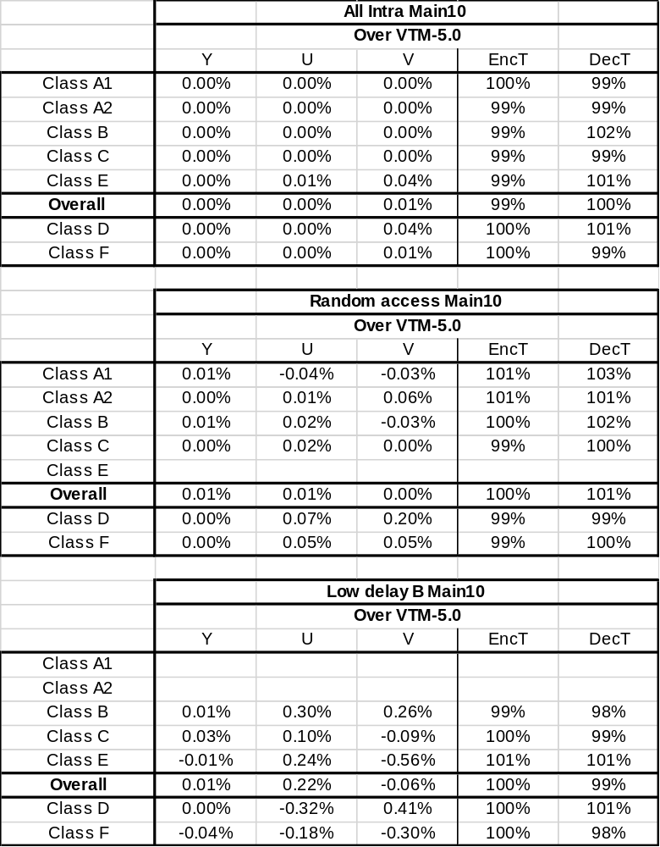

Table 2: Results of Method 2 applied for coding both ALF coefficients and clip values
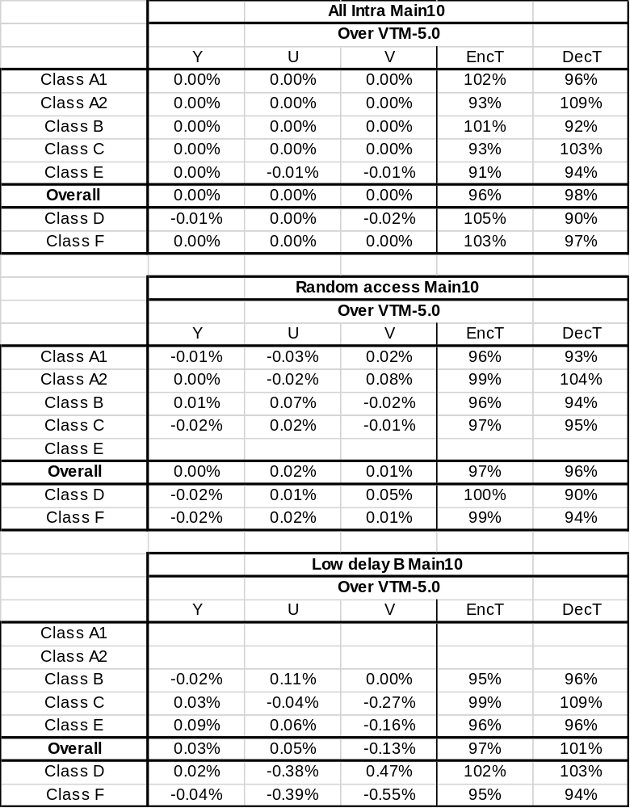

Table 3: Results of the combination of Method 1 and JVET-O0064
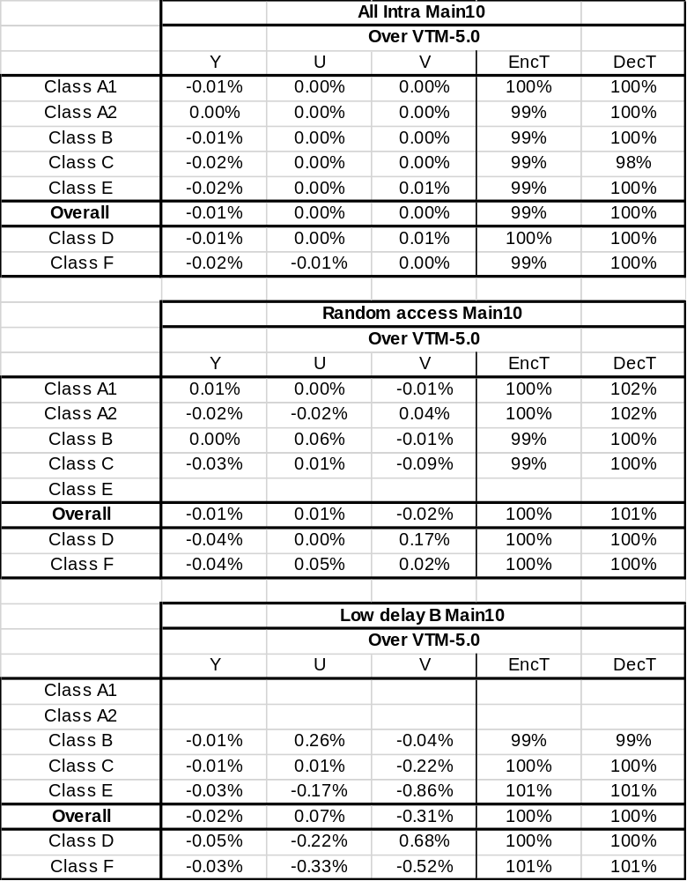

Table 4: Results of the combination of Method 2 and JVET-O0064

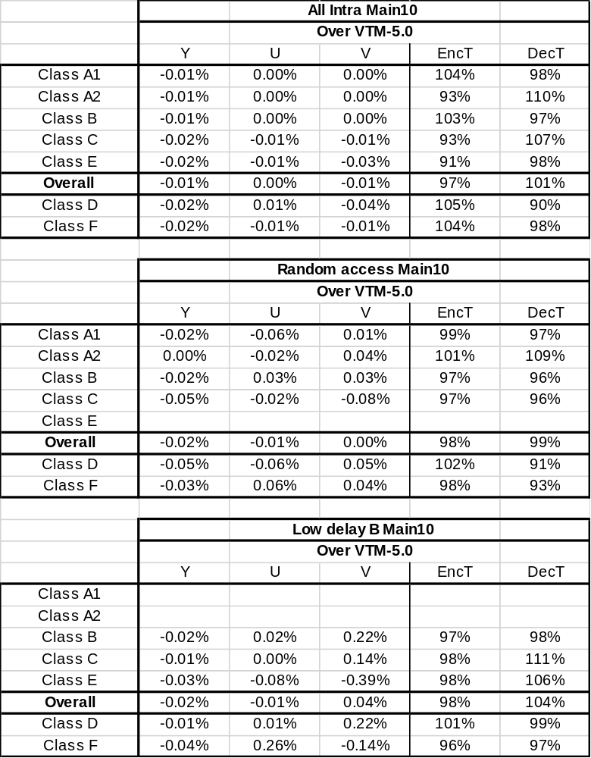

Results of Method 3 with EGk=2
Table 5: Results of Method 3 with EGk=2 applied for both ALF coefficients and clip values
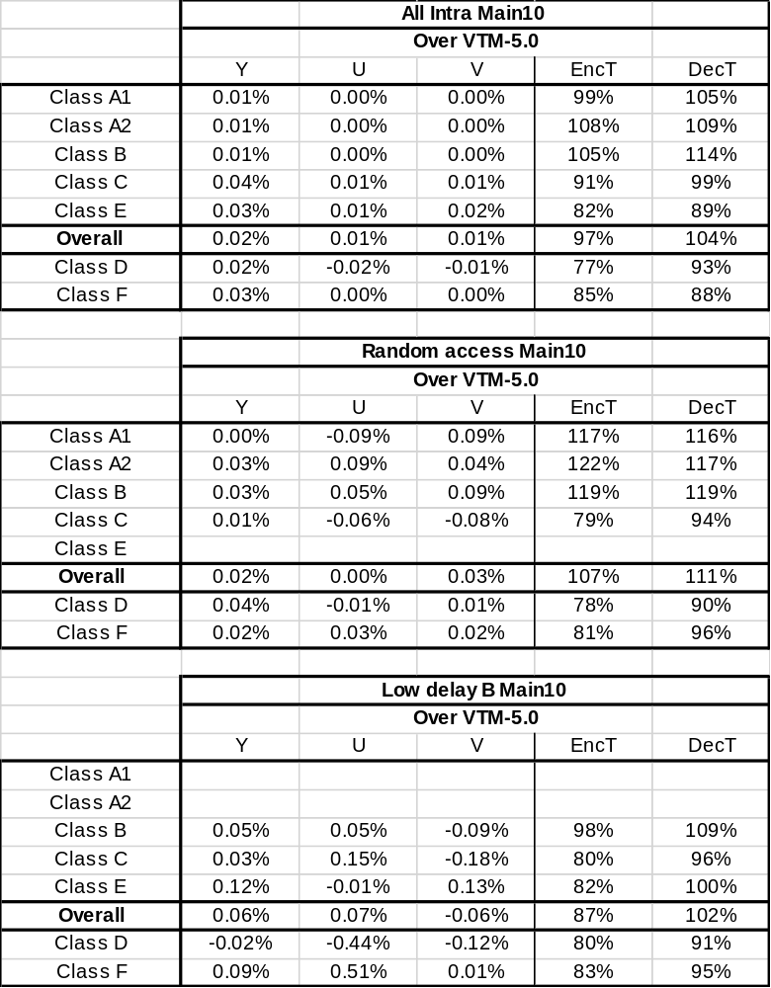

Table 6: Results of the combination of Method 3 with EGk=2 and JVET-O0064

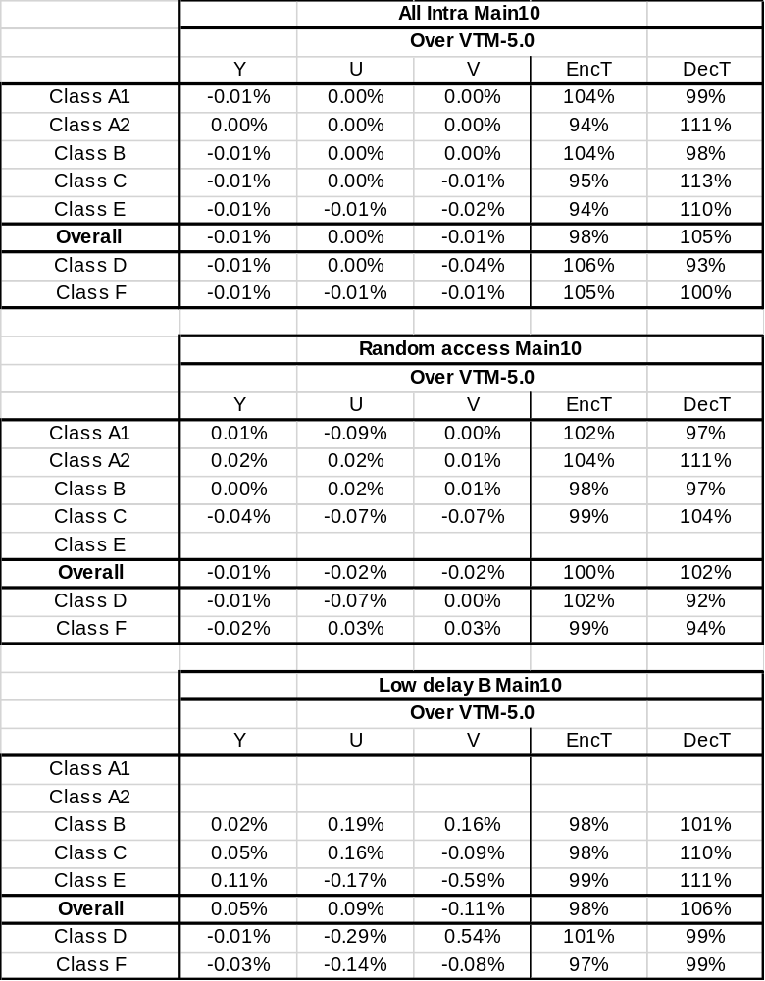

Results of Method 3 with EGk=3

Table 7: Results of Method 3 with EGk=3 applied for both ALF coefficients and clip values
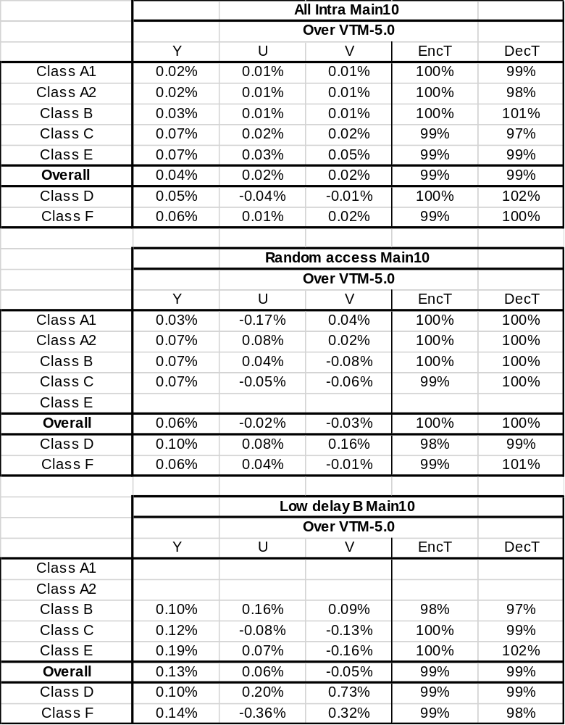

Table 8: Results of the combination of Method 3 with EGk=3 and JVET-O0064
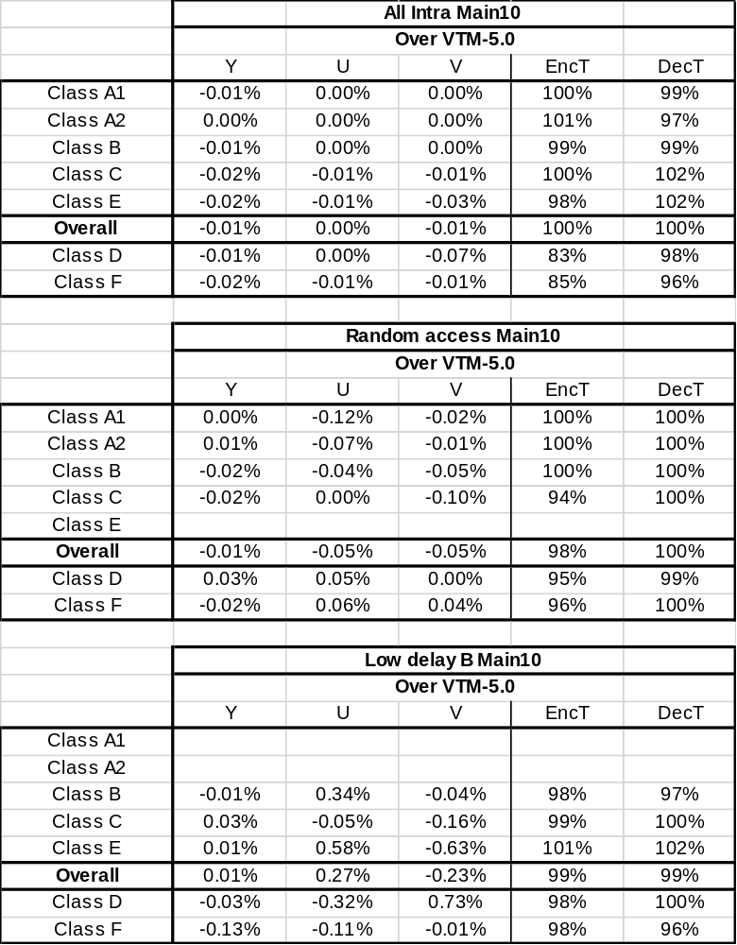

Results of Method 3 with EGk=4
Table 9: Results of Method 3 with EGk=4 applied for both ALF coefficients and clip values
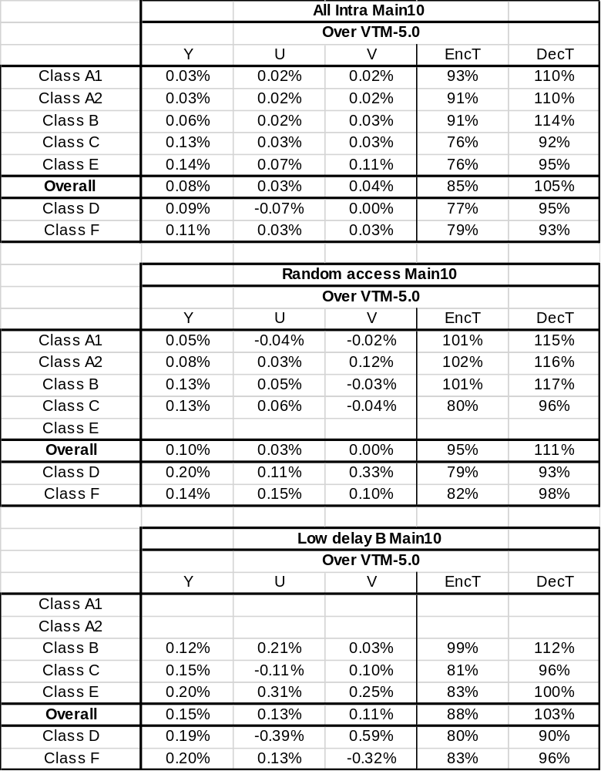

Table 10: Results of the combination of Method 3 with EGk=4 and JVET-O0064
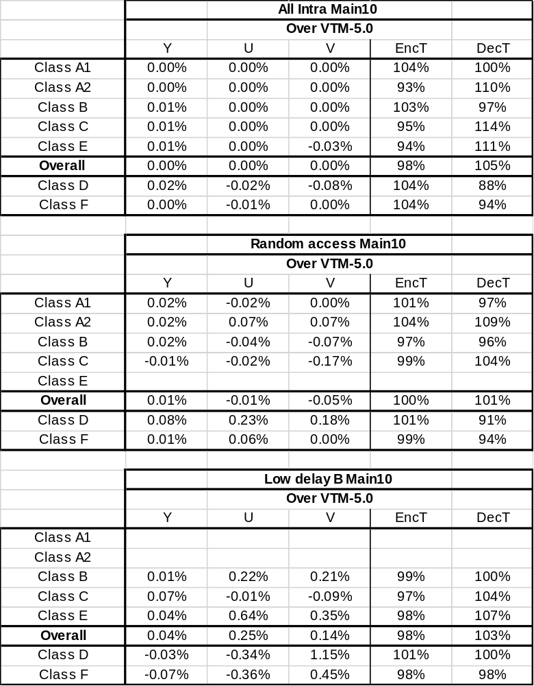

Reference
[1] F. Bossen, J. Boyce, X. Li, V. Seregin, K. Sühring, “JVET common test conditions and software reference configurations for SDR video”, JVET-N1010, 14th meeting, Geneva, CH, 19-27 March 2019.

[2] N. Hu, V. Seregin, H. E. Egilmez, M. Karczewicz, “CE5: Coding tree block based adaptive loop filter (CE5-4)”, JVET-N0415, 14th meeting, Geneva, CH, 19-27 March 2019.

[3] J. Taquet, P. Onno, C. Gisquet, G. Laroche, “CE5: Results of tests CE5-3.1, CE5-3.2, CE5-3.3 and CE5-3.4 on Non-Linear Adaptive Loop Filter”, JVET-N0242, 14th meeting, Geneva, CH, 19-27 March 2019.

[4] B. Bross, J. Chen, S. Liu, “Versatile Video Coding (Draft 5)”, JVET-N1001, 14th meeting, Geneva, CH, 19-27 March 2019.

Patent rights declaration(s)
Qualcomm Inc. may have current or pending patent rights relating to the technology described in this contribution and, conditioned on reciprocity, is prepared to grant licenses under reasonable and non-discriminatory terms as necessary for implementation of the resulting ITU-T Recommendation | ISO/IEC International Standard (per box 2 of the ITU-T/ITU-R/ISO/IEC patent statement and licensing declaration form).

