    Joint Video Experts Team (JVET)  of ITU-T SG 16 WP 3 and ISO/IEC JTC 1/SC 29/WG 11  15th Meeting: Gothenburg, SE, 3–12 July 2019 | Document: JVET-O0648-v1

Title: | Non-CE5: On Exp-Golomb Coding of ALF Filter Coefficients and Clip Values
Status: | Input document to JVET
Purpose: | Proposal
Author(s) or  Contact(s): | Hilmi E. Egilmez, Nan Hu,  Vadim Seregin, Marta Karczewicz  5775 Morehouse Dr.,  San Diego, CA, 92121, USA | Tel:  Email: | +1(858)651-3483  hegilmez@qti.qualcomm.com
Source: | Qualcomm Inc.
_____________________________

Abstract
This document presents various simplifications for signaling of Exp-Golomb order (EGk) used to build codes for signaling ALF filter coefficients and clip values. In VTM-5.0, the EGk signalling involves a recursive prediction among neighboring EGks and an additional flag used as an offset for the prediction. All the presented simplifications remove the recursive prediction and the offset flag. Other tested simplifications include (i) signaling a single EGk for all positions instead of signalling separate EGks for different groups of positions, (ii) and using a fixed EGk without signalling.
The experimental results under common test conditions show that the proposed simplifications lead to almost no performance change.

Introduction
In VTM-5.0, the adaptive loop filter (ALF) uses Exp-Golomb codes for signaling filter coefficients and clip values, where associated Exp-Golomb order (EGk) are adaptively selected and signalled.
This contribution proposes a set of modifications to simplify the signaling process of EGk without degrading the coding efficiency. The proposed modifications are applied for signalling of EGk for filter coefficients and clipping values and for both luma and chroma components. Specifically, the following issues are addressed:
- Currently in VTM-5.0 the signaling of EGks requires a recursive prediction, where each EGk is predicted from a previously signaled EGk. In this contribution, the recursive prediction in EGk signaling is removed.
- A flag called eg_order_increase_flag is signaled whether to increase a value of the signalled EGk by one.
- A set of EGks is signalled, and an EGk is selected based on the coefficient position.
- Although there are only 4 possible clip values, the corresponding indices are signaled using the same way of signaling ALF coefficients (using Exp-Golomb codes with adaptive EGk). In JVET-O0064, it has been shown that signaling of clip parameters can be simplified by using truncated unary or fixed-length codes without any significant effect on coding performance. Combination of proposed modifications for signaling ALF coefficients and the simplifications in JVET-O0064 is also tested in this contribution.

Description of methods
The proposed simplification for EGk signaling are discussed in the following subsections.

Method 1: Simplifications with separate signaling of EGk for different position groups
The recursive prediction in EGk signalling is removed, and it is signalled using unary codes for each position group i. Since an EGk is signalled directly without any prediction, the eg_order_increase_flag used for prediction is also removed.
In the VVC draft 5 (JVET-N1010-v8), this corresponds to replacing the following recursive equation for position group i,
expGoOrder [ i ] = ( i = = 0 ? alf_min_eg_order_minus1 + 1 : expGoOrderY[ i − 1 ] ) + (1)
alf_eg_order_increase_flag[ i ]
with the following equation:
expGoOrder [ i ] = alf_luma_eg_order_minus1[ i ] + 1 , (2)
where unary codes are used for signaling alf_eg_order_minus1[ i ] (for i-th position group), which can take values from 0 to 6, inclusively. Note that alf_eg_order_increase_flag is also removed.

Method 2: Simplifications with a single EGk signaled for all positions
On top of Method 1, this method further removes the position dependent EGk signaling, and introduces a single EGk value signaled for all positions. In the VVC draft 5 (JVET-N1010-v8), this change can be reflected by replacing (1) with the following equation:
expGoOrder = alf_luma_eg_order_minus1 + 1, (3)
where the dependency on position groups denoted as [i] in (1) and (2) is removed.

Method 3: Simplifications with a fixed EGP
This method uses a fixed EGk value without signalling. This corresponds to changing equation (1) with
expGoOrder = k, (4)
where k denotes the fixed EGP value.

Combinations of Methods 1, 2 and 3 with JVET-O0064
The simplification methods described in the previous subsections are applied to both signaling of ALF coefficients and signaling of clip values. The signaling of clip values can be further simplified by using truncated unary or fixed-length codes as shown in JVET-O0064.
The following section includes results of applying the proposed methods only for signaling ALF coefficients and using fixed-length codes for signaling clip values (see Section 3.3).

Experimental results
The described methods are implemented in VTM-5.0, and the results are presented in following subsections.

Results of Methods 1 and 2
Table 1: Results of Method 1 applied for coding both ALF coefficients and clip values
 | All Intra
 | Over VTM-5.0
 | Y | U | V | EncT | DecT
Class A1 | 0.00% | 0.00% | 0.00% | 100% | 99%
Class A2 | 0.00% | 0.00% | 0.00% | 99% | 99%
Class B | 0.00% | 0.00% | 0.00% | 99% | 102%
Class C | 0.00% | 0.00% | 0.00% | 99% | 99%
Class E | 0.00% | 0.01% | 0.04% | 99% | 101%
Overall | 0.00% | 0.00% | 0.01% | 99% | 100%
Class D | 0.00% | 0.00% | 0.04% | 100% | 101%
Class F | 0.00% | 0.00% | 0.01% | 100% | 99%
 | Random Access
 | Over VTM-5.0
 | Y | U | V | EncT | DecT
Class A1 | 0.01% | -0.04% | -0.03% | 101% | 103%
Class A2 | 0.00% | 0.01% | 0.06% | 101% | 101%
Class B | 0.01% | 0.02% | -0.03% | 100% | 102%
Class C | 0.00% | 0.02% | 0.00% | 99% | 100%
Class E
Overall | 0.01% | 0.01% | 0.00% | 100% | 101%
Class D | 0.00% | 0.07% | 0.20% | 99% | 99%
Class F | 0.00% | 0.05% | 0.05% | 99% | 100%
 | Low Delay B
 | Over VTM-5.0
 | Y | U | V | EncT | DecT
Class A1
Class A2
Class B | 0.01% | 0.30% | 0.26% | 99% | 98%
Class C | 0.03% | 0.10% | -0.09% | 100% | 99%
Class E | -0.01% | 0.24% | -0.56% | 101% | 101%
Overall | 0.01% | 0.22% | -0.06% | 100% | 99%
Class D | 0.00% | -0.32% | 0.41% | 100% | 101%
Class F | -0.04% | -0.18% | -0.30% | 100% | 98%

Table 2: Results of Method 2 applied for coding both ALF coefficients and clip values
 | All Intra
 | Over VTM-5.0
 | Y | U | V | EncT | DecT
Class A1 | 0.00% | 0.00% | 0.00% | 102% | 96%
Class A2 | 0.00% | 0.00% | 0.00% | 93% | 109%
Class B | 0.00% | 0.00% | 0.00% | 101% | 92%
Class C | 0.00% | 0.00% | 0.00% | 93% | 103%
Class E | 0.00% | -0.01% | -0.01% | 91% | 94%
Overall | 0.00% | 0.00% | 0.00% | 96% | 98%
Class D | -0.01% | 0.00% | -0.02% | 105% | 90%
Class F | 0.00% | 0.00% | 0.00% | 103% | 97%
 | Random Access
 | Over VTM-5.0
 | Y | U | V | EncT | DecT
Class A1 | -0.01% | -0.03% | 0.02% | 96% | 93%
Class A2 | 0.00% | -0.02% | 0.08% | 99% | 104%
Class B | 0.01% | 0.07% | -0.02% | 96% | 94%
Class C | -0.02% | 0.02% | -0.01% | 97% | 95%
Class E
Overall | 0.00% | 0.02% | 0.01% | 97% | 96%
Class D | -0.02% | 0.01% | 0.05% | 100% | 90%
Class F | -0.02% | 0.02% | 0.01% | 99% | 94%
 | Low Delay B
 | Over VTM-5.0
 | Y | U | V | EncT | DecT
Class A1
Class A2
Class B | -0.02% | 0.11% | 0.00% | 95% | 96%
Class C | 0.03% | -0.04% | -0.27% | 99% | 109%
Class E | 0.09% | 0.06% | -0.16% | 96% | 96%
Overall | 0.03% | 0.05% | -0.13% | 97% | 101%
Class D | 0.02% | -0.38% | 0.47% | 102% | 103%
Class F | -0.04% | -0.39% | -0.55% | 95% | 94%

Table 3: Results of the combination of Method 1 and JVET-O0064
 | All Intra
 | Over VTM-5.0
 | Y | U | V | EncT | DecT
Class A1 | -0.01% | 0.00% | 0.00% | 100% | 100%
Class A2 | 0.00% | 0.00% | 0.00% | 99% | 100%
Class B | -0.01% | 0.00% | 0.00% | 99% | 100%
Class C | -0.02% | 0.00% | 0.00% | 99% | 98%
Class E | -0.02% | 0.00% | 0.01% | 99% | 100%
Overall | -0.01% | 0.00% | 0.00% | 99% | 100%
Class D | -0.01% | 0.00% | 0.01% | 100% | 100%
Class F | -0.02% | -0.01% | 0.00% | 99% | 100%
 | Random Access
 | Over VTM-5.0
 | Y | U | V | EncT | DecT
Class A1 | 0.01% | 0.00% | -0.01% | 100% | 102%
Class A2 | -0.02% | -0.02% | 0.04% | 100% | 102%
Class B | 0.00% | 0.06% | -0.01% | 99% | 100%
Class C | -0.03% | 0.01% | -0.09% | 99% | 100%
Class E
Overall | -0.01% | 0.01% | -0.02% | 100% | 101%
Class D | -0.04% | 0.00% | 0.17% | 100% | 100%
Class F | -0.04% | 0.05% | 0.02% | 100% | 100%
 | Low Delay B
 | Over VTM-5.0
 | Y | U | V | EncT | DecT
Class A1
Class A2
Class B | #VALUE! | #VALUE! | #VALUE! | #NUM! | #NUM!
Class C | -0.01% | 0.01% | -0.22% | 100% | 100%
Class E | -0.03% | -0.17% | -0.86% | 101% | 101%
Overall | #VALUE! | #VALUE! | #VALUE! | #NUM! | #NUM!
Class D | -0.05% | -0.22% | 0.68% | 100% | 100%
Class F | -0.03% | -0.33% | -0.52% | 101% | 101%

Table 4: Results of the combination of Method 2 and JVET-O0064
 | All Intra
 | Over VTM-5.0
 | Y | U | V | EncT | DecT
Class A1 | #VALUE! | #VALUE! | #VALUE! | #NUM! | #NUM!
Class A2 | #VALUE! | #VALUE! | #VALUE! | #NUM! | #NUM!
Class B | #VALUE! | #VALUE! | #VALUE! | #NUM! | #NUM!
Class C | -0.02% | -0.01% | -0.01% | 93% | 107%
Class E | -0.02% | -0.01% | -0.03% | 91% | 98%
Overall | #VALUE! | #VALUE! | #VALUE! | #NUM! | #NUM!
Class D | -0.02% | 0.01% | -0.04% | 105% | 90%
Class F | #VALUE! | #VALUE! | #VALUE! | #NUM! | #NUM!
 | Random Access
 | Over VTM-5.0
 | Y | U | V | EncT | DecT
Class A1 | #VALUE! | #VALUE! | #VALUE! | #NUM! | #NUM!
Class A2 | #VALUE! | #VALUE! | #VALUE! | #NUM! | #NUM!
Class B | #VALUE! | #VALUE! | #VALUE! | #NUM! | #NUM!
Class C | -0.05% | -0.02% | -0.08% | 97% | 96%
Class E
Overall | #VALUE! | #VALUE! | #VALUE! | #NUM! | #NUM!
Class D | -0.05% | -0.06% | 0.05% | 102% | 91%
Class F | #VALUE! | #VALUE! | #VALUE! | #NUM! | #NUM!
 | Low Delay B
 | Over VTM-5.0
 | Y | U | V | EncT | DecT
Class A1
Class A2
Class B | #VALUE! | #VALUE! | #VALUE! | #NUM! | #NUM!
Class C | #VALUE! | #VALUE! | #VALUE! | #NUM! | #NUM!
Class E | #VALUE! | #VALUE! | #VALUE! | #NUM! | #NUM!
Overall | #VALUE! | #VALUE! | #VALUE! | #NUM! | #NUM!
Class D | -0.01% | 0.01% | 0.22% | 101% | 99%
Class F | #VALUE! | #VALUE! | #VALUE! | #NUM! | #NUM!

Results of Method 3 with EGk=2
Table 5: Results of Method 3 with EGk=2 applied for both ALF coefficients and clip values
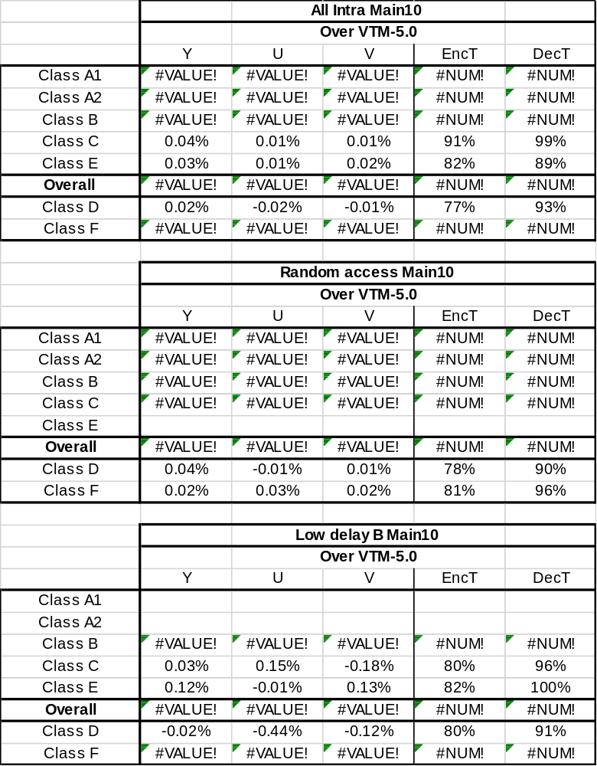

Table 6: Results of the combination of Method 3 with EGk=2 and JVET-O0064

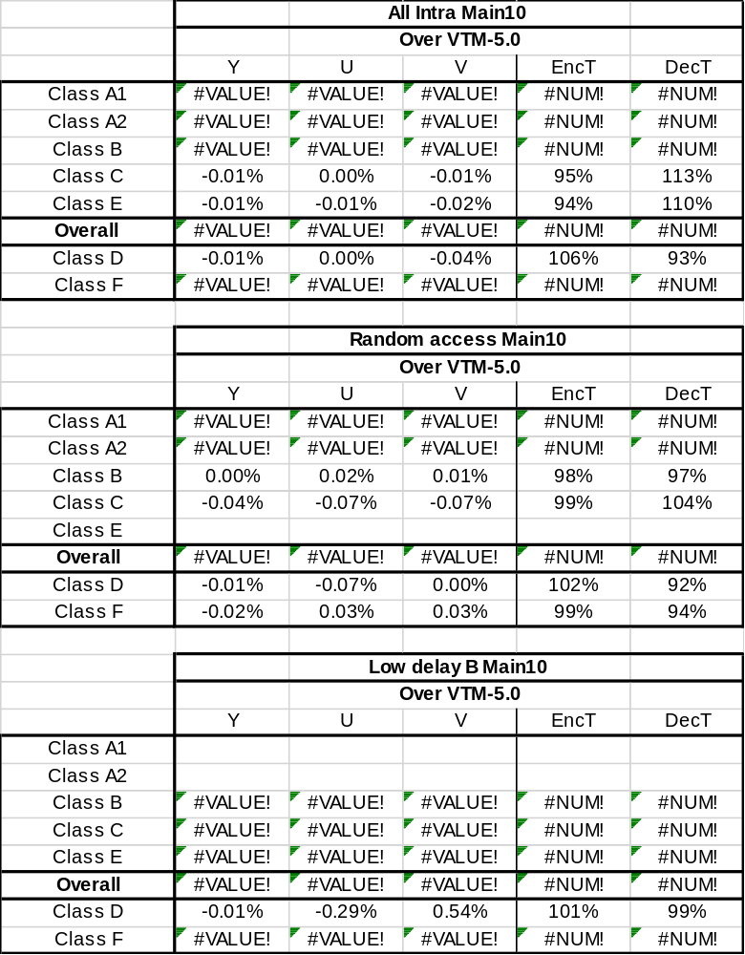

Results of Method 3 with EGk=3
Table 7: Results of Method 3 with EGk=3 applied for both ALF coefficients and clip values
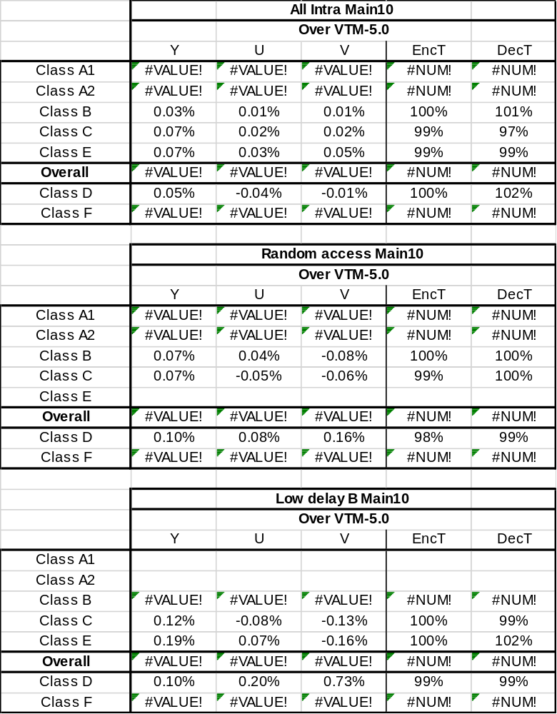

Table 8: Results of the combination of Method 3 with EGk=3 and JVET-O0064
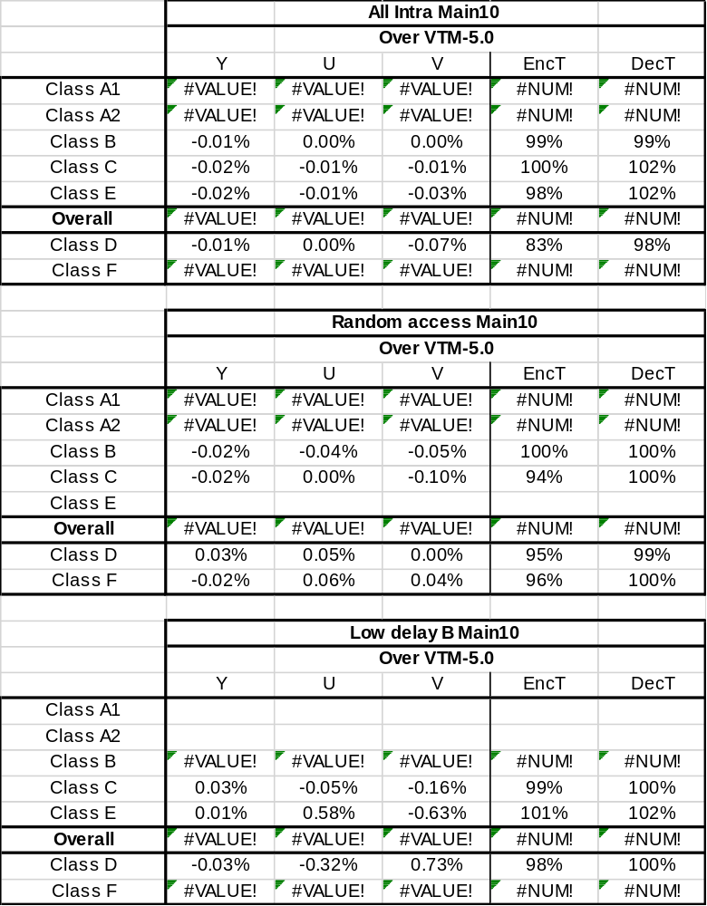

Results of Method 3 with EGk=4
Table 9: Results of Method 3 with EGk=4 applied for both ALF coefficients and clip values
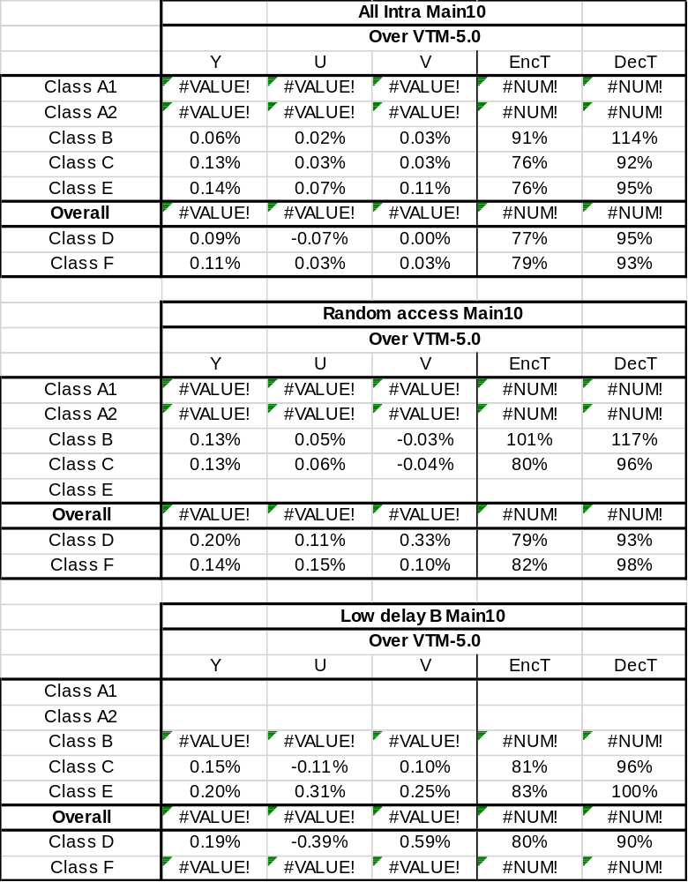

Table 10: Results of the combination of Method 3 with EGk=4 and JVET-O0064

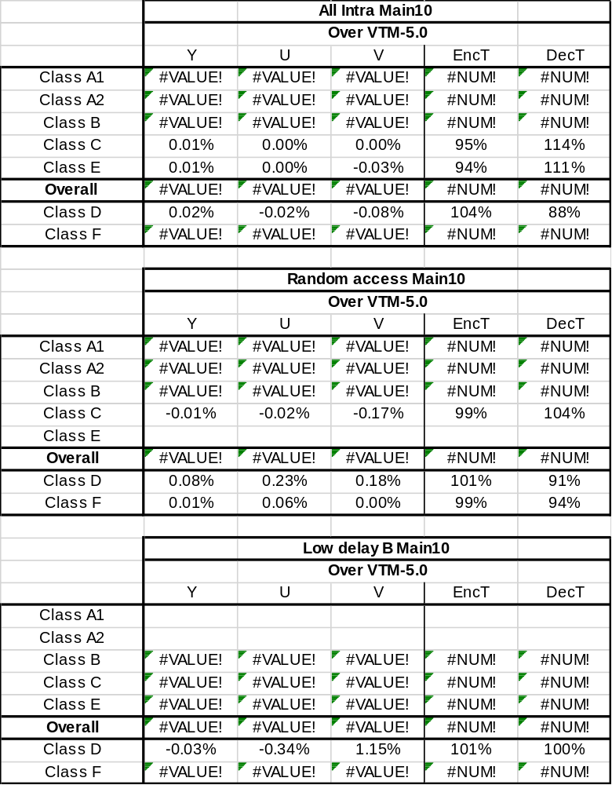

Reference
[1] F. Bossen, J. Boyce, X. Li, V. Seregin, K. Sühring, “JVET common test conditions and software reference configurations for SDR video”, JVET-N1010, 14th meeting, Geneva, CH, 19-27 March 2019.

Patent rights declaration(s)
Qualcomm Inc. may have current or pending patent rights relating to the technology described in this contribution and, conditioned on reciprocity, is prepared to grant licenses under reasonable and non-discriminatory terms as necessary for implementation of the resulting ITU-T Recommendation | ISO/IEC International Standard (per box 2 of the ITU-T/ITU-R/ISO/IEC patent statement and licensing declaration form).

